The Single Sign on system is developed using Windows Identity Foundation where in a claim aware application(RP) redirect to a STS issuer for authentication and issuing identity token

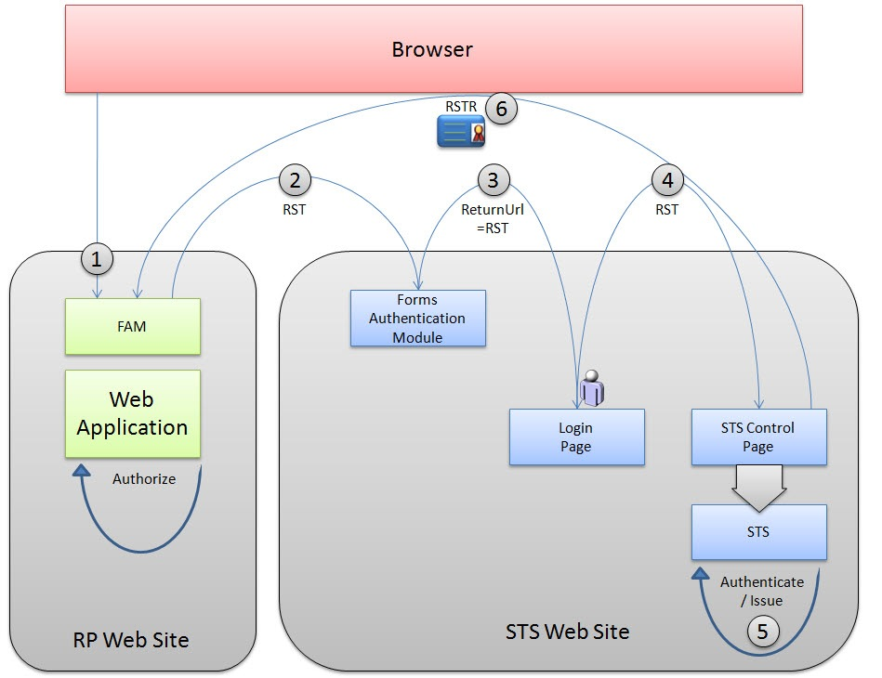
Current SSO setup at Pidilite

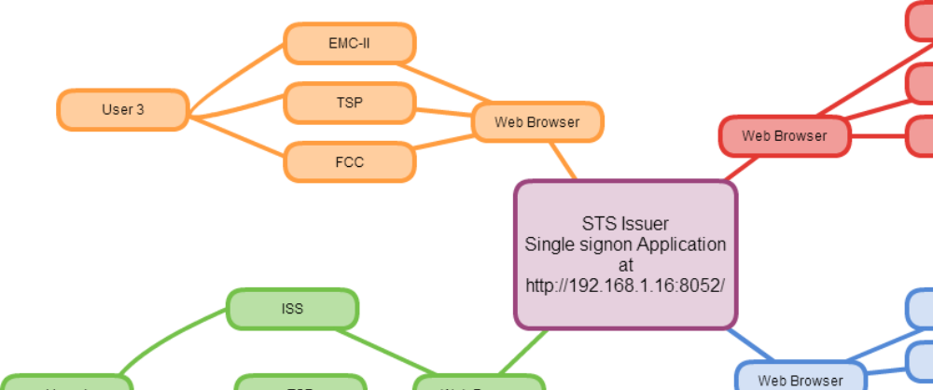

User management
Single User database will be maintained for both Sales/Marketing Hierarchy users and non sales/marketing hierarchy users
User locking/unlocking can be handled through admin module
For non sales hierarchy users data will be sync from Employee master.
for users leaving the organisation account will be disabled based on employee master database

User Alias
For different application which are currently live, the username can be different from the SSO username, a provision will be made in the system to create user alias for different applications

Permission for user
User permission can be set based on user roles/group, division & location
Overriding rules can be created for exceptions

Security
Secure 128 SSL/TLS communication can be setup between SSO portal and Business applications.

Login
For TSI login will be through TSICode
For all other users login will be through employee code
(need to see how tsi will access applications which uses employee code)

