ELWIS 2 – Upload Documents Plugin 1.0

INSTALL NOTES
Support Microsoft Word XP, 2003 versions.
1.- Close all open MS Word windows.

2.- Install plugin executing setup.exe installer.

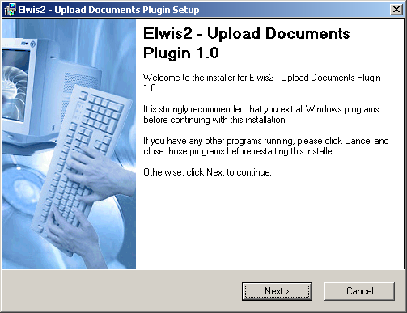

3.- Open your MS word, if installation was successful two buttons was added to standar toolbar.

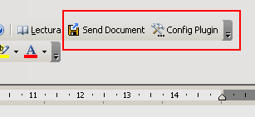
4.- Config plugin pressing “Config plugin” button, and put Elwis Server Host URL and the port in wich Jboss running.

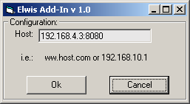

5.- Then press OK. Configuration was saved and then go to Elwis2 application and interact with “Communications “ tab inside Contact Manager module.
Plugin is avalaible when you make a letter or fax in communication options.

After you save the communication a windows will be opened, with download title, choose open and then edit your generated document.
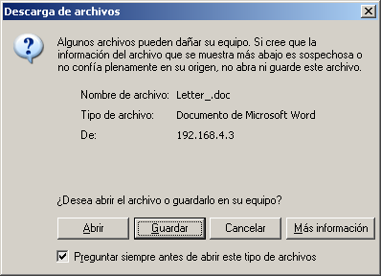

6.- After you finish with modification of documents, press send Document.
If you want to close status of documents check close.

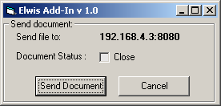
After press send document.

