UNIVERSITY OF LAGOS
Department of Computer Science
SMART HOME ENERGY MANAGEMENT SYSTEM
A Real-Time Embedded System for Automated Residential Energy Control and Monitoring
CSC419 — Real-Time Embedded Systems
Project Report
February 2026

Abstract
This project presents the design and implementation of a Smart Home Energy Management System (SHEMS), an embedded real-time system that automates the control of household appliances to reduce energy waste in residential environments. In many homes, university hostels, and small offices, energy is wasted daily through appliances such as air conditioners and lighting systems being left running in unoccupied rooms or in conditions where they are not needed. The proposed system addresses this problem by integrating multiple sensors, including temperature sensors, passive infrared occupancy detectors, and light-dependent resistors, to continuously monitor environmental conditions across different rooms. A central microcontroller processes the sensor data and executes predefined control logic to automatically adjust air conditioning based on room temperature and occupancy, switch off or dim lights when rooms are empty or when sufficient natural light is available, and log all energy consumption data for analysis.
The system follows a layered software architecture that separates the hardware abstraction layer, the control logic layer, and the presentation layer to ensure modularity and ease of maintenance. A web-based monitoring dashboard allows users to view real-time sensor readings, appliance states, and historical energy usage analytics remotely. The methodology adopts an iterative software development life cycle, with system behaviour modelled using use case diagrams, data flow diagrams, and finite state machines. The embedded control logic is simulated in Python, while the microcontroller layer is prototyped in a simulated Arduino environment.
Results from a 24-hour simulation across four rooms demonstrate that the system achieved a 65.2% reduction in energy consumption compared to the unmanaged baseline, saving 95.73 kWh and an estimated N6,510 daily at the Band A electricity tariff rate.

Chapter 1: Introduction

1.1 Background to the Study
Energy consumption in residential and institutional buildings has grown significantly in recent decades, driven by the increasing use of electrical appliances such as air conditioning systems, lighting, and electronic devices. A substantial portion of this consumption is avoidable, arising from appliances left running in unoccupied rooms, air conditioning systems operating at full capacity when outdoor temperatures are moderate, and lights remaining on during daytime hours when natural illumination is sufficient.
Traditional approaches to managing energy usage rely on manual control by occupants, which is inherently inconsistent and unreliable. The concept of smart home automation has emerged as a solution to this problem, using embedded systems, sensors, and software-based control logic to monitor environmental conditions and manage appliances automatically. Real-time embedded systems are particularly suited to this application because they must respond to sensor inputs within defined time constraints to maintain effective control, a characteristic that distinguishes them from batch or interactive computing systems.
The development of affordable microcontrollers, low-cost sensors, and wireless communication technologies has made it increasingly practical to deploy such systems in homes, hostels, and small office environments at a reasonable cost.

1.2 Statement of the Problem
In most residential buildings, university hostels, and small offices in Nigeria, there is no automated mechanism for managing energy consumption. Air conditioners continue to run at full capacity in empty rooms, lights remain on throughout the day even when natural sunlight is available, and occupants have no visibility into how much energy individual appliances consume over time. This leads to significant energy waste and inflated electricity bills. Manual control is the only available method, but it depends entirely on occupant behaviour and is therefore unreliable. There is a need for an intelligent, automated system that can monitor room conditions in real time, make control decisions without human intervention, and provide occupants with data-driven insights into their energy usage patterns.

1.3 Aim and Objectives
The aim of this project is to design and implement a Smart Home Energy Management System that automatically controls household appliances based on real-time environmental and occupancy data to reduce energy waste.
The specific objectives are:
- To design a sensor-based monitoring subsystem that captures room temperature, occupancy status, and ambient light levels in real time.
- To develop control logic using finite state machines that automatically manages air conditioning and lighting systems based on sensor inputs.
- To implement an energy usage logging and analytics module that records appliance consumption data and generates usage reports.
- To build a web-based monitoring dashboard that displays real-time sensor data, appliance states, and energy consumption trends.
- To simulate the complete system using software-based sensor emulation and a simulated microcontroller environment.

1.4 Scope of Study
This project focuses on the software design and simulation of a smart home energy management system. The system monitors two primary environmental parameters (temperature and ambient light) and one occupancy parameter (presence detection) to control two categories of appliances (air conditioning and lighting). The simulation models a residential environment with four rooms, each equipped with its own set of sensors. The microcontroller logic is prototyped in a simulated Arduino environment using Tinkercad, while the control logic, backend API, and dashboard are implemented as software components running on a standard computer. The project does not cover the physical fabrication of hardware, integration with actual power distribution systems, or deployment in a live building.

1.5 Significance of Study
This project contributes to the growing body of work on smart home automation and embedded systems design by presenting a modular, software-driven approach to residential energy management. The layered architecture and use of standard design patterns (Observer, MVC, state machine) make the system easily extensible and maintainable. For students and researchers, the project demonstrates how real-time embedded system concepts, such as periodic task scheduling, sensor data acquisition, and actuator control, can be applied to a practical domestic problem. For end users, the system offers a cost-effective path to reducing energy consumption without requiring expensive commercial smart home solutions. The energy analytics component provides actionable insights that can inform behavioural changes in addition to the automated controls.

Chapter 2: Methodology
This chapter describes the systematic approach adopted in the design and development of the Smart Home Energy Management System. It covers the system requirements, system models, architectural patterns, algorithms, and the software development life cycle.
The development methodology follows an iterative software development life cycle (SDLC), where the system is designed, implemented, and tested in incremental stages.

2.1 System Requirements

2.1.1 Functional Requirements
- Continuously monitor room temperature using simulated temperature sensors at a sampling rate of once every five minutes.
- Detect room occupancy using simulated passive infrared (PIR) motion sensors.
- Measure ambient light levels using simulated light-dependent resistors (LDRs), returning values on a scale from 0 to 1023.
- Automatically activate AC when occupied and temperature exceeds 28°C, deactivate when unoccupied or below 24°C.
- Automatically switch on lighting when occupied and ambient light falls below 300.
- Log all sensor readings and appliance state changes to a persistent database.
- Calculate and store energy consumption data per appliance per room.
- Expose all data through a RESTful API.
- Display real-time data on a web-based dashboard.
- Allow users to manually override appliance states.

2.1.2 Non-Functional Requirements
- Response time: Process sensor readings and execute control decisions within 1 second.
- Modularity: Distinct, loosely coupled layers allowing independent modification.
- Scalability: Support addition of new room zones and sensor types.
- Reliability: Handle sensor failures by defaulting to safe state (appliances off).
- Usability: No more than 3 clicks to reach any data on the dashboard.

2.1.3 Hardware Requirements (Simulated)
Table 1: Hardware Component Mapping
Component | Specification | Simulated In
Microcontroller | Arduino Uno (ATmega328P) | Tinkercad / Python
Temperature Sensor | LM35 (analog, 0–150°C) | Python sine wave
PIR Motion Sensor | HC-SR501 (digital) | Python probability
Light Sensor (LDR) | GL5528 (analog, 0–1023) | Python daylight curve
Relay Module | 4-channel 5V relay | Python boolean state
Wi-Fi Module | ESP8266 | Flask API (localhost)

2.2 System Models

2.2.1 Use Case Diagram
The system involves two primary actors: the Occupant (human user who interacts with the dashboard) and the Environment (physical surroundings generating sensor inputs).
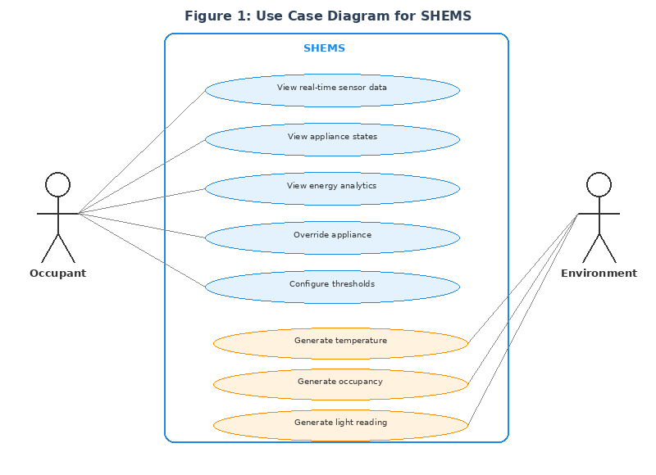
Figure 1: Use Case Diagram for SHEMS

2.2.2 Data Flow Diagrams
The Level 0 DFD (Context Diagram) represents the entire SHEMS as a single process, showing data flows between the system and its external entities.
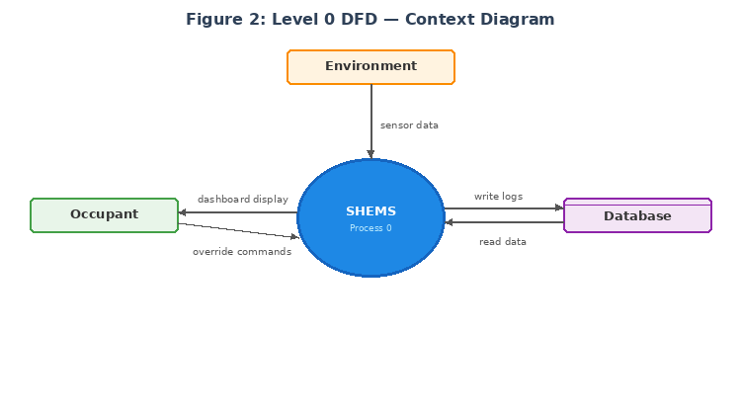
Figure 2: Level 0 DFD — Context Diagram
The Level 1 DFD decomposes the SHEMS into four sub-processes: Sensor Data Acquisition (P1), Control Logic Engine (P2), Data Logging and Analytics (P3), and Dashboard and API Server (P4).
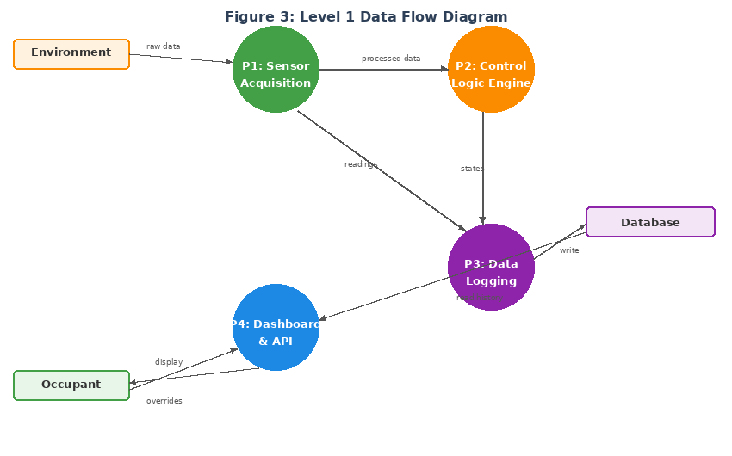
Figure 3: Level 1 Data Flow Diagram

2.2.3 Finite State Machine — AC Control
The air conditioning system uses a three-state finite state machine with a 4°C hysteresis band (24°C to 28°C) to prevent rapid on/off cycling.
Table 2: AC FSM State Transitions
Current State | Condition | Next State
OFF | Occupied AND temp ≥ 28°C | COOLING
OFF | Occupied AND temp < 28°C | STANDBY
STANDBY | Temp rises above 28°C | COOLING
STANDBY | Room becomes unoccupied | OFF
COOLING | Temp falls below 24°C | STANDBY
COOLING | Room becomes unoccupied | OFF
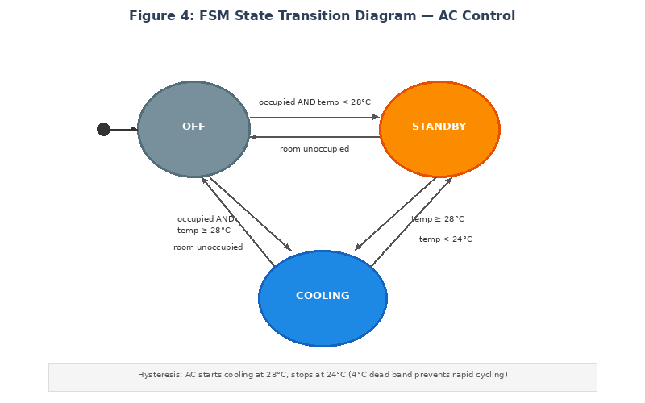
Figure 4: FSM State Transition Diagram — AC Control

2.2.4 Finite State Machine — Lighting Control
Table 3: Lighting FSM State Transitions
Current State | Condition | Next State
OFF | Occupied AND light < 300 | ON
ON | Unoccupied OR light ≥ 300 | OFF
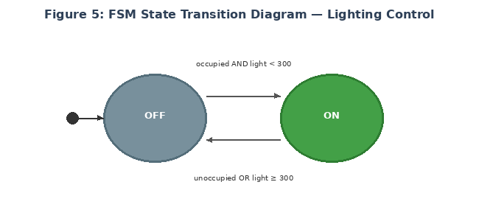
Figure 5: FSM State Transition Diagram — Lighting Control

2.2.5 Layered Architecture
The system adopts a layered software architecture where each layer communicates only with adjacent layers, enforcing separation of concerns.
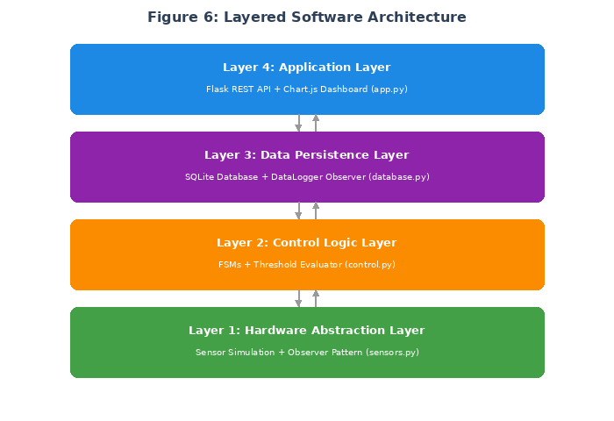
Figure 6: Layered Software Architecture

2.2.6 Observer Pattern
The Observer design pattern decouples sensors from controllers. Each sensor notifies registered observers whenever a new reading is available.
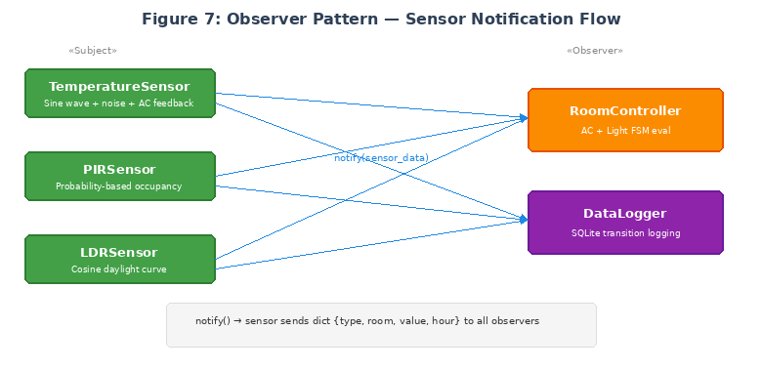
Figure 7: Observer Pattern — Sensor Notification Flow

2.3 Algorithms
Algorithm 1: Periodic Sensor Data Acquisition
Input: sensor_list, interval (5 minutes)
Output: sensor_readings per room per sensor type

BEGIN
LOOP every <interval>:
FOR each sensor IN sensor_list:
raw_value ← sensor.read()
IF raw_value IS out_of_range THEN
raw_value ← sensor.last_valid_reading
END IF
normalized ← normalize(raw_value, sensor.type)
NOTIFY all observers with (room, type, normalized)
END FOR
END LOOP
END
Algorithm 2: AC Control Logic (FSM)
Input: room_state, temperature, is_occupied
Output: new_state, ac_command (ON/OFF)
Constants: UPPER = 28°C, LOWER = 24°C

BEGIN
CASE room_state OF:
"OFF":
IF occupied AND temp >= UPPER: COOLING, ON
ELSE IF occupied: STANDBY, OFF
ELSE: OFF, OFF
"STANDBY":
IF NOT occupied: OFF, OFF
ELSE IF temp >= UPPER: COOLING, ON
ELSE: STANDBY, OFF
"COOLING":
IF NOT occupied: OFF, OFF
ELSE IF temp < LOWER: STANDBY, OFF
ELSE: COOLING, ON
END CASE
END
Algorithm 3: Lighting Control
Input: light_level, is_occupied
Output: light_command (ON/OFF)
Constant: THRESHOLD = 300

BEGIN
IF occupied AND light_level < THRESHOLD THEN
light_command ← ON
ELSE
light_command ← OFF
END IF
END
The corresponding source codes for all algorithms are provided in the Appendix.

2.4 Software Development Life Cycle
The project follows an iterative incremental model consisting of four iterations: (1) Sensor Simulation and HAL, (2) Control Logic and State Machines, (3) Backend, Database and Analytics, and (4) Dashboard and Integration. Each iteration was independently testable before integration.

Chapter 3: Implementation and Results

3.1 Development Environment
Table 4: Development Tools and Technologies
Component | Tool / Technology | Version
Programming Language | Python | 3.8+
Web Framework | Flask | 3.x
Database | SQLite3 | Built-in
Frontend Charting | Chart.js | 4.4.0
Arduino Simulation | Tinkercad | Online
IDE | VS Code / PyCharm | Latest
Version Control | Git + GitHub | Latest
Operating System | Windows 10+ / Ubuntu 24 | —

3.2 System Implementation

3.2.1 Sensor Simulation Module (sensors.py)
The TemperatureSensor generates readings following a sinusoidal daily curve centred on room-specific base temperatures reflecting Nigerian indoor conditions (27–30°C). Gaussian noise of ±0.5°C is applied. When AC is active, a cooling effect reduces temperature by up to 6°C. The PIRSensor uses time-based probability distributions: 80% during evening hours, 20% during daytime, and 10% during sleep hours. The LDRSensor follows a cosine daylight curve from 6:00 AM to 6:00 PM. All sensors implement the Observer pattern via the SensorSubject base class.

3.2.2 Control Logic Module (control.py)
The ACController FSM operates across three states (OFF, STANDBY, COOLING) with a 4°C hysteresis band. The LightController uses two states (OFF, ON), activating only when both conditions are met: room occupied AND ambient light below 300. The RoomController coordinates both FSMs and supports manual override capability.

3.2.3 Data Persistence Module (database.py)
Table 5: Database Schema
Table | Key Fields | Purpose
sensor_log | room_id, sensor_type, value, timestamp | Raw sensor readings
appliance_log | room_id, appliance, state, is_on, timestamp | State change events
energy_log | room_id, appliance, kwh, period_start/end | Computed energy
Table 6: Appliance Power Ratings
Appliance | Power Rating (kW)
Air Conditioning (window unit) | 1.50
Room Lighting (60W equivalent) | 0.06

3.2.4 Web Application Module (app.py)
Table 7: REST API Endpoints
Method | Endpoint | Description
GET | /api/status | Current state of all rooms
GET | /api/room/<room_id> | Detailed status for one room
GET | /api/history/<id>/<type> | Sensor reading history
GET | /api/energy | Energy consumption and savings
POST | /api/override | Manual appliance control
POST | /api/tick | Advance simulation one step
GET | /api/stats | Database row counts
POST | /api/reset | Clear database for fresh run

3.2.5 Simulation Engine (simulation.py)
The simulation engine orchestrates the complete 24-hour test across four rooms with 288 time steps at 5-minute intervals.

3.3 Simulation Parameters
Table 8: Simulation Configuration
Parameter | Value
Total Duration | 24 hours
Time Steps | 288 (5-minute intervals)
Number of Rooms | 4
Base Time | 2026-02-13 00:00:00
AC Upper Threshold | 28°C
AC Lower Threshold | 24°C
Light Threshold | 300 / 1023
Table 9: Room Configuration
Room | Base Temperature (°C) | Description
Living Room | 29.0 | Main common area
Bedroom | 27.0 | Sleeping quarters
Kitchen | 30.0 | Highest base temp (cooking heat)
Study Room | 28.0 | Work / study area

3.4 Simulation Results

3.4.1 Energy Consumption Results
Table 10: Energy Consumption by Room and Appliance (24-Hour Period)
Room | AC (kWh) | Lighting (kWh) | Total (kWh)
Living Room | 11.88 | 0.56 | 12.44
Bedroom | 11.38 | 0.62 | 12.00
Kitchen | 12.75 | 0.59 | 13.34
Study Room | 12.75 | 0.63 | 13.38
Total | 48.75 | 2.40 | 51.15
Air conditioning dominated total energy consumption at 95.3% (48.75 kWh out of 51.15 kWh), with lighting accounting for 4.7%. This distribution is consistent with real-world residential energy profiles in tropical climates.

3.4.2 Energy Savings Analysis
Table 11: Energy Savings Comparison
Metric | Without SHEMS | With SHEMS | Savings
AC Energy (kWh) | 144.00 | 48.75 | 95.25
Lighting Energy (kWh) | 2.88 | 2.40 | 0.48
Total Energy (kWh) | 146.88 | 51.15 | 95.73
Estimated Cost (N) | 9,987.84 | 3,477.86 | 6,509.98
Savings Percentage | — | — | 65.2%
The SHEMS achieved a 65.2% reduction in total energy consumption across four rooms, saving 95.73 kWh per day. At the Band A tariff rate of N68 per kWh, this translates to a daily cost saving of approximately N6,510.

3.4.3 Database Statistics
Table 12: System Data Volume (24-Hour Simulation)
Metric | Count
Sensor readings logged (sensor_log) | 3,456
Appliance state change events (appliance_log) | 102
Energy computation records (energy_log) | 8
The transition-only logging strategy reduced appliance records by 97% compared to logging every simulation step.

Chapter 4: Conclusion

4.1 Summary of Findings
The Smart Home Energy Management System successfully demonstrates that automated, software-driven control of household appliances can produce significant energy savings without requiring manual intervention. The 24-hour simulation across four rooms showed a 65.2% reduction in energy consumption compared to the unmanaged baseline, translating to an estimated daily cost saving of approximately N6,510 at the current Band A electricity tariff.
The layered software architecture proved effective in separating concerns. The Observer design pattern enabled clean sensor-to-controller communication without tight coupling, while the finite state machines provided predictable, verifiable control behaviour. The hysteresis mechanism in the AC controller successfully prevented chattering. Air conditioning accounted for 95.3% of total energy consumption, confirming that occupancy-aware AC control is the single most impactful energy management strategy in tropical climates.

4.2 Limitations
The system has several limitations. The simulation uses probabilistic occupancy models rather than actual PIR sensor data. The temperature model assumes uniform room temperature without accounting for insulation quality, window placement, or cross-ventilation. The baseline scenario assumes continuous 24-hour AC operation, which may overstate actual waste. The simulation does not model electricity grid constraints such as power outages, voltage fluctuations, or time-of-use tariff variations.

4.3 Recommendations for Further Work
- Integration with physical hardware (Arduino Uno, ESP8266, HC-SR501 PIR sensors, LM35 temperature sensors) to validate control logic against real sensor data.
- Extension to additional appliance types including ceiling fans, water heaters, automated window blinds, and standby power management.
- Incorporation of machine learning algorithms to predict occupancy patterns based on historical data, enabling pre-conditioning of rooms.
- Integration with the Nigerian national grid’s smart metering infrastructure for tariff-aware scheduling.
- Development of a mobile application interface with push notifications when energy usage exceeds thresholds.
The modular architecture of the current system is designed to accommodate these extensions without requiring fundamental restructuring, as new sensor types, appliance controllers, and analytics modules can be added as additional observers within the existing pattern.

