CN

ASSIGNEMENT 7

Akshat Patil

Roll: 10

AIDS_A

**Implement Socket programming to create Client and Server to send Hello message.( Implement TCP and UDP Socket)**

**Using TCP**

**Server**

***import* socket**

**s = socket.socket()**

**print('socket created')**

**s.bind(('localhost',9999))**

**s.listen(3)**

**print("waiting for connection")**

***while* True:**

**c,addr = s.accept()**

**name = c.recv(1024).decode()**

**print("connected with",addr,name)**

**c.send(bytes('Hello World','utf-8'))**

**c.close()**

**Client**

***import* socket**

**c = socket.socket()**

**c.connect(('localhost',9999))**

**name = input("Enter Your name")**

**c.send(bytes(name,'utf-8'))**

**print(c.recv(1024).decode())**

**OUTPUT**

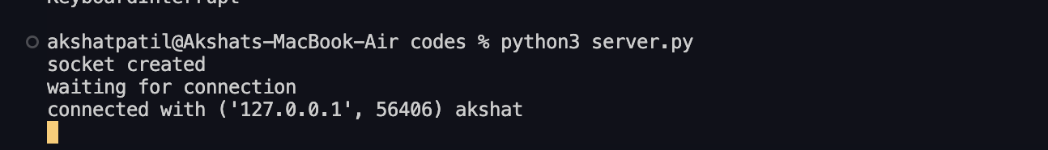

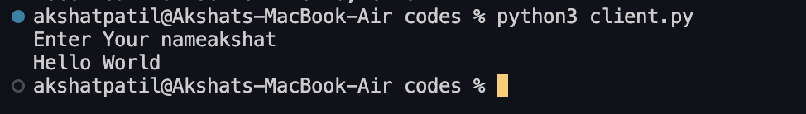

**Using UDP**

**Server**

***import* socket**

**SERVER_IP = "127.0.0.1"**

**SERVER_PORT = 12345**

**server_socket = socket.socket(socket.AF_INET, socket.SOCK_DGRAM)**

**server_socket.bind((SERVER_IP, SERVER_PORT))**

**print(f"UDP Server is listening on {SERVER_IP}:{SERVER_PORT}...")**

***while* True:**

**message, client_address = server_socket.recvfrom(1024)**

**print(f"Received from {client_address}: {message.decode()}")**

**response = "Hello, Client!"**

**server_socket.sendto(response.encode(), client_address)**

**Client**

***import* socket**

**SERVER_IP = "127.0.0.1"**

**SERVER_PORT = 12345**

**client_socket = socket.socket(socket.AF_INET, socket.SOCK_DGRAM)**

**message = "Hello"**

**client_socket.sendto(message.encode(), (SERVER_IP, SERVER_PORT))**

**response, _ = client_socket.recvfrom(1024)**

**print(f"Received from server: {response.decode()}")**

**client_socket.close()**

**Output**

