**CN ASSIGNMENT 9**

Akshat Patil   
AIDS SY A   
12311353   
Roll No. 10

*Write a program using TCP socket for wired network for following:*

*a. Say Hello to Each other b. File transfer c. Calculator (Arithmetic)*

***Output:***

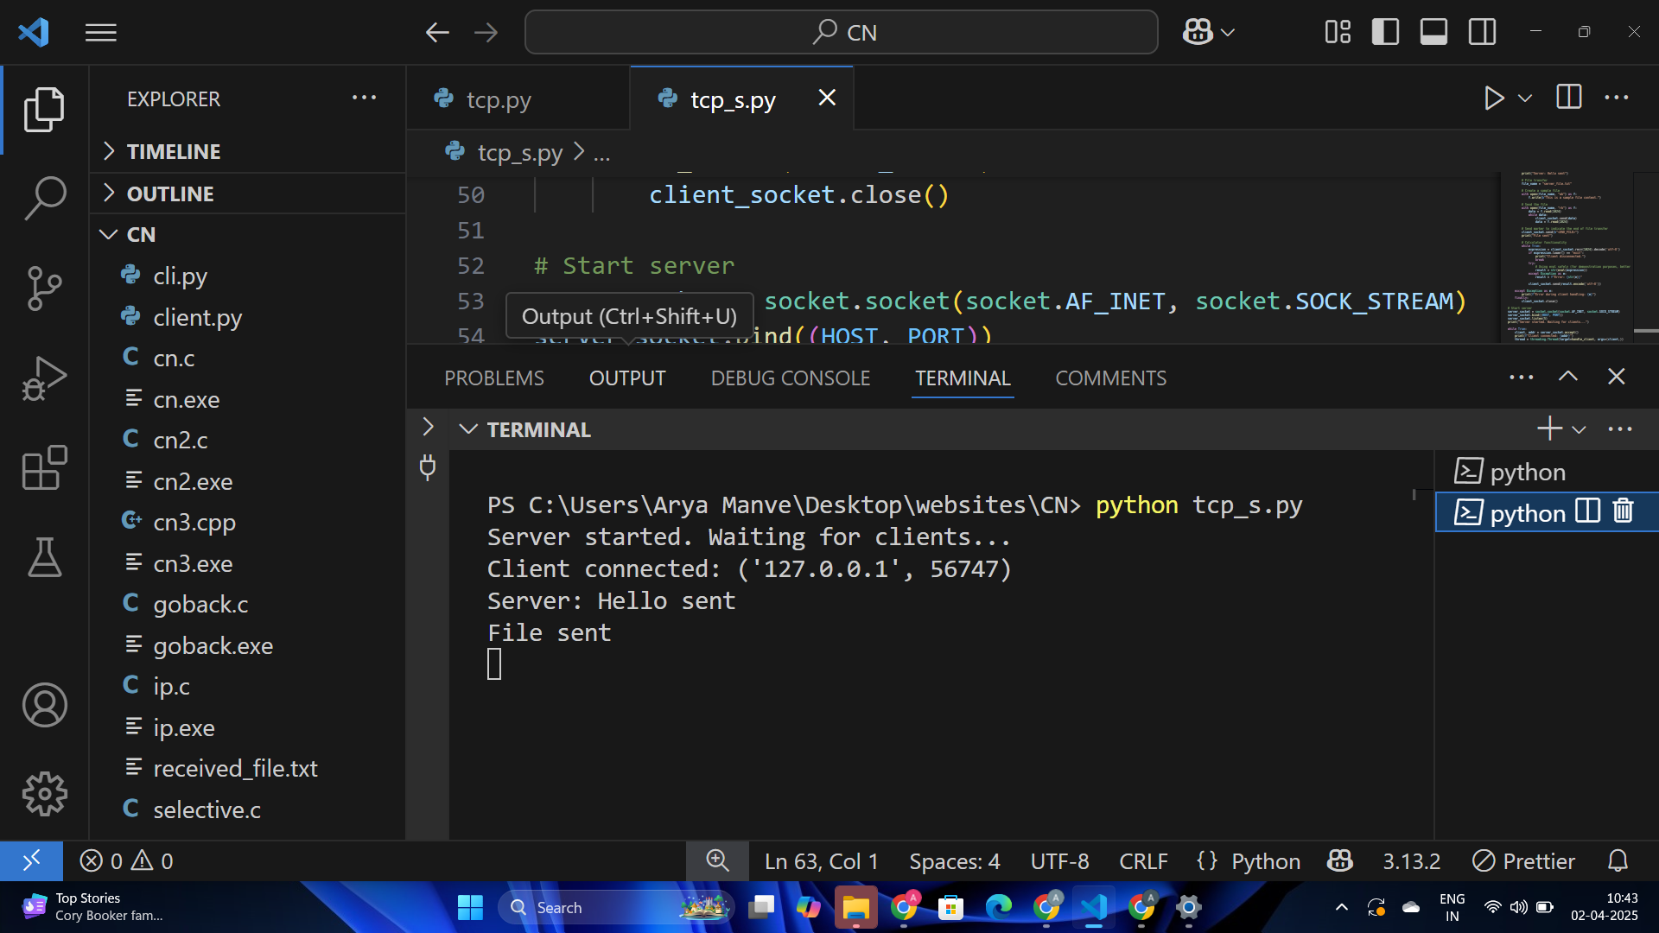

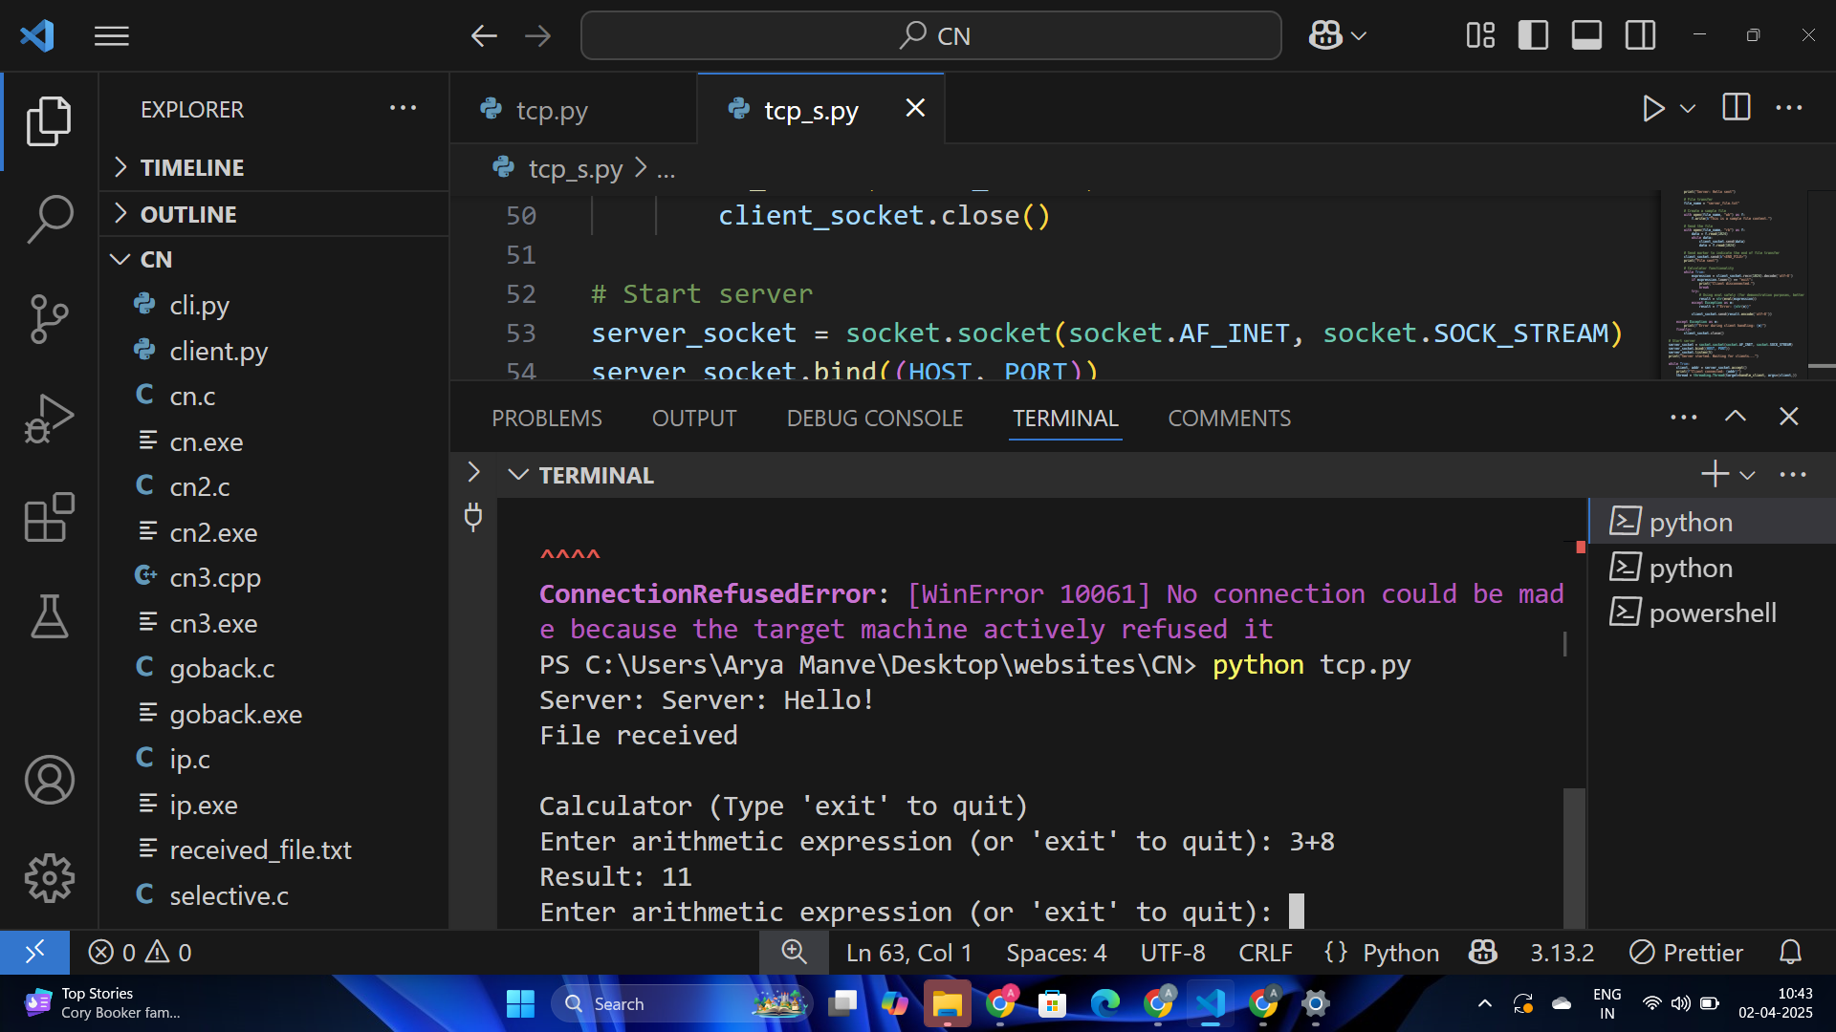

***Code:***

client.py

*import socket*

*# Server configurations*

*SERVER_IP = '127.0.0.1'*

*SERVER_PORT = 1234*

*# Connect to the server*

*client_socket = socket.socket(socket.AF_INET, socket.SOCK_STREAM)*

*client_socket.connect((SERVER_IP, SERVER_PORT))*

*# Receive greeting*

*greeting = client_socket.recv(1024).decode('utf-8')*

*print(f"Server: {greeting}")*

*# File reception*

*file_name = "received_file.txt"*

*with open(file_name, "wb") as f:*

*while True:*

*data = client_socket.recv(1024)*

*if b"<END_FILE>" in data:*

*# Remove the marker before writing the file*

*f.write(data.replace(b"<END_FILE>", b""))*

*break*

*f.write(data)*

*print("File received")*

*# Calculator functionality*

*print("\nCalculator (Type 'exit' to quit)")*

*while True:*

*expression = input("Enter arithmetic expression (or 'exit' to quit): ")*

*client_socket.send(expression.encode('utf-8'))*

*if expression.lower() == "exit":*

*break*

*result = client_socket.recv(1024).decode('utf-8')*

*print(f"Result: {result}")*

*# Close connection*

*client_socket.close()*

server.py

*import socket*

*import threading*

*# Server configurations*

*HOST = '127.0.0.1'*

*PORT = 1234*

*# Handle client communication*

*def handle_client(client_socket):*

*try:*

*# Send greeting*

*client_socket.send(b"Server: Hello!")*

*print("Server: Hello sent")*

*# File transfer*

*file_name = "server_file.txt"*

*# Create a sample file*

*with open(file_name, "wb") as f:*

*f.write(b"This is a sample file content.")*

*# Send the file*

*with open(file_name, "rb") as f:*

*data = f.read(1024)*

*while data:*

*client_socket.send(data)*

*data = f.read(1024)*

*# Send marker to indicate the end of file transfer*

*client_socket.send(b"<END_FILE>")*

*print("File sent")*

*# Calculator functionality*

*while True:*

*expression = client_socket.recv(1024).decode('utf-8')*

*if expression.lower() == "exit":*

*print("Client disconnected.")*

*break*

*try:*

*# Using eval safely (for demonstration purposes, better alternatives exist)*

*result = str(eval(expression))*

*except Exception as e:*

*result = f"Error: {str(e)}"*

*client_socket.send(result.encode('utf-8'))*

*except Exception as e:*

*print(f"Error during client handling: {e}")*

*finally:*

*client_socket.close()*

*# Start server*

*server_socket = socket.socket(socket.AF_INET, socket.SOCK_STREAM)*

*server_socket.bind((HOST, PORT))*

*server_socket.listen(5)*

*print("Server started. Waiting for clients...")*

*while True:*

*client, addr = server_socket.accept()*

*print(f"Client connected: {addr}")*

*thread = threading.Thread(target=handle_client, args=(client,))*

*thread.start()*