Akshat Patil

CN assignment

AIDS-A

Roll 10

Task: **Write a program using UDP Sockets to enable file transfer (Script, Text, Audio and Video one file each) between two machines.**

receiver.py

*import* socket

IP = "0.0.0.0" *# Listen on all interfaces*

PORT = 5001

BUFFER_SIZE = 65535 *# Max UDP size*

sock = socket.socket(socket.AF_INET, socket.SOCK_DGRAM)

sock.bind((IP, PORT))

print(f"[Receiver] Listening on port {PORT}...")

*# Receive filename*

data, addr = sock.recvfrom(BUFFER_SIZE)

filename = data.decode()

print(f"[Receiver] Receiving file: {filename}")

sock.sendto(b"FILENAME_RECEIVED", addr)

*# Open file to write binary data*

*with* open(f"received_{filename}", "wb") *as* f:

*while* True:

data, addr = sock.recvfrom(BUFFER_SIZE)

*if* data == b"EOF":

print("[Receiver] File transfer complete.")

*break*

f.write(data)

sock.sendto(b"ACK", addr)

sender.py

*import* socket

*import* os

RECEIVER_IP = "0.0.0.0"

PORT = 5001

BUFFER_SIZE = 65535 *# Max UDP size*

FILE_PATH = "./read.txt"

sock = socket.socket(socket.AF_INET, socket.SOCK_DGRAM)

filename = os.path.basename(FILE_PATH)

sock.sendto(filename.encode(), (RECEIVER_IP, PORT))

print(f"[Sender] Sent filename: {filename}")

*# Wait for filename ACK*

ack, _ = sock.recvfrom(BUFFER_SIZE)

*if* ack != b"FILENAME_RECEIVED":

print("[Sender] Error receiving filename ACK.")

exit()

*# Send file in chunks*

*with* open(FILE_PATH, "rb") *as* f:

*while* True:

chunk = f.read(BUFFER_SIZE)

*if* not chunk:

*break*

sock.sendto(chunk, (RECEIVER_IP, PORT))

ack, _ = sock.recvfrom(BUFFER_SIZE)

*if* ack != b"ACK":

print("[Sender] Packet ACK failed.")

*break*

*# Send EOF marker*

sock.sendto(b"EOF", (RECEIVER_IP, PORT))

print("[Sender] File sent successfully.")

Output:

Receiver terminal

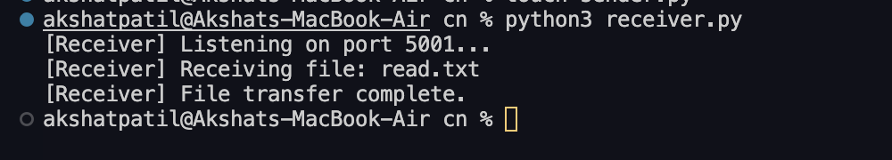

Sender terminal

