IronBCI → VRChat Avatar Control
Step-by-Step Setup Manual
Control your VRChat avatar with real EEG brainwave data
June 9, 2026

Overview
This manual documents the complete setup process for connecting an IronBCI EEG device to VRChat to control an avatar using real-time brainwave data. The full pipeline is:

- IronBCI device (EEG cap on head) → Bluetooth BLE
- PiEEG Server on Windows PC → reads EEG signal
- OSC protocol (UDP port 9000) → sends EEG band values
- VRChat running on PC → receives EEG_Alpha, EEG_Beta, EEG_Delta, EEG_Theta, EEG_Gamma
- Avatar animator → reacts to brainwave parameters in real time

The 5 EEG bands sent as avatar float parameters (0–1, rolling normalized):

- EEG_Delta — 0.5–4 Hz (deep sleep / drowsy)
- EEG_Theta — 4–8 Hz (meditative / creative)
- EEG_Alpha — 8–13 Hz (relaxed / calm) ← easiest to control
- EEG_Beta — 13–30 Hz (focused / alert)
- EEG_Gamma — 30–100 Hz (high cognition)

Step 1 — Install PiEEG Server
Install PiEEG Server with IronBCI Bluetooth support on your Windows PC.

Command (run in terminal/PowerShell):
pip install pieeg-server[ironbci]

Launch with IronBCI and OSC enabled:
pieeg-server --device ironbci8 --osc

This auto-scans for your IronBCI via BLE and starts streaming EEG data to VRChat on port 9000.

Optional — target device by address:
pieeg-server --device ironbci8 --ble-address AA:BB:CC:DD:EE:FF --osc

Open the dashboard to verify signal quality:
http://localhost:1617

Step 2 — VRChat OSC Bridge Active
Once PiEEG Server is running, the VRChat OSC Bridge panel appears showing live EEG data streaming to VRChat.

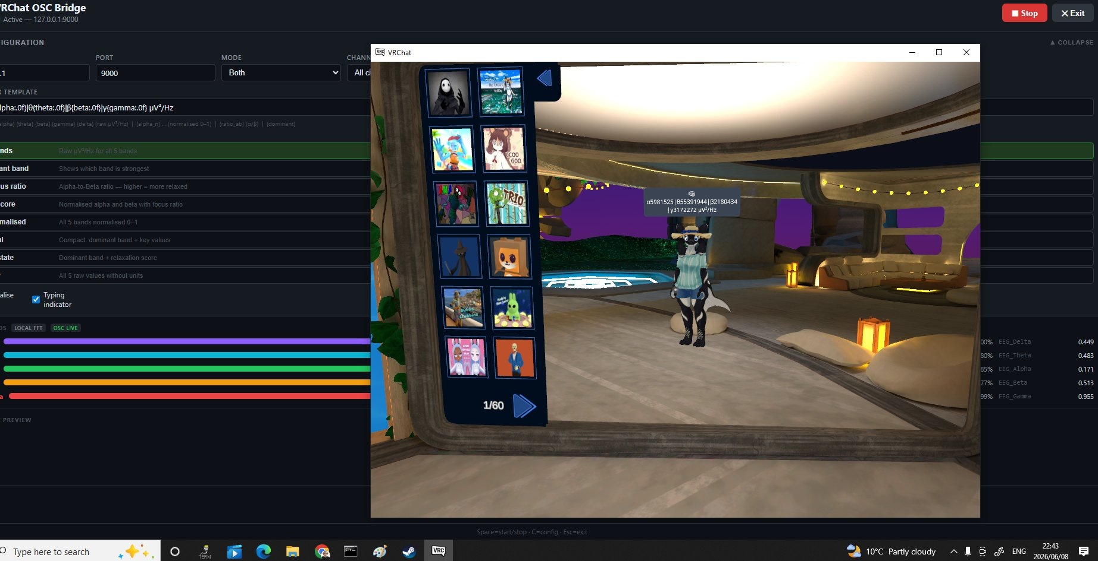
VRChat OSC Bridge active — EEG bands visible bottom right with live values

Key indicators that everything is working:
- Status shows: Active — 127.0.0.1:9000
- Port: 9000, Mode: Both (chatbox + avatar parameters)
- Colored bars at bottom show live EEG band activity
- Bottom right shows: EEG_Delta, EEG_Theta, EEG_Alpha, EEG_Beta, EEG_Gamma with float values
- Data visible above avatar head in VRChat

Step 3 — Launch VRChat on Windows
VRChat was launched on Windows PC in desktop mode via Steam. The avatar and world loaded successfully.

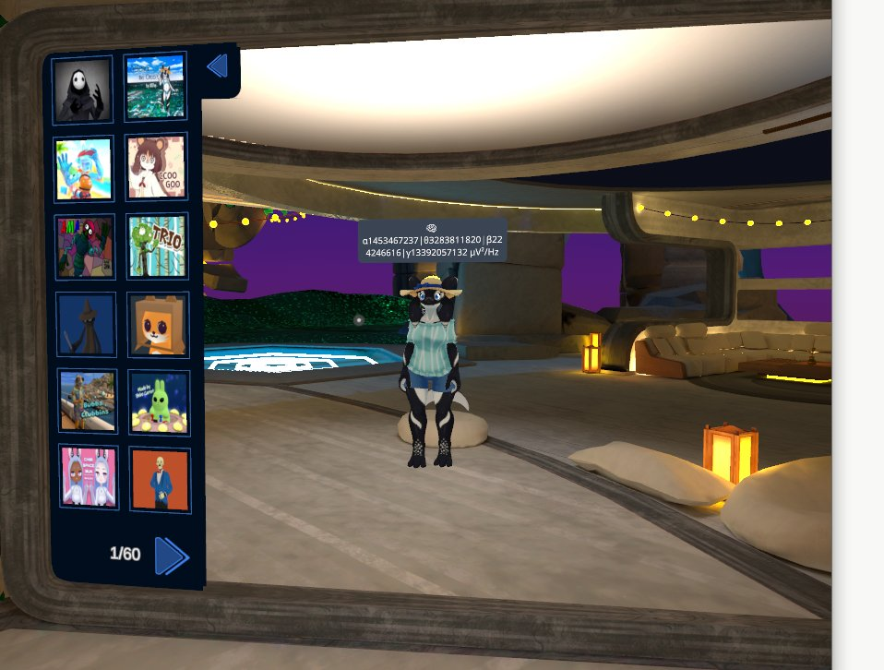
VRChat running in desktop mode — avatar in world with EEG data showing above head

Enable OSC in VRChat:
- Hold left controller menu button → Action Menu opens
- Navigate to OSC → Enabled → toggle ON
- OSC Debug screen available at OSC → OSC Debug (shows live incoming messages)

VRChat OSC Ports:
- UDP 9000 — PiEEG Server sends TO VRChat (default, no config needed)
- UDP 9001 — VRChat sends back to your app

For Meta Quest users: VRChat must run on PC (via Air Link or Steam Link), not natively on the headset. OSC is a PC-side feature.

Step 4 — Install VRChat Creator Companion
The VRChat Creator Companion (VCC) manages Unity projects and SDK packages for avatar creation.

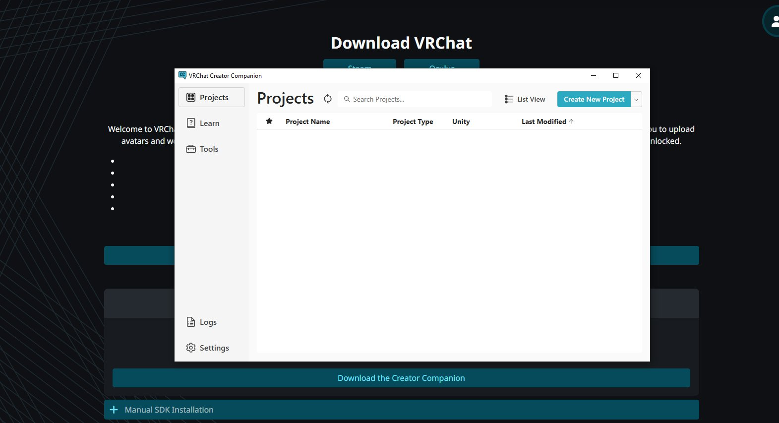
VRChat Creator Companion — Projects panel (empty, ready to create new project)

Download from: https://vrchat.com/home/download — look for 'Download Creator Companion'.

Step 5 — Create New Unity Avatar Project
In the Creator Companion, click 'Create New Project' and select the Unity 2022 Avatar Project template.

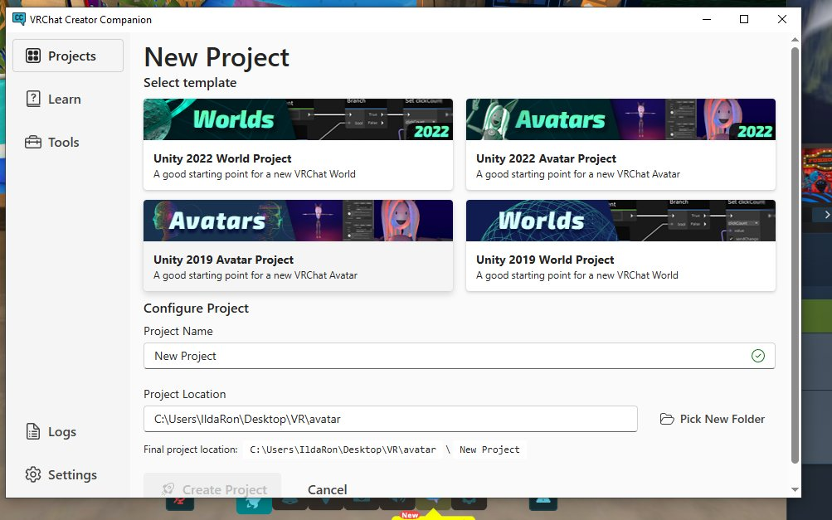
New Project screen — select 'Unity 2022 Avatar Project' template

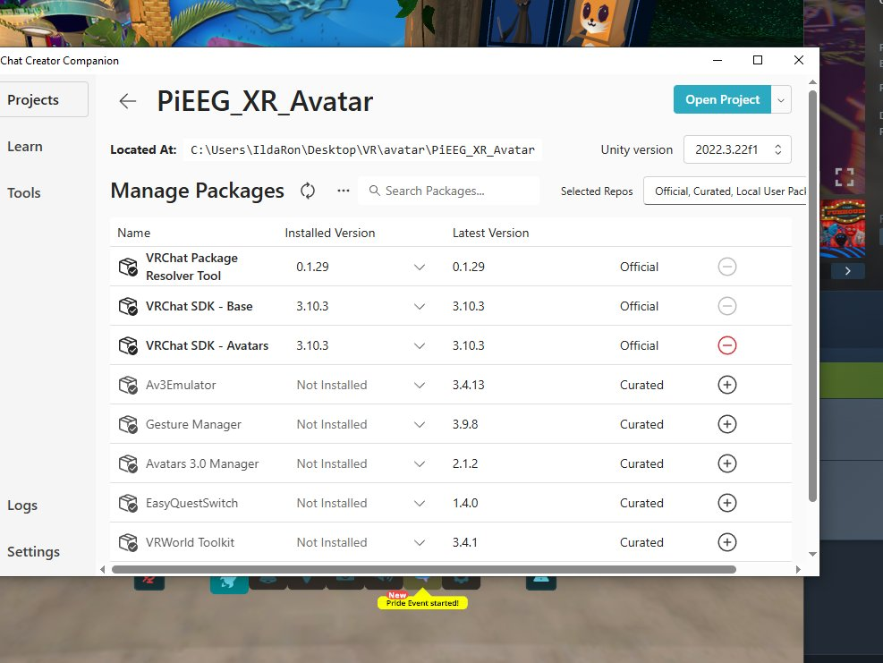
Project 'PiEEG_XR_Avatar' created with VRChat SDK packages installed

The project was named 'PiEEG_XR_Avatar' and saved to: C:\Users\IldaRon\Desktop\VR\avatar\PiEEG_XR_Avatar

Packages automatically installed:
- VRChat Package Resolver Tool — 0.1.29
- VRChat SDK - Base — 3.10.3
- VRChat SDK - Avatars — 3.10.3

Step 6 — Open Project in Unity
Click 'Open Project' in VCC to launch Unity 2022.3.22f1 with the avatar project.

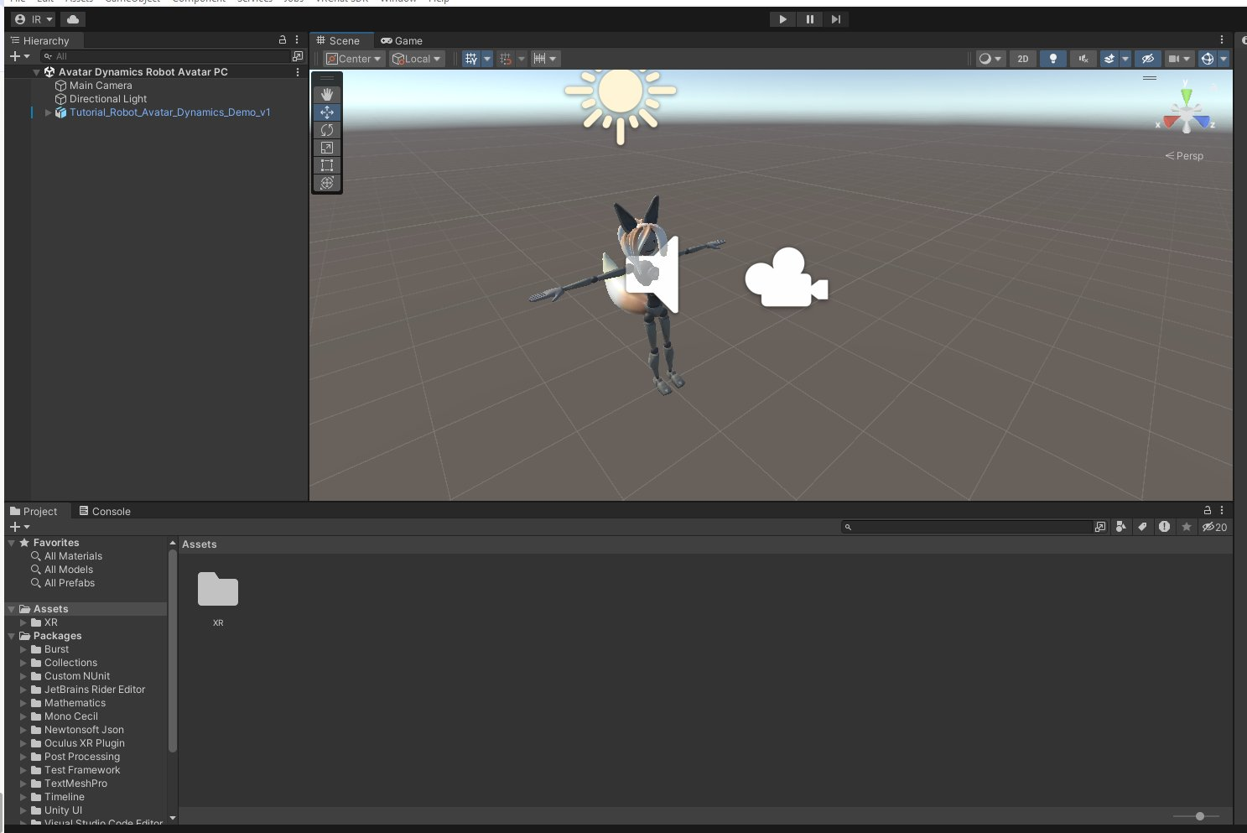
Unity open with Tutorial_Robot_Avatar_Dynamics_Demo_v1 — official VRChat sample avatar

The project comes with the official VRChat Tutorial Robot Avatar as a ready-to-use starting point. The avatar includes Armature, Body, and Dynamics (PhysBones for hair, tail, ears).

Step 7 — Add EEG Expression Parameters
The VRC Avatar Descriptor needs Expression Parameters to receive OSC values from PiEEG Server.

Process:
- Select the avatar in Hierarchy
- In Inspector → VRC Avatar Descriptor → Expressions → click Customize
- Click the circle icon next to Parameters
- Create a new VRCExpressionParameters asset

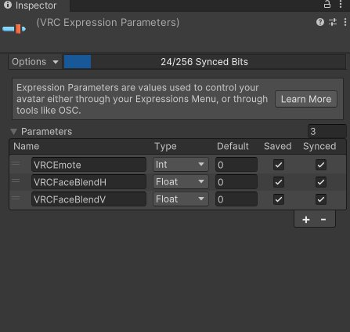
VRC Expression Parameters panel — ready to add EEG parameters

Added 5 EEG float parameters by clicking '+' for each:

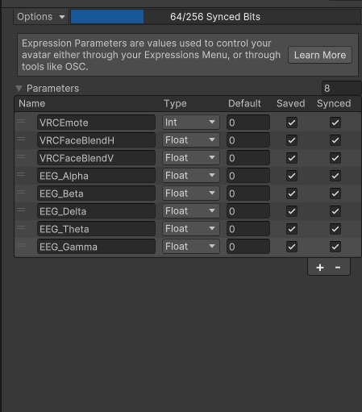
All 5 EEG parameters added — Float type, Default 0, Synced checked

Parameters added (all Float, Default 0, Saved: unchecked, Synced: checked):
- EEG_Alpha
- EEG_Beta
- EEG_Delta
- EEG_Theta
- EEG_Gamma

Total: 64/256 Synced Bits used.

Step 8 — Create EEG Animator Controller
An Animator Controller drives avatar animations based on the EEG float values.

Process:
- Assets panel → right-click XR folder → Create → Animator Controller
- Named: EEG_Controller
- Double-click to open in Animator window
- Click Parameters tab → add 5 Float parameters matching exactly the OSC names

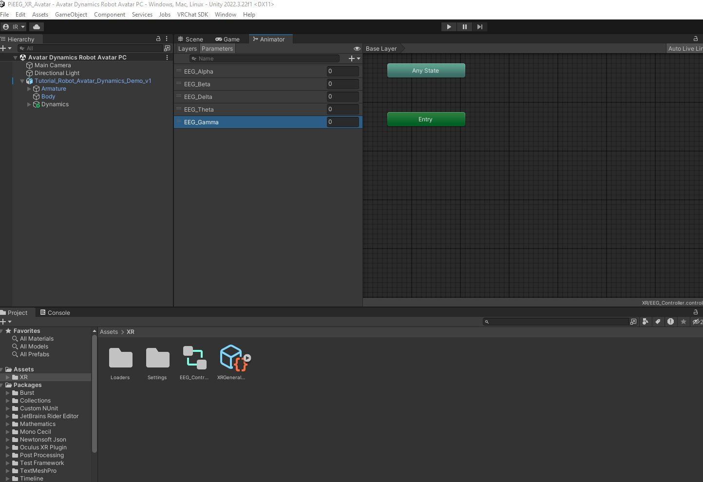
Animator Parameters panel — all 5 EEG float parameters added

Step 9 — Create Blend Tree for Tail Animation
A Blend Tree smoothly interpolates between animation states based on a float parameter value.

Process:
- In Animator → Layers tab → right-click in grid → Create State → From New Blend Tree
- Double-click the Blend Tree state to open it
- Parameter automatically set to EEG_Alpha
- Created two animation clips: EEG_Alpha_Low and EEG_Alpha_High
- Added both clips as Motion Fields in the Blend Tree

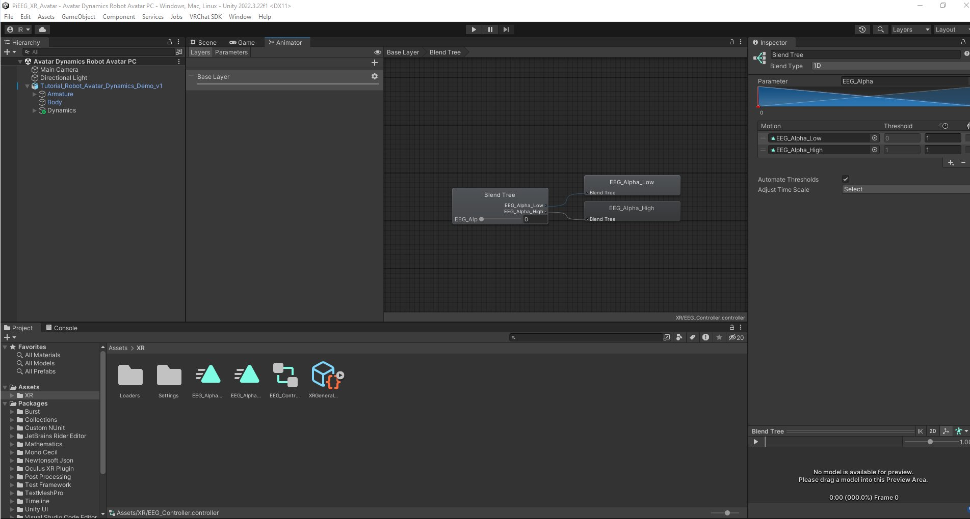
Blend Tree configured — EEG_Alpha drives blend between Low (0) and High (1) states

Blend Tree settings:
- Blend Type: 1D
- Parameter: EEG_Alpha
- EEG_Alpha_Low at threshold 0 (tail down / resting)
- EEG_Alpha_High at threshold 1 (tail raised / relaxed)

Step 10 — Assign Controller and Parameters to Avatar
Connect the EEG_Controller to the avatar's Animator component and assign the Expression Parameters.

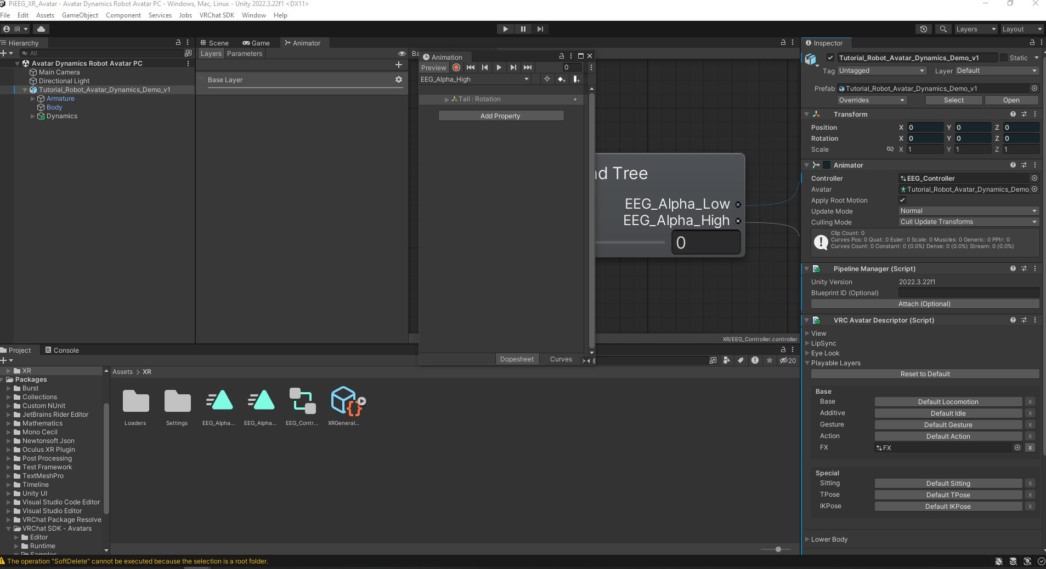
Playable Layers — FX layer assigned to EEG_Controller

Assignments made:
- Animator component → Controller field → EEG_Controller
- VRC Avatar Descriptor → Expressions → Parameters → VRCExpressionParameters
- VRC Avatar Descriptor → Playable Layers → FX → EEG_Controller

The FX layer is the correct layer for OSC-driven parameter animations in VRChat.

Step 11 — Install Av3Emulator for Local Testing
Since the VRChat account needs trust level to upload avatars, Av3Emulator allows local testing inside Unity without uploading.

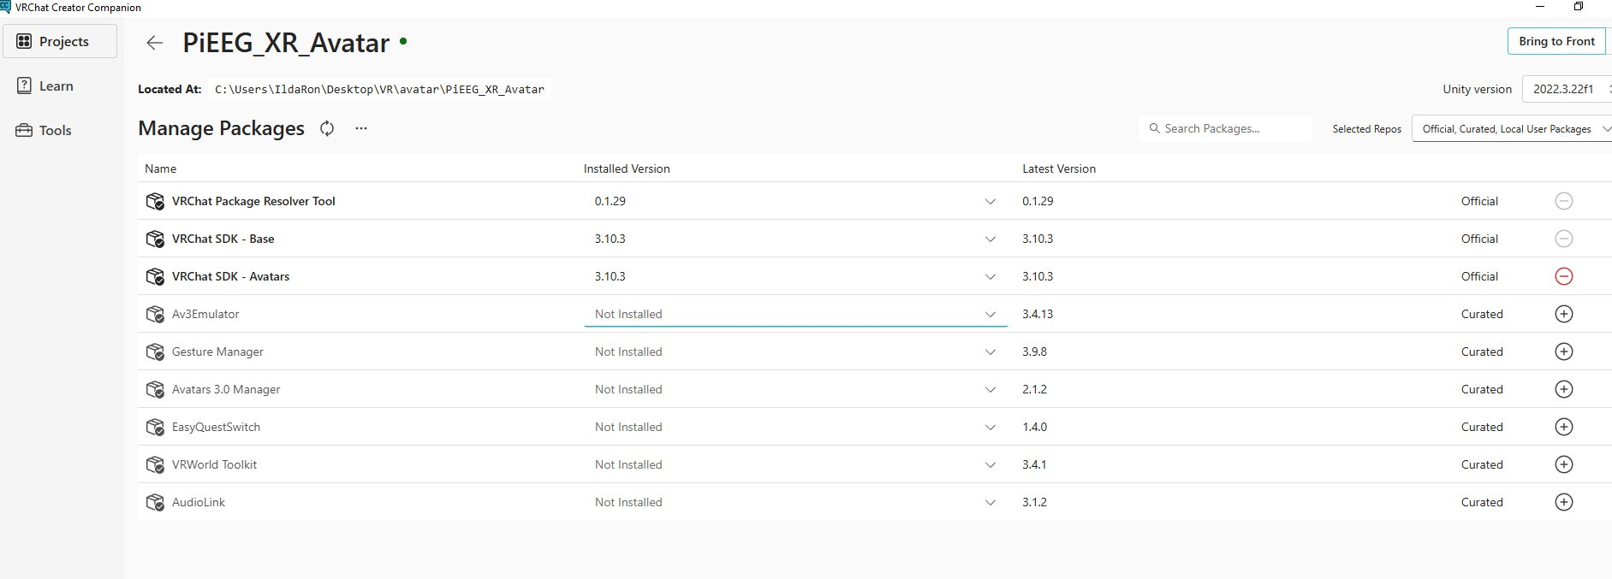
Creator Companion — Av3Emulator available for installation

Installation:
- In Creator Companion → PiEEG_XR_Avatar project
- Find Av3Emulator (Curated, version 3.4.13)
- Click + to install
- Return to Unity — project reloads with emulator

Step 12 — VRChat SDK Sign In
Signed into the VRChat SDK Control Panel using VRChat account credentials.

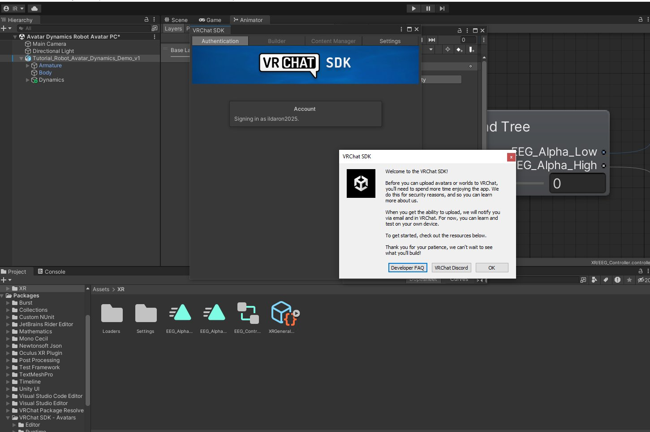
VRChat SDK welcome message — signed in as ildaron2025

Note: New VRChat accounts require time spent in the app before avatar upload is enabled. This is VRChat's trust system for security. Local testing with Av3Emulator works without upload permission.

Step 13 — Avatar Bone Structure
The Tutorial Robot Avatar has a rich bone structure including PhysBones for dynamic movement:

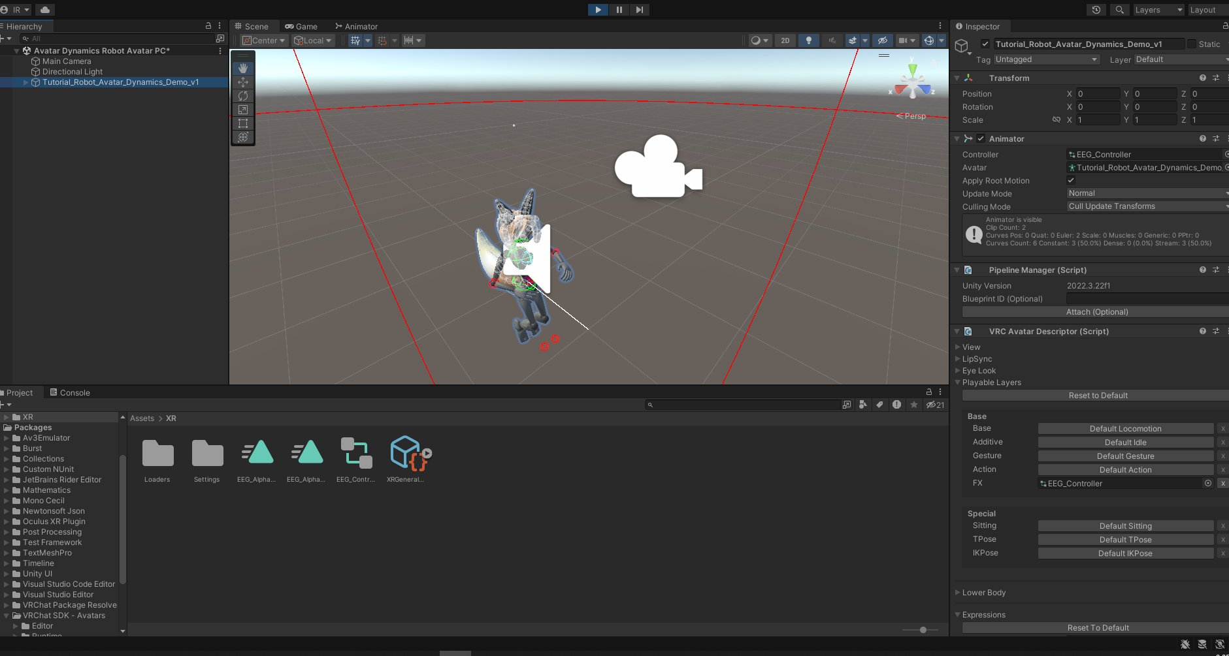
Full hierarchy — PhysBones include Hair, Tail, Ear-Left, Ear-Right, Button

Available PhysBone targets for EEG control:
- Ear-Left / Ear-Right — react to EEG_Alpha (ears perk up when relaxed)
- Tail — chain of bones (Tail → Tail.001 → ... → Tail.Tip)
- Hair — dynamic hair movement

PhysBone OSC Parameter control:
VRC PhysBone components have a 'Parameter' field under Options. Setting this to 'EEG_Alpha' makes the PhysBone directly respond to the OSC value — no animation clip needed. This is the recommended approach for ears and tail.

PhysBone → Options → Parameter field → type: EEG_Alpha

Next Steps
To complete the EEG-avatar integration:

1. PhysBone parameter control (recommended):
- Select Ear-Left in Hierarchy
- Inspector → VRC Phys Bone → Options → Parameter field
- Type: EEG_Alpha
- Repeat for Ear-Right
- Now ears respond directly to relaxation level

2. Test in Play mode:
- Press Play in Unity
- Open Animator window → Parameters tab
- Drag EEG_Alpha slider 0→1 and watch ears move

3. Upload to VRChat (when account trust level allows):
- VRChat SDK → Show Control Panel → Builder tab
- Click Build & Publish
- Avatar will appear in your VRChat avatar list

4. Use in VRChat with IronBCI:
- Put on EEG cap
- Run: pieeg-server --device ironbci8 --osc
- Launch VRChat, enable OSC in Action Menu
- Switch to your uploaded avatar
- Relax to raise Alpha → ears perk up in real time!

Troubleshooting

EEG data not showing in VRChat:
- Check pieeg-server is running with --osc flag
- Verify OSC is enabled in VRChat Action Menu
- Check OSC Debug screen in VRChat for incoming messages
- Confirm IronBCI is connected (check dashboard at localhost:1617)

Tail/ears not moving:
- PhysBones override animation — use the Parameter field in PhysBone component
- Make sure parameter name matches exactly (case sensitive): EEG_Alpha
- Confirm EEG_Controller is assigned to FX layer in Playable Layers

OSC cache issue:
- If parameters don't appear, delete the cached config:
%AppData%\..\LocalLow\VRChat\VRChat\OSC\{userId}\Avatars\{avatarId}.json

Quick Reference

Key commands:
pip install pieeg-server[ironbci] # Install
pieeg-server --device ironbci8 --osc # Start streaming
http://localhost:1617 # Dashboard

OSC parameters sent by PiEEG:
/avatar/parameters/EEG_Alpha float 0-1
/avatar/parameters/EEG_Beta float 0-1
/avatar/parameters/EEG_Delta float 0-1
/avatar/parameters/EEG_Theta float 0-1
/avatar/parameters/EEG_Gamma float 0-1

Files created in Unity project:
Assets/XR/EEG_Controller.controller # Animator Controller
Assets/XR/VRCExpressionParameters # Expression Parameters
Assets/XR/EEG_Alpha_Low.anim # Animation clip
Assets/XR/EEG_Alpha_High.anim # Animation clip

