Section 1:

Our company has been selected to build a class roll book application. It is to be developed in several stages. In the first stage, we will implement a Student class and demonstrate its functionality with a driver class

SECTION 2:

|  |  |
| --- | --- |
| Inputs | Outputs |
| Last Name | Welcome Message |
| First Name | Prompts for info |
| Major | Student Menu |
| Classification | Goodbye Message |
| Hours Completed | Display all attributes and values of a Student object |
| GPA | Error Message |
| JPG File |  |

Section 3:

Student Class

To give us the ability to make Student objects to store their first name, last name, major, classification, gpa, hours completed, and a jpg file. It should have getters and setters for our attributes, and it will have a few basic constructors. It will also have a toString method.

Driver Class

The driver class will welcome the user and allow them to create new student objects. They will be prompted for the data, and they will have the ability to display a Student. The driver class handles all interaction with the user.

Classification Class

This class is used to create an enum to be used in the other classes.

Section 4:

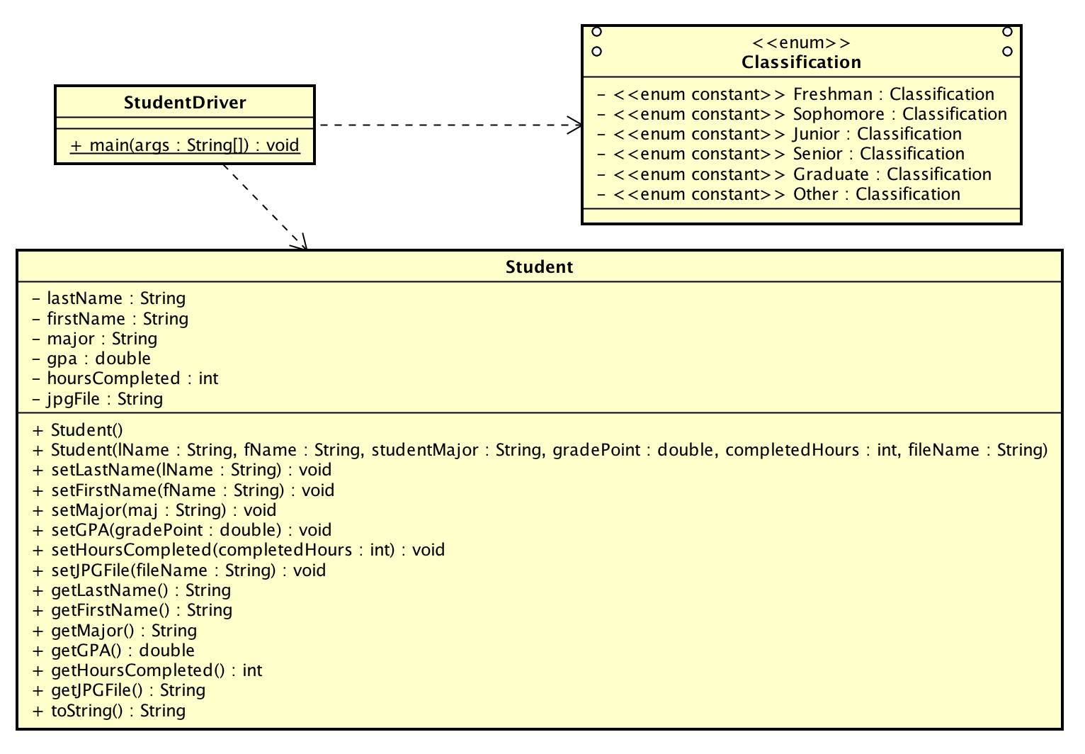

Section 5:

Import proper things

Declare variables and set up creating a Student

Display Welcome Screen

Display Menu to see if the user wants to make a new student or display a student

If New Student, create a new student and prompt for the information and save into an object

If they choose to display Student, check to make sure there is a Student, then display the info

If they choose to exit, end the program

Display goodbye message

Section 6:

|  |  |  |
| --- | --- | --- |
|  |  |  |
|  | Main Menu Option | Expected Output |
|  | 1 | Should Prompt for info |
|  | 2 | Should Show students to display |
|  | 3 | Should Exit Program |
|  |  |  |
|  |  |  |
| Prompts | Input | Expected Output |
| Last Name | Cowell | Cowell |
| First Name | Dakota | Dakota |
| Major | CSCI | CSCI |
| Major | csci | CSCI |
| Classification | junior | Junior |
| Hours Completed | 46 | 46 |
| Hours Completed | -12 | Invalid |
| Hours Completed | 0 | 0 |
| GPA | 4.0 | 4.0 |
| GPA | -3 | Invalid |
| GPA | 0.0 | 0.0 |
| JPG File | Name.jpg | Name.jpg |
| JPG File | water.jpg | water.jpg |