Exercise1

1. Change Lab1Ex1 to Hello

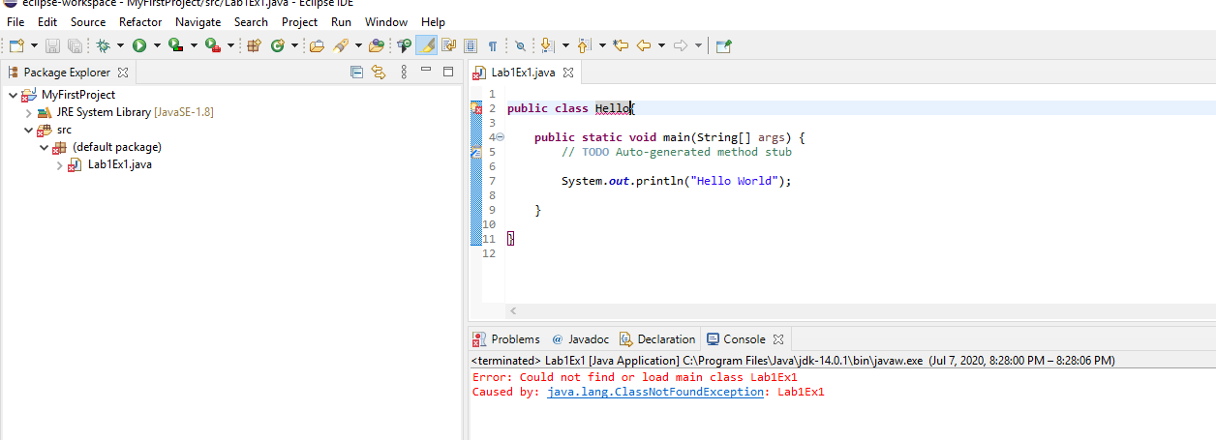

1. Remove the first quotation mark in the String

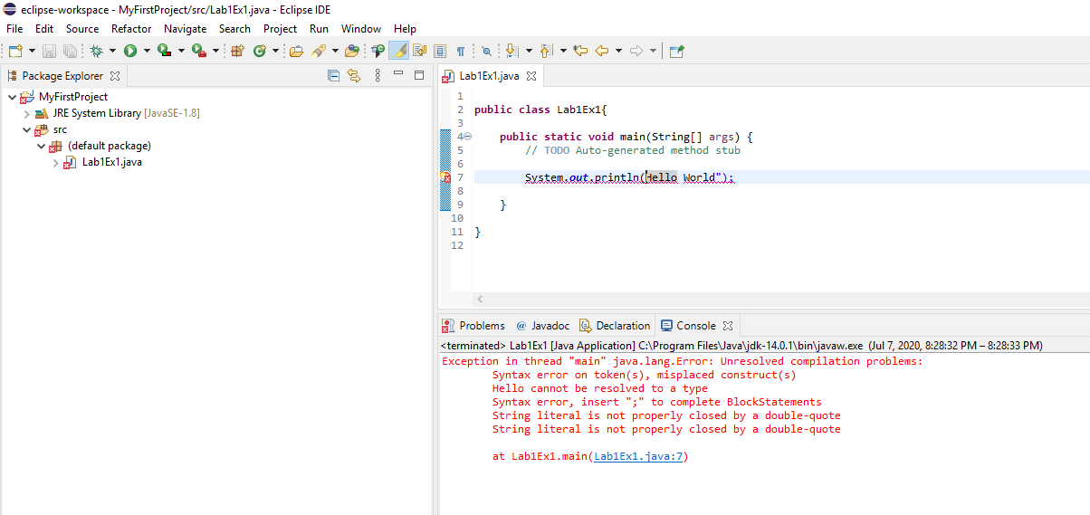

1. Remove the semicolon

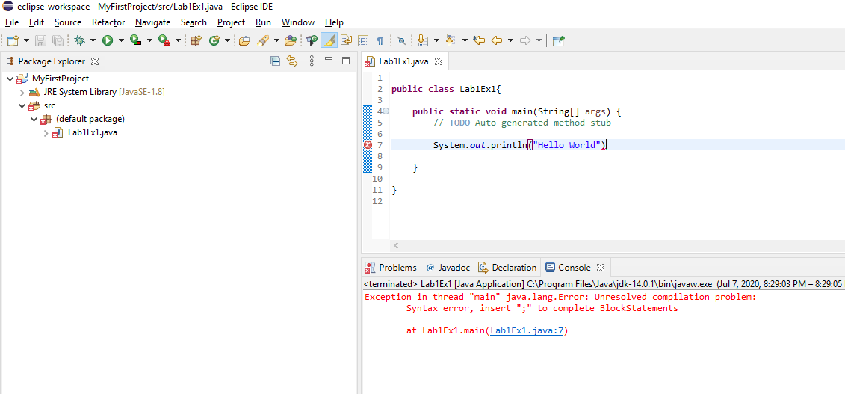

1. Remove the last brace in the program

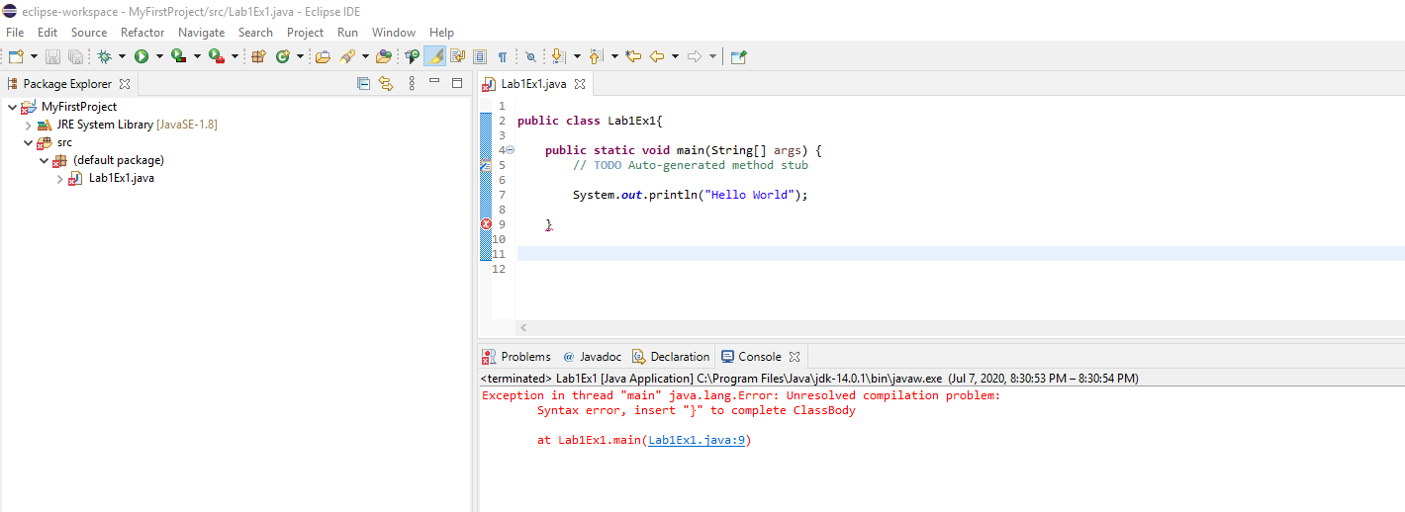

Recompiled Org. Code

