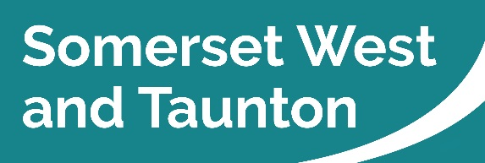 | Somerset West and Taunton  Deane House, Belvedere Road  Taunton TA1 1HE

Request to Film
10 May 2018

Filming Guidance

To film in Somerset West and Taunton we require:

- A current copy of Public Liability Insurance (PLI).
- Details of the nature of the filming (i.e. that it will not cause offence to any section of the community).
- The dates and times of the proposed filming.
- Areas to be affected by the filming.
- State if filming will impact on any highways, pedestrian thoroughfares or have any traffic management implications in which case the relevant Highways Authority should be informed.

Drone Filming

- Drones are more formally known as Unmanned Aerial Vehicles (UAV).
- If the council wishes to film using a drone, we will only hire a Civil Aviation Authority (CAA) licenced pilot or company.
- A pilot also requires permission of the landowners to take off and land the drone on their property. Therefore, if we are approached by a company requesting to drone film on our land they must be CAA licenced. A copy of the licence will be required.
- If they are licenced they should have a valid ‘Permissions for Aerial Works’ certificate. If the pilot is not licenced they will not be insured or have Public Liability Insurance and they are not allowed to work or provide commercial services.
- We will ask a drone pilot for their Public Liability Insurance prior to giving permission.
- A pilot cannot fly a drone directly over people, roads or buildings where permission has not been given by the person or land owner. Drones can fly directly over or near to people who are deemed ‘under control’ – for example actors, presenters or extras. They would need to be safety briefed and aware they are going to be filmed by a drone.
- Drones can fly up to 400ft (restricted air space starts at 500ft).
- Sub 7k rig drone cannot fly within 50 metres of a property, road, or member of the public where the landowner has not given permission. A drone over 7k rig must have at least 150 metres clearance of a property where permission has not been obtained.
- The pilots may be required to contact Air Traffic Control when fly8ing near to an airport or aerodrome so the drone can be operated safely at certain height on a specified date and time.
- Drones cannot be flown at night or out of daylight hours unless the company has special permissions for night time flying.
- Using a drone to record images of other people without their consent could be construed as a breach of Data Protection or the CCTV Code of Practice which was extended to include public use of drones where they are collecting information about individuals.
- Any qualified drone pilot should complete a site assessment before agreeing to undertake a job. The responsibility of any flight and its legalities rest with the drone operator and if the CAA conditions are broken this may invalidate their insurance policy.
- To find out more visit the CAA website – www.caa.co.uk

For more information about services visit www.somersetwestandtaunton.gov.uk

