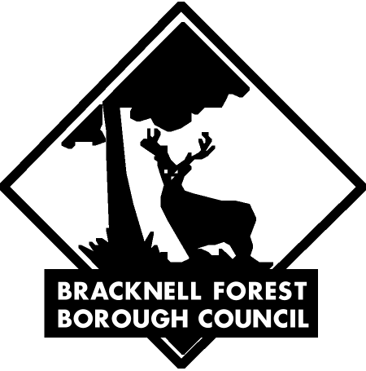

Byelaws for pleasure grounds, public walks and
open spaces made by the Bracknell Forest
Borough Council under Sections 12 and 15 of
the Open Spaces Act 1906

Date made 27th July 2001
Date confirmed 8th October 2001
Date of operation 5th November 2001

