ㅣ
학번: 2024105626 이름:김도우

기말고사 코드 반영 본인의 Github 주소:
(예시) https://github.com/prulen/2026-final-test.git

문제1 – CNN

SOURCE CODE
import torch
import torch.nn as nn
import torchvision.datasets as datasets
import torchvision.transforms as transforms
import torch.optim as optim
import matplotlib.pyplot as plt

use_cuda = torch.cuda.is_available()
device = torch.device("cuda" if use_cuda else "cpu")
print(f"사용 디바이스: {device}")

# ===== 수정 금지 =====
batch_size = 16
kwargs = {'num_workers': 1, 'pin_memory': True} if use_cuda else {}

train_dataset = datasets.MNIST(
'./data', train=True, download=True,
transform=transforms.Compose([
transforms.ToTensor(),
transforms.Normalize((0.1307,), (0.3081,))
])
)
train_loader = torch.utils.data.DataLoader(
train_dataset, batch_size=batch_size, shuffle=True, **kwargs
)
test_dataset = datasets.MNIST(
'./data', train=False,
transform=transforms.Compose([
transforms.ToTensor(),
transforms.Normalize((0.1307,), (0.3081,))
])
)
test_loader = torch.utils.data.DataLoader(
test_dataset, batch_size=batch_size, shuffle=False, **kwargs
)
print(f'학습: {len(train_dataset):,}개 | 테스트: {len(test_dataset):,}개')
# ===== 수정 금지 끝 =====

class MyLeNet5_2(nn.Module):
def __init__(self):
super(MyLeNet5_2, self).__init__()

# TODO ①-A : conv_1 → Conv2d(1, 32, kernel_size=5, padding=2)
self.conv_1 = nn.Conv2d(1,32,kernel_size=5, padding=2) # ← 교체하세요

# TODO ①-B : maxpool_1 → MaxPool2d(kernel_size=(2,2), stride=2)
self.maxpool_1 = nn.MaxPool2d(kernel_size=(2,2), stride=2) # ← 교체하세요

# TODO ①-C : conv_2 → Conv2d(32, 64, kernel_size=5)
self.conv_2 = nn.Conv2d(32, 64, kernel_size=5) # ← 교체하세요

# TODO ①-D : maxpool_2 → MaxPool2d(kernel_size=(2,2), stride=2)
self.maxpool_2 = nn.MaxPool2d(kernel_size=(2,2), stride=2) # ← 교체하세요

# TODO ①-E : conv_3 → Conv2d(64, 256, kernel_size=5)
self.conv_3 = nn.Conv2d(64, 256, kernel_size=5) # ← 교체하세요

# TODO ①-F : relu → nn.ReLU()
self.relu = nn.ReLU() # ← 교체하세요

# TODO ①-G : fc_1 → Linear(256, 128)
self.fc_1 = nn.Linear(256, 128) # ← 교체하세요

# TODO ①-H : fc_2 → Linear(128, 10)
self.fc_2 = nn.Linear(128, 10) # ← 교체하세요

def forward(self, x):
# TODO ② : 순전파 구현
x=self.conv_1(x)
x=self.relu(x)
x=self.maxpool_1(x)
x=self.conv_2(x)
x=self.relu(x)
x=self.maxpool_2(x)
x=self.conv_3(x)
x=x.view(-1,256) #flatten
x=self.fc_1(x)
x=self.relu(x)
res=self.fc_2(x)
return res # ← 이 줄을 지우고 구현하세요

# ===== 수정 금지 =====
model_test = MyLeNet5_2()
print(model_test)
total_params = sum(p.numel() for p in model_test.parameters())
print(f"파라미터 수: {total_params:,}개")
# ===== 수정 금지 끝 =====

# TODO ③ : epochs 수정
epochs = 3
learning_rate = 0.01

# TODO ④ : 학번/이름 (필수)
STUDENT_ID = "2024105626" #e.g., 20201111111
STUDENT_NAME = "DOWOO KIM" #e.g., Hong Gil Dong

# ===== 수정 금지 =====
model = MyLeNet5_2().to(device)
optimizer = optim.Adadelta(model.parameters(), lr=learning_rate)
scheduler = optim.lr_scheduler.StepLR(optimizer, step_size=1, gamma=0.1)
loss_function = nn.CrossEntropyLoss()

print(f"학번: {STUDENT_ID} 이름: {STUDENT_NAME}")
print(f"epochs={epochs} lr={learning_rate} optimizer=Adadelta")
# ===== 수정 금지 끝 =====

# ===== 수정 금지 =====
def train(model, device, train_loader, optimizer, loss_function, epoch):
model.train()
for batch_idx, (data, target) in enumerate(train_loader):
data, target = data.to(device), target.to(device)
optimizer.zero_grad()
output = model(data)
loss = loss_function(output, target)
loss.backward()
optimizer.step()
if batch_idx % 1000 == 0:
print('Train Epoch: {} [{}/{} ({:.0f}%)]\tLoss: {:.6f}'.format(
epoch, batch_idx * len(data), len(train_loader.dataset),
100. * batch_idx / len(train_loader), loss.item()))

def test(model, device, test_loader, loss_function):
model.eval()
test_loss, correct = 0, 0
with torch.no_grad():
for data, target in test_loader:
data, target = data.to(device), target.to(device)
output = model(data)
test_loss += loss_function(output, target).item()
pred = output.argmax(dim=1, keepdim=True)
correct += pred.eq(target.view_as(pred)).sum().item()
test_loss /= len(test_loader.dataset)
acc = 100. * correct / len(test_loader.dataset)
print('\nTest set: Average loss: {:.4f}, Accuracy: {}/{} ({:.2f}%)\n'.format(
test_loss, correct, len(test_loader.dataset), acc))
return acc
# ===== 수정 금지 끝 =====

# ===== 수정 금지 =====
test_accs = []
for epoch in range(epochs):
train(model, device, train_loader, optimizer, loss_function, epoch)
acc = test(model, device, test_loader, loss_function)
test_accs.append(acc)
scheduler.step()

print("=" * 50)
print(f" 학번: {STUDENT_ID} 이름: {STUDENT_NAME}")
print(f" 최종 Test Accuracy: {test_accs[-1]:.2f}%")
print("=" * 50)

plt.figure(figsize=(8, 4))
plt.plot(range(1, epochs+1), test_accs, 'r-o', markersize=8, linewidth=2)
plt.title(f'MyLeNet5_2 Test Accuracy\n{STUDENT_ID} {STUDENT_NAME}')
plt.xlabel('Epoch'); plt.ylabel('Accuracy (%)'); plt.legend(['Test Acc'])
plt.grid(True, alpha=0.4); plt.tight_layout()
# ===== 수정 금지 끝 =====

OUTPUT (Screen Shots)
#1 | [제출 결과]
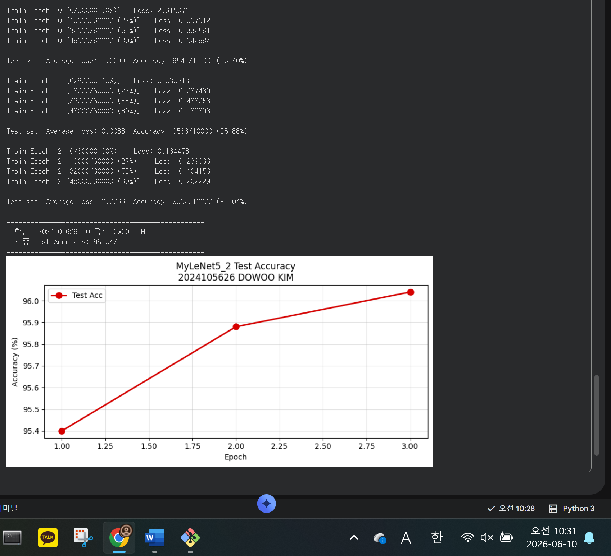

Github (Screen Shots)
#1 | 본인 Github에 Commit내용 또는 PR 내용을 제출 시간과 함께 제출
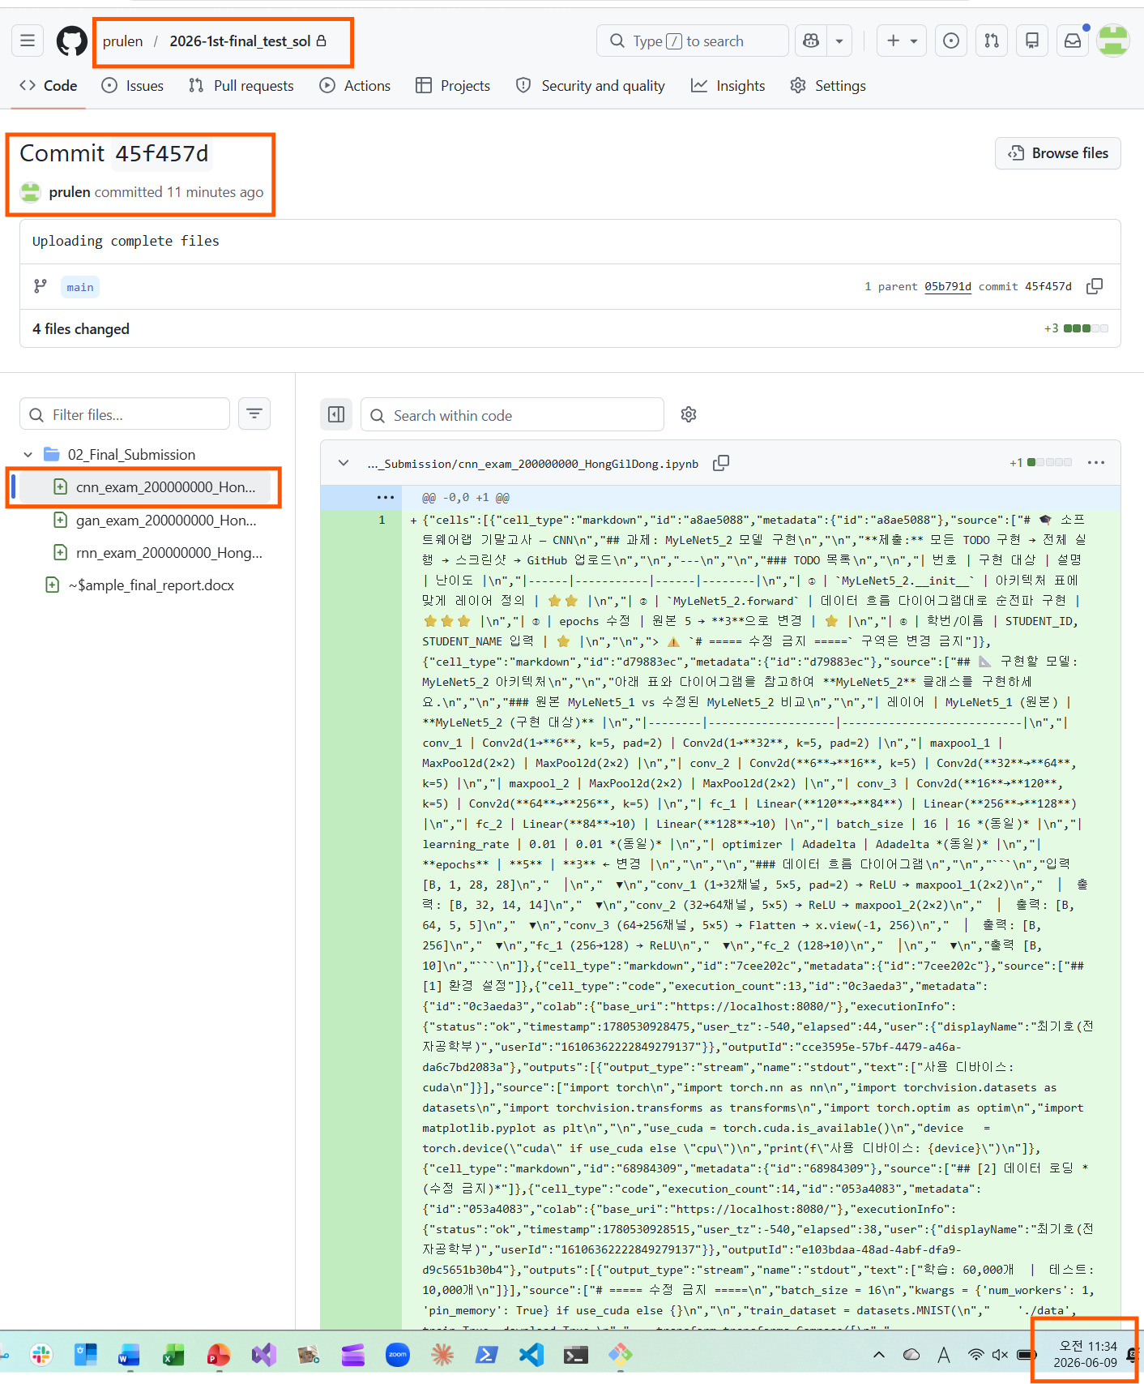

문제2 – GAN

SOURCE CODE
import os
import torch
import torchvision
import torch.nn as nn
from torchvision import transforms
from torchvision.utils import save_image
import matplotlib.pyplot as plt

device = torch.device('cuda' if torch.cuda.is_available() else 'cpu')
print(f"사용 디바이스: {device}")

sample_dir = 'samples'
os.makedirs(sample_dir, exist_ok=True)

# TODO ① : 하이퍼파라미터 (변경표 참고)
latent_size = 64 # 수정 금지
num_epochs = 20 # ← 수정 대상
batch_size = 128 # ← 수정 대상
image_size = 784 # 수정 금지

# TODO ④ : 학번/이름 (필수)
STUDENT_ID = "2024105626" # (e.g., 20000000000)
STUDENT_NAME = "DOWOO KIM" # (e.g., Hong Gil Dong)

# ===== 수정 금지 =====
print(f"latent_size={latent_size} batch_size={batch_size} num_epochs={num_epochs}")
print(f"학번: {STUDENT_ID} 이름: {STUDENT_NAME}")
# ===== 수정 금지 끝 =====

# ===== 수정 금지 =====
transform = transforms.Compose([
transforms.ToTensor(),
transforms.Normalize(mean=[0.5], std=[0.5])
])
mnist = torchvision.datasets.MNIST(root='data/', train=True, transform=transform, download=True)
# ===== 수정 금지 끝 =====

# TODO ② : 수정된 Discriminator D
# 784 → 512 → 256 → 128 → 64 → 1
D = nn.Sequential(
nn.Linear(784,512),
nn.LeakyReLU(0.2),
nn.Linear(512,256),
nn.LeakyReLU(0.2),
nn.Linear(256,128),
nn.LeakyReLU(0.2),
nn.Linear(128,64),
nn.LeakyReLU(0.2),
nn.Linear(64,1),
nn.Sigmoid()
) # ← nn.Sequential(...) 로 교체하세요

# TODO ③ : 수정된 Generator G
# 64 → 256 → 512 → 256 → 128 → 784
G = nn.Sequential(
nn.Linear(64,256),
nn.ReLU(),
nn.Linear(256,512),
nn.ReLU(),
nn.Linear(512,256),
nn.ReLU(),
nn.Linear(256,128),
nn.ReLU(),
nn.Linear(128,784),
nn.Tanh())
# ← nn.Sequential(...) 로 교체하세요

# ===== 수정 금지 =====
D = D.to(device)
G = G.to(device)

criterion = nn.BCELoss()
d_optimizer = torch.optim.Adam(D.parameters(), lr=0.0002)
g_optimizer = torch.optim.Adam(G.parameters(), lr=0.0002)

print("D 파라미터:", sum(p.numel() for p in D.parameters()), "개")
print("G 파라미터:", sum(p.numel() for p in G.parameters()), "개")
print("D:", D)
print("G:", G)
# ===== 수정 금지 끝 =====

# ===== 수정 금지 =====
def denorm(x):
return (x + 1) / 2

def reset_grad():
d_optimizer.zero_grad()
g_optimizer.zero_grad()

total_step = len(data_loader)
d_loss_hist, g_loss_hist = [], []

for epoch in range(num_epochs):
for i, (images, _) in enumerate(data_loader):
# ── 실제 배치 크기 사용 (마지막 배치 오류 방지) ──────────────
actual_batch = images.size(0) # ← 버그 수정
images = images.reshape(actual_batch, -1).to(device)
real_labels = torch.ones(actual_batch, 1).to(device)
fake_labels = torch.zeros(actual_batch, 1).to(device)

# ── D 학습 ─────────────────────────────────────────────────
outputs = D(images)
d_loss_real = criterion(outputs, real_labels)
real_score = outputs

z = torch.randn(actual_batch, latent_size).to(device)
fake_images = G(z)
outputs = D(fake_images)
d_loss_fake = criterion(outputs, fake_labels)
fake_score = outputs

d_loss = d_loss_real + d_loss_fake
reset_grad()
d_loss.backward()
d_optimizer.step()

# ── G 학습 ─────────────────────────────────────────────────
z = torch.randn(actual_batch, latent_size).to(device)
fake_images = G(z)
outputs = D(fake_images)
g_loss = criterion(outputs, real_labels)
reset_grad()
g_loss.backward()
g_optimizer.step()

if (i+1) % 200 == 0:
print('Epoch[{}/{}] Step[{}/{}] d:{:.4f} g:{:.4f} D(x):{:.2f} D(G):{:.2f}'.format(
epoch+1, num_epochs, i+1, total_step,
d_loss.item(), g_loss.item(),
real_score.mean().item(), fake_score.mean().item()))

d_loss_hist.append(d_loss.item())
g_loss_hist.append(g_loss.item())

if (epoch+1) % 10 == 0:
fake_save = fake_images.reshape(fake_images.size(0), 1, 28, 28)
save_image(denorm(fake_save),
os.path.join(sample_dir, f'fake_images-{epoch+1}.png'))

torch.save(G.state_dict(), 'G.ckpt')
torch.save(D.state_dict(), 'D.ckpt')
print("\n✅ 학습 완료!")
# ===== 수정 금지 끝 =====

# ===== 수정 금지 =====
fig, axes = plt.subplots(1, 2, figsize=(14, 5))
axes[0].plot(d_loss_hist, 'r-o', markersize=4, label='D Loss')
axes[0].plot(g_loss_hist, 'b-o', markersize=4, label='G Loss')
axes[0].axhline(0.693, color='gray', linestyle='--', alpha=0.7, label='ln2')
axes[0].set_title(f'GAN Training Loss\n{STUDENT_ID} {STUDENT_NAME}', fontsize=12)
axes[0].set_xlabel('Epoch'); axes[0].legend(); axes[0].grid(True, alpha=0.4)

G.eval()
with torch.no_grad():
z_sample = torch.randn(64, latent_size).to(device)
fake_grid = G(z_sample).reshape(-1, 1, 28, 28)
fake_grid = denorm(fake_grid).cpu()
grid = torchvision.utils.make_grid(fake_grid[:16], nrow=4, normalize=False)
axes[1].imshow(grid.permute(1, 2, 0).numpy(), cmap='gray')
axes[1].set_title(f'Generated Samples (Epoch {num_epochs})', fontsize=12)
axes[1].axis('off')

plt.tight_layout()
plt.show()
# ===== 수정 금지 끝 =====

OUTPUT (Screen Shots)
#2 | [제출 결과]
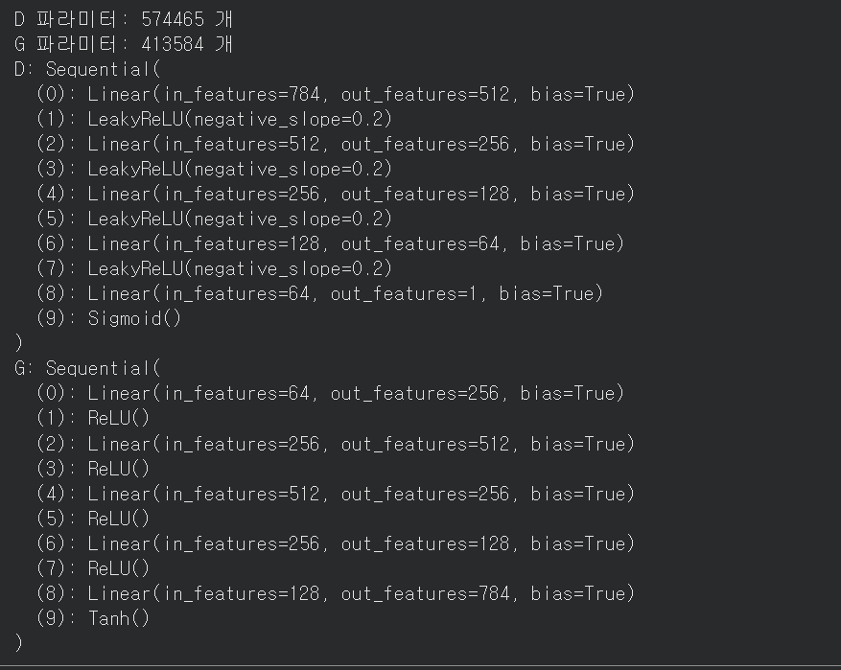

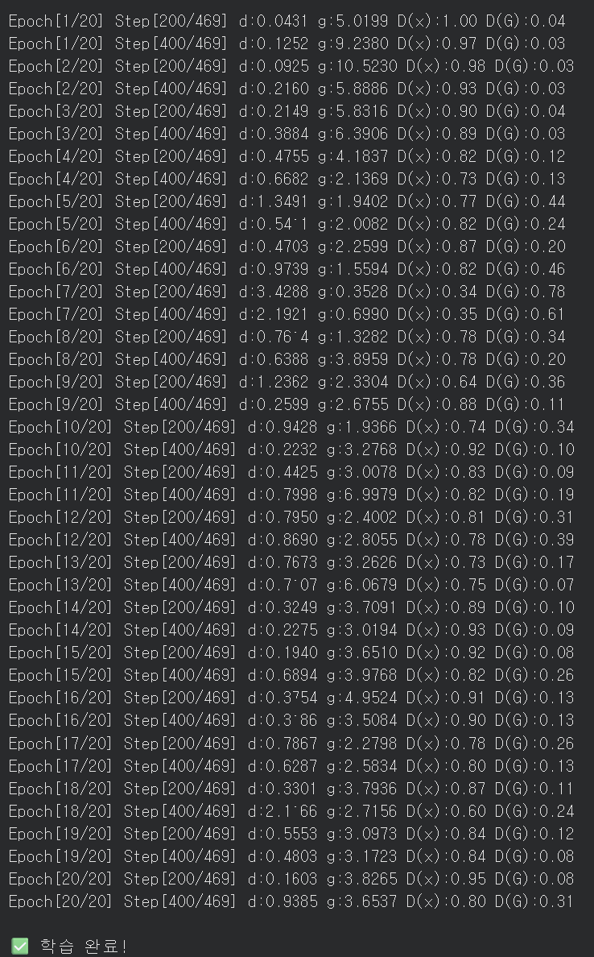
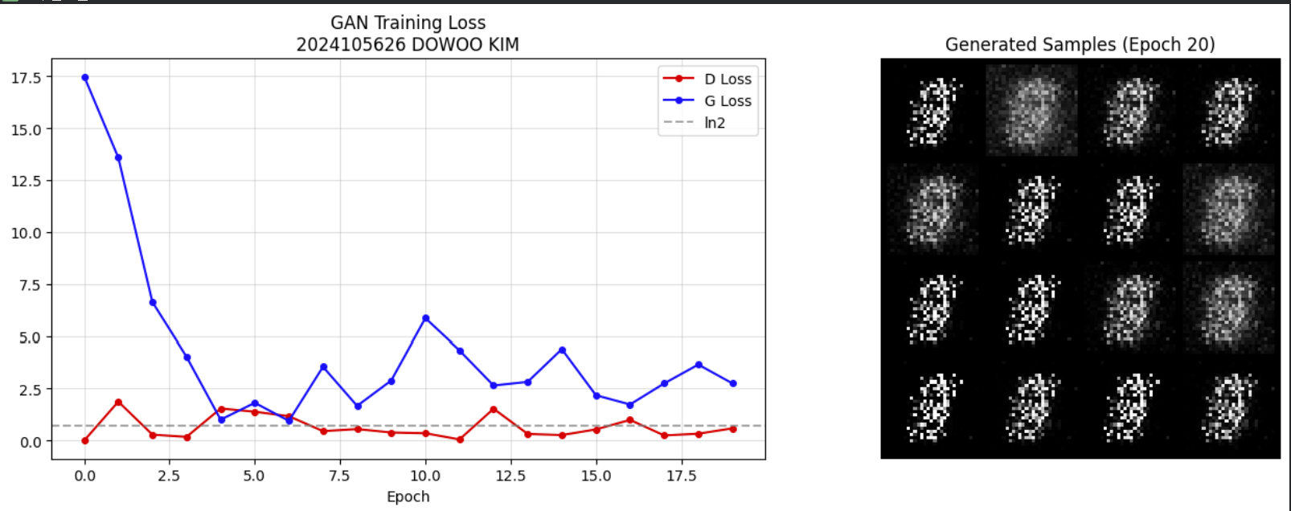

Github (Screen Shots)
#2 | 본인 Github에 Commit내용 또는 PR 내용을 제출 시간과 함께 제출
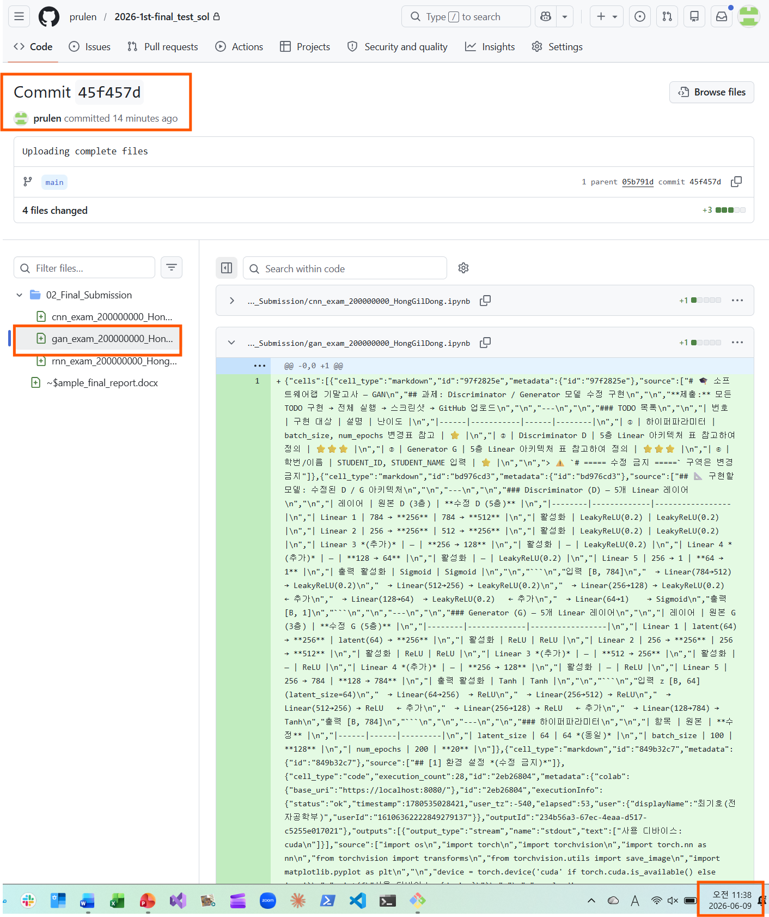

문제3 – rnn

SOURCE CODE
최종 소스 코드 (제출파일 copy & past)하기

OUTPUT (Screen Shots)
#3 | [제출 결과]
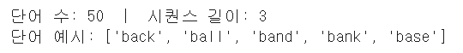

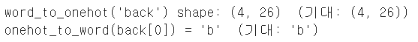

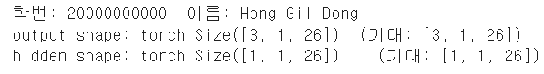

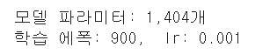

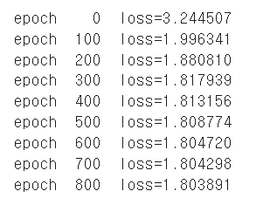

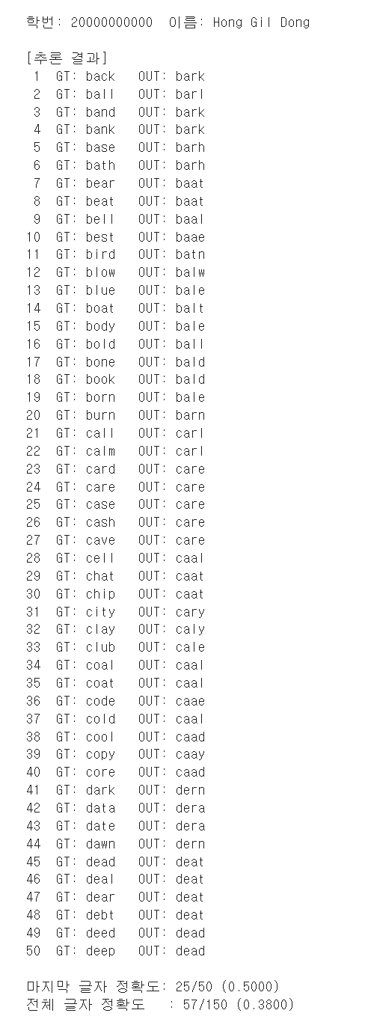

Github (Screen Shots)
#3 | 본인 Github에 Commit내용 또는 PR 내용을 제출 시간과 함께 제출
