Task 2:





Task 3:

Task 4:

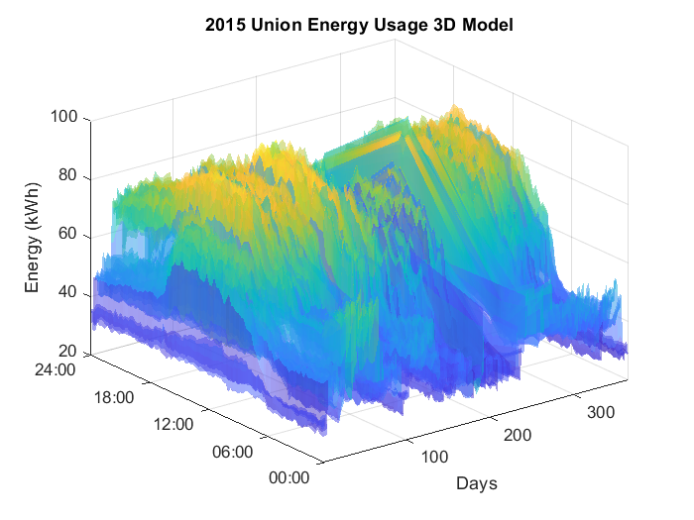

Task 5:

