5/9/2020

Problem analysis, research, and design

Pierce Kinghorn 12091381

Table of Contents

Introduction 2

Problem description 2

Ease of use 2

Functionality 2

Security 2

Pricing 3

Analysing android apps 3

ZOOM 3

Strengths 4

Weaknesses 4

LinkedIn 4

Strengths 4

Weaknesses 4

Microsoft Teams 4

Strengths 4

Weaknesses 4

Proposed app 5

Design Basics 5

Points of difference 5

Basic Sketch Designs 6

Target market 9

Ethical concerns 9

References 10

# Problem description

The problem that will be discussed and analysed in this report will be relating to communication, more specifically, the ability to share files, messages, host meetings and to do so securely with all these functions being easily accessible. Users must be able to upload, download, and view uploaded files that are within their permissions. Access both individual and group chats and pin important messages. Securely host video meetings that restrict personnel access. There are many different aspects that can be analysed and discussed for this problem. These aspects can be vital to making an app both popular and successful. A summary of these aspects is the ease of use, functionality, security, visuals, and pricing. These come together to create the overall user experience. Each of these aspects will be used as a basic outline that will be used when analysing and comparing the apps that will be listed below. Going into further detail of each of these aspects starting with ease of use.

## Ease of use

There are several different factors to be considered when discussing the ease of use of an app, these are user involvement. The inclusion of user involvement during the development of the app and is vital to developing a successful app. This allows for the other factors to be tested in more depth during development. The other more basic factors are the ease of navigation which is how easily users can navigate around the app to reach apps provided functions (Moutahir 2018). Recognizable error messages so users can easily troubleshoot or find fix’s themselves. Auto fill-in fields when necessary will also greatly increase the user’s overall experience (Kutlay 2018). The visuals and the design layout of the app are also contained inside this category as both are vital to the user’s overall experience and enjoyment while using the app.

## Functionality

This section will cover all the functions that must be provided in the app to fulfill its intended purpose to solve the problem, this being, being able to easily communicate. This covers several functions such as, a messaging system that allows groups of varying sizes to clearly communicate with each other, a secure file hosting server to store and share files, video meetings that are both quick and easy to setup. Offline functionality is another vital part of creating a successful app although data access and functionality will be limited based on the restrictions made in the app. While the app is offline users will not be able to use a most of the features provided by the app except for viewing chat history if the user has permissions. By allowing the app to function offline there will be increased reliability, although this may influence the app’s pricing. These are all the necessary functions that must be provided for the app to successfully solve the problem. Apps are not limited to only providing these functions and by providing additional features they can both increase the user experience by adding wanted functionality or decrease the user experience by adding meaningless complexity into it.

## Security

Security is a large factor that will influence the popularity of the app within an informed audience. The security of the app can and will be the deciding factor on if an app is successful or not. The user’s concern for security is not unwarranted as an app with any online capabilities can be culpable to being able to allow unwanted persons into the phone’s data. This client-side leaking of data is the primary concern most users have when they consider security. Another source of personal data can leak from is from the apps server database if there is one. An unreliable and insecure server can be prone to be infiltrated which can also leak personal information (Raphael 2020).

## Pricing

There are several ways apps generate revenue. The first method of payment is an initial purchase price, this method while not as popular is still used for a variety of apps. Another income strategy is a subscription, where users will often pay monthly instalments for use of the app. This is the most common payment method of apps that are likely to be successful on release. The most common form of revenue is advertising. Advertisement involves having other businesses or products being advertised within the app. The reason for this method’s success is that due to the user not requiring to pay to use the app, this removes the barrier for entry for a large portion of the market. While advertisements are the most popular form of revenue for apps, overuse of advertisements or intrusive advertisements can lead to user dissatisfaction and lead to the app not being used. Due to this having a balance of non-intrusive ads and generating revenue can be complex.

# Analysing android apps

The chosen apps related to the problem description were chosen based on the top three apps in the recommended section on the google play store. While these apps do not have the highest possible ratings, they are among the most used apps concerning the problem listed above. These apps are ZOOM, LinkedIn, and Microsoft Teams. Each of the apps will be analysed using the above criteria, ease of use, functionality, security, and pricing.

To summarise

* Ease of Use – Navigation, Visuals, Auto-fill fields.
* Functionality – Upload download files, both individual and group messaging, host/join video meetings.
* Security – Login security, authentication.
* Pricing – Method of revenue.

## ZOOM

Starting with zoom, and its ease of use. Navigation, the navigation of the zoom is almost clear, concise, and simple due to the singular function provided by the app. The benefit of this is that all of the apps settings and the use of the app itself can be access by only a few button presses. Functionally, the app performs its role in being a platform for online video meetings successfully. Other functionality includes a messaging system, emotes, and the ability to record meetings (if permitted by host) for later viewings. The accessibility of the app is its greatest strengths with hosts being able start hosting with a few buttons presses and viewers themselves can join meetings (if login is not required) by simply clicking on a URL. This allows the app to very efficient for casual use. On the visual side, the app lacks customisability, although its unnecessary due to the app’s simple design and features. Comparing this app the problem described above it fulfills the function being a platforms for meetings and having a messaging system, as limited as the messaging system is. The security of the app is where the app starts to have downsides with the meetings themselves being unsecure and easily accessible from unwanted participants. The app ‘can’ have a basic login system if enabled although has no additional authentication that can be enabled. In terms of pricing, the app has a free version which is great for casual use with negligible limits if used in a casual fashion. The app also has a professional version which is payed for via a subscription which expands on the functions provided.

### Strengths

* Accessibility
* Easy setup

### Weaknesses

* Weak security
* Resource intensive

## LinkedIn

First analysing the navigation, LinkedIn uses a hidden sidebar to navigate between the apps primary functions. The app also uses a toolbar which resides at the top of the screen to navigate each of the individual section. These two different navigation tools may lead to confusion and can be finicky at times. Visually, the app uses a basic blue and white colour scheme without any additional customisability options. Opposing this the app features an overwhelming unnecessary number of filters for several of its functions such as notification. The functions the app provides is different to ZOOM app where ZOOM focuses on individual meetings as its primary function, LinkedIn prioritises communication with a large community through both an email and messaging system. LinkedIn allows users to follow other users and communities, and while not within the problem description also support job posting/searching. While the app boasts better security then ZOOM, it still does not offer any additional type of option authentication. The app features several pricing options all of which are viable these are, free, trial, and subscription.

### Strengths

* Large community network
* Number of features provided

### Weaknesses

* Lack of customizability
* Unnecessary clutter

## Microsoft Teams

Lastly Microsoft Teams or MT, in a similar case to the previous app, this app also used a left side, sidebar as the main form of navigation in the app. In a similar yet different way MT also so has a secondary navigation bar, however unlike LinkedIn it rests on the left side of the screen along with the primary navigation bar. This allows for faster and more efficient navigation in the app. Visually the app has more customisability, while the app has a default blue and while scheme, users can change the colour scheme. Functionally, this app aligns the closest with the problem description with it being able to server as a webinar platform, file sharing system, and have a messaging system. Although it does not successfully succeed in the community networking portion compared to LinkedIn. Another downside is the pricing of the app, with there being no free version and the subscription being quite expensive itself. Security wise, MT boasts the best security out of the two previous apps.

### Strengths

* Advance data protection and security systems
* Ease of use

### Weaknesses

* Expensive
* Heavy reliance on Microsoft software products

# Proposed app

## Design Basics

While designing the app, the use of the information found while analysing the other apps and integrating their strengths and discarding their weakness, this will lead to a more efficient and successful design. A summary of the incorporated aspects is, the simple interface design of ZOOM, the community network and messaging system of LinkedIn, and the usability and navigation of MT. The functions that the app will provide will feature a messaging system that will be integrated with all aspects of the app, regardless of the function currently in use. This is to ensure that whatever function is being used the messaging system stays recognisable. The way this will function will be selected from the left side, hidden sidebar as one of the navigation options which will open a screen which contain a selection of all current conversations. Selecting one will show the chat window. This allows users to easily manage several conversations at once and is easily accessible due to it being found in the main navigation bar. Users will also be able to share files and customise these conversation rooms e.g. permissions. Users will be able to join chat rooms by entering a link that can be generated by members of the chatroom. When use the webinar/video meeting function the app will generate a temporarily chatroom where participants will be automatically invited to.

The app’s revenue income methods will a subscription method. The app will also feature a free version that will contain most functions, with the exception on not being able to create chatrooms, limited file share sizes, and customizability options.

## Points of difference

The main points of difference between this app and the apps previously analysed is the combination of their functions. This being the ability to host video meetings like ZOOM and MT and the ability to manage contacts and grow a network like LinkedIn. Other differences will be the free version capabilities as non-paying users will be able to use all the app’s vital functions. This will greatly increase the apps accessibility which is vital to creating large communities.

To summarise incentives

* The ability to create chatrooms
* Customisability
* File share size

To summarise functions.

* Messaging system
* Host/join video meetings
* Manage contacts
* Share files

## Basic Sketch Designs

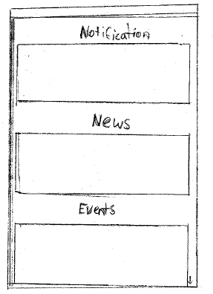**Main menu screen**

This screen will be the first screen shown to users upon start up, this screen shows any notifications they have missed, such as messages and invites. The news section shows any general news such as upcoming webinars and updates to the app. The event section will list all events (meetings) the user is currently tracking.

**Main menu screen with sidebar**

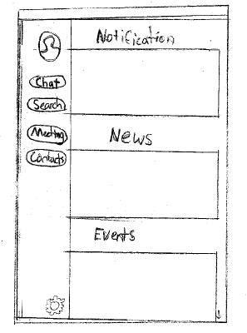

This screen shows the navigation bar after the user has ‘pulled’ it out. This sidebar allows users to navigate to their profile (by clicking on avatar icon), search topics and events (clicking on search), host and join meetings (clicking on meetings), manage contacts (clicking on contacts), and view settings (clicking on the cog).

**Main menu screen with sidebar and chat toolbar**

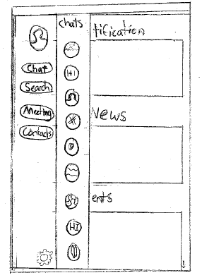

This screen shows the app after a use selects the chat button in the navigation bar. The apps screen does not change, rather another sidebar pulls out, this then shows all available chat groups. Selecting an icon will navigate to the selected chat group.

**Chat Page**

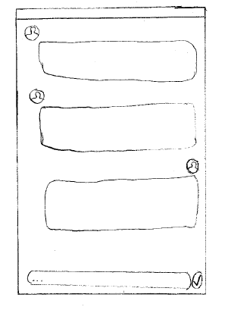

This page shows a brief design of what a chat page would look like, selecting the bottom bar will expand a keyboard. Users will also be able to post files in these chatrooms.

**Meetings Screen**

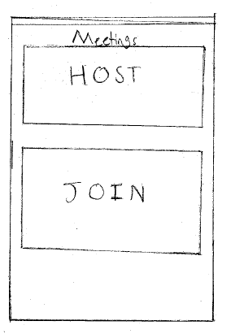

Users navigate to this screen upon selecting the ‘Meetings’ button in the navigation bar. Clicking host will generate a join code and show a settings screen where users can set up permissions e.g. Selecting join will prompt the user to enter a code.

**Meetings Screen after selecting join**

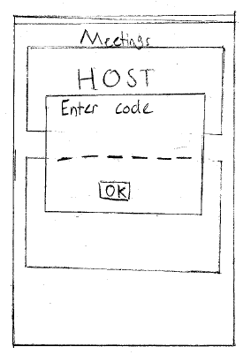

This prompt appears after selecting join on the previous screen. Users can type in the six letter code word to enter the respective meeting.

# Target market

The target market demographic information will have a varying range due to the nature of the app, the targeted age would be anywhere from 18 years and up, although it is not limited to this age demographic (Krill 2010). The app also does not aim to sell itself for a specific gender. The income level of the users could be anywhere between lower and high-class due to users being able to use the app for free with the loss of some features. The Ethnicity of the user is also negligible to consider outside of users living in areas where information is censored, due to the possible political nature of some broadcasts (Advertising in mobile apps 2020).

The needs/wants that users of the target audience the app is aimed for are users that want to establish a business network. Users will also want to join webinars and communicate with other users e.g. share interests and thought on the subject item. The design of the advertisements to reach this audience will be designed to accentuate and raise the value of the app’s flexibility and usefulness, adds would also heavily prioritise the user’s ability to share their thoughts. The advertisements themselves will be shown on common websites digitally rather than physically. This is due to digital marking having been able to reach a larger audience and having a larger sense of agency with the target audience compared to physical (Cave 2016).

# Ethical concerns

Ethics is a necessary factor to consider when designing an app, although implementing ethics into an app can be difficult due to the nature of proper ethical practice. There a few vital points to consider when discussing the implementation of good ethics in an app. Examples of ethics would be creating mechanisms in the app the require user consent when handing data in an easy to understand and concise manner. It was found that using an agile design method and requiring user input for the development phase allowed for less unintentional unethical designs to be developed in the app (Implementing Ethics 2016).

# References

Cave, J 2016, *Digital Marketing Vs, Traditional Marketing: Which One Is Better?,* viewed 26 April 2020, <https://www.digitaldoughnut.com/articles/2016/july/digital-marketing-vs-traditional-marketing>

Krill, P 2010, *‘ RIM:* Smartphone App Builders Must Know Audience; Fragmentation in the Mobile Space Has Made It Imperative for Developers to Know Who Their Customers Are to Effectively Target Them’, InfoWorld, November 16 2010

Kutluay, BK 2018, *Importance of App Design for Mobile Developers and Design Trends,* viewed 23 April 2020, <https://medium.com/nyc-design/importance-of-app-design-for-mobile-developers-and-design-trends-e8a982469f1>

Moutahir, H 2018, *The Ultimate Guide for Creating a Successful Mobile App in 2020,* viewed 23 April 2020, <https://medium.com/@HichamMoutahir/the-ultimate-guide-for-creating-a-successful-mobile-app-in-2018-74f7311a85f1>

Raphael, JR 2020, *8 mobile security threats you should take seriously in 2020,* viewed 23 April 2020, <https://www.csoonline.com/article/3241727/8-mobile-security-threats-you-should-take-seriously-in-2020.html>

Rooksby, J, Asadzadeh, P, Morrison, A, McCallum, C, Gray, C, Chalmbers, M 2016, *Implementing Ethics for a Mobile App Development,* viewed 30 April 2020, <https://johnrooksby.org/papers/OzCHI16-rooksby-implementingEthics.pdf>

Shacklett, M 2015, *10 ease-of-use considerations for building topnotch apps,* viewed 20 April 2020, <https://www.techrepublic.com/blog/10-things/10-ease-of-use-considerations-for-building-topnotch-apps/>

Sungjun, P & Byungho, P 2020,’ Advertising on Mobile Apps Versus the Mobile Web: Which Delivers Better Advertisement Recognition and Willingness to Buy?’, Journal of Advertising Research (2020)

ZOOM, viewed 9 May 2020, <https://play.google.com/store/apps/details?id=us.zoom.videomeetings&hl=en>

LinkedIn, viewed 9 May 2020, <https://play.google.com/store/apps/details?id=com.linkedin.android&hl=en_US>

Microsoft Teams, viewed 9 May 2020, <https://play.google.com/store/apps/details?id=com.microsoft.teams&hl=en_US>