U-Pb – Lu-Hf spot matcher user guide
Piero A. B. de Sampaio

Directory structure and setup
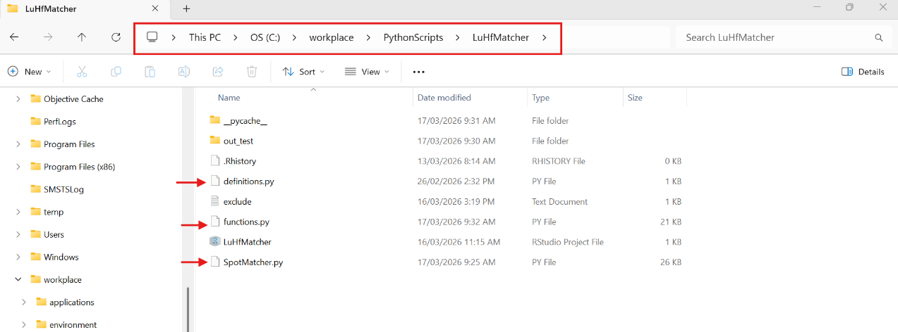
The workflow relies on three separate .py scripts: definitions.py, functions.py and SpotMacher.py (Fig. 1). The three scripts need to be located within the same directory. Python scripts need to be located inside “C:\workplace” and the creation of a sub-directory within “C:\workplace” to store these files is recommended (Fig. 1).
Figure 1: Directory structure.
The definitions.py file contains constants used for calculations, such as λ¹⁷⁶Lu and ¹⁷⁶Lu/¹⁷⁷Hf and ¹⁷⁶Hf/¹⁷⁷Hf for different reservoirs (CHUR, DM). These values can be edited if necessary.
The functions.py file contains the functions called by the main script. This includes functions to parse inputs, perform isotopic calculations, calculate ages and aggregate spots into sample-level statistics.
Finally, the main script is the SpotMatcher.py file. This is the main workflow script that will read the Lu-Hf and U-Pb data and match the spots by “grain.spot” numbers and give the options to output spot-level and sample-level .xlsx files.
There is also an optional exclude.txt file on Fig. 1. This file is only important if the user wants to have the excluded spots pre-selected instead of selecting them in run-time.
Important: the script relies on the Python package xlrd, which is not installed by default when installing Anaconda. The rest of the packages are installed by default.

Running the script
If Python was installed using Anaconda there will be a software called Anaconda Prompt available on your computer. Running the script from Anaconda Prompt is recommended to avoid having to set up path variables. Once Anaconda Prompt, navigate to the script location using the “cd” (change directory) command and typing the directory path on the prompt (Fig. 2). Once in the correct directory run the script by typing “python SpotMatcher.py” and pressing enter.
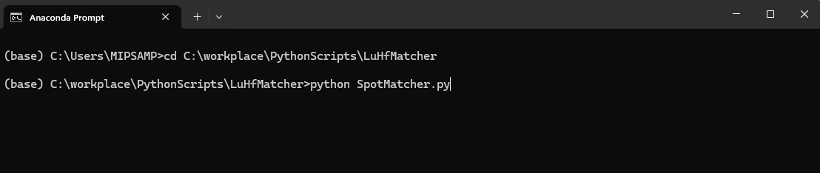
Figure 2: Anaconda prompt interface. First step is navigating to the correct directory. In this case the script was located in “C:\workplace\PythonScripts\LuHfMatcher”, but it would work in any directory inside “C:\workplace”. After confirming the directory, run the script by typing python SpotMatcher.py and pressing enter.

Workflow
Once the script is running, it will prompt the user for three choices: (1) the U-Pb files directory, (2) The Lu-Hf file and (3) the output directory. If the entered output directory does not exist, it will be created. For example, if the user just types a name, the output directory will be created as a new folder within the script directory.
Note that the input for U-Pb is a directory and the input for Lu-Hf is an excel file. Examples:
- V:\GS54_GeochronologyLaboratory\Projects\Isotope_studies\ES46_2023-24\Lu-Hf\2_sent\Batch_71_to do after oxygen #16 is done\U-Pb_files
- V:\GS54_GeochronologyLaboratory\Projects\Isotope_studies\ES46_2024-25\Lu-Hf\3. Data received\Copy of GSWA Batch _71 2024 Hf summary.xlsx
The U-Pb files in the U-Pb directory can be either .xls or .txt tables. Excel 2003 files ca be either a standard U-Pb file (so long as it has the sheet “excel_table” or a “.Table1” file. The Lu-Hf file must be an excel file with the following columns (in this order):
A: Sample/spot
B: Duration (s)
C: 176Hf/177Hf
D: 2SE
E: 176Lu/177Hf
F: 2SE
G: 176Yb/177Hf
H: 2SE
I: 178Hf/177Hf
J: 2SE
K: Total Hf Beam
L: TK comment

Once the files are read correctly the script will print the name of the samples found in the current dataset and it will output any spots in the Lu-Hf dataset that couldn’t be matched to U-Pb spots so these can be manually checked (Fig. 3).
The script then automatically calculates weighted-mean ²⁰⁷Pb/²⁰⁶Pb ages for the igneous grains. The default behaviour is to calculate the weighted-mean of the ²⁰⁴Pb-corrected ²⁰⁷Pb/²⁰⁶Pb ratio and then calculate the age associated with the weighted-mean ratio. The GSWA criterion of outlier rejection, in which values > 2.5σ of the weighted mean are excluded, is adopted for the weighted-mean calculation.
Figure 3: Initial output
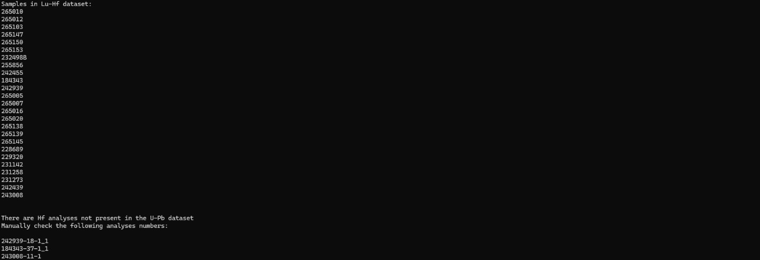
The user will then be prompted to overwrite the igneous ages for specific samples if they want to (e.g. if a sample is highly discordant and the crystallisation age is a Tera-Wasserburg lower intercept age). Should the user want to change an igneous age they should reply “Y” to the prompt, then select a sample from the available samples and type in the new age and uncertainty, in the format XXXX/XX, where “/” separates the age from the uncertainty. It does not have to be an integer, and ages with decimal significant digits are also valid. To finish editing ages, type “X”.
The user is then prompted to type in the name for the spot-level output, which is an excel table with WAGIMS formatting. The file extension (.xlsx) must be included in the file name. Isotopic calculations are made relative to the weighted-mean igneous age in the case of Group “I” spots, and relative to the individual spot age for all other groups.
After entering the name for the spot-level file, the user is asked whether to calculate sample-level statistics (for GeoView-type information). If “N” is typed, the script finishes and the spot-level table will be available in the output directory. If “Y” is typed the user is prompted for the sample-level file name.
After entering the sample-level file name there is a prompt to exclude spots from calculation of sample-level statistics. Two options are available. Option “1” allows the users to select spots to exclude from calculations during script run time. In this option the script will go through all samples, showing the available igneous spots to exclude. The user then selects the spots to exclude from that sample and presses “X” to go to the next sample.
Option “2” reads the “exclude.txt” file containing the spots to be excluded. The “exclude.txt" file should have one spot per row, formatted as in Fig. 4.

The sample-level statistics spreadsheet has information for εHf(i), 2-stage T_{DM} and TCR (crustal residence). For each of these variables the spreadsheet contains median, uncertainty about the median, average, standard deviation, maximum, minimum, weighted mean and 95% confidence interval of the weighted mean.
Figure 4: Structure of the exclude.txt file

