Summary: AI-assisted work on CustomerManagementApi

Author: Piero Viano
Date: 2025-11-09

1. Overview of activities
- Task 1 — Documentation
- Generated `ReadMe.txt` describing `CustomersController`, `AppDbContext`, `Customer` model and `Program`.
- Created `API-documentation.txt` describing endpoints, parameters, responses and examples.
- Task 2 — Code comments
- Added XML-style comments to `Customer`, `AppDbContext`, `CustomersController` and `Program.cs` to improve IntelliSense and maintainability.
- Task 3 — Client and tests
- Added a .NET 8 console client project `CustomerManagementApi.Client` demonstrating API usage.
- Added xUnit tests in `CustomerManagementApi.Tests`, covering happy-paths and edge cases; then fixed minor null-checks discovered while running tests.
- Task 4 — Refactor for testability and DI
- Identified problems (static in-memory root, controller-created DbContext, tight coupling).
- Refactored controller to accept `AppDbContext` via DI and return proper HTTP responses (no static methods).
- Updated `Program.cs` startup guidance to register `AppDbContext` with DI and support provider selection (InMemory vs SQLite) via configuration (`appsettings.json`).

2. Methods and prompts used
- Prompts (representative):
- "Please, generate a concise, well-structured README.txt file explaining the CustomersController class"
- "Add to the ReadME.txt file documentation regarding AppDbContext, Customer and program classes"
- "Please, add comments for classes, methods, and properties for the various classes inside the project ..."
- "Please, generate API endpoint documentation for the CustomersController class ... in a file named API-documentation.txt"
- "Please, generate a new console application project named CustomerManagementApi.Client containing example usage code for the CustomersController class ..."
- "Please, generate unit tests for the CustomersController class using xunit. Ensure that tests cover: happy path scenarios, edge cases, error conditions, boundary values"
- "Please identify the issues in CustomersControler class. I'm interested to have code easily testable, to not depent on InMemoryDatabase and avoid static method usage. I would like to use dependency injection in a way that I can use both InMemory database and real SQLite database thanks to a configurtion"
- Techniques
- Iterative prompting: generate artifacts, run tests, fix failing behaviors, re-prompt for refactor.
- Use minimal, focused code changes to keep diffs small and tests passing.
- Prefer DI-based design: constructor injection for `AppDbContext`.
- Use configuration-driven provider selection: `appsettings.json` + conditional registration in `Program.cs`.

3. Supporting evidence (key before / after snippets)
- CustomersController (before): controller created DbContext instances internally and used a static _dbRoot.

4. Screenshots
--------------
- Screenshots cannot be embedded programmatically here. To capture evidence:
1. Run tests in Visual Studio __Test Explorer__ or `dotnet test` and take a screenshot of the passing tests.
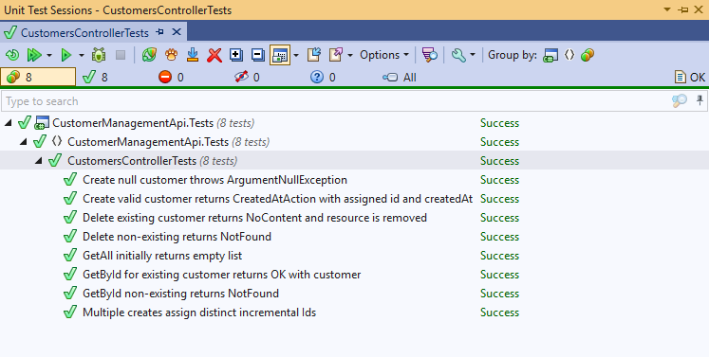
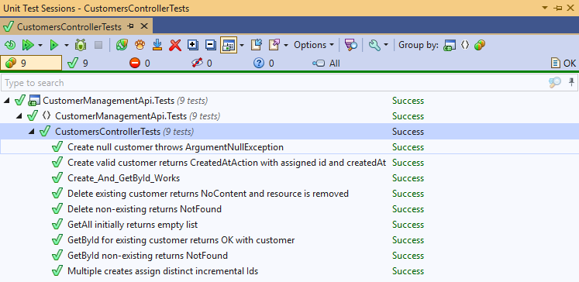
2. Open `Program.cs` and `CustomersController.cs` in Visual Studio and capture before/after views.
Differences are visible here (the full PR is https://github.com/pvianoria/CustomerManagementApi/pull/2):
- https://github.com/pvianoria/CustomerManagementApi/pull/2/files#diff-48e848455ce3b5a30eaa9abb215c06aa054cd610bed007c0af289567918af061
- https://github.com/pvianoria/CustomerManagementApi/pull/2/files#diff-5887363128ff93b1186bd2b41e803e5346a427680b34f00a5ea029f85f897c49

5. Insights on GitHub Copilot
- Strengths
- Rapid generation of documentation, sample clients, and tests.
- Good at producing consistent templates (README, API docs, DTOs).
- Useful for proposing DI-based refactors and configuration-driven approaches.
- Limitations / Caveats
- Generated code sometimes needs small manual corrections (e.g., null checks, model validation).
- Tests generated by AI may assume pre-existing behavior; running them reveals mismatches that require manual adjustment or code fixes.
- For provider-specific behaviors (SQLite vs InMemory) it's safer to make DI- and configuration-driven changes and to write integration tests for each provider.
- Best practices observed
- Use Copilot to scaffold artifacts, then run tests and iteratively refine.
- Keep changes small and review suggested code for edge-cases (nulls, validation, error paths).
- Prefer DI and factories (`IDbContextFactory`) so Copilot-generated examples remain flexible.

6. Actionable next steps
- Add integration tests using a persistent or in-memory SQLite connection (open connection mode) if you need provider-level assurances.

