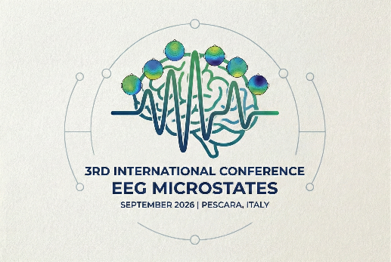

Third International Conference on EEG Microstates 15th–18th September 2026, Pescara, Italy

Dear Colleagues and Researchers,
We are pleased to announce the opening of registration for the Third International Conference on EEG Microstates, an event dedicated to advancing our understanding of brain dynamics through cutting-edge research and interdisciplinary collaboration. The conference will take place from September 15th to 18th, 2026, at the Aurum in Pescara, Italy. The meeting will focus on the latest developments in EEG microstate research, bringing together leading experts in the field of cognitive and clinical neuroscience.
Over the past years, microstate analysis has become a valid methodological approach for investigating brain function and cognition, as well as their alterations in neurological and psychiatric conditions. This conference aims to foster discussion on methodological advances, theoretical frameworks, and translational applications of EEG microstates.
Conference Highlights: Keynote Speakers: Internationally renowned researchers will present state-of-the-art findings on EEG microstates and Electrical Neuroimaging, addressing current challenges and future directions in the field.
Oral and Poster Sessions: Participants from around the world will share their latest research results, methodological innovations, and clinical applications related to EEG microstates.
Interactive Workshops: Pre-conference workshops will provide hands-on experience in EEG microstate analysis, interpretation, and the use of advanced software tools and neuroimaging techniques.
Networking Opportunities: The conference will offer multiple opportunities to connect with fellow researchers, establish collaborations, and strengthen international partnerships in neuroscience and neuroimaging.
Call for Abstracts and Registration: We warmly invite researchers, scientists, and clinicians from diverse disciplines to submit abstracts for oral and poster presentations related to EEG microstates and Electrical Neuroimaging. Further details regarding submission guidelines and registration will be available on the official conference website.
Venue: Aurum, Pescara, Italy (https://www.comune.pescara.it/vivere-il-comune/luoghi/aurum/)
Official conference website: https://microstatesconference2026.com/
Important Dates:
- Registration will open on the official conference website on March 29th.
- Abstract Submission Opens: June 24th
- Abstract Submission Deadline: June 30th
- Early Bird Registration Deadline: July 20th
Join us in Pescara for an engaging scientific meeting on EEG microstates and brain dynamics.
We look forward to welcoming you to this stimulating and collaborative event.
For inquiries, please contact: Filippo Zappasodi, filippo.zappasodi@unich.it; Pierpaolo Croce, pierpaolo.croce@unich.it
Sincerely,
The Organizing Committee of the Third Conference on EEG Microstates 2026
Filippo Zappasodi, University Chieti-Pescara
Pierpaolo Croce, University Chieti-Pescara
Laura Marzetti, University Chieti-Pescara

Thomas Koenig, University Bern
Christoph Michel, University Geneva

