Introduction to Virtual/Augmented Reality and Telepresence

Assignment 2
Topic: Building a VR App on Your Mobile Phone

This assignment will teach you how to target a VR App on a mobile phone, navigate using the phone’s capabilities, and display a scene in stereo using Google Cardboard. The model displayed is a low polygon medieval village from Unity assets.
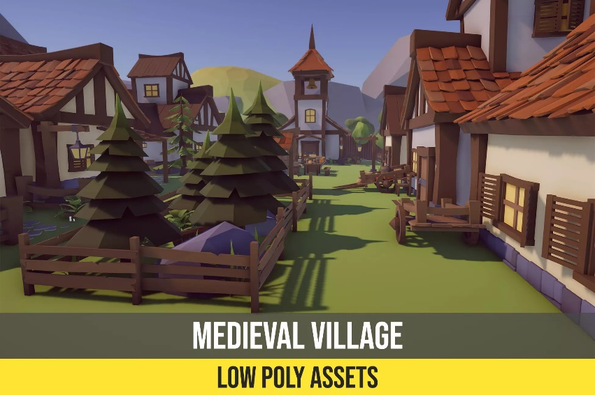
To guide you at developing this App, here are the step-by-step tutorials on how to transfer a unity model on your mobile phone:
- For Android, please follow the following instructions:
  - https://docs.unity3d.com/Manual/android.html
  - https://developers.google.com/unity/packages#android
  - How to Build a Unity Game to Android
- For IOS, please follow the following instructions:
  - https://docs.unity3d.com/Manual/iphone.html
  - How to Build a Unity Game to iOS
You can choose which OS to use based on your mobile device.
Once the App is ported, I would like you to add the following to the mobile phone capabilities:
- Part I: In mono mode (no cardboard VR), please develop a way to navigate the virtual world by pointing with your finger on the screen using basic gestures such as:
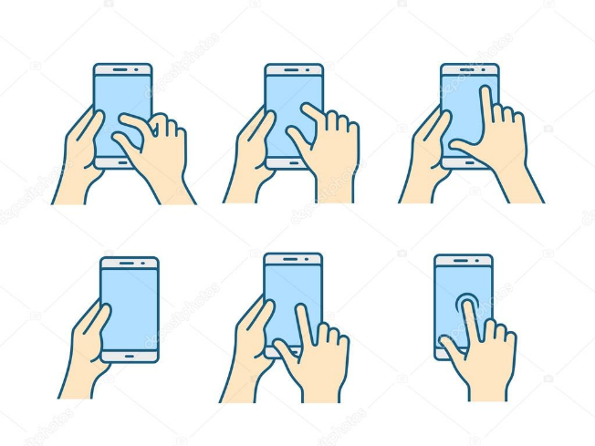
- You can use Mobile device input https://docs.unity3d.com/Manual/MobileInput.html
- Part II: I would like you to implement navigation in the virtual world by using the CARDBOARD thumb hole at the bottom of the entry point. This way you can type on the display while the smartphone is in the Cardboard. In addition, the thumb hole enables you to tap rapidly (e.g. for shooters) and even to make swiping movements. Use head movements to navigate within the VR environment. Tilt your head left, right, up, or down to explore the virtual world or interact with objects. You can buy the following Google Cardboard at Amazon for $14.90. It can be delivered in a day.
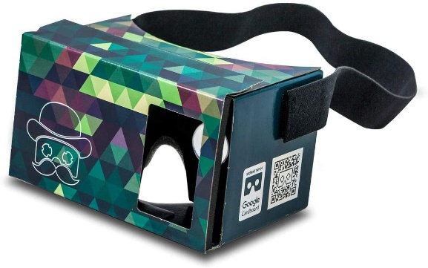

The making will be based on the following:
- The functionality of the App 70%
- Additional features: FOV 10% IOC 10% navigation 10%
Send the working game (as a video capture) and a Unity 3D project in the eclass on October 20.

