Introduction to Virtual/Augmented Reality and Telepresence
Assignment 3
Real-time Facial Animation
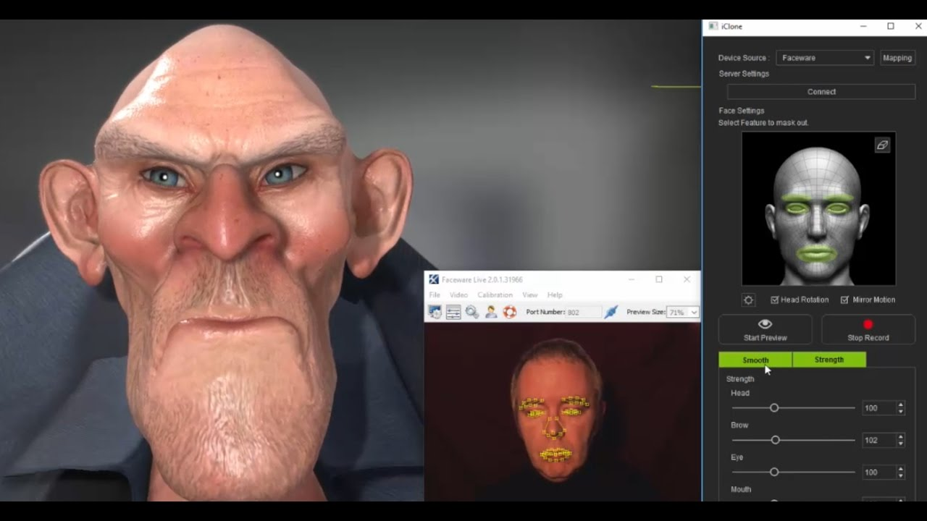

For this assignment we will use Faceware facial animation software.

A description on how to use Faceware can be found in:

- Introduction to Faceware Studio

Importing the Live Client for Unity package

The Faceware Live Client for Unity package can be installed from the Unity Asset Store. Simply search for "Faceware" and you can select and import it into your Unity project. After importing the Faceware Live Client for Unity package you're almost ready to connect to Live Server and see your real-time facial animation data that is streaming from Live Server. There are just a few easy steps we need to complete first.

You'll need to be streaming data from Faceware Live Server to see animation in Unity. You can do this by requesting a free 30 days trial

If you have an IOS machine you can use instead Live Capture.

Marking Scheme

Extra points (10%) for new functionalities such as:
- Exaggerated face motion creating a clown like animation effect
- Retargeting to other faces such a cartoon, dog, or a cat

Send the working game unity 3D project and a video capture to eclass on November 3.

