Introduction to Virtual/Augmented Reality and Telepresence

Assignment 4
Topic: 3D SOUND EFFECTS IN UNITY

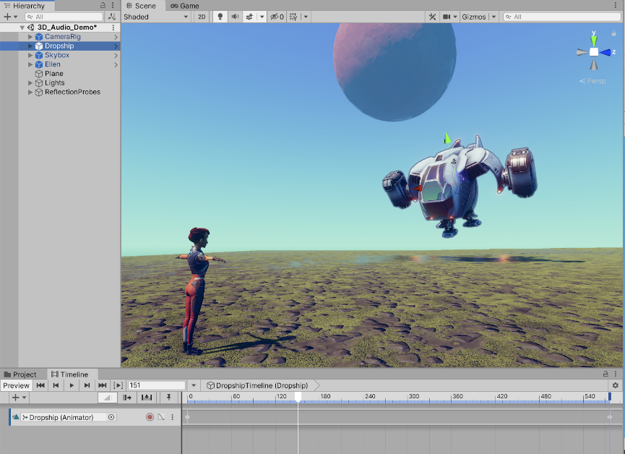

Create a simple soundscape game that teaches you many principles of working with sound in Unity.
Follow the tutorial instructions on 3D Audio in Unity
Load this game asset and modify the soundscape using what you have learned from the tutorial. In this tutorial, do part one and then implement the sound interfaces and then add extras functionalities such as:
- Add your sound to the environment
- Improving user interface
Making will be based on the following:
- The functionality of the game is 70%
- Additional features: new sounds 20% and new interface 10%
Send the working game as an unity 3D project and a video capture to eclass on November 17.

