Introduction to Virtual/Augmented Reality and Telepresence

Assignment 5
Augmented Reality Museum
Using Unity 3D, I would like you to create a museum AR application that contains two laser-scanned objects. To develop the AR application, we will use Google ARCore for Android or iOS using the Unity XR plug-in framework. The main idea is to create the ability to hold a museum object in your hand. Then, you should change the objects with a click and add sound and text to describe the object selected.

Source of museum artefacts provided in eclass.
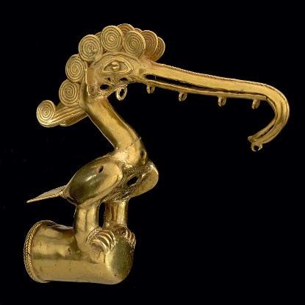
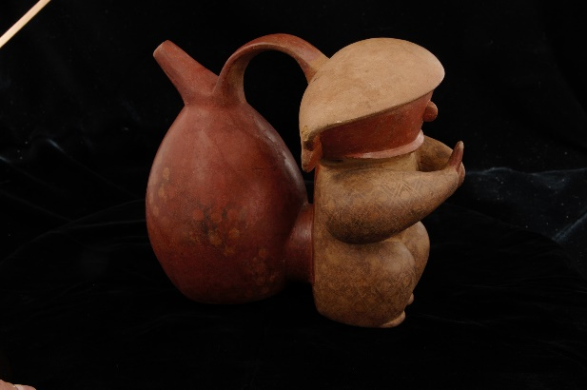
Pictures:

Once the museum model is ready, I would you to prepare a Unity executable for an android phone.
The making will be based on the following:
- The functionality of the game is 70%
- Additional features: Visual Quality 10% Display speed optimization using scene graph and LOD 30%
Send the working Unity 3D project and a video using eclass on December 5

