Template for JOBIM 2017 Proceedings [Titre/Title]

FirstName LastName11, FirstName LastName22 and FirstName LastName32

1 Laboratory, Address, zip code, Town, Country

2 Laboratory, Address, zip code, Town, Country

Corresponding Author: firstname.lastname@email.fr

**Abstract** The abstract of the paper (optional for short contributions) must be typeset in italic, with Times New Roman 11-point font. The left and right margins must be set to 3cm. 350 words maximum.

**Keywords** Some keywords, important, relevant. Five relevant keywords maximum. The keywords must be typeset in regular, with *Times New Roman* 11-point font. The left and right margins must be set to 3cm.

1. Introduction (*Times New Roman* 12-point type, bold)

The **Title**: *Times New Roman* bold 14-point font, center

The **Authors names**: *Times New Roman 11-point font*. Center as well. Please typeset the last name(s) of author(s) in small caps, starting with an uppercase first letter

The **Addresses**: *Courier New 9-point* font

The **Email**: *Courier New 9-point font.* Just give the email address of the corresponding author

1. Document Structure (*Times New Roman* 12-point type, bold)

The **Text:** use *Times New Roman* 11-point font and 6-point spacing between paragraphs. Italics may be used to emphasize words in running text. Bold type and underlining should be avoided. With these sizes, the interline distance should be set so that around 50 lines occur on a full-text page.

* 1. Page Numbering (*Times New Roman* 11-point type, bold)

Pages must NOT be numbered. Final pagination will be set by the editors of the proceedings.

* 1. Figures and Photographs (*Times New Roman* 11-point type, bold)

Please produce your figures such that they display well in black & white mode, and integrate them into your text file. Please note that no figure will be taken into account if not integrated in your text file.

Figures should be numbered and should have a caption which should always be positioned under the figures. The final sentence of a caption should end with a period. Please center the captions between the margins and set them in *Times New Roman* 11-points font, bold for the heading and *Times New Roman* 11-point font for the text.

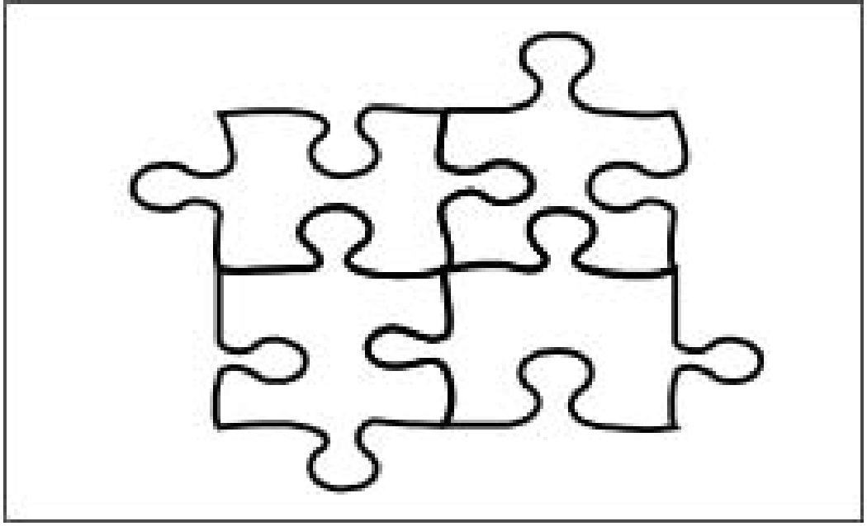

Fig 1. Old jobim puzzle (end of the 20th century).

1. Citations

The list of references is headed *References*, it should be placed at the end of your contribution. It should be in *Times New Roman* 10-point font. Please do not insert a page break before the list of references. For citations in the text, please use square brackets [1] and consecutive ordered numbers [2,3] in list of references. Please find below examples on how to format references corresponding to articles [1], books [2], book chapters and proceedings [3].

1. Warning

Note that the maximum length of *Proceedings* submission must not exceed **8 pages**. A paper disregarding the format described in this document will be rejected (even if it was previously accepted by the program committee).

Acknowledgements

Acknowledgements are possible at the end of the document just before the References list. It should be in Times New Roman 10-point font.

References

1. Alan D Sokal. Transgressing the boundaries: Toward a transformative hermeneutics of quantum gravity. *Social text*, (46/47):217–252, 1996.
2. Barbara Gastel and Robert A Day. *How to write and publish a scientific paper*. ABC-CLIO, 2016.
3. Graham Cormode, Shanmugavelayutham Muthukrishnan, and Jinyun Yan. Scienceography: the study of how science is written. In *International Conference on Fun with Algorithms*, pages 379–391. Springer, 2012.