Template for JOBIM 2017 Highlight [Titre/Title]
FirstName LastName11, FirstName LastName22 and FirstName LastName32
1 Laboratory, Address, zip code, Town, Country
2 Laboratory, Address, zip code, Town, Country

Corresponding Author: firstname.lastname@email.fr

Paper Reference: Meert et al. (2016) Unknown species discovered by metagenomics of frikandels. Annals of Improbable Research. http://dx.doi.org/11.0110/0111/111-1110-0001
Abstract The abstract of the paper (optional for short contributions) must be typeset in italic, with Times New Roman 11-point font. The left and right margins must be set to 3cm. 350 words maximum.
Keywords Some keywords, important, relevant. Five relevant keywords maximum. The keywords must be typeset in regular, with Times New Roman 11-point font. The left and right margins must be set to 3cm.
- Introduction (Times New Roman 12-point type, bold)
The Title: Times New Roman bold 14-point font, center
The Authors names: Times New Roman 11-point font. Center as well. Please typeset the last name(s) of author(s) in small caps, starting with an uppercase first letter
The Addresses: Courier New 9-point font
The Email: Courier New 9-point font. Just give the email address of the corresponding author
The Paper reference: Times New Roman 10-point font, bold. First author, year, title, Journal, DOI link in blue
- Document Structure (Times New Roman 12-point type, bold)
Text: Times New Roman 11-point font and 6-point spacing between paragraphs. Italics may be used to emphasize words in running text. Bold type and underlining should be avoided.
  - Page Numbering (Times New Roman 11-point type, bold)
Pages must NOT be numbered. Final pagination will be set by the editors of the proceedings.
  - Figures and Photographs (Times New Roman 11-point type, bold)
Figures should be numbered and should have a caption which should always be positioned under the figures. The final sentence of a caption should end with a period. Please center the captions between the margins and set them in Times New Roman 11-points font, bold for the heading and Times New Roman 11-point font for the text.

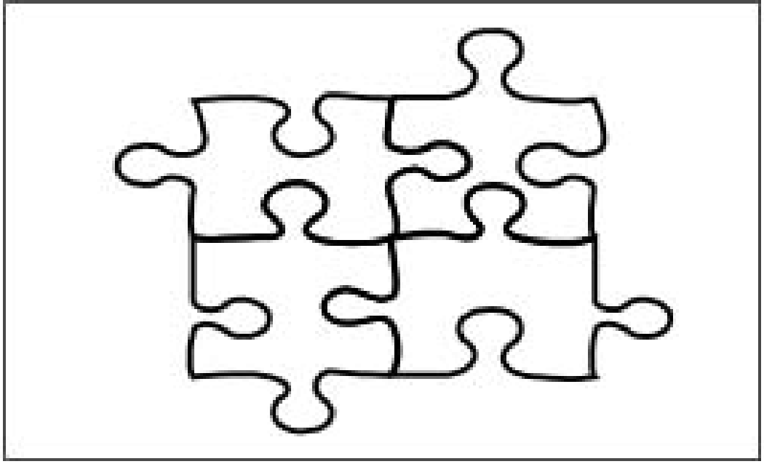
Fig 1. Old jobim puzzle (end of the 20th century).

- Citations
The list of references is headed References, it should be placed at the end of your contribution. It should be in Times New Roman 10-point font. Please do not insert a page break before the list of references. For citations in the text, please use square brackets [1] and consecutive ordered numbers [2,3] in list of references. Please find below examples on how to format references corresponding to articles [1], books [2], book chapters and proceedings [3].
- Warnings
Note that the maximum length of Highlight submission must not exceed 2 pages. A paper disregarding the format described in this document will be rejected (even if it was previously accepted by the program committee).
Acknowledgements
Acknowledgements are possible at the end of the document just before the References list. It should be in Times New Roman 10-point font.
References
- Alan D Sokal. Transgressing the boundaries: Toward a transformative hermeneutics of quantum gravity. Social text, (46/47):217–252, 1996.
- Barbara Gastel and Robert A Day. How to write and publish a scientific paper. ABC-CLIO, 2016.
- Graham Cormode, Shanmugavelayutham Muthukrishnan, and Jinyun Yan. Scienceography: the study of how science is written. In International Conference on Fun with Algorithms, pages 379–391. Springer, 2012.

