Togh.com

Installation guide

# Local Environment

How to setup a local environment?

## Prerequisite

Java (JDK)> 1.8 must be installed

## Clone the repository

Let’s say the clone is done in **c:\togh**

Do a git clone <https://github.com/pierre-yves-monnet/togh>

Or go to <https://github.com/pierre-yves-monnet/togh>, then click on **code**.

Click on Download ZIP

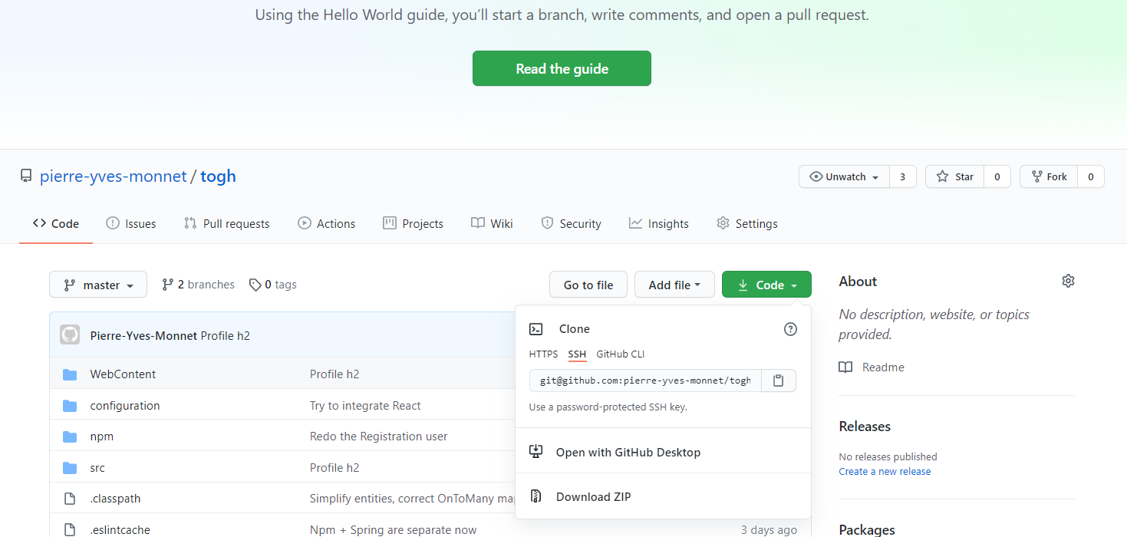

## Install npm

Go to <https://www.npmjs.com/get-npm> and click on Download.

## Download all npm modules

Go to c:\togh\npm

Execute

c:\togh\npm

npm install

## Install maven

https://maven.apache.org/download.cgi

## Install Tomcat

Download from here:

https://tomcat.apache.org/download-90.cgi

Chose "[64-bit Windows zip](https://apache.osuosl.org/tomcat/tomcat-9/v9.0.41/bin/apache-tomcat-9.0.41-windows-x64.zip) ([pgp](https://downloads.apache.org/tomcat/tomcat-9/v9.0.41/bin/apache-tomcat-9.0.41-windows-x64.zip.asc), [sha512](https://downloads.apache.org/tomcat/tomcat-9/v9.0.41/bin/apache-tomcat-9.0.41-windows-x64.zip.sha512))" for exemple (not the service installer)

Unzip it under c:\tomcat

## Copy the tomcat configuration

Copy c:\togh\tomcat_conf to c:\tomcat

2 files has to be copied. One file conf/server.xml should overwrite an existing file.

## War generation

Execute a mvn install in the togh directory

cd c:\togh

mvn install

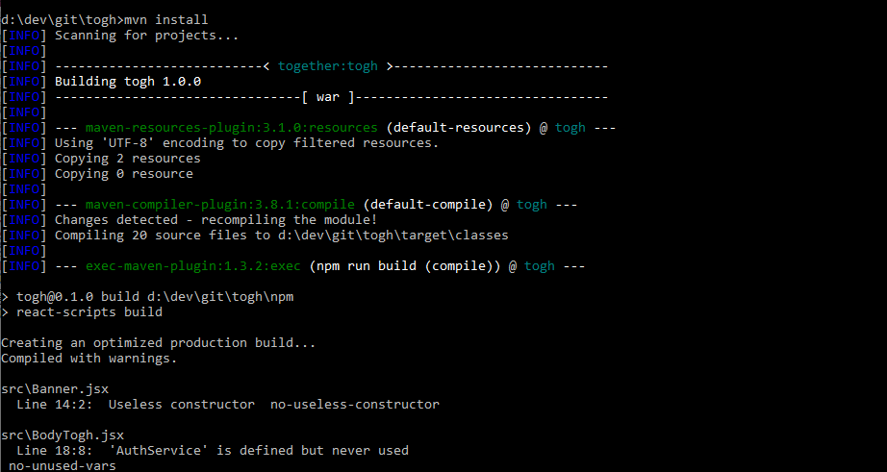

This will generate a WAR file under c:\togh\target\

## Copy the war file on Tomcat

Just copy the file

copy c:\togh\target\togh-1.0.0.war c:\tomcat\webapps

Theses files:

* Increase memory to 1 Gb and set the Spring h2 profiles

set CATALINA_OPTS=-D -Dfile.encoding=UTF-8 -Xms1024m -Xmx1024m -XX:+HeapDumpOnOutOfMemoryError -Dspring.profiles.active=h2

* Setup the server port on 7080 for Tomcat

## Start Tomcat

Start it from a command line

cd c:\togh\tomcat\bin

startup.bat

It should be available behind the URL http://localhost:7080/togh/api/ping

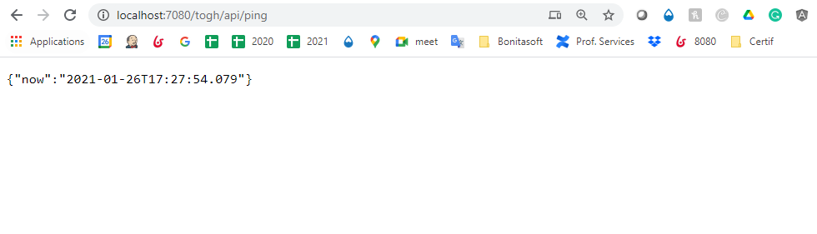

## Start npm

Start it from c:\togh\npm

cd c:\togh\npm

npm start

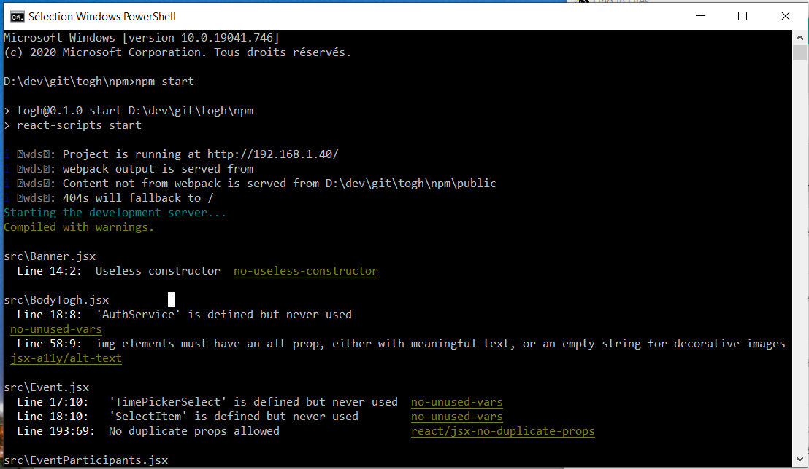

Application is available on <http://localhost:3000>

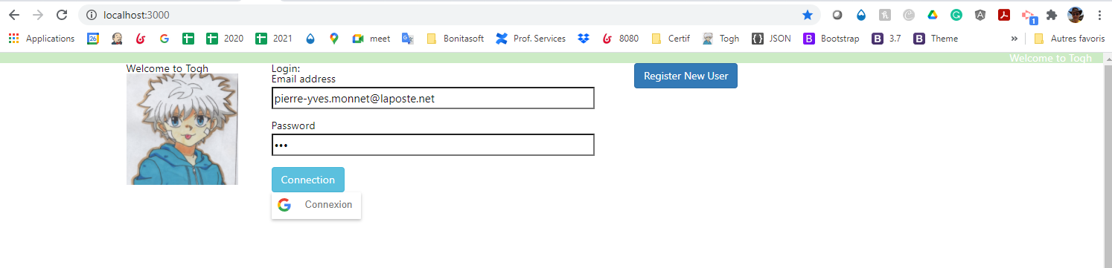

Note: dans la version actuelle, quand tu cree un event, tu ne bascule pas immediatement dedans. Il faut alors faire Refresh et clicker sur la ligne

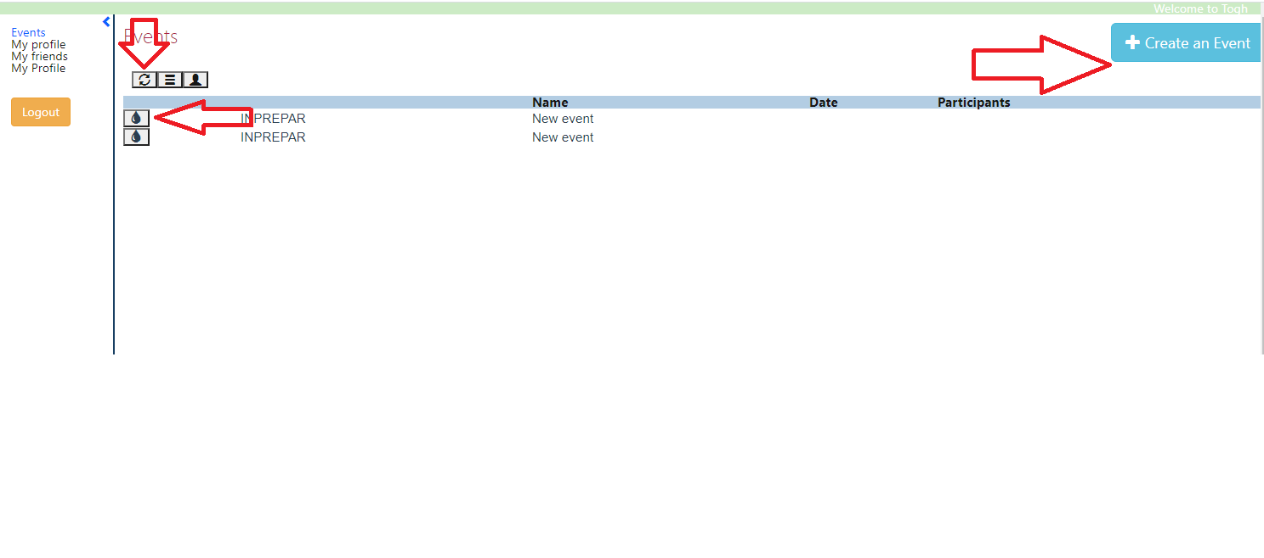

And don’t try to select a date: application goes to hell!!

