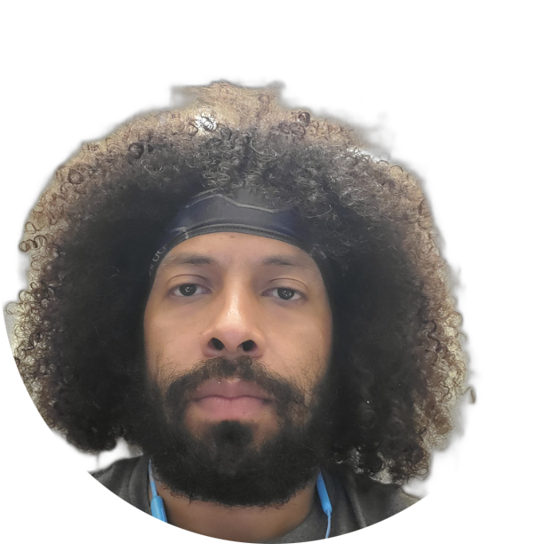

Pierre A Arnette | 6194367650 | pierre0685@gmail.com

# About me

I love to learn new things, such as Python, and help others sovle complex problems

# Work Experience

**CLP** *2013 -2018* Lead teacher and Fitness Coordinator for five different locations

**Uber** *2018 -Current*CSR and Program Specialist

# Skills

* Python
* Jira
* Salesforce