The SKEMASNET project
Session Key Management in a Spontaneous Network

CS642 - Distributed Systems | PARK Hyunho - 20094045  RICCIARDI Gianni M. - 20096093  ALAUZET Pierre - 20096699
November 30th, 2009 | HGP Team

Background
The Skemasnet project goal is to find an efficient way to merge several private networks in terms of number of exchanged messages and their size. This protocol aims to leverage pre-existing secure networks to share new session keys. We are considering scenarios such as meetings or multi-player games on handled devices, where some tens of users, divided into two independent groups, decide to merge their spontaneous networks (e.g. to share same documents in an enlarged meeting or to play the same match). Users are almost always in visual contact one to each other.
Usually in this kind of context Group Key Agreement (GKA) is used to create and share a new session key when needed. We surveyed several papers to understand how it works and to compare it to our idea.

Merging networks

We are assuming the presence of a membership management system, so each member has the list of all other users in the same spontaneous network. Moreover, during the establishing phase of each network, as soon as a user join it taking the session key from a connected user (using a secure side channel, e.g. the infrared ports on their laptops or portable devices), he/she broadcasts his/her public key to all users in the network; in this way, once the spontaneous network is established, each user has the public key of all other users in the same network.
In case of merging networks, one user is chosen as a leader in each network in order to manage the creation of the new key; all users, after a social agreement, select the leader on the users list: when the leader receives a signed election message from each user, he assumes the role of leader and sends a signed confirmation message to all users. From now on all other users will wait for a new key from the leader, sent as a message they can check using his/her public key.
The two leaders meet face to face, create the new key and share it using a secure side channel. Once the new key is available, each leader sends it to all users belonging to his/her former network, using the latter and signing the message containing the new key. In the message containing the new session key, all public keys belonging to users of the other network are also attached.
Using the new key a new common spontaneous network is established, and users from both original networks can communicate one to each other. In order to get the new key an attacker should have one of the keys used to establish one of the merging networks.
Since we are not using a Public Key Infrastructure (PKI) with a common CA in our scenario (considering it not a suitable requirement for our cases of use), it is not possible to check the identity of each user in a trustful way. Our idea is to leverage human interaction in order to ensure a level of security for membership management that is acceptable for applications running on top of this kind of networks.
Each host owning the new key is able to share it again using the aforementioned secure side channel: in this way new users can join the network in the usual way (i.e. obtaining the session key from a connected user through the use of the side channel and broadcasting their own public key).

We were considering 2 cases of merging networks:
- Merging of networks A & B and creation of a new network
- Group B joins the group A

As an update and revision, we will focus on the case 1.

Case 1: Merging of networks A & B and creation of a new network

Initial situation | 1  A  B
After merging | A  B  New network  1  1
Let us give the scenario we want to follow for the merging of two networks:

Preface | Decision making comes from human interaction.  Two groups meet and decide to merge their networks and then they choose two leaders (one per network).
Initial phase | Thanks to the joining procedure, each user has the public key   of all other users in the same network.  All users of each network, after a social agreement, select the leader on the users list.  When the leader receives a signed election message from each user, he assumes the role of leader and sends a signed confirmation message to all users.  The two leaders meet face to face and share a new session key using a secure side channel.  A  B  A  B  A  B  A  B
Propagation phase | Each leader propagates the new key to his/her members of pre-existing network through the network itself using a signed message.  A  B
Creation & communication phase | Users from both original networks can communicate one to each other.  C
Joining phase | If a new node requests to join the new network, it is performed as a common joining process. Each host owning the new key is able to share it again.  Public key of the new user is sent to the connected user who broadcasts it to all other users; the session key is delivered to joining user.  B  C  The new node joined the network and communicates with the others.  C

Leaving users


When a user leaves the network and there is the need to allow the access to the network itself only to remaining users, a new session key has to be generated: a leader is elected with the same procedure used for merging networks; the leader generates the new key and send it to all other users (of course not considering the leaving user) encrypting it with their public key. Using the new session key a new spontaneous network is established without the leaving user being able to access it.

Preface | Decision making comes from human interaction.  A user decides to leave the network.  A
Initial phase | All users of each network, after a social agreement, select the leader on the users list.  A  When the leader receives a signed election message from each user, he assumes the role of leader and sends a signed confirmation message to all users.  A
Propagation phase | The leader creates the new key and sends it to all other users, encrypting it with their public keys.  A
Communication phase | Nodes can now communicate once again, in a new secure network that the previous node cannot see anymore.  A

Comparison to GKA

Group Key Agreement (GKA) is a mechanism to create and share a common session key for a group of users without the use of a secure side channel. Each member is involved in the creation of a new key and provide a public contribution.
However it requires to create a new session key when a change in the network occurs: when a user joins, when a user leaves and in the case of merging networks.
For the creation and the distribution of a new session key 2N-1 messages are required to be exchanged to elect a leader, and 2N-1 messages to create and share a new session key (N to collect public contributes and N to deliver it) and the size of each message used to deliver a session key is

SizeOfSessionKey * 2 * N

Instead in our idea when a user join a message (of SizeOfSessionKey bytes) with the session key is exchanged on the side channel and, once the user is on the network, N messages (with a size depending on the size of public keys) are required to send his/her public key to all other users. In the case of a leaving user we need 2(N-1) messages to elect the leader (N-1 election messages from users to the future leader, and N-1 confirmation messages from the elected leader to all the users) and N-1 messages to deliver the new key to all users (SizeOfSessionKey). In the case of merging networks, we need 2(N-1) to elect the leader, as above, and N-2 messages (total number of users after the merger excluding the two leaders) to share the new key: the size of the latter is

SizeOfSessionKey + max(N1, N2)*SizeOfPubKey

where N1 and N2 are the respective numbers of users in the merging networks.

To summarize, let us compare the

- Number of exchanged messages:
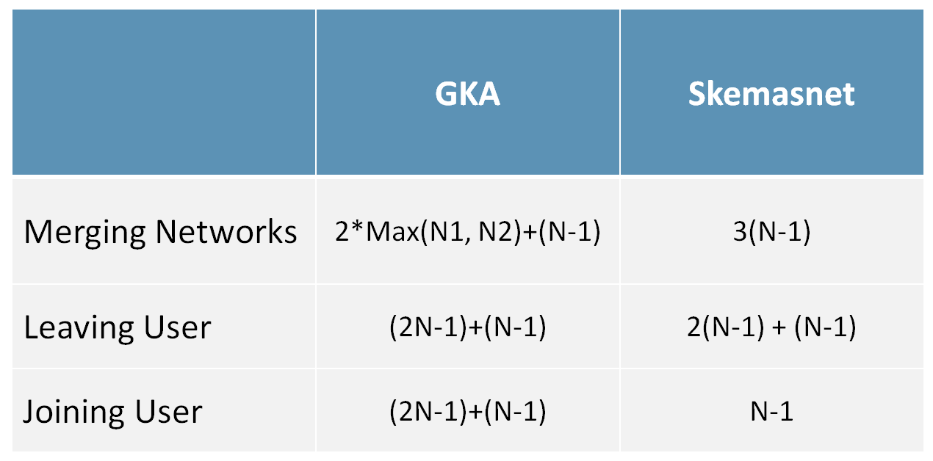

- Size of exchanged messages to deliver a new session key:
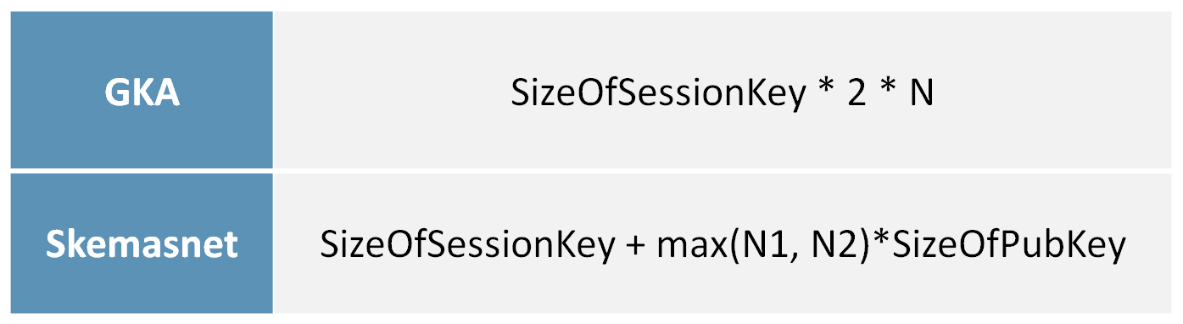

Implementation
In order to implement our solution and demonstrate our algorithm, we will use the ns-2 simulator. Written in C++ with an OTcl simulation interface, the Network Simulation version 2 is popularly used in the simulation of routing and multicast protocols, among others, and is heavily used in ad-hoc networking research. Ns supports an array of popular network protocols, offering simulation results for wired and wireless networks alike. It can be also used as limited-functionality network emulator. One advantage of using ns-2 is that the result will be visible and understandable.

Thanks to ns-2, our development consisting in
- Implement our Skemasnet and the GKA algorithm
- Simulate 3 scenarios: merging between 2 networks, the joining and the leaving of several nodes
- Compare our implementation with GKA in term of number & size of exchanging messages

Since we are focusing about number and size of messages, we are not implementing encryption algorithm. Current implementation does not reflect the overhead of message size.

We have implemented GKA and Skemasnet algorithms in C++ and build a bunch of test games for the 3 scenarios (up to 5 tests per scenario). Concerning the merging of two networks and the joining of node into a network, we took between 10 and 50 nodes per network. Concerning the leaving of a node from a network, we executed some tests with networks up to 50 nodes.

Results
We will explain our results thanks to homemade diagrams measuring the overhead of our network following the GKA and Skemasnet algorithms. We will compare GKA and Skemasnet results of the 3 different scenarios taking in account:
- The number of exchanged messages per node
- The size of exchanged messages per node

- Number of exchanged messages per node

The results of this part will show the number of exchanged messages between nodes from a network, using Skemasnet and GKA algorithms. We will add more and more nodes at each test and display diagrams of results:
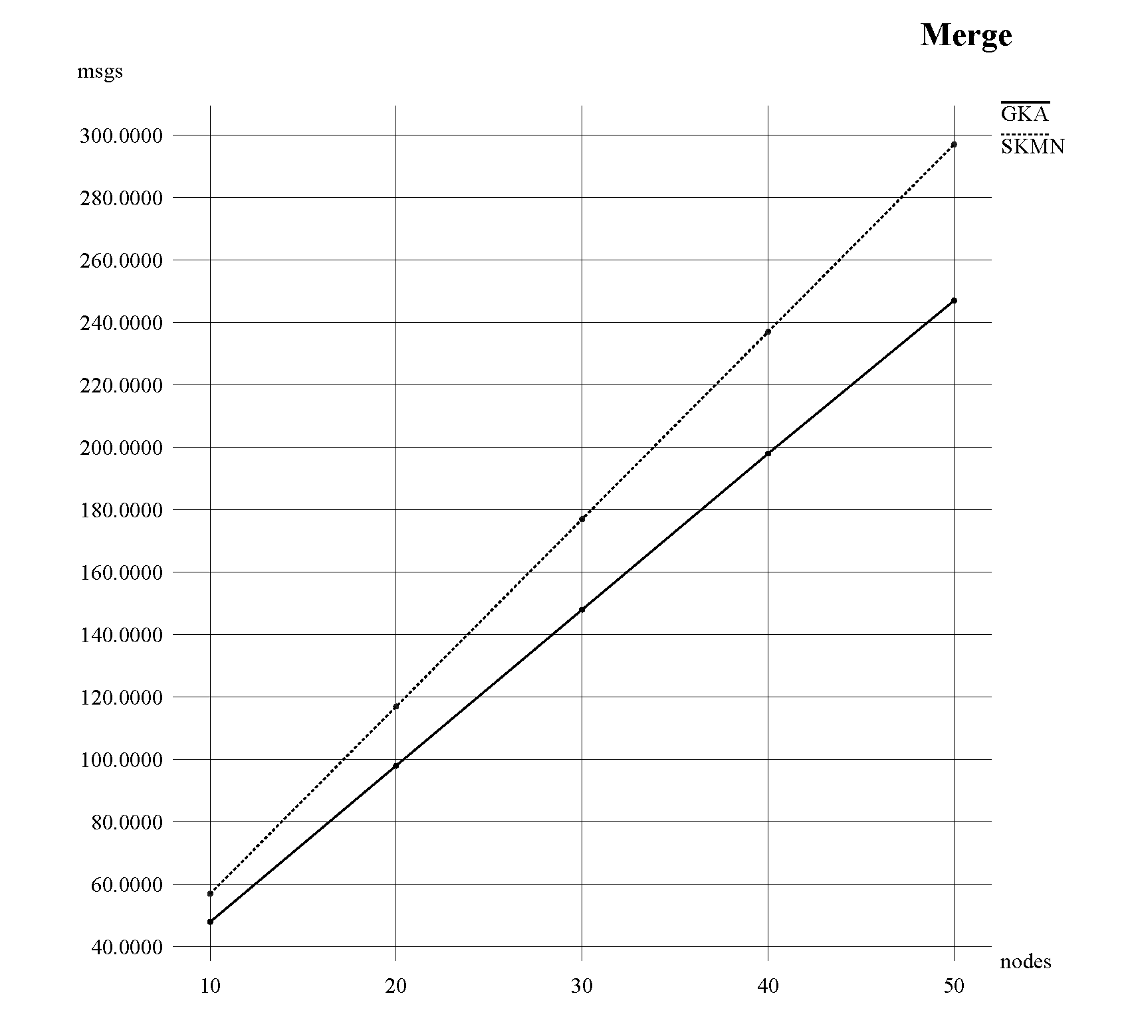
Comments

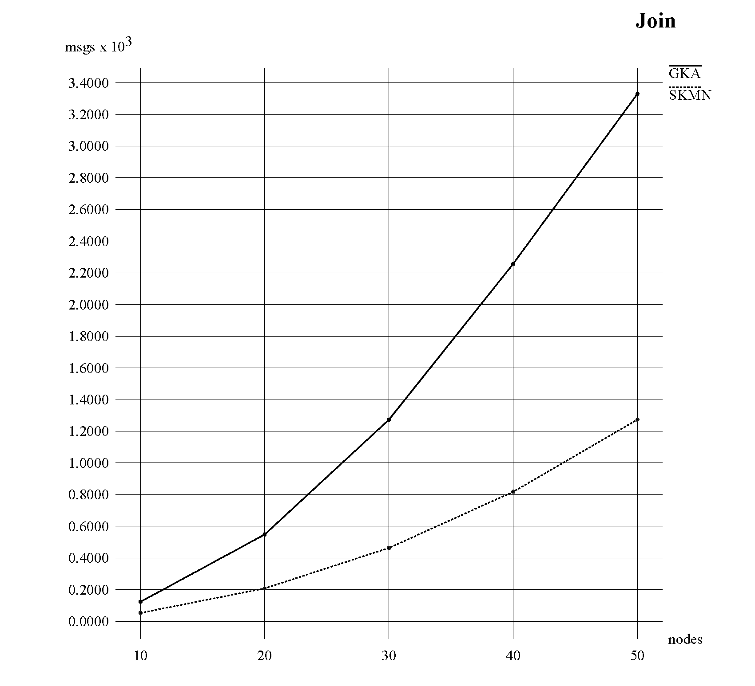
Comments

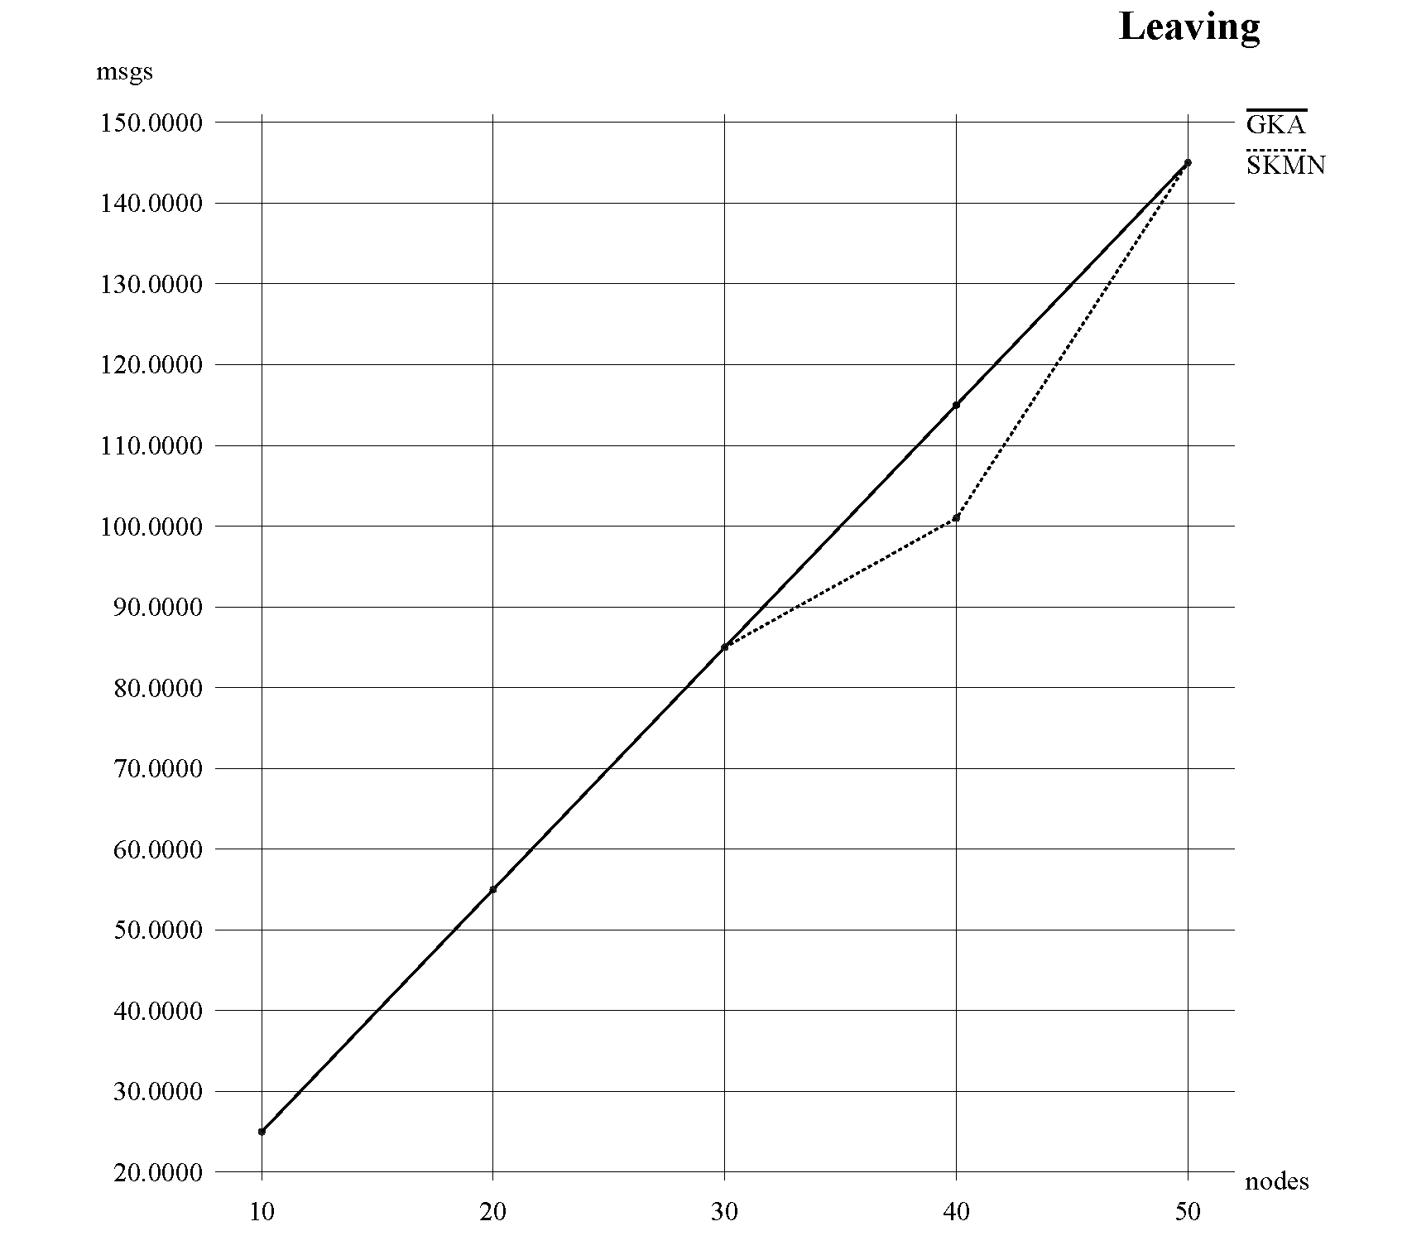
Comments

2. Size of exchanged messages per node

We compare the size of messages exchanged in networks using Skemasnet and GKA algorithms in order to have an idea of the network occupation.
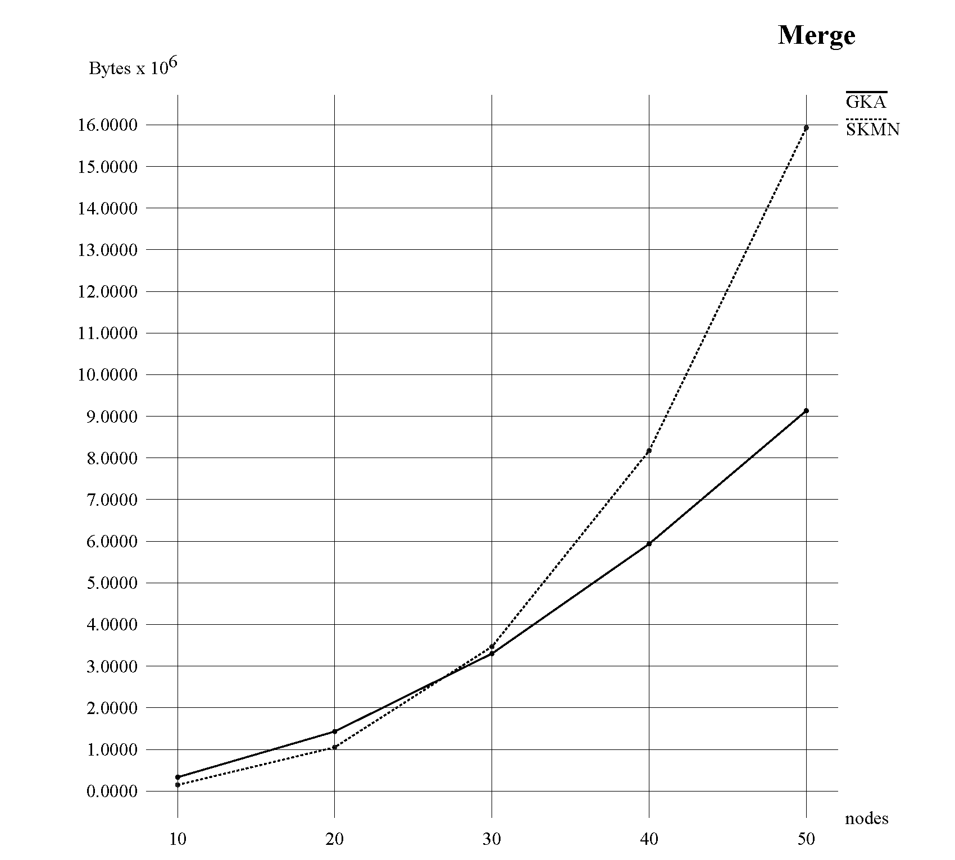

comments

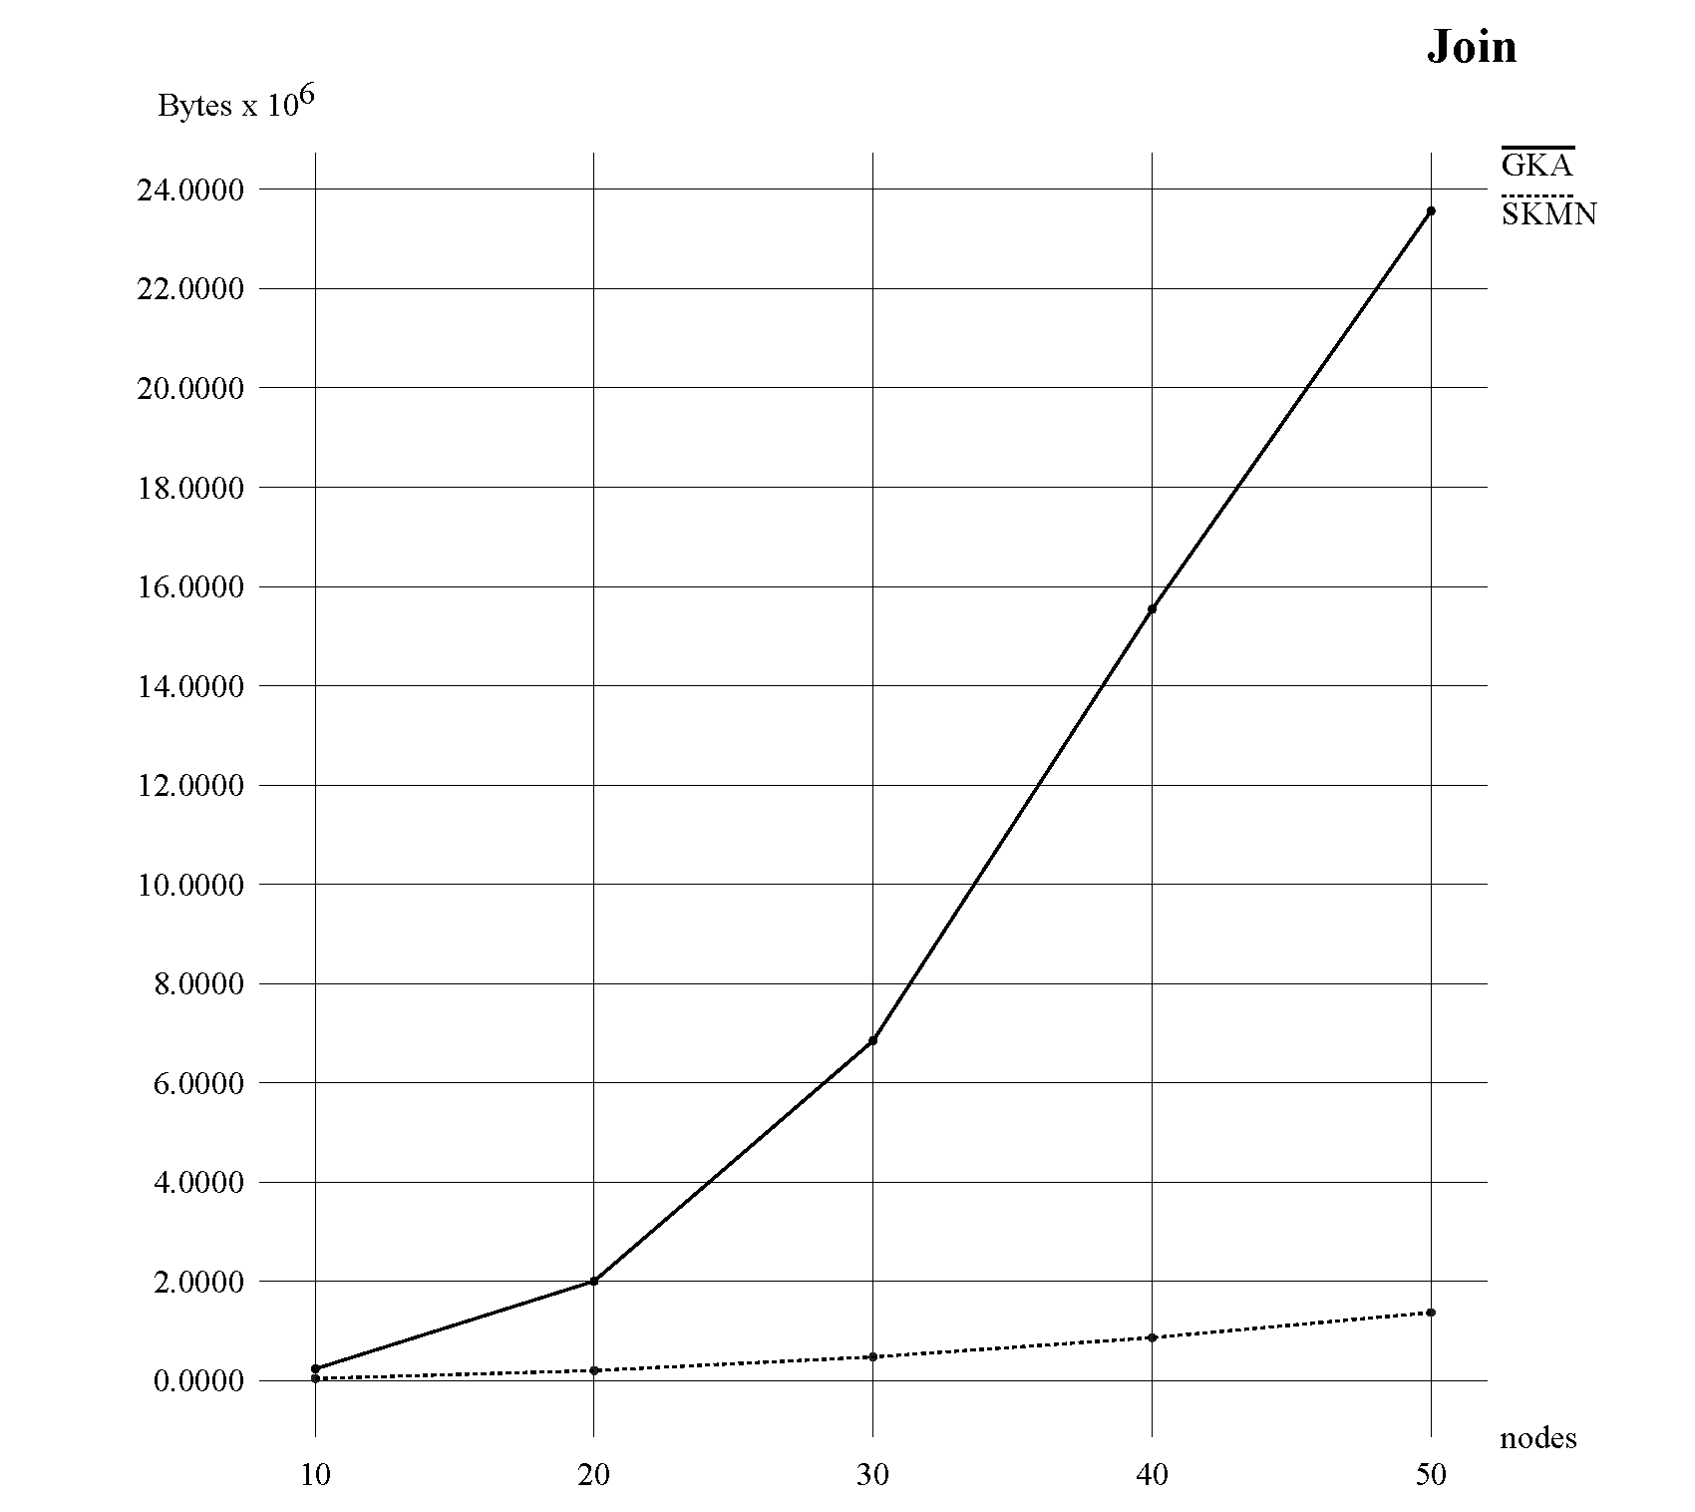
Comments

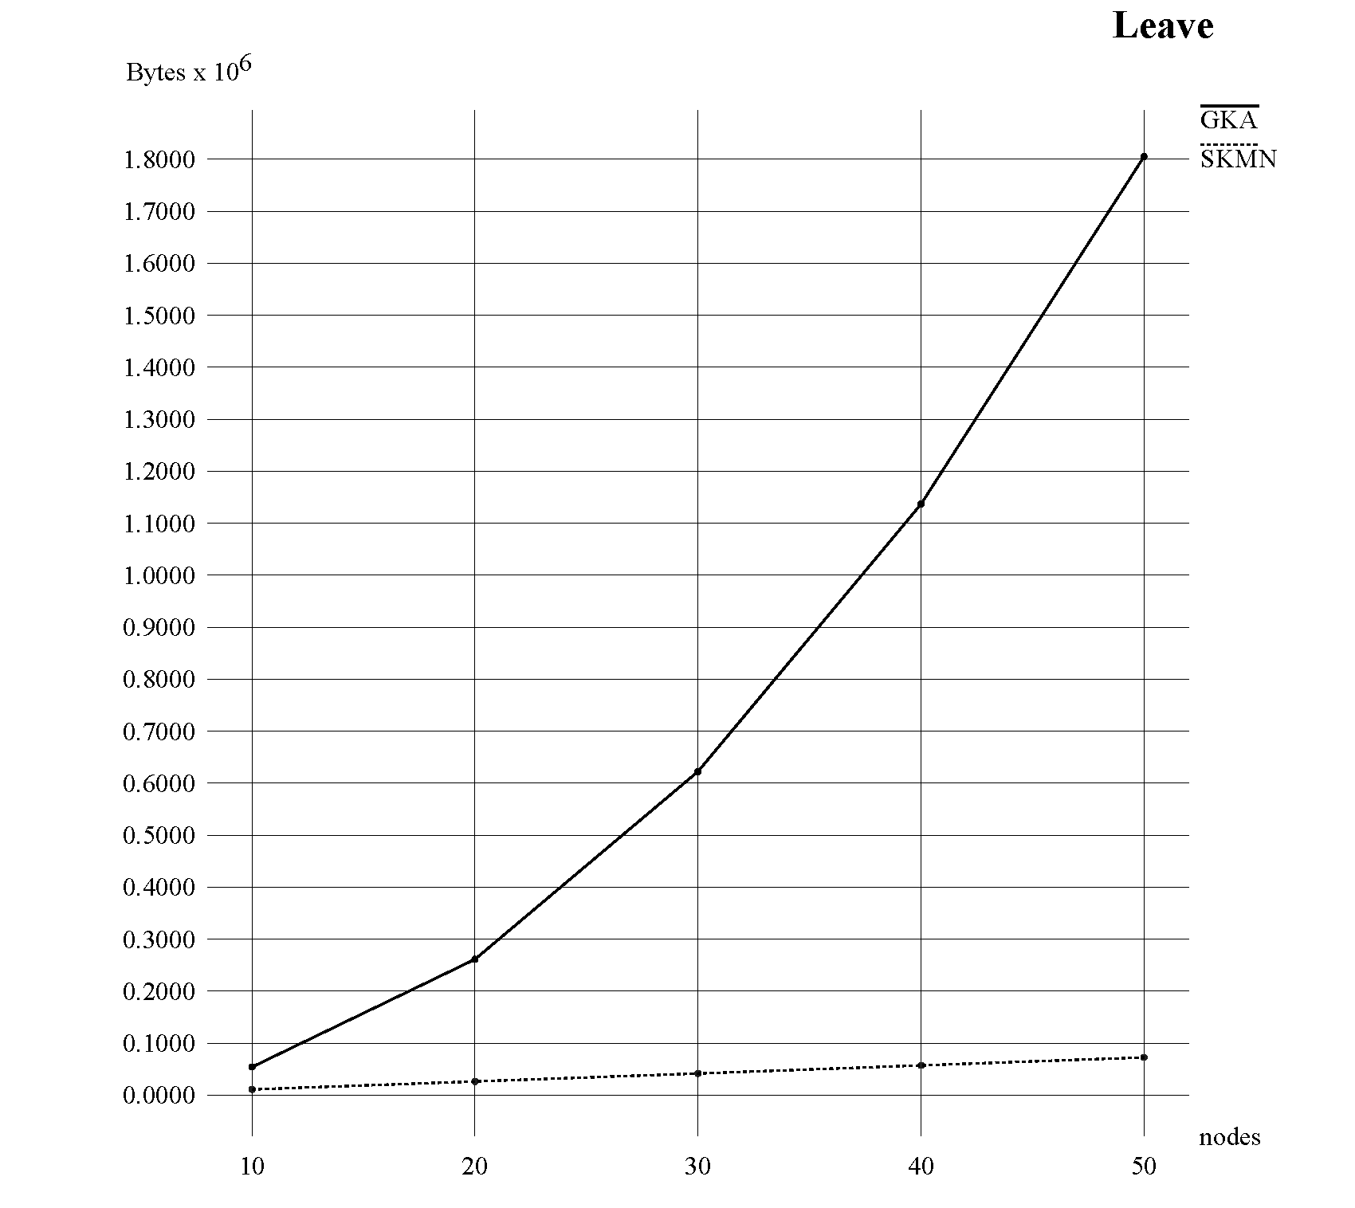
Comments

Conclusion

We got positive results with Skemasnet algorithm concerning number and size of messages. Skemasnest is using smaller messages and fewer messages than GKA algorithm.

Of course, Skemasnet algorithm cannot replace a strong and powerful algorithm as GKA as it can just be used in a special context. Indeed, Skemasnet may be applied with small networks with less than 150 nodes. Moreover people have to know each others, at least few of them, as it is based on social agreement for creating the session key and start mergin spontaneous networks.
References

[1] Johann Van Der Merwe, Dawoud Dawoud, and Stephen Mcdonald
A Survey on Peer-to-Peer Key Management for Mobile Ad Hoc Networks

[2] Dirk Balfanz, D. K. Smetters, Paul Stewart and H. Chi Wong
Talking To Strangers: Authentication in Ad-Hoc Wireless Networks

[3] Michael Steiner, Gene Tsudik, Michael Waidner
Diffie-Hellman Key Distribution Extended to Group Communication

[4] Daniel Augot, Raghav Bhaskar, Valerie Issarny and Daniele Sacchetti
An Efficient Group Key Agreement Protocol for Ad hoc Networks

[5] http://www.isi.edu/nsnam/ns/,
Official website of ns-2 simulator, accessed on November 29th 2009

