The SKEMASNET project
Session Key Management in a Spontaneous Network

CS642 - Distributed Systems

PARK Hyunho - 20094045
RICCIARDI Gianni M. - 20096093
ALAUZET Pierre - 20096699
October 21rd, 2009HGP Team
Introduction
The Skemasnet project goal is to find an efficient way to merge multiple private networks in terms of number of messages and size of the messages. This protocol aims to leverage pre-existing secure networks to share new session keys. We are considering scenarios such as meetings or multi-player games on handled devices, where some tens of users, divided into two independent groups, decide to merge their spontaneous networks (e.g. to share same documents in an enlarged meeting or to play the same match).
Usually in this kind of context Group Key Agreement (GKA) is used to create and share a new session key when needed. We surveyed several papers to understand how it works and to compare it to our idea.

Merging networks
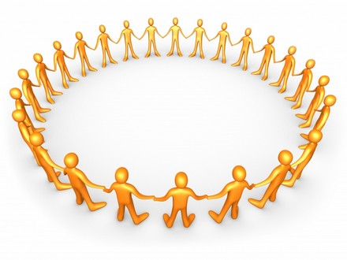
We are assuming the presence of a membership management system, so each member has the list of all other users in the same spontaneous network.
In case of merging networks, one user is chosen as a leader in each network in order to manage the creation of the new key; all users, after a social agreement, select the leader on the users list: when the leader receives an election message from each user, he assumes the role of leader and sends a confirmation message to all users, along with his public key, signed using his private key. From now on all other users will wait for a new key from the leader, sent as a message they can check using his public key. In this sense we can say that the elected leader is trustable.
The two leaders meet face to face, create the new key and share it using a secure side channel (e.g. infrared ports on their laptops or portable devices). Once the new key is available, each leader sends it to all users (multicast) belonging to his/her former network, using the latter and signing the message containing the new key.
Using the new key a new common spontaneous network is established, and users from both original networks can communicate one to each other.
In order to get the new key an attacker should have one of the keys used to establish one of the merging networks.
Since we are not using a Public Key Infrastructure (PKI) with a common CA in our scenario (considering it not a suitable requirement for our cases of use), it is not possible to check the identity of each user in a trustful way. Our idea is to leverage human interaction in order to ensure a level of security for membership management that is acceptable for applications running on top of this kind of networks.
Each host owning the new key is able to share it again using the aforementioned secure side channel: in the case of a single isolated user he needs to ask for the new key to a connected user (i.e. a user able to use the new network); instead in case of a group of isolated users, they can use the same procedure described above in a recursive way, delegating a leader to obtain the new key and then receiving it from him/her using the still-running network.(We assumed that there is no such isolated nodes and groups due to our target environment is consisting small number of members on a same place.)

(update following pictures?)

We are considering 2 cases of merging networks:

- Merging of networks A & B and creation of a new network
- Group B joins the group A

Case 1: Merging of networks A & B and creation of a new network

Initial situationAfter merging
1
A
B
A
B
New network
1
1

Case 2: Group B joins the group A

Initial situationAfter merging
1
A
B
A
B
1

Let us give the scenario we want to follow for the merging of two networks:

Preface | Decision making comes from human interaction.  Two groups meet and decide to merge their networks and then they choose two leaders (one per network).
Initial Phase |   Leaders create a new session key (or choose a key among two used keys)  A  B
Propagate Phase | Each leader propagates the new key to the members of his/her pre-existing network through the network itself.  A  B
Waiting Phase | If a new node requests to join the new network, it is performed as a common joining process.  A  B
Leaving users
When a user leaves the network and there is the need to allow the access to the network itself only to remaining users, a new session key has to be generated: a leader is elected with the same procedure used for merging networks; the leader generates the new key and collect the public keys from all users, in order to be able to send them the new key in a encrypted message using the existing network (which the leaving user can still access).
Using the new session key a new spontaneous network is established without the leaving user being able to access it.

(pictures required?)
Comparison to GKA
Group Key Agreement (GKA) is a mechanism to create and share a common session key for a group of users without the use of a secure side channel. Each member is involved in the creation of a new key and providing a public contribution.
However it requires to create a new session key when a change in the network occurs: when a user joins, when a user leaves and in the case of merging networks.
For the creation and the distribution of a new session key 2N messages are required to be exchanged and the size of each message used to deliver a session key is

SizeOfSessionKey * 2 * N

Instead in our idea...

(what here now?)

Status of the implementation so far

References

