Project Plan

Game Description
The game will be a 3D tower defense game played from an isometric perspective. It will feature levels which will be procedurally generated creating and endless amount of random levels. Enemy waves will travel from one end of the level towards the players home base taking the shortest route available. Upon reaching the base, the enemies will capture villager and begin to the villager back to the enemies starting point. If an enemy carrying a villager is destroyed, the villager will slowly begin to make their way back to the base, but other enemies can recapture the villager during this period.

The player will be in control of a character which can freely move around each level. The players tasks will be to build towers to stop the oncoming waves of enemies. The player will also gather resources spread across the map in order to build and upgrade towers. As the player gathers resources, paths which were previously blocked by resources will open up providing enemies shorter routes between their spawn area and the players home base. In between levels, the player will also be able to purchase permanent upgrades to their character and towers.

Technology
All coding will be done in C++ and we will use OpenGL and programmable shaders for graphics rendering. For our graphics engine we will be using the OGRE engine. OGRE is a flexible 3D graphics engine which contains a class library which abstracts all the details of using underlying system libraries such as OpenGL. ORGE also provides features such as Material and Shader support, scene management, particle effects, animation support, and many other graphical rendering features. There are also a large variety of add-ons that ORGE supports such as add-ons for lighting, creating GUIs, and a variety of physics engines.

In game physics and collision detection will be done using the Bullet Physics Library. Bullet Physics is a professional open source collision detection, rigid body and soft body dynamics library. Bullet Physics can be used on platform such as PC, Mac OSX, Linux, it is open source, and it is also compatible with OGRE the use of the ogrebullet add-on.

If the need arises during development, other libraries, and add-ons will be researched and used as necessary.

Class Diagram
See 483_project_class_diagram image.
Design
For our design we will be using a variation on the observer pattern through use of an EventHandler class. This class will be responsible for registering and unregistering subscribers (other objects), collecting events from other classes, and broadcasting all collected events to its subscribers so they can update their states accordingly. By using this approach, instead of having classes which need to implement multiple functions to talk to multiple classes for multiple event types; classes will only need to be responsible for notifying the event handler that an event has occurred and be able to handle relevant events broadcast by the event handler.
The Game class will be the main component which drives the main game loop. It will be in charge of initializing the game state, switching between game states, and its update and render functions will trigger the update and render functions for all other classes. The Game class will also be responsible for telling the event handler to broadcast all events so each class in it correct state for updating and rendering.

All classes which will be responsible for producing a large amount of objects such as tower classes and enemy classes will have a corresponding manager class such as the TowerManager and EnemyManager. These manager classes will be responsible for creating and destroying objects of their corresponding classes. In addition it will also us to save memory by prevent the creation of duplicate objects by instead passing a reference to the existing object and keeping a reference count for the object.
Task List
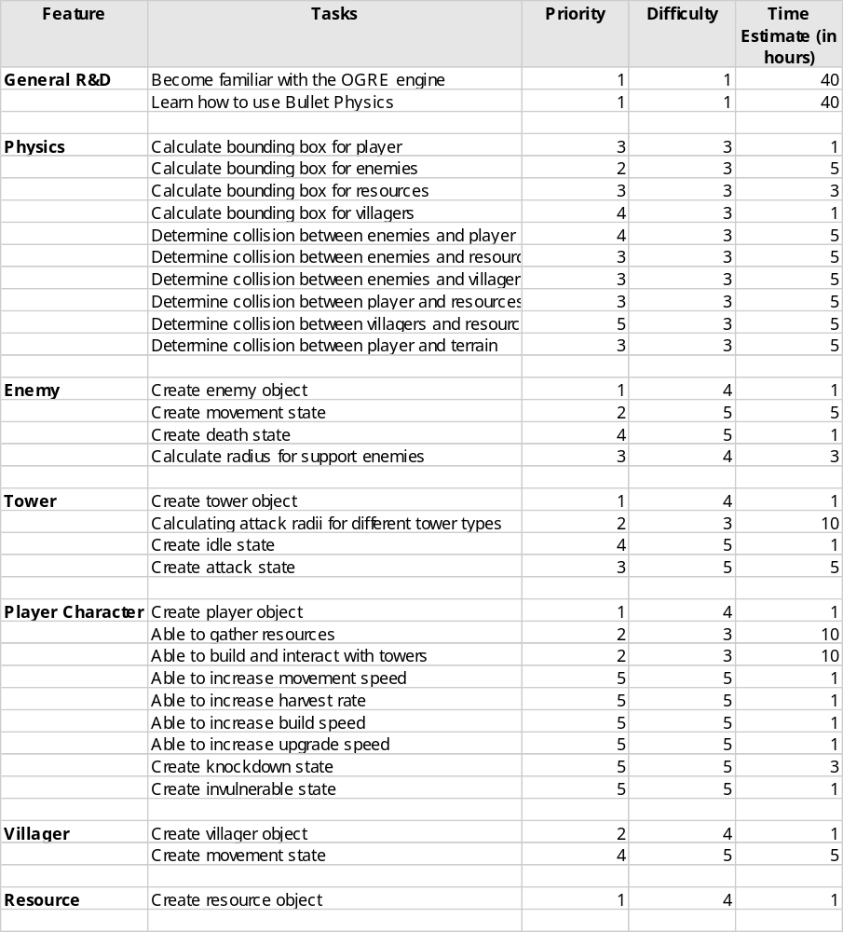

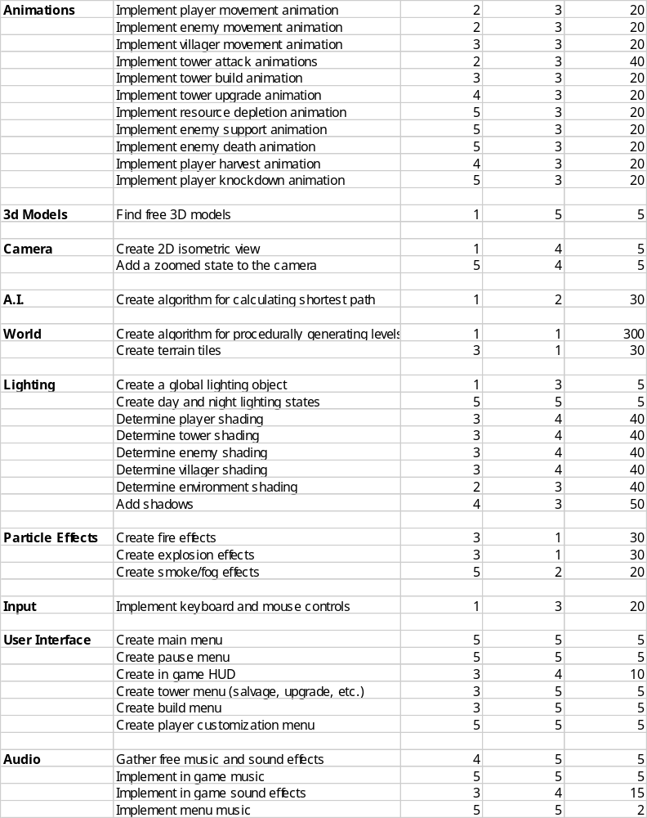

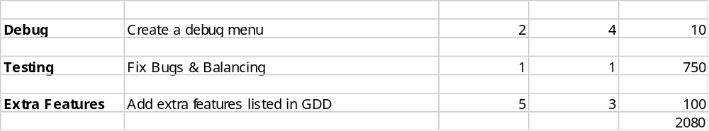

Dependency Chart
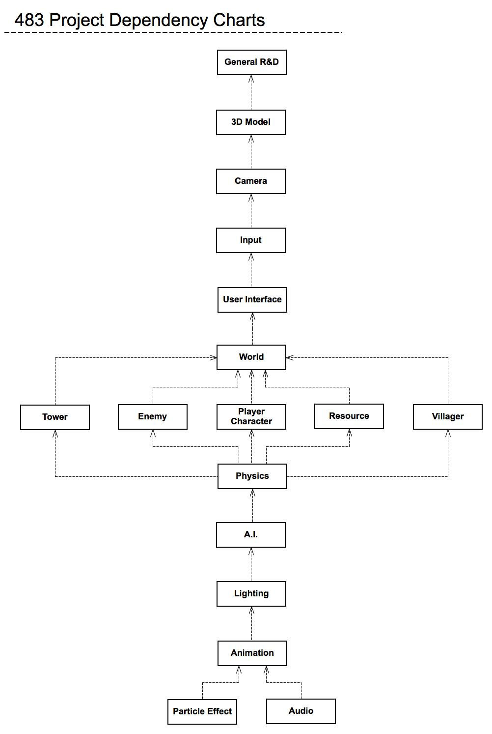
Deliverables
Deliverable 1 - Complete design and become familiar with technology by October 17th.
Deliverable 2 - Base classes built by October 31st.
Deliverable 3 - Implement lighting, shortest path algorithm and keyboard and mouse support by November 14th.
Deliverable 4 - Terrain generation and camera complete by January 3rd.
Deliverable 5 - Physics and animations implemented by January 31st.
Deliverable 6 - Alpha complete by February 15th. This include a fully functioning procedurally generated level with at least one tower, enemy type, and resource type.
Deliverable 7 - Beta/Code Complete complete by March 29th. Game is in its complete state and thorough bug and play testing begins.
Deliverable 8 - Game Complete by April 20th

Class Interaction Examples with Pseudo Code
// Pseudo code for tower attack

ArrowTower::EnemyInRange()
{
if (EnemyManager::EnemiesInRange(m_fRange))
{
m_pEnemies = EnemyManager::GetEnemiesInRange(m_fRange);
m_eState = AttackState;
}
}

ArrowTower::Attack()
{
if (m_iCurrentTarget < pEnemies->size())
{
if(pEnemies[m_iCurrentTarget] != dead && pEnemies[m_iCurrentTarget]->InRange(m_fRange))
{
pEnemies[i]->Attacked(m_iAttackPower);
}
else
{
m_iCurrentTarget++;
}
}
else
{
m_eState = IdleState;
m_iCurrentTarget = 0;
}
}

ArrowTower::Update()
{
if (m_eState == AttackState)
{
Attack();
}
else
{
EnemyInRange();
}
// other update code
}

// Pseudo code for an Explode Event

BombTower::EnemyInRange()
{
if (EnemyManager::EnemiesInRange(m_fRange))
{
m_pEnemies = EnemyManager::GetEnemiesInRange(m_fRange);
m_eState = AttackState;
}
}

BombTower::Attack()
{
if (m_iCurrentTarget < pEnemies->size())
{
if(pEnemies[m_iCurrentTarget] != dead && pEnemies[m_iCurrentTarget]->InRange(m_fRange))
{
EventHandler::AddEvent(ExplodeEvent);
}
else
{
m_iCurrentTarget++;
}
}
else
{
m_eState = IdleState;
m_iCurrentTarget = 0;
}
}

BombTower::Update()
{
if (m_eState == AttackState)
{
Attack();
}
else
{
EnemyInRange();
}
// other update code
}

EventHandler::AddEvent(pEvent)
{
// Code for adding events
}

EventHandler::Update()
{
BroadcastEvents();
}

Enemy::HandleExplodeEvent(pEvent)
{
// code for hadnling event
}

FireEnemy::HandleExplodeEvent(pEvent)
{
// code for handling event different from how a normal enemy handles an explode event
}

// Pseudo code for building a tower

Player::TileClick(p_fPos)
{
Tile* pTile = World->GetTile(p_fPos);
if (!pTile->HasTower() && pTile->IsValid())
{
// code for selecting tower to build
TowerManager::AddTower(p_fPos);
}
else if (pTilee->HasTower())
{
// code for upgrading towers
}
else
{
// code for handling clicking on invalid tiles
}
}

TowerManager::AddTower(p_fPos)
{
Tower* pTower = new Tower();

Tile* pTile = World::GetTile(pfPos);
pTile->PlaceTower(pTower);

towers.push_back(pTower);
}

