1. Operations instructions

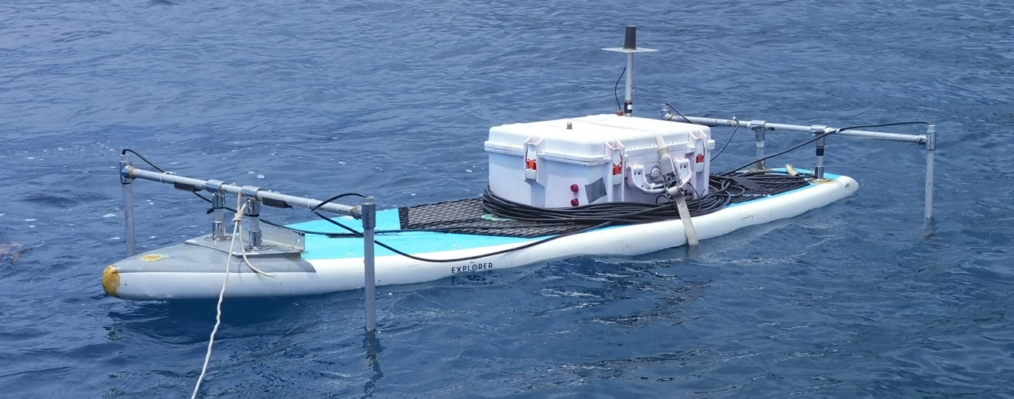

Table of Contents

1 Global 3

1.1 Installation of mission planner on the laptop 3

1.2 Before mission: 3

1.3 Before starting the mission 3

1.4 During Mission 3

1.5 After Mission 4

2 Acoustic tracking : 4

2.1 Before mission : 4

2.2 Before starting the mission 4

2.3 During mission 4

2.4 After the mission 4

3 Bathymetry survey : 5

3.1 Before mission 5

3.2 Before starting the mission 5

3.3 3. During Mission 5

3.4 4. After the mission 5

4 Photogrammetry survey : 5

4.1 Before mission 5

4.2 Before start mission 6

4.3 During Mission 6

4.4 After mission 6

# Global

Before starting operation you must have been read the Rover ardupilot documentation and made the “First time setup” and “First Drive and tuning” tutorial” available at :

<https://ardupilot.org/rover/>

## Installation of mission planner on the laptop

## Before mission:

-Charging battery: Laptop, 10Ah 4S lipo, RC transmitter

-Checking SD cards: Autopilot, camera

-Checking SIM card on USB dongle

-Download field map offline and add it to mission planner

## Before starting the mission

-Deployment assembly of the ASV

-Power the system in the waterproof case

-Connect the RFD900 USB cable to the laptop

-Connect the ASV and mission planner. Serial connection at 57600 baud

*Find to COM port in device manager of the laptop*

-Go to manual mode, start the  RC transmitter, ARM the thruster, and test it:

*One can refer to the sense of the wind coming out of the thrusters to determine if they rotate the right way. For instance, when moving the joystick up to go forward, some wind should be felt on the back of both thrusters.*

Then DISARM the thruster.

-Wait for the GPS fix and check on mission planner if the GPS status reads "RTK Fixed".

*If using LoRa RTK frame correction install and start the GPS base as in 2.2.2 RTK GNSS*

-When the GPS signal is fixed, check if the ASV icon on mission planner points in the right direction. If not, restart the compass calibration. See tutorial at : LINK

If using the echosounder, it is recommended to put the board into the water and check that a  coherent value can be read in the rangefinder field in “State”.

-The ASV is ready to go

## During Mission

-Lift the ASV in the water

-Depending of what you want to do see Acoustic tracking, Bathymetric, and photogrammetric sections

-Check the ASV. if there is a problem and dangerous situation DISARM thruster and abort mission

## After Mission

-Use RC transmitter and in Manual mode bring back the ASV to you

-Lift the board out of the water

-Once in the dry place, unplug batteries

-Remove SD card from autopilot

-Download and save log data

# Acoustic tracking :

## Before mission :

-Do global: **3.1.1. Before mission**

-Charge the battery of the acoustic beacon U1

-Charging camera battery

-Checking camera SD card

## Before starting the mission

-Do global: **3.1.2. Before start mission**

-Deploy and fixed arm holding acoustic receivers

-Plug the 4 acoustics receivers connector into the waterproof case. The numbers are written on the box, the connector, and the electrical board inside the case. *Follow instructions given in X.X.X Underwater GPS*.

-Check and put a 3A fuse in the fuse holder

-Fix the camera on the thruster support. The angle of the camera allows the field of view to see the surface of the water on the video

-Start the recording and plug its USB cable

-Connection in SSH to the raspberry thought internet. *See SSH connection in software instruction*

-Start the tracking script. *See tracking in software instruction*

## During mission

-Do global : **3.1.3. During mission**

-Equip the target with the acoustic beacon

-ASV should start following the target on the water

-Check the ASV. if there is a problem and dangerous situation DISARM thruster and abort mission

## After the mission

-Do global : **4. After mission**

-Remove SD card from camera and download videos

-Download log file on the raspberry

-Visualize and process data with matlab script : X.m. *See software file*

# Bathymetry survey :

## Before mission

-Define speed and space between transect of the mission with field depth and resolution wanted.

*we often use as waypoints speed : 0.8m/s and 2m between transects*

-Draw a polygon around to survey zone in flight plan of mission planner and save it

-Create a mission with auto waypoint survey grid and the parameters wanted and save it. it will indicate the approximate time of the mission

-for more information visit Ardupilot wiki at : <https://ardupilot.org/planner/docs/mission-planner-flight-plan.html>

-Do global: **1.2 Before mission**

## Before starting the mission

-Do global: 2. Before start mission

-Load and write the survey mission in the autopilot

## 3. During Mission

-Deploy the ASV

-Set Home mission in mission planner

-In mission planner Actions or with the RC transmitter ARM the thruster and go to AUTO mode. The ASV should start its mission

-Check the ASV. if there is a problem and dangerous situation DISARM thruster and abort mission

## 4. After the mission

-Check-list global: **4. After mission**

-Visualize and process log data with python script : X.py. *See software file*

# Photogrammetry survey :

## Before mission

-Charging camera battery

-Checking camera SD card

-Define speed and space between transect of the mission with field depth and resolution wanted. for photogrammetric survey we use X.excel file. See software file

*we often use as waypoints speed : 0.8m/s and 1m between transects*

-Draw a polygon around to survey zone in flight plan of mission planner and save it

-Create a mission with auto waypoint survey grid and the parameters wanted and save it. it will indicate the approximate time of mission

-for more information visit ardupilot wiki at : <https://ardupilot.org/planner/docs/mission-planner-flight-plan.html>

-Do global: **1.2 Before mission**

## Before start mission

-Do global: **1.3 Before starting the mission**

-Load and write the survey mission in the autopilot

-Fix camera on the thruster support. The camera need to face down

-Start the recording and plug its USB cable

## During Mission

-Deploy the ASV

-Set Home mission in mission planner

-In mission planner Actions or with the RC transmitter ARM the thruster and go to AUTO mode. The ASV should starts its mission

-Check the ASV. if there is a problem and dangerous situation DISARM thruster and abort mission

## After mission

-Check-list global: **1.5** **After mission**

-Remove SD card from camera and download videos

-Visualize and pre-process videos with python script : X.py. See software file