Z_HomeAssignment1.R
Pierre Klintefors
Fri Dec 07 13:53:10 2018
rm(list=ls(all=TRUE)) # clears the workspace
graphics.off() # clears graphics
#################
#Load Packages
##############
require(lsr)
## Loading required package: lsr
require(psych)
## Loading required package: psych
require(car)
## Loading required package: car
## Loading required package: carData
##
## Attaching package: 'car'
## The following object is masked from 'package:psych':
##
## logit
require(lm.beta)
## Loading required package: lm.beta
#set working directory
########################
setwd("~/PSYP13/Rwork")
#######################
###Import data
#######################
pain.dataset <- read.csv("~/PSYP13/Rwork/home_sample_1.csv")
View(pain.dataset)
############################
###Descriptive data
############################
describe(pain.dataset)
## vars n mean sd median trimmed mad min max
## ID* 1 160 80.50 46.33 80.50 80.50 59.30 1.00 160.00
## pain 2 160 4.88 1.43 4.91 4.86 1.42 1.00 8.63
## sex* 3 160 1.46 0.50 1.00 1.45 0.00 1.00 2.00
## age 4 160 41.19 15.32 40.00 40.16 4.45 27.00 222.00
## STAI_trait 5 160 39.66 4.62 40.00 39.69 4.45 25.00 52.00
## pain_cat 6 160 29.75 4.82 29.50 29.65 5.19 17.00 48.00
## cortisol_serum 7 160 5.00 0.86 5.06 5.00 0.85 2.72 7.30
## cortisol_saliva 8 160 4.98 0.90 4.95 4.98 0.90 2.40 7.67
## mindfulness 9 160 3.05 0.99 3.06 3.05 0.87 0.12 5.89
## weight 10 160 70.22 10.66 70.39 70.02 11.64 47.81 100.61
## range skew kurtosis se
## ID* 159.00 0.00 -1.22 3.66
## pain 7.64 0.09 -0.17 0.11
## sex* 1.00 0.15 -1.99 0.04
## age 195.00 10.26 118.38 1.21
## STAI_trait 27.00 -0.12 0.49 0.36
## pain_cat 31.00 0.30 0.65 0.38
## cortisol_serum 4.57 -0.03 -0.34 0.07
## cortisol_saliva 5.28 -0.02 0.04 0.07
## mindfulness 5.77 0.08 0.03 0.08
## weight 52.80 0.19 -0.41 0.84
pain.dataset2 <- pain.dataset
#####################################
###Correct the age of participant 28
#####################################
pain.dataset2$age[28] = 22
View(pain.dataset2)
describe(pain.dataset2)
## vars n mean sd median trimmed mad min max
## ID* 1 160 80.50 46.33 80.50 80.50 59.30 1.00 160.00
## pain 2 160 4.88 1.43 4.91 4.86 1.42 1.00 8.63
## sex* 3 160 1.46 0.50 1.00 1.45 0.00 1.00 2.00
## age 4 160 39.94 5.46 40.00 40.05 4.45 22.00 60.00
## STAI_trait 5 160 39.66 4.62 40.00 39.69 4.45 25.00 52.00
## pain_cat 6 160 29.75 4.82 29.50 29.65 5.19 17.00 48.00
## cortisol_serum 7 160 5.00 0.86 5.06 5.00 0.85 2.72 7.30
## cortisol_saliva 8 160 4.98 0.90 4.95 4.98 0.90 2.40 7.67
## mindfulness 9 160 3.05 0.99 3.06 3.05 0.87 0.12 5.89
## weight 10 160 70.22 10.66 70.39 70.02 11.64 47.81 100.61
## range skew kurtosis se
## ID* 159.00 0.00 -1.22 3.66
## pain 7.64 0.09 -0.17 0.11
## sex* 1.00 0.15 -1.99 0.04
## age 38.00 -0.05 0.82 0.43
## STAI_trait 27.00 -0.12 0.49 0.36
## pain_cat 31.00 0.30 0.65 0.38
## cortisol_serum 4.57 -0.03 -0.34 0.07
## cortisol_saliva 5.28 -0.02 0.04 0.07
## mindfulness 5.77 0.08 0.03 0.08
## weight 52.80 0.19 -0.41 0.84
#############################
###Create regression model 1
#############################
model.1 <- lm(formula = pain ~ sex + age,
data = pain.dataset2)
print(model.1)
##
## Call:
## lm(formula = pain ~ sex + age, data = pain.dataset2)
##
## Coefficients:
## (Intercept) sexmale age
## 8.72049 0.28454 -0.09954
##########################################################
####Create regression model 2 containging all predictors
##########################################################
model.2 <- lm(formula = pain ~ sex + age + STAI_trait + pain_cat + mindfulness + cortisol_serum + cortisol_saliva,
data = pain.dataset2)
print(model.2)
##
## Call:
## lm(formula = pain ~ sex + age + STAI_trait + pain_cat + mindfulness +
## cortisol_serum + cortisol_saliva, data = pain.dataset2)
##
## Coefficients:
## (Intercept) sexmale age STAI_trait
## 3.50957 0.32378 -0.06212 -0.02663
## pain_cat mindfulness cortisol_serum cortisol_saliva
## 0.07033 -0.23956 0.42506 0.25493
####################################
###Normality assumption and residuals
#####################################
# QQ plot
windows()
plot(model.2, which = 2)
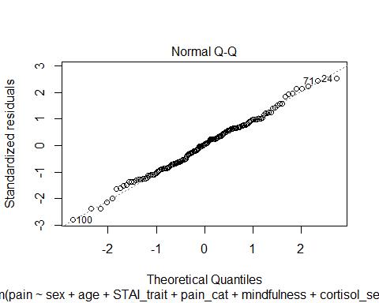
# skew and kurtosis
describe(residuals(model.2))
## vars n mean sd median trimmed mad min max range skew kurtosis
## X1 1 160 0 1.08 0.04 -0.01 1.12 -3.05 2.74 5.78 -0.02 -0.09
## se
## X1 0.09
# histogram
hist(residuals(model.2), breaks = 20)
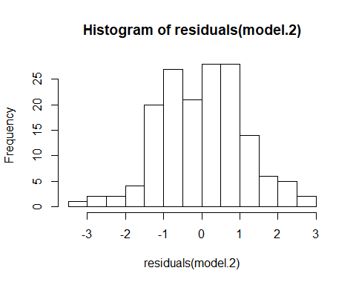
#################################################
### Extreme values
#################################################
plot(pain.dataset2$pain ~ pain.dataset2$sex)
###assess leverage
abline(lm(pain ~ age, data = pain.dataset2))
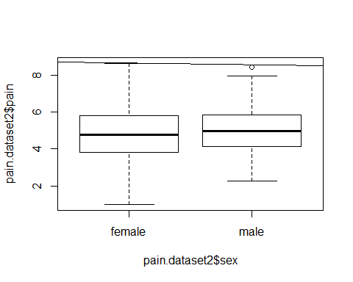
plot(model.2, which = 5)
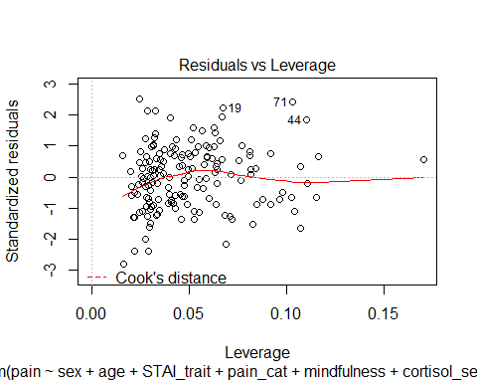
###############################
####Plot to detect outliers
###############################
# checking for influential outliers = extreme values with high leverage
# Cook's distance > 1, or Cook's distance > 4/N
4/nrow(pain.dataset2)
## [1] 0.025
windows()
plot(x = model.2, which = 4)
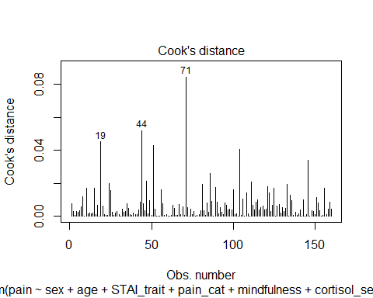
windows()
plot(x = model.2, which = 5)
lev =hat(model.matrix(model.2))
plot(lev)
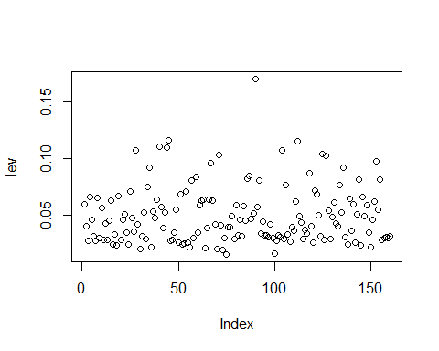
pain.dataset2[lev > .15,]
## ID pain sex age STAI_trait pain_cat cortisol_serum
## 90 ID_90 5.737575 male 41 25 25 6.179193
## cortisol_saliva mindfulness weight
## 90 5.599963 5.28728 55.99322
######################
###Mahalanbois distance
######################
N= nrow(pain.dataset2)
mahad=(N-1)*(lev-1 / N)
tail(sort(mahad),5)
## [1] 16.51147 16.58277 17.32709 17.46433 26.04212
order(mahad,decreasing=T)[c(5,4,3,2,1)]
## [1] 44 40 112 45 90
###############################
###New dataset with row 90 excluded
###############################
pain.dataset3 <- pain.dataset2[-90,]
View(pain.dataset3)
#########################################
###Update the models with the new dataset
#########################################
new_model.1 <- model.1 <- lm(formula = pain ~ sex + age,
data = pain.dataset3)
new_model.2 <- lm(formula = pain ~ sex + age + STAI_trait + pain_cat + mindfulness + cortisol_serum + cortisol_saliva,
data = pain.dataset3)
######################################################
###Create a histogram of the distribution of residuals
######################################################
hist( x = residuals(new_model.2), xlab = "Value of residual", main = "Distrubution of residuals",
breaks = 20)
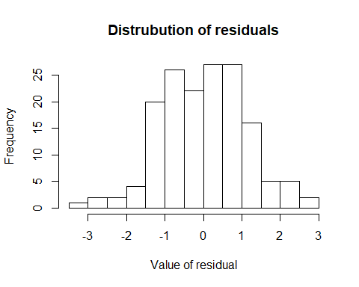
hatvalues( model = new_model.2 )
## 1 2 3 4 5 6
## 0.06066371 0.04089413 0.02786314 0.06698946 0.04750529 0.03348277
## 7 8 9 10 11 12
## 0.02930303 0.06638603 0.03091113 0.05683366 0.02941955 0.04422871
## 13 14 15 16 17 18
## 0.02860081 0.04679676 0.06477371 0.02521260 0.03534308 0.02462047
## 19 20 21 22 23 24
## 0.06883299 0.02956010 0.04804242 0.05489968 0.03607359 0.02476555
## 25 26 27 28 29 30
## 0.07100858 0.04776766 0.03604636 0.10729321 0.04245789 0.02059229
## 31 32 33 34 35 36
## 0.03204851 0.05297177 0.02956189 0.07539657 0.09279888 0.02206557
## 37 38 39 40 41 42
## 0.05653160 0.04779657 0.06655901 0.11153675 0.05752030 0.04041688
## 43 44 45 46 47 48
## 0.05363660 0.11063793 0.11837130 0.02813205 0.03047465 0.03613516
## 49 50 51 52 53 54
## 0.05502476 0.02741412 0.06890814 0.02475675 0.02743814 0.07127142
## 55 56 57 58 59 60
## 0.02653977 0.02208947 0.08407855 0.03108542 0.08400454 0.03644181
## 61 62 63 64 65 66
## 0.05934630 0.06307260 0.06420674 0.02168159 0.03939689 0.06513529
## 67 68 69 70 71 72
## 0.09983800 0.06671368 0.04475455 0.02162917 0.10320798 0.04520890
## 73 74 75 76 77 78
## 0.01993958 0.03209713 0.01630140 0.04041060 0.03986960 0.05191872
## 79 80 81 82 83 84
## 0.02953501 0.06037597 0.03263768 0.04714031 0.03212735 0.05872740
## 85 86 87 88 89 91
## 0.04621716 0.08632204 0.08672817 0.05323857 0.05234586 0.05847946
## 92 93 94 95 96 97
## 0.08135279 0.03440532 0.05129294 0.03557882 0.03491708 0.03106260
## 98 99 100 101 102 103
## 0.04218016 0.03112465 0.01637383 0.02775870 0.03328837 0.03120431
## 104 105 106 107 108 109
## 0.10736615 0.03102965 0.07903763 0.03539956 0.02893236 0.03980046
## 110 111 112 113 114 115
## 0.03874693 0.06404670 0.11952814 0.05009521 0.04370649 0.03200325
## 116 117 118 119 120 121
## 0.03749389 0.03518665 0.08897439 0.04075074 0.02629307 0.08115839
## 122 123 124 125 126 127
## 0.07106610 0.05431366 0.03277847 0.11330115 0.02899018 0.10477473
## 128 129 130 131 132 133
## 0.05533773 0.02952092 0.04955026 0.06377772 0.04335423 0.04107627
## 134 135 136 137 138 139
## 0.07686328 0.05358588 0.09213164 0.03150113 0.02497893 0.06563366
## 140 141 142 143 144 145
## 0.03695660 0.06033510 0.02808042 0.05181516 0.08183782 0.02459961
## 146 147 148 149 150 151
## 0.06914893 0.05146470 0.05991664 0.03501988 0.02224826 0.04634983
## 152 153 154 155 156 157
## 0.06426790 0.09894721 0.05723375 0.08262434 0.03129111 0.03127739
## 158 159 160
## 0.03231100 0.03137574 0.03285650
windows()
plot( x = new_model.2, which = 2 )
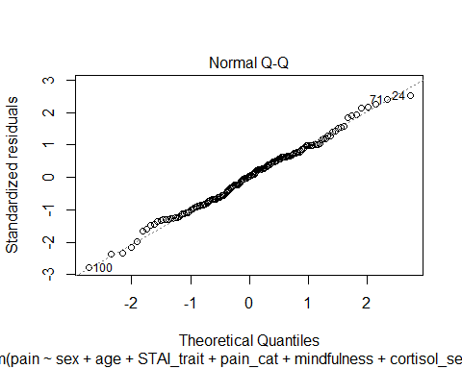
##########################################
###Linearity
#######################################
yhat.2 <- fitted.values( object = new_model.2 )
plot( x = yhat.2,
y = pain.dataset3$pain,
xlab = "Fitted Values",
ylab = "Observed Values")
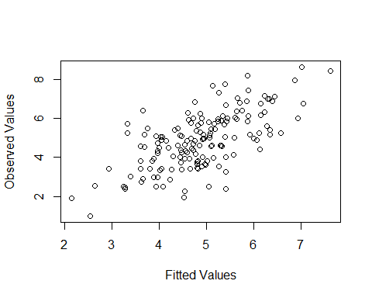
plot(x = new_model.2, which = 1)
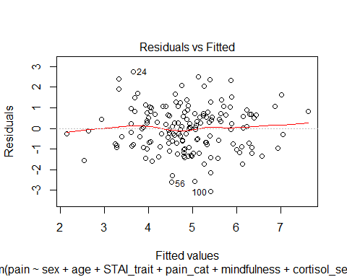
windows()
residualPlots( model = new_model.2 )
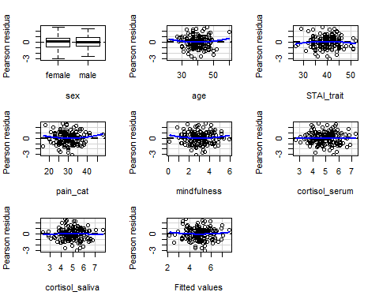
## Test stat Pr(>|Test stat|)
## sex
## age 0.9844 0.3265
## STAI_trait -0.9155 0.3614
## pain_cat 1.0975 0.2742
## mindfulness 1.0219 0.3085
## cortisol_serum -0.1438 0.8859
## cortisol_saliva -0.3343 0.7386
## Tukey test 0.6679 0.5042
######################################
###Checking for homogeneity
######################################
ncvTest( new_model.2 )
## Non-constant Variance Score Test
## Variance formula: ~ fitted.values
## Chisquare = 0.002066753, Df = 1, p = 0.96374
#####################################
###Checking for collinearity
####################################
vif(mod = new_model.2)
## sex age STAI_trait pain_cat
## 1.020798 1.448256 2.000610 1.976541
## mindfulness cortisol_serum cortisol_saliva
## 1.394334 4.851173 5.382354
cor(pain.dataset3$cortisol_serum, pain.dataset3$cortisol_saliva)
## [1] 0.8798839
#################################################
###Creating a a new model without cortisol_salvia
#################################################
final.model <- lm(formula = pain ~ sex + age + pain_cat + STAI_trait + mindfulness + cortisol_serum,
data = pain.dataset3)
#with participant 90 included
final.model2 <- lm(formula = pain ~ sex + age + pain_cat + STAI_trait + mindfulness + cortisol_serum,
data = pain.dataset2)
###############################################
### Checking the final model
###############################################
ncvTest( final.model )
## Non-constant Variance Score Test
## Variance formula: ~ fitted.values
## Chisquare = 0.009958858, Df = 1, p = 0.92051
vif(mod = final.model)
## sex age pain_cat STAI_trait mindfulness
## 1.020060 1.297563 1.753096 1.773815 1.375562
## cortisol_serum
## 1.383458
windows()
residualPlots( model = final.model )
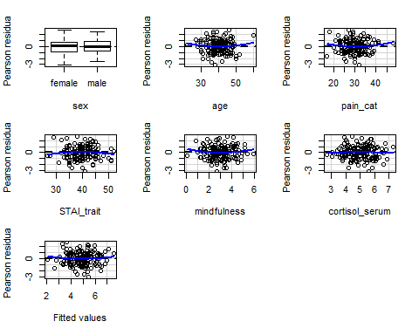
## Test stat Pr(>|Test stat|)
## sex
## age 0.9046 0.3671
## pain_cat 1.0497 0.2955
## STAI_trait -0.9080 0.3653
## mindfulness 1.1003 0.2730
## cortisol_serum -0.2195 0.8266
## Tukey test 0.7276 0.4669
windows()
plot(final.model, which = 2)
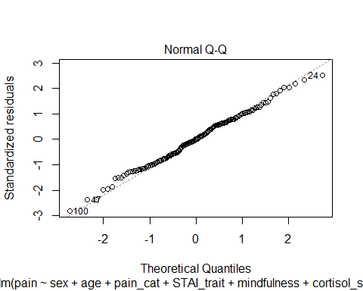
windows()
plot(x = final.model, which = 5)
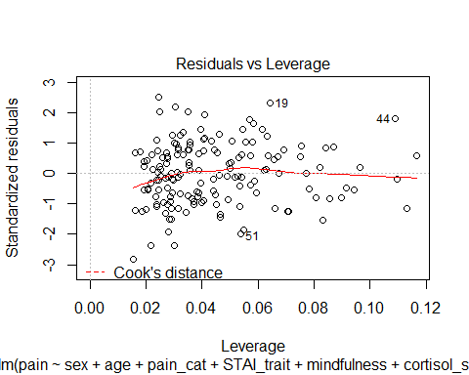
windows()
plot(x = final.model, which = 4)
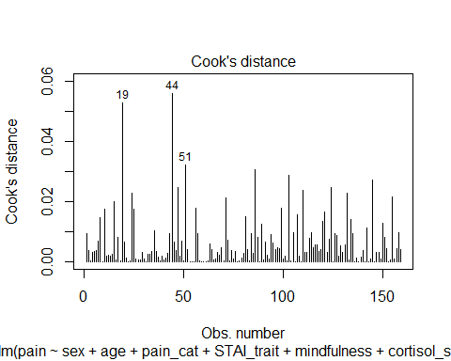
windows()
lev2 =hat(model.matrix(final.model))
plot(lev2)
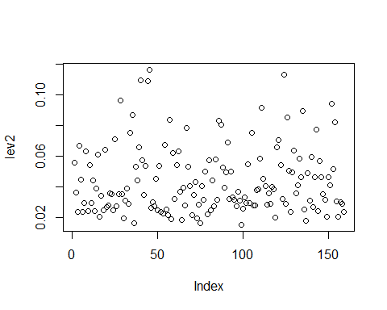
pain.dataset3[lev2 > .15,]
## [1] ID pain sex age
## [5] STAI_trait pain_cat cortisol_serum cortisol_saliva
## [9] mindfulness weight
## <0 rows> (or 0-length row.names)
N= nrow(pain.dataset3)
mahad=(N-1)*(lev2-1 / N)
tail(sort(mahad),5)
## [1] 14.22916 16.20331 16.30323 16.87764 17.41566
order(mahad,decreasing=T)[c(5,4,3,2,1)]
## [1] 28 44 40 124 45
################################################
###Compare and test for the best regression model
################################################
summary(new_model.1)
##
## Call:
## lm(formula = pain ~ sex + age, data = pain.dataset3)
##
## Residuals:
## Min 1Q Median 3Q Max
## -3.1981 -0.9353 0.0137 0.8812 3.2982
##
## Coefficients:
## Estimate Std. Error t value Pr(>|t|)
## (Intercept) 8.72377 0.78322 11.138 < 2e-16 ***
## sexmale 0.27348 0.21371 1.280 0.203
## age -0.09962 0.01952 -5.104 9.57e-07 ***
## ---
## Signif. codes: 0 '***' 0.001 '**' 0.01 '*' 0.05 '.' 0.1 ' ' 1
##
## Residual standard error: 1.336 on 156 degrees of freedom
## Multiple R-squared: 0.1459, Adjusted R-squared: 0.135
## F-statistic: 13.33 on 2 and 156 DF, p-value: 4.527e-06
summary(final.model)
##
## Call:
## lm(formula = pain ~ sex + age + pain_cat + STAI_trait + mindfulness +
## cortisol_serum, data = pain.dataset3)
##
## Residuals:
## Min 1Q Median 3Q Max
## -3.08187 -0.82888 0.01132 0.75735 2.73413
##
## Coefficients:
## Estimate Std. Error t value Pr(>|t|)
## (Intercept) 3.93520 1.32765 2.964 0.003526 **
## sexmale 0.31175 0.17759 1.755 0.081200 .
## age -0.07050 0.01829 -3.854 0.000171 ***
## pain_cat 0.05899 0.02413 2.444 0.015651 *
## STAI_trait -0.01127 0.02613 -0.431 0.666750
## mindfulness -0.26280 0.10551 -2.491 0.013826 *
## cortisol_serum 0.62104 0.12060 5.150 7.97e-07 ***
## ---
## Signif. codes: 0 '***' 0.001 '**' 0.01 '*' 0.05 '.' 0.1 ' ' 1
##
## Residual standard error: 1.105 on 152 degrees of freedom
## Multiple R-squared: 0.4311, Adjusted R-squared: 0.4087
## F-statistic: 19.2 on 6 and 152 DF, p-value: < 2.2e-16
AIC(new_model.1, final.model)
## df AIC
## new_model.1 4 548.3924
## final.model 8 491.7811
AIC(final.model2)
## [1] 494.1627
AIC(model.1)
## [1] 548.3924
###############################################
### Hierarchical regression to test the best model
###############################################
anova(new_model.1, final.model)
## Analysis of Variance Table
##
## Model 1: pain ~ sex + age
## Model 2: pain ~ sex + age + pain_cat + STAI_trait + mindfulness + cortisol_serum
## Res.Df RSS Df Sum of Sq F Pr(>F)
## 1 156 278.58
## 2 152 185.56 4 93.028 19.051 1.02e-12 ***
## ---
## Signif. codes: 0 '***' 0.001 '**' 0.01 '*' 0.05 '.' 0.1 ' ' 1
####################################################
###Table for coefficents with confience intervals
####################################################
summary(new_model.1)
##
## Call:
## lm(formula = pain ~ sex + age, data = pain.dataset3)
##
## Residuals:
## Min 1Q Median 3Q Max
## -3.1981 -0.9353 0.0137 0.8812 3.2982
##
## Coefficients:
## Estimate Std. Error t value Pr(>|t|)
## (Intercept) 8.72377 0.78322 11.138 < 2e-16 ***
## sexmale 0.27348 0.21371 1.280 0.203
## age -0.09962 0.01952 -5.104 9.57e-07 ***
## ---
## Signif. codes: 0 '***' 0.001 '**' 0.01 '*' 0.05 '.' 0.1 ' ' 1
##
## Residual standard error: 1.336 on 156 degrees of freedom
## Multiple R-squared: 0.1459, Adjusted R-squared: 0.135
## F-statistic: 13.33 on 2 and 156 DF, p-value: 4.527e-06
confint(new_model.1)
## 2.5 % 97.5 %
## (Intercept) 7.1766859 10.2708576
## sexmale -0.1486525 0.6956195
## age -0.1381745 -0.0610648
lm.beta(new_model.1)
##
## Call:
## lm(formula = pain ~ sex + age, data = pain.dataset3)
##
## Standardized Coefficients::
## (Intercept) sexmale age
## 0.00000000 0.09514962 -0.37948461
summary(final.model)
##
## Call:
## lm(formula = pain ~ sex + age + pain_cat + STAI_trait + mindfulness +
## cortisol_serum, data = pain.dataset3)
##
## Residuals:
## Min 1Q Median 3Q Max
## -3.08187 -0.82888 0.01132 0.75735 2.73413
##
## Coefficients:
## Estimate Std. Error t value Pr(>|t|)
## (Intercept) 3.93520 1.32765 2.964 0.003526 **
## sexmale 0.31175 0.17759 1.755 0.081200 .
## age -0.07050 0.01829 -3.854 0.000171 ***
## pain_cat 0.05899 0.02413 2.444 0.015651 *
## STAI_trait -0.01127 0.02613 -0.431 0.666750
## mindfulness -0.26280 0.10551 -2.491 0.013826 *
## cortisol_serum 0.62104 0.12060 5.150 7.97e-07 ***
## ---
## Signif. codes: 0 '***' 0.001 '**' 0.01 '*' 0.05 '.' 0.1 ' ' 1
##
## Residual standard error: 1.105 on 152 degrees of freedom
## Multiple R-squared: 0.4311, Adjusted R-squared: 0.4087
## F-statistic: 19.2 on 6 and 152 DF, p-value: < 2.2e-16
confint(final.model)
## 2.5 % 97.5 %
## (Intercept) 1.31217065 6.55823059
## sexmale -0.03911660 0.66260853
## age -0.10664580 -0.03436127
## pain_cat 0.01131163 0.10666215
## STAI_trait -0.06289930 0.04035132
## mindfulness -0.47126346 -0.05433657
## cortisol_serum 0.38277418 0.85931471
lm.beta(final.model)
##
## Call:
## lm(formula = pain ~ sex + age + pain_cat + STAI_trait + mindfulness +
## cortisol_serum, data = pain.dataset3)
##
## Standardized Coefficients::
## (Intercept) sexmale age pain_cat STAI_trait
## 0.00000000 0.10846179 -0.26857154 0.19800013 -0.03515355
## mindfulness cortisol_serum
## -0.17870462 0.37054082

