Z_HomeAssignment2.R
Pierre Klintefors
Fri Dec 07 13:53:27 2018
rm(list=ls(all=TRUE)) # clears the workspace
graphics.off() # clears graphics
#################
#Load Packages
##############
require(lsr)
## Loading required package: lsr
require(psych)
## Loading required package: psych
require(car)
## Loading required package: car
## Loading required package: carData
##
## Attaching package: 'car'
## The following object is masked from 'package:psych':
##
## logit
require(lm.beta)
## Loading required package: lm.beta
#set working directory
########################
setwd("~/PSYP13/Rwork")
#######################
###Import data
#######################
pain.dataset <- read.csv("~/PSYP13/Rwork/home_sample_1.csv")
View(pain.dataset)
pain.dataset2 <- pain.dataset
#####################################
###Correct the age of participant 28
#####################################
pain.dataset2$age[28] = 22
pain.dataset3 <- pain.dataset2[-90,]
#######################################
###Creating an initial regression model
#######################################
initial.model <- lm(formula = pain ~ sex + age + weight + STAI_trait + pain_cat + mindfulness + cortisol_serum,
data = pain.dataset3)
####################################
###Normality assumption and residuals
#####################################
# QQ plot
windows()
plot(initial.model, which = 2)
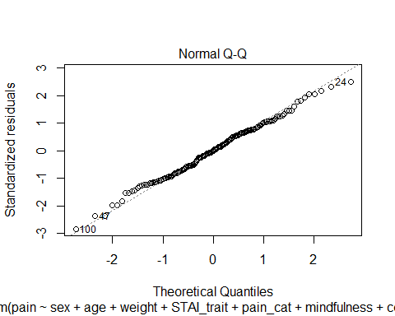
#Leverage
lev =hat(model.matrix(initial.model))
plot(lev)
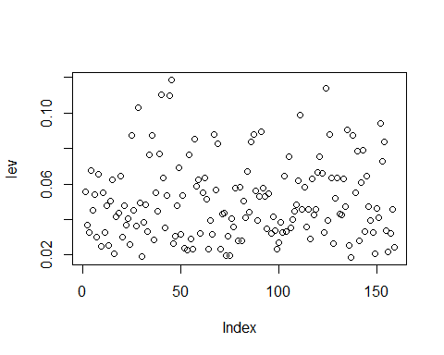
pain.dataset3[lev > .10,]
## ID pain sex age STAI_trait pain_cat cortisol_serum
## 28 ID_28 5.974395 female 22 37 27 5.154391
## 40 ID_40 1.905852 female 44 41 20 3.364435
## 44 ID_44 5.246381 male 60 44 22 5.563952
## 45 ID_45 7.115986 female 40 51 48 5.586030
## 125 ID_125 5.154284 male 31 51 38 4.939596
## cortisol_saliva mindfulness weight
## 28 5.061626 3.774372 65.58572
## 40 3.992772 5.889072 79.06280
## 44 5.142998 3.400188 61.84221
## 45 5.145947 1.261916 83.62699
## 125 5.330456 1.641613 87.88967
#Mahalanobis distance
N= nrow(pain.dataset3)
mahad=(N-1)*(lev-1 / N)
tail(sort(mahad),5)
## [1] 15.25581 16.31483 16.42988 16.97981 17.76001
order(mahad,decreasing=T)[c(5,4,3,2,1)]
## [1] 28 44 40 124 45
###Linearity
yhat.2 <- fitted.values( object = initial.model )
plot( x = yhat.2,
y = pain.dataset3$pain,
xlab = "Fitted Values",
ylab = "Observed Values")
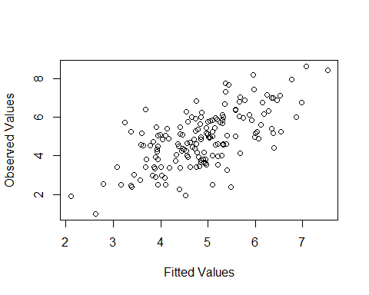
plot(x = initial.model, which = 1)
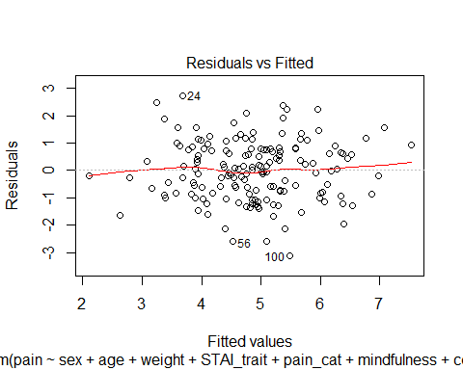
windows()
residualPlots( model = initial.model )
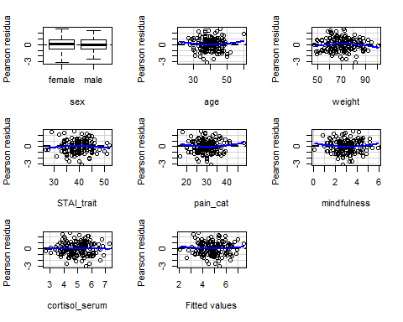
## Test stat Pr(>|Test stat|)
## sex
## age 0.9184 0.3599
## weight -1.2965 0.1968
## STAI_trait -0.9180 0.3601
## pain_cat 1.0353 0.3022
## mindfulness 1.1006 0.2728
## cortisol_serum -0.2259 0.8216
## Tukey test 0.7016 0.4830
######################################
###Checking for homogeneity
######################################
ncvTest( initial.model )
## Non-constant Variance Score Test
## Variance formula: ~ fitted.values
## Chisquare = 0.0120298, Df = 1, p = 0.91266
#####################################
###Checking for collinearity
####################################
vif(mod = initial.model)
## sex age weight STAI_trait pain_cat
## 1.021309 1.359969 1.152777 1.978386 1.753487
## mindfulness cortisol_serum
## 1.380744 1.421648
#####################################
###Backward regreesion with full model
######################################
backward.model <- (step(initial.model, direction = "backward"))
## Start: AIC=40.49
## pain ~ sex + age + weight + STAI_trait + pain_cat + mindfulness +
## cortisol_serum
##
## Df Sum of Sq RSS AIC
## - weight 1 0.076 185.56 38.559
## - STAI_trait 1 0.291 185.77 38.743
## <none> 185.48 40.494
## - sex 1 3.720 189.20 41.651
## - pain_cat 1 7.315 192.80 44.644
## - mindfulness 1 7.637 193.12 44.910
## - age 1 16.814 202.29 52.291
## - cortisol_serum 1 32.011 217.49 63.808
##
## Step: AIC=38.56
## pain ~ sex + age + STAI_trait + pain_cat + mindfulness + cortisol_serum
##
## Df Sum of Sq RSS AIC
## - STAI_trait 1 0.227 185.78 36.753
## <none> 185.56 38.559
## - sex 1 3.762 189.32 39.750
## - pain_cat 1 7.295 192.85 42.689
## - mindfulness 1 7.573 193.13 42.919
## - age 1 18.133 203.69 51.383
## - cortisol_serum 1 32.373 217.93 62.128
##
## Step: AIC=36.75
## pain ~ sex + age + pain_cat + mindfulness + cortisol_serum
##
## Df Sum of Sq RSS AIC
## <none> 185.78 36.753
## - sex 1 3.856 189.64 38.019
## - mindfulness 1 7.468 193.25 41.020
## - pain_cat 1 7.533 193.32 41.073
## - age 1 23.341 209.12 53.571
## - cortisol_serum 1 37.242 223.03 63.803
############################################
###Table coefficients backward model
###########################################
#Backward model
summary(backward.model)
##
## Call:
## lm(formula = pain ~ sex + age + pain_cat + mindfulness + cortisol_serum,
## data = pain.dataset3)
##
## Residuals:
## Min 1Q Median 3Q Max
## -3.07579 -0.80419 -0.00558 0.76463 2.74853
##
## Coefficients:
## Estimate Std. Error t value Pr(>|t|)
## (Intercept) 3.84302 1.30686 2.941 0.00378 **
## sexmale 0.31527 0.17693 1.782 0.07675 .
## age -0.07360 0.01679 -4.384 2.15e-05 ***
## pain_cat 0.05475 0.02198 2.491 0.01382 *
## mindfulness -0.26070 0.10512 -2.480 0.01422 *
## cortisol_serum 0.59815 0.10801 5.538 1.30e-07 ***
## ---
## Signif. codes: 0 '***' 0.001 '**' 0.01 '*' 0.05 '.' 0.1 ' ' 1
##
## Residual standard error: 1.102 on 153 degrees of freedom
## Multiple R-squared: 0.4304, Adjusted R-squared: 0.4118
## F-statistic: 23.13 on 5 and 153 DF, p-value: < 2.2e-16
confint(backward.model)
## 2.5 % 97.5 %
## (Intercept) 1.26120697 6.42483619
## sexmale -0.03426543 0.66481219
## age -0.10675838 -0.04043338
## pain_cat 0.01132238 0.09817155
## mindfulness -0.46837563 -0.05302366
## cortisol_serum 0.38476982 0.81152075
lm.beta(backward.model)
##
## Call:
## lm(formula = pain ~ sex + age + pain_cat + mindfulness + cortisol_serum,
## data = pain.dataset3)
##
## Standardized Coefficients::
## (Intercept) sexmale age pain_cat mindfulness
## 0.0000000 0.1096890 -0.2803513 0.1837680 -0.1772764
## cortisol_serum
## 0.3568782
#####################################
###Theory based model
#####################################
theory.model <- lm(formula = pain ~ sex + age + pain_cat + STAI_trait + mindfulness + cortisol_serum,
data = pain.dataset3)
####################################
####Compare models
####################################
summary(theory.model)
##
## Call:
## lm(formula = pain ~ sex + age + pain_cat + STAI_trait + mindfulness +
## cortisol_serum, data = pain.dataset3)
##
## Residuals:
## Min 1Q Median 3Q Max
## -3.08187 -0.82888 0.01132 0.75735 2.73413
##
## Coefficients:
## Estimate Std. Error t value Pr(>|t|)
## (Intercept) 3.93520 1.32765 2.964 0.003526 **
## sexmale 0.31175 0.17759 1.755 0.081200 .
## age -0.07050 0.01829 -3.854 0.000171 ***
## pain_cat 0.05899 0.02413 2.444 0.015651 *
## STAI_trait -0.01127 0.02613 -0.431 0.666750
## mindfulness -0.26280 0.10551 -2.491 0.013826 *
## cortisol_serum 0.62104 0.12060 5.150 7.97e-07 ***
## ---
## Signif. codes: 0 '***' 0.001 '**' 0.01 '*' 0.05 '.' 0.1 ' ' 1
##
## Residual standard error: 1.105 on 152 degrees of freedom
## Multiple R-squared: 0.4311, Adjusted R-squared: 0.4087
## F-statistic: 19.2 on 6 and 152 DF, p-value: < 2.2e-16
summary(backward.model)
##
## Call:
## lm(formula = pain ~ sex + age + pain_cat + mindfulness + cortisol_serum,
## data = pain.dataset3)
##
## Residuals:
## Min 1Q Median 3Q Max
## -3.07579 -0.80419 -0.00558 0.76463 2.74853
##
## Coefficients:
## Estimate Std. Error t value Pr(>|t|)
## (Intercept) 3.84302 1.30686 2.941 0.00378 **
## sexmale 0.31527 0.17693 1.782 0.07675 .
## age -0.07360 0.01679 -4.384 2.15e-05 ***
## pain_cat 0.05475 0.02198 2.491 0.01382 *
## mindfulness -0.26070 0.10512 -2.480 0.01422 *
## cortisol_serum 0.59815 0.10801 5.538 1.30e-07 ***
## ---
## Signif. codes: 0 '***' 0.001 '**' 0.01 '*' 0.05 '.' 0.1 ' ' 1
##
## Residual standard error: 1.102 on 153 degrees of freedom
## Multiple R-squared: 0.4304, Adjusted R-squared: 0.4118
## F-statistic: 23.13 on 5 and 153 DF, p-value: < 2.2e-16
summary(initial.model)
##
## Call:
## lm(formula = pain ~ sex + age + weight + STAI_trait + pain_cat +
## mindfulness + cortisol_serum, data = pain.dataset3)
##
## Residuals:
## Min 1Q Median 3Q Max
## -3.10653 -0.81294 -0.00052 0.77648 2.72395
##
## Coefficients:
## Estimate Std. Error t value Pr(>|t|)
## (Intercept) 3.805790 1.430229 2.661 0.008634 **
## sexmale 0.310199 0.178249 1.740 0.083852 .
## age -0.069505 0.018786 -3.700 0.000302 ***
## weight 0.002210 0.008906 0.248 0.804350
## STAI_trait -0.013483 0.027681 -0.487 0.626912
## pain_cat 0.059077 0.024208 2.440 0.015831 *
## mindfulness -0.264412 0.106040 -2.494 0.013727 *
## cortisol_serum 0.626032 0.122633 5.105 9.82e-07 ***
## ---
## Signif. codes: 0 '***' 0.001 '**' 0.01 '*' 0.05 '.' 0.1 ' ' 1
##
## Residual standard error: 1.108 on 151 degrees of freedom
## Multiple R-squared: 0.4314, Adjusted R-squared: 0.405
## F-statistic: 16.36 on 7 and 151 DF, p-value: 6.216e-16
AIC(theory.model, backward.model, initial.model)
## df AIC
## theory.model 8 491.7811
## backward.model 7 489.9757
## initial.model 9 493.7163
###########################################
### Hierarachal regression
############################################
#Initial vs backward
anova(backward.model, initial.model)
## Analysis of Variance Table
##
## Model 1: pain ~ sex + age + pain_cat + mindfulness + cortisol_serum
## Model 2: pain ~ sex + age + weight + STAI_trait + pain_cat + mindfulness +
## cortisol_serum
## Res.Df RSS Df Sum of Sq F Pr(>F)
## 1 153 185.78
## 2 151 185.48 2 0.30289 0.1233 0.8841
#Theory-based vs backward
anova(theory.model, backward.model)
## Analysis of Variance Table
##
## Model 1: pain ~ sex + age + pain_cat + STAI_trait + mindfulness + cortisol_serum
## Model 2: pain ~ sex + age + pain_cat + mindfulness + cortisol_serum
## Res.Df RSS Df Sum of Sq F Pr(>F)
## 1 152 185.56
## 2 153 185.78 -1 -0.22725 0.1862 0.6667
############################################
###AIC
############################################
AIC(initial.model, theory.model, backward.model)
## df AIC
## initial.model 9 493.7163
## theory.model 8 491.7811
## backward.model 7 489.9757
####################################
###Import new pain data
####################################
new.pain <-read.csv("https://raw.githubusercontent.com/kekecsz/PSYP13_Data_analysis_class-2018/master/home_sample_2.csv ")
View(new.pain)
############################################################
###Make prediction on the new dataset with the two equations
############################################################
pred_back <- predict(backward.model, new.pain)
pred_theory <- predict(theory.model, new.pain)
###########################################################
###Calculate sum of squared residuals
###########################################################
RSS_back = sum((new.pain[ , "pain"] - pred_back)^2)
RSS_theory = sum((new.pain[ , "pain"] - pred_theory)^2)
RSS_back
## [1] 247.2062
RSS_theory
## [1] 245.8722

