Reliable design of the CAN bit synchronization block

Mohamed K. Al-Mekkawy*, Ahmed M. Mahmoud**, Alexander Zavochikove*** and Aly E. Salama****
*Department of space science, National Authority for Remote Sensing and Space Science, Cairo, Egypt
**Department of Systems and Computers, Electronics Research Institute, Giza, Egypt
***Department of R&D, Hartron Consat, Zaporozhzhya, Ukraine
****Department of Electronics and Electrical Communications, Cairo University, Giza, Egypt

Abstract: The CAN bit synchronization plays an important role of data handling on CAN networks and dramatically affects the performance of the network by means of permanent or temporary errors while transferring frames among the network nodes or confuses the network configuration by changing the status of a frequently faulty transmitter node to an error passive one for long periods. In this paper we present a design and implementation of CAN bit synchronization algorithm, which deploys majority voting technique for accurate synchronization that suites military and space applications. The simulation results of some critical case studies on FPGA are demonstrated to prove the efficiency of the design.

Keywords: CAN bus, Automaton, FPGA, Synchronization and Simulation.

- Introduction
The controller area network (CAN) bus, developed originally for car industry, is reliable, fast and cost effective for multi master and real time applications. It is ideally suites applications requiring high number of short messages for multi recipients and system-wide data consistency is mandatory in a short period of time with high reliability in rugged operating environments [1].
As CAN supports up to 1Mbps, so when two or more CAN nodes simultaneously transmit a frame, a misplaced sample point may cause one of the transmitters to become error passive. Each node in the CAN network has its own clock generator and its timing parameters of the bit time, which can be configured individually for each node [2].
All CAN bus nodes have to be hardly synchronized at the beginning of each message, with the first falling edge of a frame. In order for bit wise arbitration to work, the time required to transmit a single bit must be long enough that the bit fills the entire cable length and all stations have a consistent read back value.
Synchronization of all the CAN nodes and compensating the error of either the oscillator frequency variations caused by temperature or/and voltage changes or propagation delay caused by the external and internal delays is the responsibility of the synchronization block.
Bit values on the bus line may take possible values: recessive which is represented by logic ‘1’ and only appears when all nodes send ‘1’; dominant, which is represented by logic ‘0’ and sufficient to appear on the bus if at least one node transmits zero [3].
There is only one start bit available at the beginning of each frame, which is not sufficient to keep the bit sampling of the receiver synchronous with the transmitter, so to enable each receiver correctly sample the received bit stream, a local continuous resynchronization is required.
Figure 1 shows the standard one CAN bit timing subdivided into four non-overlapping time segments: the Synchronization Segment, Propagation Time Segment, Phase Buffer Segment1, and Phase buffer Segment2. Each segment is constructed of multiples of time quantum t_{q,} the smallest discrete timing resolution used by a CAN node, which is defined by the CAN node’s oscillator frequency f_{osc} and the Baud Rate Prescaler BRP as t_{q} = BRP / (f_{osc} /2). The bit rate is selected by defining the width of time quantum and the number of time quantum constructing each segment and restricted by the ranges specified in table 1.

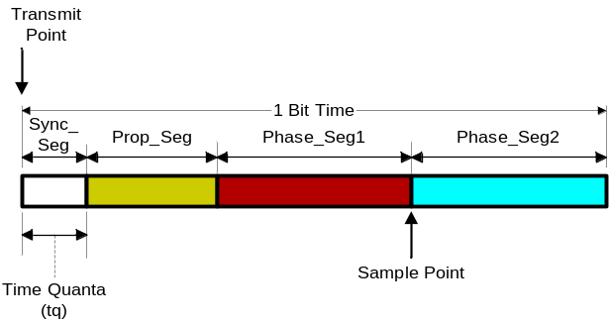
Figure 1: Standard CAN bit timing

The Synchronization Segment (Sync_Seg) is used to synchronize various nodes on the bus [4]. Output state is asserted from a transmitting node on start of this segment and its edge is expected to occur on the receiver node within it. The time delay between an edge that occurs outside of Sync_Seg and the Sync_Seg is called the phase error “e” of that edge [5]. The Propagation Time Segment (Prop_Seg) is used to compensate the signal time delays within the network. The Phase Buffer Segment1 (Phase_Seg1) and Phase Buffer Segment2 (Phase_Seg2) are used to compensate the phase edge errors, which can be lengthened or shortened by resynchronization. The Sample point, located between the two Phase Buffer Segments, is the point of time at which the bus level is interpreted as the value of this respective bit. Within the value of Synchronization Jump Width (SJW) the Sample point can move inside the defined limits of the Phase Buffer Segments.

Parameter | Range
Synchronization Segment | 1 time quantum
Propagation Time Segment | 1 to 8 time quantum
Phase Buffer Segment1 | 1 to 8 time quantum
Phase Buffer Segment2 | Maximum value of Phase_Seg 1 and the “Information processing time”
Baud Rate Prescaler | 1 to 32
Synchronization Jump Width | 1 to 4 time quantum
Table 1: Segments of the CAN bit time

- CAN bit time segments
The CAN protocol uses non-destructive bitwise bus arbitration and the dominant acknowledge bit, signal propagation from a transmitter to a receiver and back to the transmitter again must be completed within one bit time [6-7]. That’s why Propagation Time Segment is required for compensation of the delay times over the bus lines as well as for internal signal delays in both transmitting and receiving nodes. It provides the time necessary for settling the maximum signal propagation delay within the network and calculated as twice the summation value of the maximum signal propagation delay between two nodes along the network lines and the internal delay times of the transmitter and the receiver of the nodes.
The Phase Buffer time Segments before and after the nominal sampling point is reserved for shifting of the real sampling point during resynchronization to compensate the phase shift between oscillators of different nodes, where synchronization occurs on edges from recessive to dominant. Synchronization has two distinct types: Hard synchronization at the start of a frame; and Resynchronization inside a frame. After a hard synchronization, the bit time is restarted with the end of the Sync_Seg, regardless of the edge phase error. Thus hard synchronization forces the edge, which has caused the hard synchronization to lie within the synchronization segment of the restarted bit time. Resynchronization leads to shorten or lengthen the bit time such that the position of the sample point is shifted with regard to the edge. Phase buffer segment one may be between one to eight time quanta long. Phase buffer segment two is the maximum of Phase buffer segment one and the information processing time, which is the time segment starting with the sample point reserved for calculation of the subsequent bit level [6] and is less than or equal to two time quanta.
When the transmitter’s oscillator is slower than the receiver as shown in figure 2, the edge arrives delayed at the receiver so the phase error “e” of the edge which causes resynchronization is positive, Phase_Seg1 is lengthened and the sample point is shifted according to the occurred edge phase error. If the magnitude of the phase error is less than SJW, Phase_Seg1 is lengthened by the magnitude of the phase error; else it is lengthened by SJW.

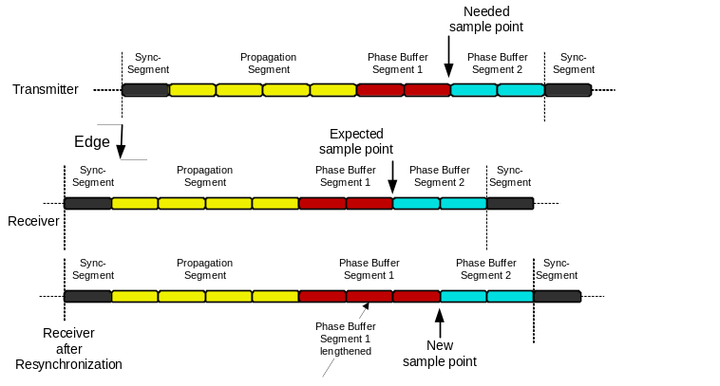 Figure 2 Late edge synchronization

When the transmitter’s oscillator is faster than the receiver as shown in figure 3, as the edge appears earlier than expected by the receiver the next bit time interval has to start earlier with negative phase error. This causes resynchronization by omitting synchronization segment and shortening Phase_Seg2, so that the distance from the edge to the sample point after resynchronization is the same as it would have been from the synchronization segment to the sample point if no edge had been detected. If the magnitude of the phase error is less than SJW, Phase_Seg2 is shortened by the magnitude of the phase error; else it is lengthened by SJW.

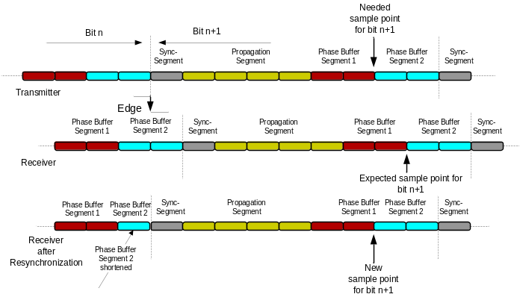
Figure 3 Early edge synchronization
If the magnitude of the phase error is more than SJW, the resynchronization cannot compensate the phase error completely.
The Sample point programming allows characteristics’ tuning to suit the bus. Early sampling allows more time quanta in Phase Buffer Segment2 hence the Synchronization Jump Width can be programmed to its maximum value (4t_{q}). Thus the sensitivity to node oscillator tolerance is decreased so that lower cost ceramic oscillator may be used [8].
Late sampling allows more quanta value in the Propagation Time Segment, which allows simpler bus topology and maximum bus length but needs more accurate oscillators [9].

- CAN bit synchronization design
Figure 4 gives the block diagram of the synchronization block where controls of the segment values may be updated anytime through operation, TSEG1 resembles the combination of propagation segment and the phase buffer segment.1, TSEG 2 resembles the phase segment 2.

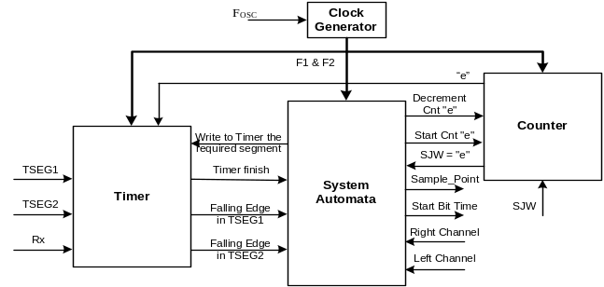
Figure 4 The synchronization block diagram

F1 and F2 are two 90° phase-shifted clocks with the same frequency used for proper operation of the automata where the input is sampled at F1 falling edge, the memory elements latches the output of the majority elements with the rising edge of F2, and the output is sampled with F2 falling edge. The clock generator forms these rising and falling edges. The timer block forms the bit segments timing according to the programmed values TSEG1, TSEG2 and the received phase error value from the counter block under the automata control while receiving data streams on Rx input from the bus. The SJW, specified in our work as 2t_{q,} limits the maximum phase error value. In case of not detecting an edge till reaching this limit the remaining bit segments are not changed. In case of detecting the edge before SJW the e value indicated in figure 4 will trigger the automata to prolong the TSEG1 by this value but in case of detecting the edge after SJW the TSEG1 is lengthened by SJW. Simply the count block determines the positive or negative phase error.
- Bit synchronization Automata design
A finite state machine (FSM) or finite automaton is a model of behaviour composed of states, transitions and actions. A state stores information about the past and reflects the input changes from the system up to the present moment [10]. A transition indicates a state change and is described by a condition that would need to be fulfilled to enable the transition. An action is a description of an activity that is to be performed at a given moment, where several possible actions exist.

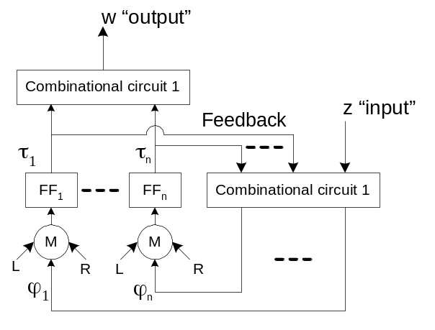

Figure 5 Automata functional representation

Finite state machines are widely used for application behaviour modelling while hardware digital systems design. In Moore machine representation the output w(t) depends only on a state and takes only entry actions which simplifies the behaviour model.
Figures 5 and 6 show Moore FSM example of the bit synchronization block. The automaton is determined by three components, S = (A, Z, W), where A, Z and W are vectors of state, input and output signals respectivley.
Figure 5 shows a simple automaton with majority voting elements, which enforce the output to have the same value of at least two of three matched inputs. In ideal case the three inputs have the same value but occasionally due to some delays in the memory elements or internal buses they change and consequently mistakes the desired output of the majority element till settling of at least two inputs. To solve feedback delay problem we decided to latch the combinational circuit 1 outputs before the majority voting elements on the falling edge of F1 as shown in figure 6 to make sure that all inputs are simultaneously applied.

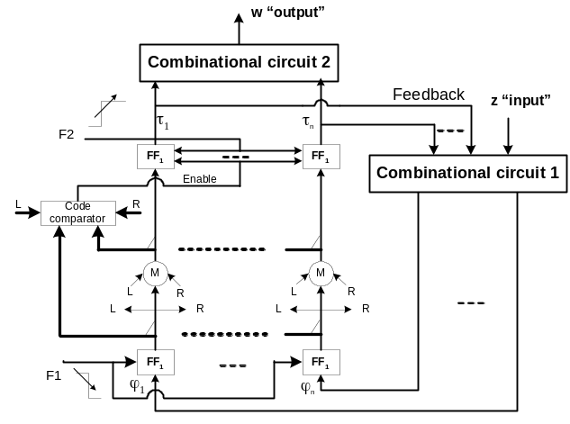
Figure 6 Enhanced automata functional representation

Measurable delays among different nodes on the CAN bus and/or bit flipping due to environmental effects increase the probability of failure, so we decided to issue all nodes outputs at the same time by adding the code comparator block shown in figure 6 which synchronizes different nodes’ majority elements before issuing the output. If one of the majority voting inputs is completely omitted due to any reason and bit-flipping error occurs in other one the code comparator disabling the output till achieving at least two identical states to the majority-voting elements, which guarantees correct operation. The notation of both L and R inputs to the code comparator block are received from inputs of the redundant synchronization blocks’ majority elements.

- FPGA simulation results
All the design has been implemented using Actel Libero v.5.2 on the schematic level to minimize the used FPGA resources. The state diagram representation of the simulated automata is shown in figure 7, where possible states, conditions and transitions are demonstrated to describe the operation sequence of the system automata block of figure 4.
Figure 8 gives the synchronization block simulation results in various situations when detecting recessive to dominant edge input. It also shows the effect of the used majority blocks and the code comparator. In all simulations the used values for the BRP, TSEG1, TSEG2 and SJW are 1, 7tq, 2tq, and 1tq respectively where the tq equals 2t_{automata}. As the basic clock of the simulated results is t_{automata} the indicated values in figure 8 equal double that used for tq taking into consideration that the bit time has to be an integer multiple of tq and the propagation time delay value is rounded to the nearest integer multiple of tq. Figure 8 a. represents the normal bit timing without delay effects and may happen if the received bit is completely synchronized or no edges detected at all, 8.b shows the effect of delay less than SJW where the falling edge within TSEG1 so the sampling point is lengthened by the “e” value, 8.c shows the effect of delay more than SJW where the falling edge within TSEG1 so the sampling point is lengthened by the SJW value, 8.d shows the effect of delay less than SJW where the falling edge within TSEG2 so the TSEG2 is shortened by the “e” value, 8.e shows the effect of delay more than SJW where the falling edge within TSEG2 so the TSEG2 is shortened by the SJW value, and figure 8.f demonstrates the effect of omitting or complete failure of one channel while the other two channels are not synchronized in time and consequently the output is not enabled till code comparator block catches two identical codes. This feature gives the design flexibility to work even when sever errors occasionally happen in single channel which increases the reliability of the system synchronization to meet the requirements of military and space applications.
Note: in all simulation the start bit time trace is comprised of two clocks. The first clock appears at the beginning of the synchronization segment and the second appears by its end. In case of detecting an edge within TSEG2 only one clock appears due to omitting the synchronization segment as shown in figure 8.d and 8.e in the period from 23 to 24 us.

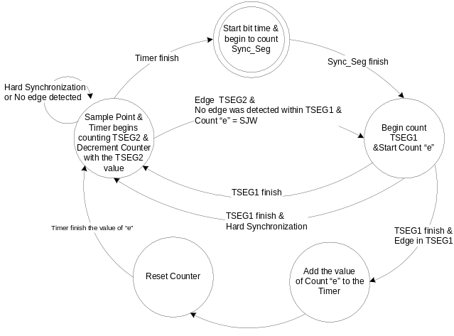

Figure 7 Automata states of the Synchronization Block

- Conclusion
This paper presents a highly reliable bit synchronization block for CAN bus by means of FPGA design basing on majority voting of an intermediate signals to make sure of complete synchronization among different nodes on the bus. Internal blocks of the automata were designed and

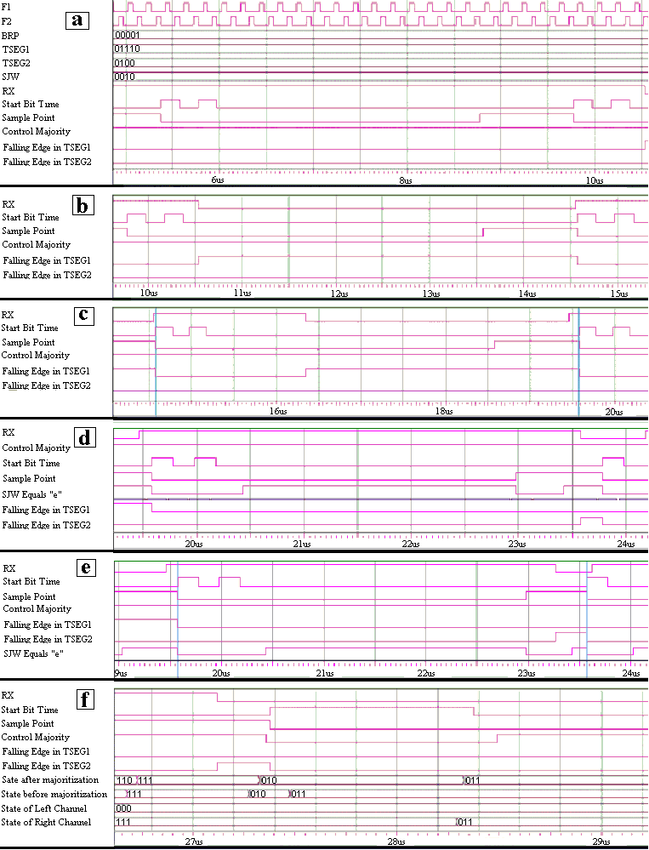

Fig. 8 Synchronization block simulation results for different trigger delay situations, (a) without trigger, (b) trigger within TSEG1 and “e” less than SJW, (c) trigger within TSEG1 and “e” more than SJW, (d) trigger within TSEG2 and “e” less than SJW, (e) trigger within TSEG2 and “e” more than SJW, (f) code comparator check.

simulated as schematic diagrams to give more control on the smallest building blocks of the synchronization block and to minimize the resources used in this implementation. The test results for different cases are illustrated which prove the effectiveness of the design algorithm even when having complete failure in one input channel. Such feature suits space and military applications as the reliability of the synchronization block has been increased. The same concept of majoritization and code comparing in different blocks of the CAN controller proves its behavior and assures its stability under high-speed operations.

References
[1] CAN in AUTOMATION International Users and Manufactures Group e. V., CAL-based Communication Profile For Industrial Systems, CiA/DS301.
[2] K. Tindel, A. Burns, and A.J. Wellings, “Calculating controller area network (CAN) message response times,” Contr. Eng. Practice, vol. 3, no. 8, pp. 1163-1169, Aug.1995.
[3] International Standard Organization, Road vehicles-Interchange of digital information- Controller area network for high-speed communication, ISO 11898, November 1993.
[4] Robert Bosch GmbH, “CAN Specification Version 2.0,” September 1991.
[5] Florian Hartwich, Armin Bassemir, “The configuration of the CAN bit timing,” 6th International CAN conference November 2-4, Turin (Italy), Robert Bosh GmbH, Abt. K8/EIS.
[6] Konrad Etschberger; “Controller Area Network, Basics Protocols, Chips and Applications,” IXXAT Automaton GmbH, 2001.
[7] Intel 82527 – Serial Communications CAN Protocol Controller, December 1995.
[8] Wolfhard Larwenz, “CAN System Engineering. From theory to Practical Applications,” Springer-Verlag, 1997.
[9] G. Cena and A. Valenzano, “An Improved CAN Field bus for Industrial Applications,” IEEE Transactions on Industrial Electronics, Vol.44, No. 4, pp. 553-564, August 1997.
[10] Kohavi, Z., ‘Switched and Finite Automaton Theory, ” McGraw-Hill, 1992.

