
OCR engine benchmark for DocIQ
PP-OCRv4 vs PP-OCRv6 (tiny / small) on synthetic and real Spanish medical documents
Amphibian Labs · DocIQ Engineering
9 July 2026 · benchmark run 8–9 July 2026
amphibianlabs.com.au

Contents

1. Executive summary
DocIQ's OCR stage was benchmarked across three engines (the incumbent PP-OCRv4 with its English recognition model, and the tiny and small tiers of PP-OCRv6) on 584 documents spanning clean synthetic renders, systematically degraded variants, and 44 real scanned Spanish medical documents with hand-corrected ground truth.
Both PP-OCRv6 tiers pass every pre-registered acceptance gate. On degraded documents, median character error rate falls from 6.8% (PP-OCRv4) to 2.7% (v6_tiny) and 1.9% (v6_small), relative error reductions of 61% and 71%. On real documents it falls from 43.2% to 30.1% (v6_tiny) and 25.7% (v6_small), reductions of 30% and 41%. Spanish accent preservation, measured at exactly 0.0 under PP-OCRv4 on every tier, reaches 1.0 (perfect) with v6_small on all tiers, including real scans. Median per-document latency falls from 7.1 s to 2.1 s on synthetic pages and from 59 s to 16 s on real PDFs (v6_tiny, CPU-only).
Recommendation: adopt PP-OCRv6_tiny as the default engine (smallest footprint, 3.3× faster, all gates passed) and expose PP-OCRv6_small as a one-line configuration option for accuracy-critical deployments. The migration is implemented on branch feat/ocr-v6 behind the DOCIQ_OCR_MODEL setting, with PP-OCRv4 retained as an escape hatch.

2. Background and objective
DocIQ is Amphibian Labs' local, privacy-first document-intelligence engine for healthcare: OCR, classification, and rule-based extraction run entirely on-premises, with an optional LLM enhancement layer. The architecture deliberately avoids large vision-language models (“skip the VLM”); its viability therefore rests on the quality of the compact OCR stage.
Two observations motivated this study. First, the production configuration initialised PaddleOCR with the English recognition model (en_PP-OCRv4_mobile_rec), suspected of stripping Spanish diacritics and forcing an accent-insensitive matching workaround (_accent_flex) throughout the extractor layer. Second, PP-OCRv6 (released June 2026) claims large accuracy and CPU-speed improvements from a single multilingual model covering 50 languages, including scenarios that dominate DocIQ's real workload: dot-matrix receipts, degraded scans, and handwriting.
Objective: decide, with pre-registered acceptance gates, whether to migrate the OCR stage to PP-OCRv6 and which tier to adopt.

3. Methodology

3.1 Datasets
Tier | Files | Source | Ground truth
Clean synthetic | 90 PNG (45 EN / 45 ES) | Rendered from structured JSON via TrueType renderer (wrapped lines, no cropping) | Exact by construction (text + fields)
Degraded synthetic | 450 PNG/JPG | 5 deterministic, seeded degradations per clean file: rotation ±2°, Gaussian noise σ=12, JPEG q=40, 50% downscale, blur r=1.2 | Inherited from clean tier
Real Spanish | 44 PDF | Scanned Colombian medical documents (FOMAG/SES/MEIDE orders, pharmacy receipts, clinical histories, handwritten letters) | Hand-corrected transcription of each page; document-type labels assigned during correction

Real-tier label distribution: 16 receipt, 15 prescription, 7 clinical_history, 6 non-medical (legal petition pages and a handwritten complaint letter, labelled “unknown” as a negative class). Transcription conventions: text as printed (including the documents' own typos and inconsistent accents); legible handwriting included; scanner watermarks, stamps, rotated margin metadata, signatures and QR codes excluded; natural top-to-bottom reading order.

3.2 Metrics
- CER / WER: character / word error rate (Levenshtein) against ground truth, whitespace-normalised, page markers stripped. Primary metric: CER.
- Accent accuracy: fraction of accented Spanish characters (á é í ó ú ñ ü, both cases) in the ground truth that survive OCR (count-based proxy).
- Classification accuracy: pipeline document-type prediction vs assigned label.
- Field recall: fraction of ground-truth field values recovered anywhere in the extracted output (fuzzy, accent- and case-insensitive); measures end-to-end extraction quality. Synthetic tiers only.
- Validated rate: fraction of documents passing Pydantic schema validation.
- Latency p50 / p95: wall-clock seconds per document, warm engine, CPU only.
- Peak RSS: peak resident memory of the benchmark process.

3.3 Protocol and environment
All 584 files were processed by the full DocIQ pipeline (OCR → language detection → classification → rule-based extraction) with the LLM layer disabled to isolate the OCR effect. Identical harness, manifest, data and ground truth for all engines; engine selection via the DOCIQ_OCR_MODEL environment variable. Single machine: Windows 11 (build 26200), Python 3.12.10, CPU-only. PP-OCRv4 ran on paddleocr 3.4.0; PP-OCRv6 tiers on paddleocr 3.7.0. Documented preprocessing modules (document orientation, unwarping, text-line orientation) were identical across engines.

4. Results

4.1 Headline comparison
Metric (median) | PP-OCRv4 | v6_tiny | v6_small
CER · clean | 0.045 | 0.017 | 0.008
CER · degraded | 0.068 | 0.027 | 0.019
CER · real | 0.432 | 0.301 | 0.257
WER · degraded | 0.542 | 0.148 | 0.094
Accent accuracy · clean & degraded | 0.000 | 1.000 | 1.000
Accent accuracy · real | 0.000 | 0.897 | 1.000
Field recall · clean | 0.875 | 0.948 | 1.000
Classification · degraded | 0.969 | 0.991 | 0.989
Classification · real | 0.568 | 0.545 | 0.545
Latency p50 · clean (s) | 7.09 | 2.09 | 4.23
Latency p50 · real (s) | 59.3 | 16.3 | 31.3
Peak RSS, full run (GB) | 3.50 | 2.83 | 3.63

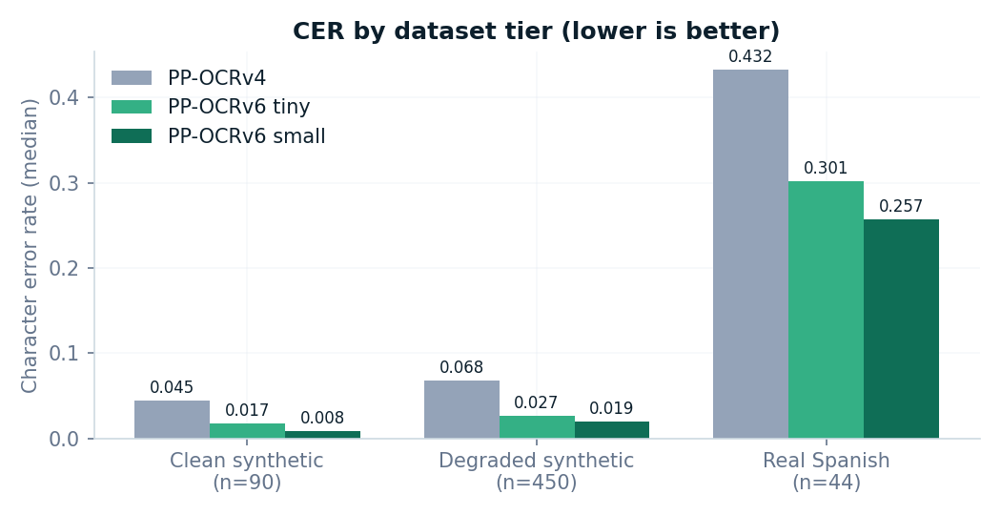
Figure 1. Median character error rate by dataset tier and engine.
Both v6 tiers improve every tier. On clean renders v6_small approaches transcription-grade output (CER 0.008). The real tier remains hardest for all engines; §5 discusses why the absolute value overstates recognition error.
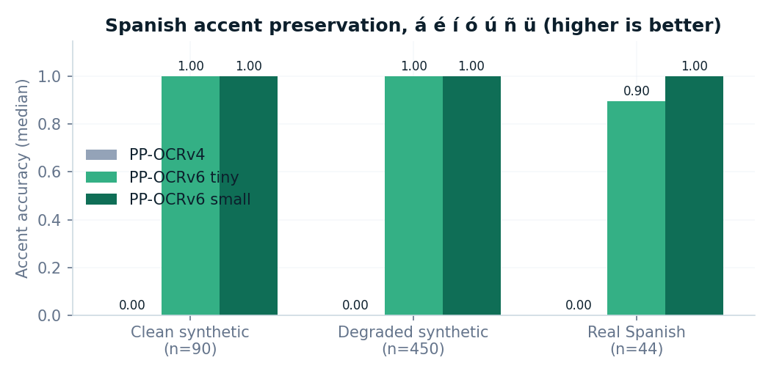
Figure 2. Spanish accent preservation by tier and engine.
The single most consequential result: PP-OCRv4's English recognition model destroys every Spanish diacritic (0.0 on all 540+ measurable documents), confirming the root cause of the _accent_flex workaround. v6_small preserves accents perfectly on every tier, including real scans.
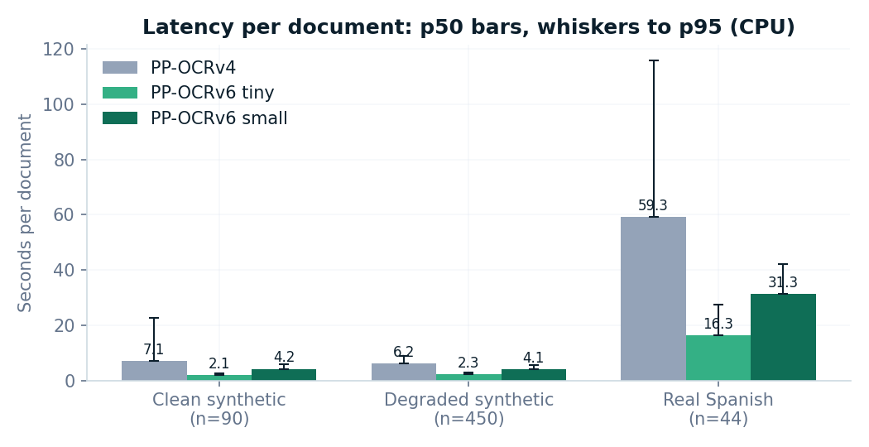
Figure 3. Per-document latency (p50 bars, whiskers to p95), CPU-only.
The published v6 CPU speed-ups replicate on commodity hardware: v6_tiny processes real multi-page PDFs 3.6× faster than v4 at materially higher accuracy.

4.2 Robustness to degradation
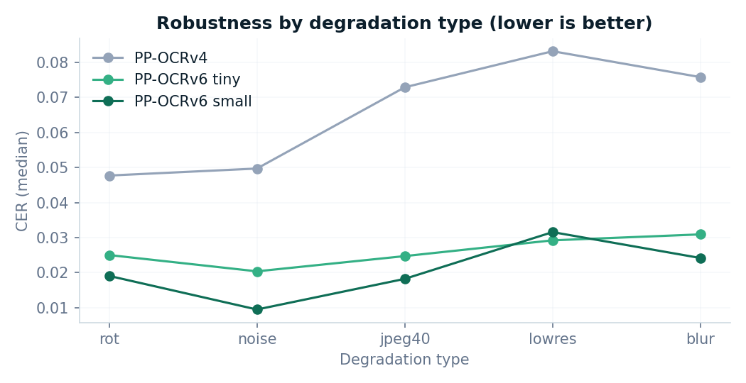
Figure 4. Median CER per degradation type.
PP-OCRv4 is most damaged by low resolution and blur; v6 tiers stay near their clean-tier baseline under all five degradations, with low resolution remaining the hardest condition for every engine. This robustness matters for DocIQ's target users, whose inputs are phone photos and re-scanned photocopies rather than pristine exports.

4.3 Real documents by type
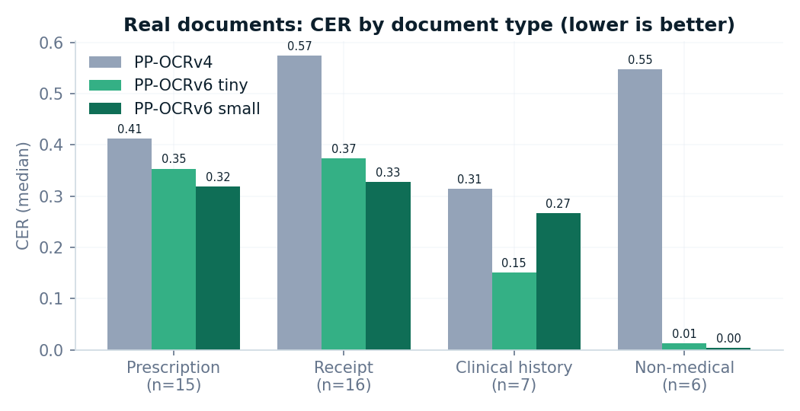
Figure 5. Real-document CER by document type.
Pharmacy receipts (thermal and dot-matrix printing, often two per scanned page) are the hardest class for every engine and show v6's largest relative gains, consistent with PP-OCRv6's stated focus on dot-matrix and display text. Typed clinical documents approach synthetic-tier accuracy under v6_small.

4.4 Acceptance gates
Gate (pre-registered) | Threshold | v6_tiny | v6_small
CER improvement, degraded tier | ≥ 15% relative | PASS (−61%) | PASS (−71%)
Accent accuracy | ≥ PP-OCRv4 | PASS (0→0.90–1.0) | PASS (0→1.0)
Field recall regression | ≤ 1 point | PASS (+7.3 pts) | PASS (+12.5 pts)
Warm latency | ≤ 0.7× v4 | PASS (0.27–0.30×) | PASS (0.53–0.60×)
Peak memory | ≤ v4 + 10% | PASS (−19%) | PASS (+3.7%)
Test suite | Green | PASS (153/153) | PASS (153/153)

5. Findings beyond the gates
- Accent loss was configuration, not fate. The 0.0 accent score traces to lang="en" in the engine initialisation. With v6 adopted, the _accent_flex regex layer in the extractors becomes removable, a follow-up simplification with test coverage already in place.
- Classification is now the bottleneck. Real-document classification stayed at 55–57% for all three engines; better OCR did not move it. Errors concentrate in (a) order pages whose printed header says “HISTORIA CLINICA” while the content is a service order, and (b) the six non-medical documents, where the classifier is forced to pick a medical type because it has no “unknown” output. Both are classifier-design issues, cleanly isolated from OCR by this benchmark.
- The receipt document type lacks a Pydantic validator (warning observed throughout the runs), capping the validated-rate metric for the most common real-world type. Small, well-defined fix.
- Reading order dominates residual real-tier CER. The worst files (CER 0.72–0.80 under v4) are pages with two receipts scanned side by side, where column interleaving (a layout problem, not recognition) inflates edit distance for every engine.

6. Limitations
- Single machine, single run per engine (median-of-3 planned originally; runtime constraints led to one full pass each). Latency figures are indicative rather than definitive.
- Ground truth for real documents was corrected by one reviewer from v4 drafts; residual transcription errors are possible, and apply equally to all engines.
- CER on multi-column pages conflates reading order with recognition accuracy (see §5).
- One degraded file (clinic_history_75__blur.png, 1 of 450) was corrupted by file synchronisation between the v4 and v6 runs; both v6 engines scored it as a failure, a ~0.2% handicap against v6. The file has been regenerated.
- Real-tier field recall is not reported: field-level ground truth was not annotated for real documents (transcriptions only).
- classification labels for mixed-content pages involve judgement calls; labels were frozen before any v6 run to avoid bias.

7. Recommendation and next steps
Adopt PP-OCRv6_tiny as DocIQ's default OCR engine and ship PP-OCRv6_small as a supported configuration (DOCIQ_OCR_MODEL=pp-ocrv6_small) for accuracy-critical deployments. Retain pp-ocrv4 as a pinnable fallback for one release cycle.
- Merge feat/ocr-v6 with default ocr_model=pp-ocrv6_tiny; update Dockerfile and model pre-download script.
- Remove or simplify _accent_flex in the extractor layer, with before/after extraction tests.
- Add a Pydantic schema for the receipt type.
- Classifier roadmap: add an unknown/none-of-the-above output path and revisit header-vs-content signals for order pages.
- Rewrite the stale Tesseract-era test modules (test_ocr.py, test_ocr_comprehensive.py) against the PaddleOCR module.
- Publish the benchmark table and Figures 1–2 as a follow-up to the “skip the VLM” article: local compact OCR now reads Spanish medical documents with perfect diacritics at 2 s/page on CPU.

8. Reproduction
The synthetic tiers are fully reproducible: the dataset builder (scripts/build_benchmark.py) and degradation generator (scripts/degrade_images.py) are deterministic and seeded, so anyone can regenerate byte-identical clean and degraded images. The harness (scripts/benchmark_ocr.py) and per-file results (benchmarks/results/*.json) ship in the repository. The 44 real documents and their ground-truth transcriptions are withheld from the public repository for patient privacy; real-tier results are reported here but reproducing them requires a private document set. A full synthetic run is:
python scripts/build_benchmark.py && python scripts/degrade_images.py
python scripts/benchmark_ocr.py --run-name v4_baseline # on main
DOCIQ_OCR_MODEL=pp-ocrv6_tiny python scripts/benchmark_ocr.py --run-name v6_tiny # on feat/ocr-v6
DOCIQ_OCR_MODEL=pp-ocrv6_small python scripts/benchmark_ocr.py --run-name v6_small

