|  |
| --- |
|  |
| Tutoriel IoT – Groupe Architecture |
|  |
| Deploy a Mosquitto Server |

**ECAM STRASBOURG EUROPE**

19 novembre 2018

Tutoriel IoT – Groupe Architecture

Deploy a Mosquitto Server

Table des matières

Installing – Windows 2

Download – mosquitto 2

Download – Dependencies 4

Import dependencies. 5

Create a service 6

Install – Linux 7

Testing 8

Open the firewall 8

Windows: 8

Linux 10

# Installing – Windows

## Download – mosquitto

Go to this page and download the latest version of *mosquitto* for windows.

<https://mosquitto.org/download/>

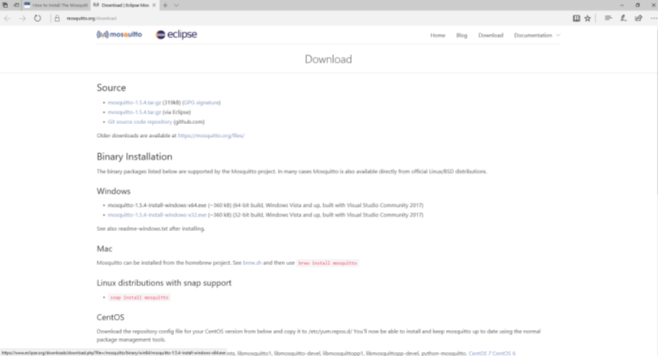

Launch the installer.

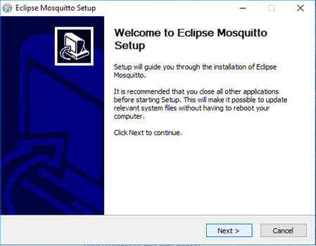

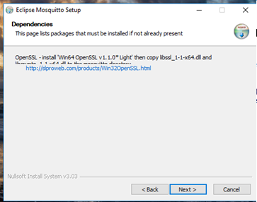

Attention to dependencies. This page shows which dependencies you must install in order to work with mosquito.

## Download – Dependencies

Now go to this site and download the download "Win64 OpenSSL v1.1.0i Light".

<http://slproweb.com/products/Win32OpenSSL.html>

You can finish the installation of mosquitto after opening the link. The installer will create a mosquitto folder and copy basic files to it. Mosquitto won't work for the moment. Before, we will need to install the dependencies.

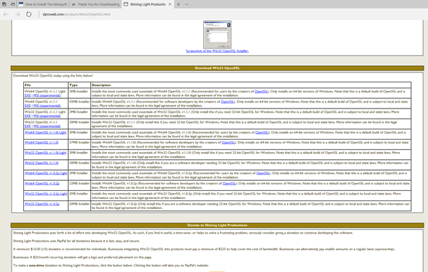

Download Win64 OpenSSL v1.1.0i Light. Launch the installation file and **remember the installation fold.**

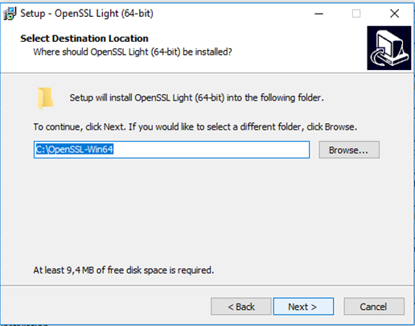

For the DLL any choice is fine.

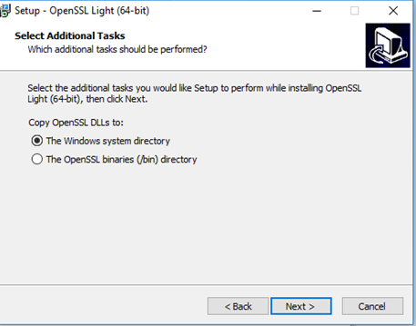

## Import dependencies.

Go to the folder in which you installed Win64 OpenSSL v1.1.0i Light. (usually C:\OpenSSL-Win64).

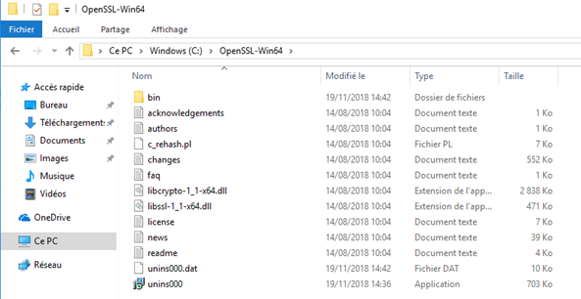

Copy these files to the "mosquitto server" folder (usually C:\Program Files\mosquitto if you have not changed):

* libssl-1_1-x64.dll
* libcrypto-1_1-x64.dll

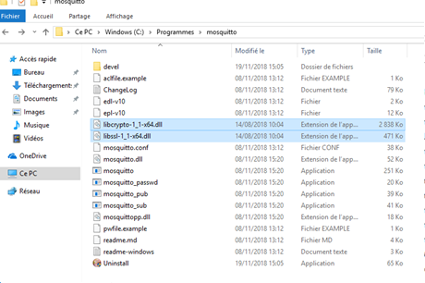

Paste and execute the "mosquitto.exe"

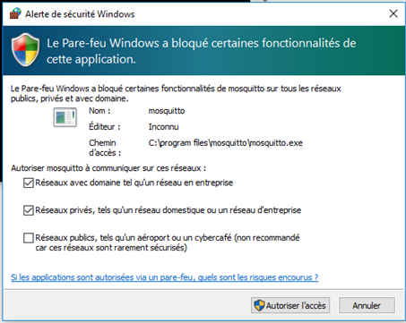

For the first use. Allow mosquitto through firewall as local and company network

## Create a service

This will launch the MQTT server automatically at start-up.

Search "CMD" on windows search, right click, and execute as admin.

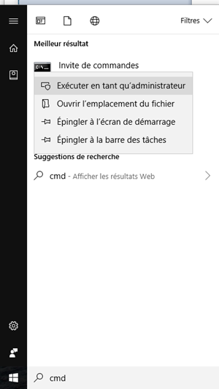

Access mosquitto folder with the following command:

cd C:\Program Files\mosquitto

Type the following to install mosquitto as a service:

mosquitto install

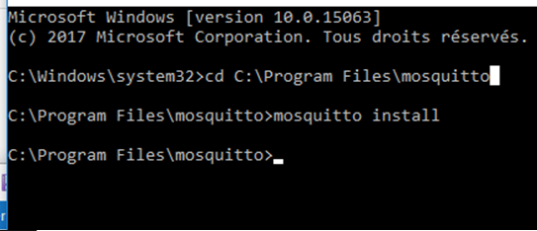

# Install – Linux

To install mosquitto on a Linux machine:

Use the terminal:

CTRL + ALT + T

Execute the following command:

su apt-get –y install mosquitto mosquitto-clients | exit

# Testing

Use the following command on a terminal to know if mosquitto in running on the server.

Netstat –a

Search on the beginning of the list for an open port 1883.

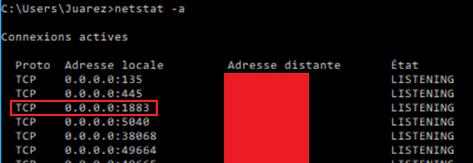

This is the proof that mosquitto server is running on local.

# Open the firewall

If you cannot send messages through machines after set-up. You may need to open the port for communication.

## Windows:

Go to the firewall configuration panel. Choose “Advanced parameters”.

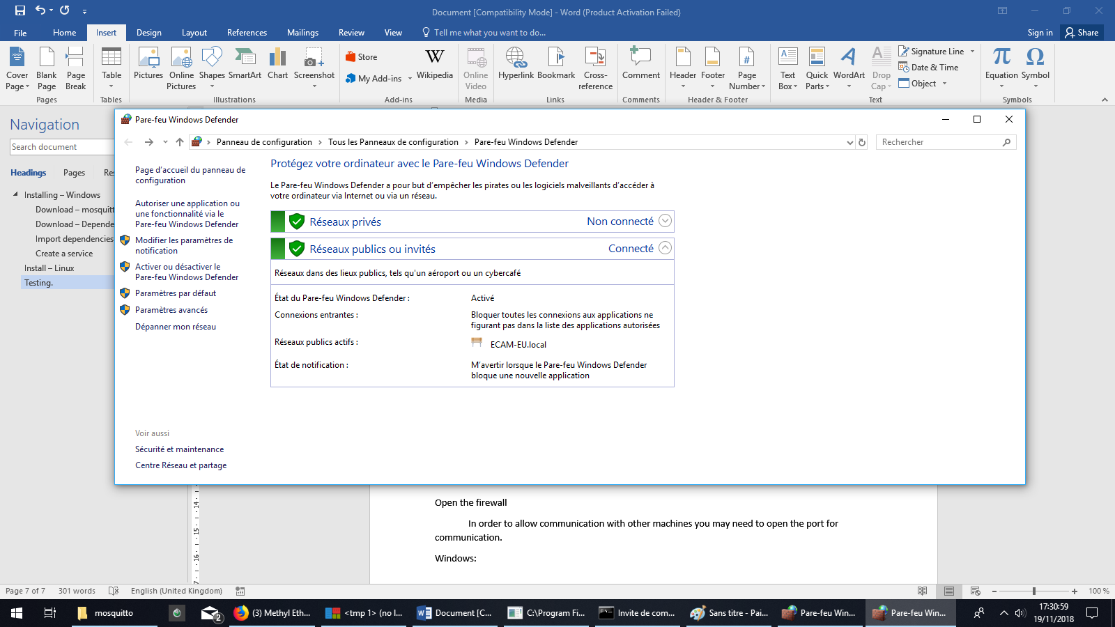

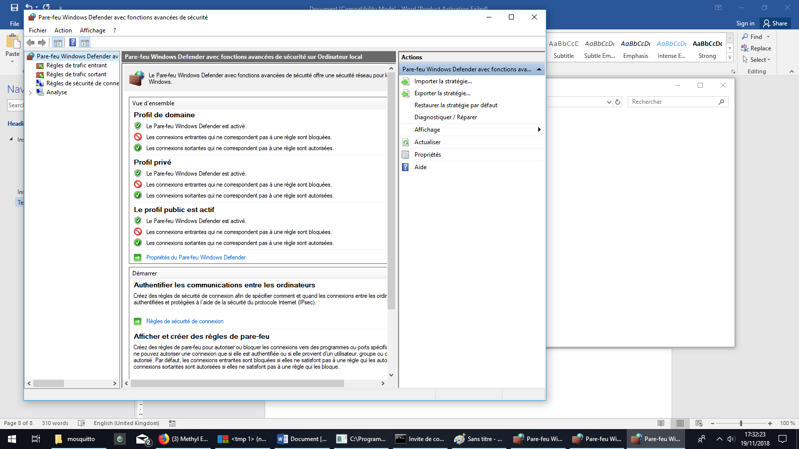

Choose “firewall outbound rules”.

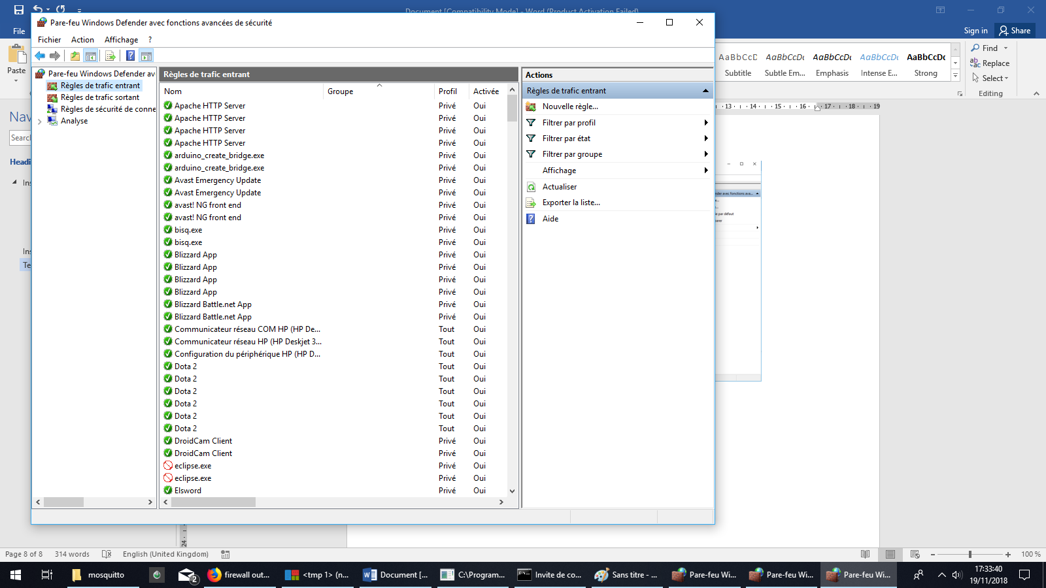

Create a new rule and choose port.

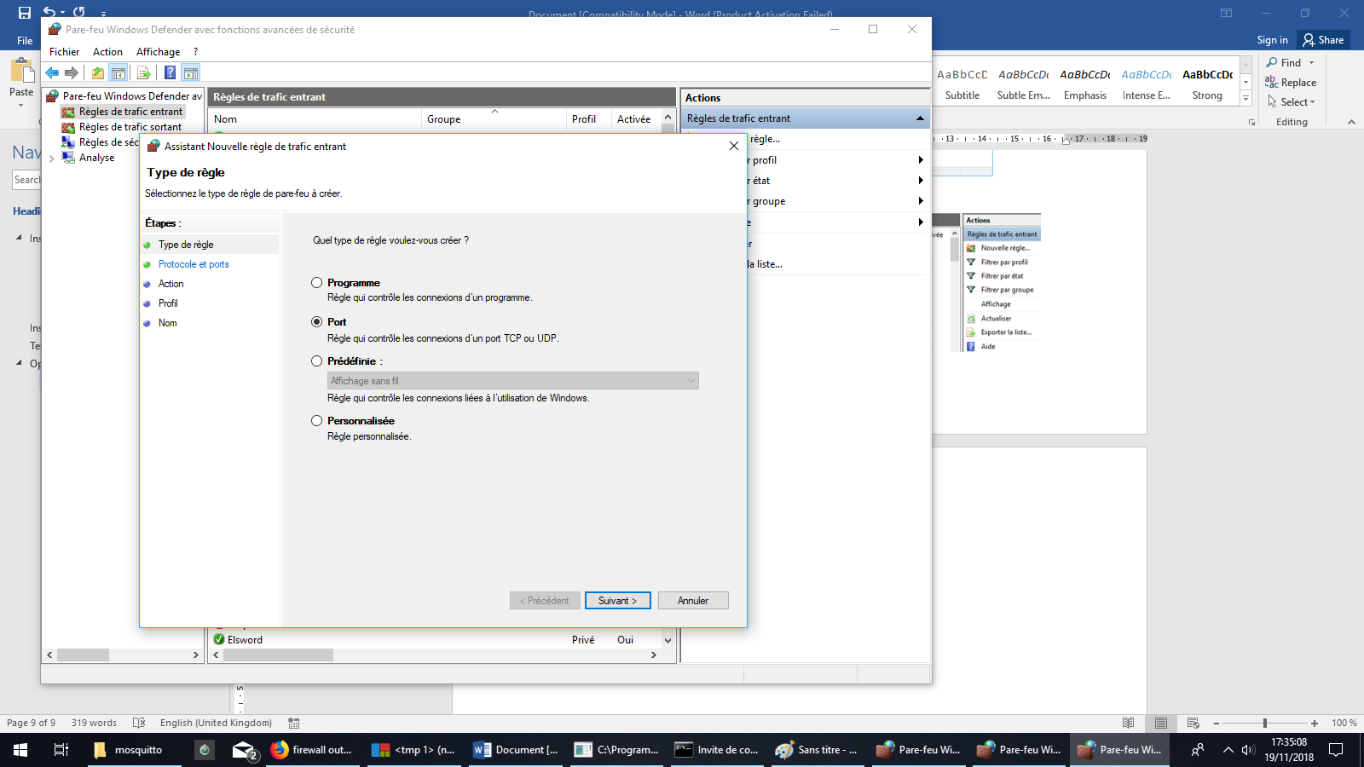

Choose port 1883 and validate it.

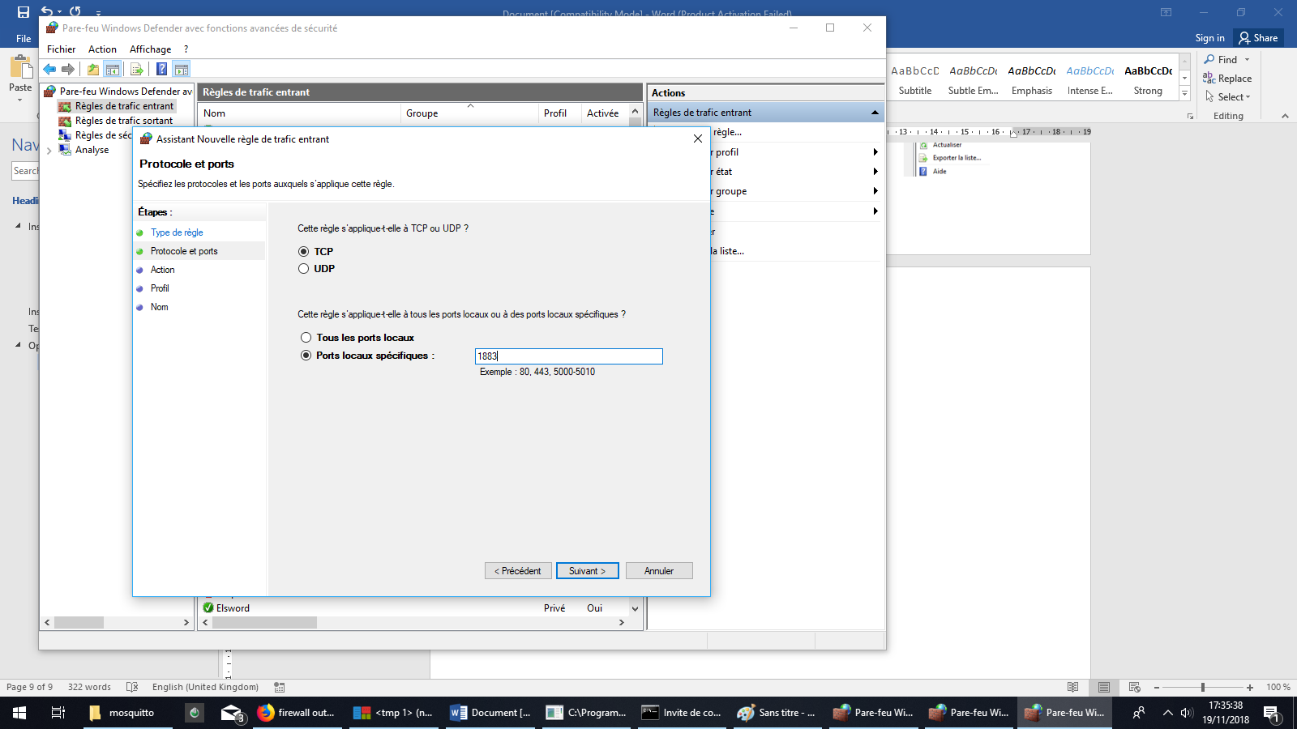

This port will remain open for communication as long as the rule remains. Erase the rule to stop it.

## Linux

Use the terminal and write the following command:

su uwf allow 1883