|  |
| --- |
|  |
| Tutoriel IoT – Groupe Architecture |
|  |
| Create a Database |

ECAM STRASBOURG EUROPE

19 novembre 2018

Tutoriel IoT – Groupe Architecture

Create a Database

Sommary

Getting started 2

Make your DB 3

Link tables and create keys 4

Export/Import your DB 5

How to export 5

How to import 5

# Getting started

A shortcut to Devserver is on your desktop:



Use this shortcut to launch Devserver. To do so, right click on the icon and choose “Run as administrator”.

When Devserver is launched, an icon appears in the [Notification Area](https://en.wikipedia.org/wiki/Notification_area) (next to the clock) - if you don't see the icon, click on Show hidden icons and move the icon next to the clock.

 or 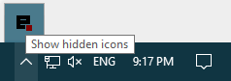

A right/left-click gives access to various menus:

# 

Start All Servers or only Database Server, and then launch the Dashboard.

# Make your DB

Once you are connected to your favorite SQL server (phpMyAdmin in this example), create a new database:

1. Create a new database
2. Enter a name and click create

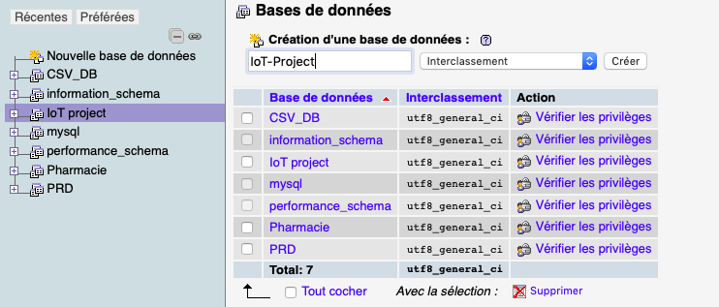

Next step is to create the tables of your database:

* Click the « Create a new table » button.

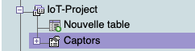

You will then have to fill your new table:

1. Enter table’s name
2. Enter columns’ name and type of data. In case of a string, you’ll have to limit the maximum length.

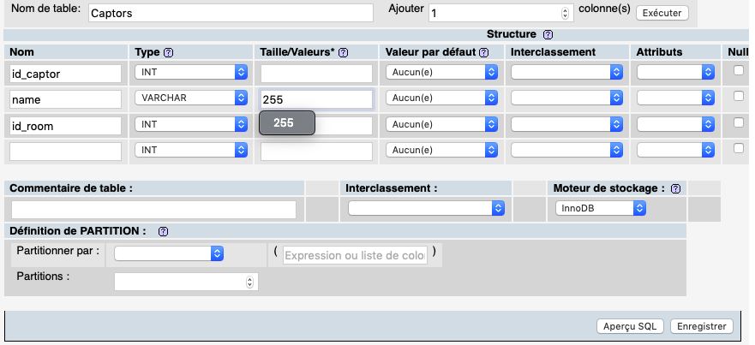

# Link tables and create keys

Once every table is created, you will have to create links in between every table.

The most important point is to define a primary key (every value of such key is unique throughout the table).

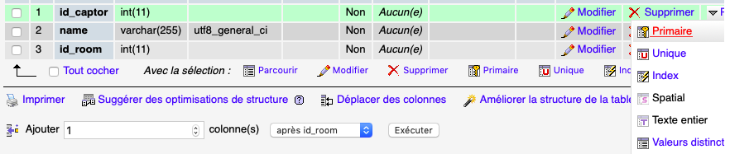

If there are foreign keys in a table, you will have to define it.

1. Under table’s structure, go to relations view
2. Select which column is referring to an external key
3. Select source table and column

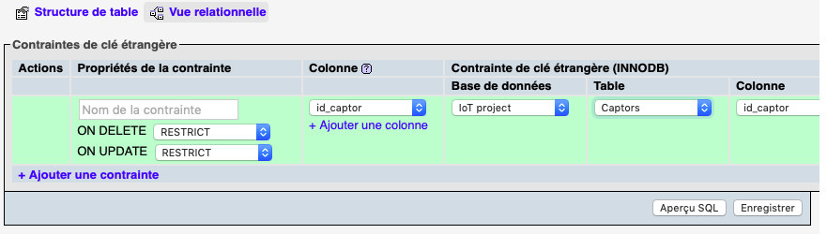

# Export/Import your DB

## How to export

You first have to go to export tabs. Go for the personalized exportation method

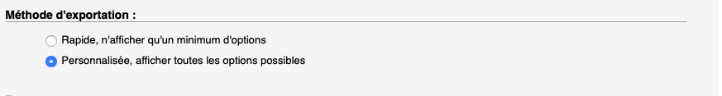

Use the output choice: “Download output in a file”

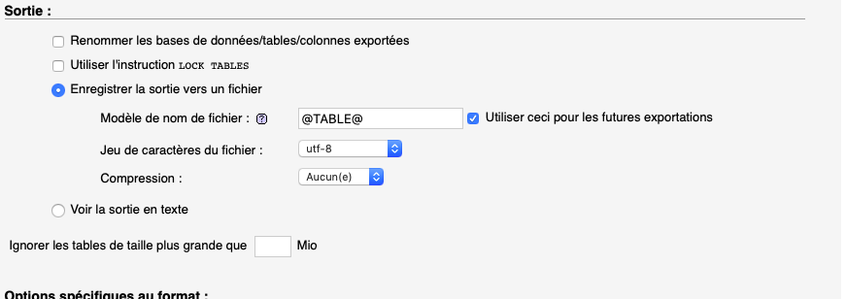

Leave other parameters as it and execute.



Your SQL file should be in your Download folder.

## How to import

