**1. Data structure**

**Independent variables**

|  |  |  |  |  |  |  |
| --- | --- | --- | --- | --- | --- | --- |
| Site | Day | Time | Observer | Tree | Bromeliads | Observation |
| CP or DO |  | Morning, noon, afternoon,  night  Can be made Day/night | Pierre or Francesca | 3 blocks of 12 trees for CP  (one was a removal tree included by mistake)  7 groups of 12 trees for DO | Present or absent (half and half for each site and day) | Two per observer per tree (4 per tree) |

**Dependent variables**

|  |  |  |  |  |  |
| --- | --- | --- | --- | --- | --- |
| Order | Species | Specimen | Diet | Behaviour | Behaviour duration |
| Some unknown (eg: leaf miners can be flies, butterflies or beetles) | Morphospecies, many new ones (NewSp)  When not sure of species, we put ca (eg: caFly_B) | If more than one specimen per morphospecies in observation |  | See below | Bounded between 0 and 300 seconds |

|  |  |  |  |
| --- | --- | --- | --- |
| Interaction type | Interaction target | Interaction duration | Interaction outcome |
| See below |  |  | See below |

**2. Behaviour**

57 categories but can essentially be divided into:

- attack and attacked (for one set of ants and a beetle chasing each other for full 300s, might be included in exploring)

- ant stuff (carrying dead sister, carrying food, building nest…)

- eating (chewing or sucking leaf/branch/flower, devouring (we took note of who ate who), sponging for flies)

- feeding/stationary (for immobile hoppers, aphids or scales, when we did not know what they were doing)

- exploring (can include stop and go moving behavior)

- lekking

- mating

- ovipositing (some uncertainty for some specimens, especially if small unidentifiable insects that could be parasitizing small eggs or laying miners)

- evolving (molting and pupating)

- parasitizing (either as adult laying eggs or visible ectoparasites on a larva)

- stationary (could include weaving web)

- tending (for ants tending scales or aphids)

We also have some random behaviors that I am unsure on how to categorize, e.g.:

spinning around itself, excavating moss, guarding nest, drinking, mosquitoes attacking us. Fortunately, they are very minor, so they can be removed or put into another category

**Fig 1. Frequency of each behaviour (n =3581, ~400 species observed)**

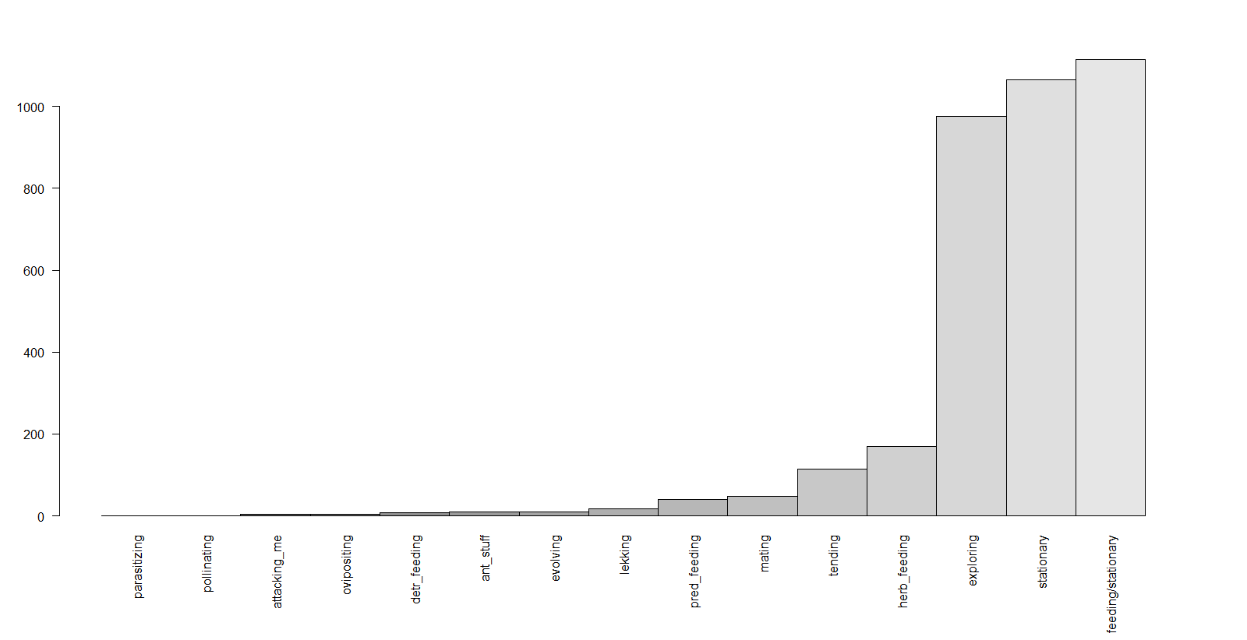

1. Stationary (how big is web weaving category? Enough to be distinct?)
2. Herbivory and detritivory (incl. feeding/stationary*, herb_feeding, detr_feeding)
3. Predation, parasitism (pred_feeding, parasitizing, “attack”)
4. Defense, whether or not successful (“attacked”)
5. Mobile (exploring)
6. Tending
7. Reproduction (mating, oviposition)
8. Development events (moulting, pupation)
9. Transporting (will largely concern ants)

*discuss

57 categories but can essentially be divided into:

- attack and attacked (for one set of ants and a beetle chasing each other for full 300s, might be included in exploring)

- ant stuff (carrying dead sister, carrying food, b…)

- eating (chewing or sucking leaf/branch/flower, devouring (we took note of who ate who), sponging for flies)

- feeding/stationary (for immobile hoppers, aphids or scales, when we did not know what they were doing)

- exploring (can include stop and go moving behavior)

- lekking

- mating

- ovipositing (some uncertainty for some specimens, especially if small unidentifiable insects that could be parasitizing small eggs or laying miners)

- evolving (molting and pupating)

- parasitizing (either as adult laying eggs or visible ectoparasites on a larva)

- stationary (could include weaving web)

- tending (for ants tending scales or aphids)

**3. Interaction type**

20 one-way broad categories, which can be divided into:

- ant stuff (can include antennal contact, trophallaxis)

- attack

- attacked

- mating

- parasitized

- parasitizing

- tending

- tended

Some rare interactions that can be included somewhere else or removed:

- sensing (when ants from different species perceive specimens from another species, includes remote sensing)

- an ant walking on a psyllid

- a face-off between to lekking flies

- a few specimens approaching each other without much action

Data simplification. Consider two types of interaction matrices: negative trophic interactions (predation, parasitism, herbivory) and positive interactions (tending). I can see two options for analysis:

Option 1. We calculate network properties (e.g. linkage density, connectedness, nestedness) for each half-block of one treatment (with/ without bromeliads). That will give us n=3 for CP and n=7 for DO. I am worried that we will not have enough data to make a useful network if we go down to level of tree, or subdivide according to time of day. However, it does give us enough replication to do some stats.

Option 2. Create a single global network with all the data. Combine this global network with the species discovered in vacuum samples to create tree-scale ecological networks. Calculate network metrics (e.g. linkage density, connectedness, nestedness) and do similar analysis as for vacuum sample data. Advantage: finer resolution networks so more replication – unless such poor overlap in species between the two datasets.

We did not account for arthropods that were already being chewed on by a predator.

**Fig 2. Frequency of each interaction (n = 382)**

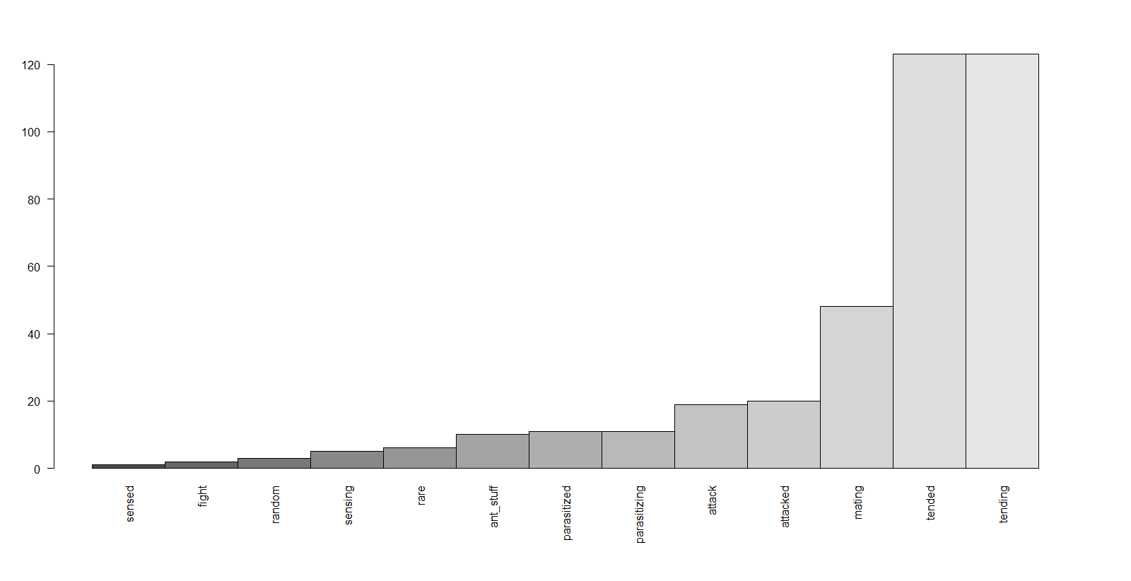

**Fig 3. Frequency of each interaction-involved species. I still have to update some species names, but the most involved species are ants, honeydew-makers, and mating beetles**

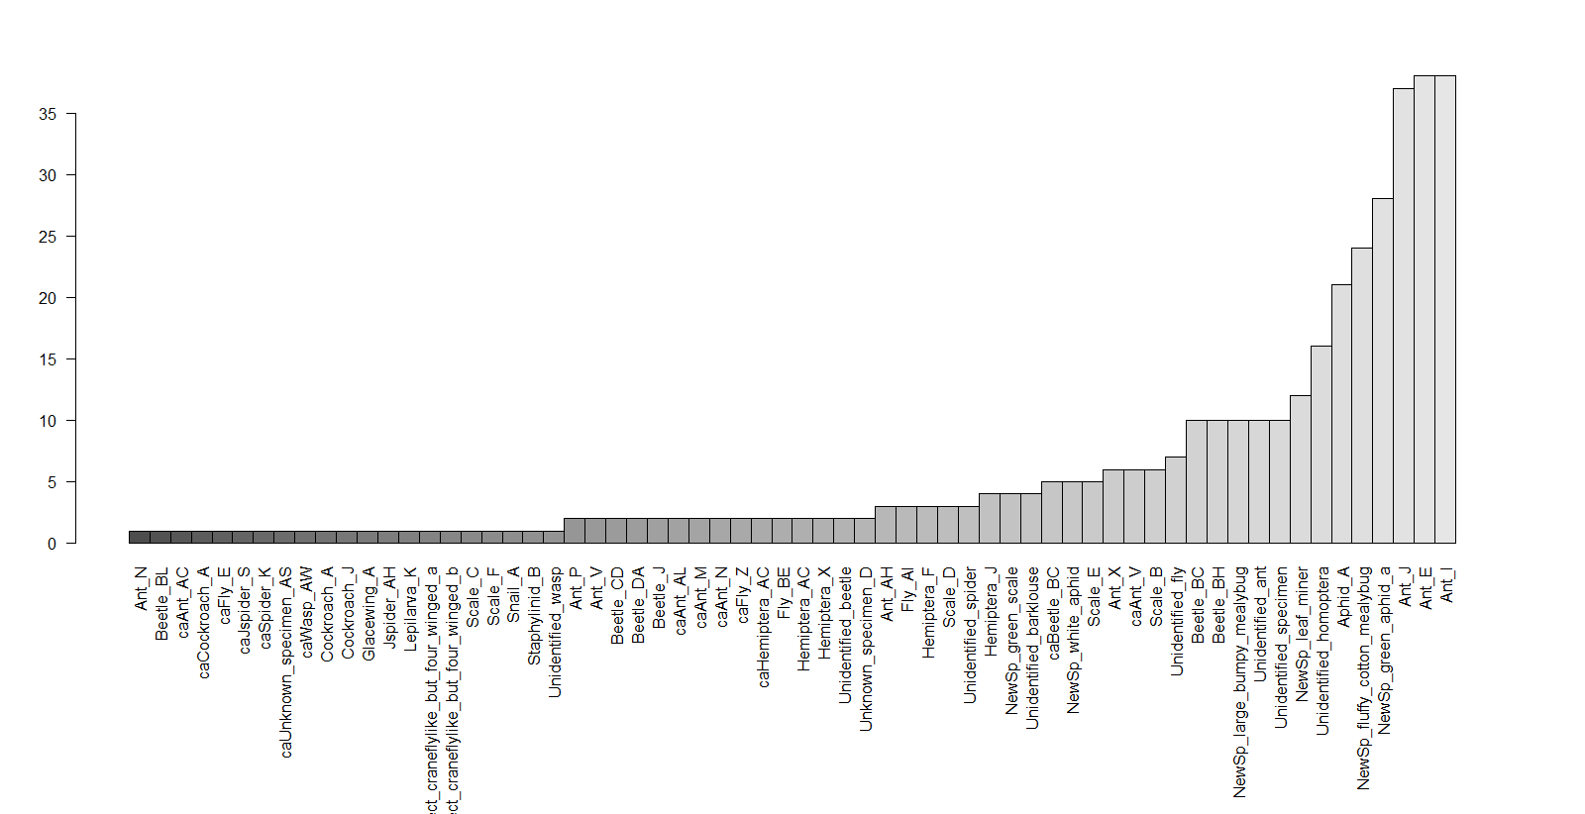

**4. Interaction outcome**

21 outcomes, depending on interaction

- ant stuff (cooperation, food received or given)

- resuming (when both go back to hat they were doing before)

- flight (when escaping from attack)

- miss (when target escaped)

- death (when not able to escape)

- success (when target seized)

- honeydew (tending/tended outcome)

- mating

Rare outcomes:

- avoidance of sensed enemy ant

- outcome of lekking fly fight

**Fig 4. Frequency of each interaction outcome (n = 382)**