0 – Original data structure
29 sites, 8 – 192 bromeliads and 15 – 61 species in each site
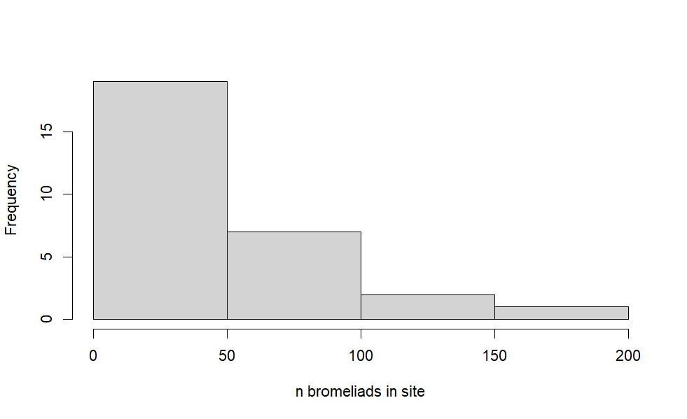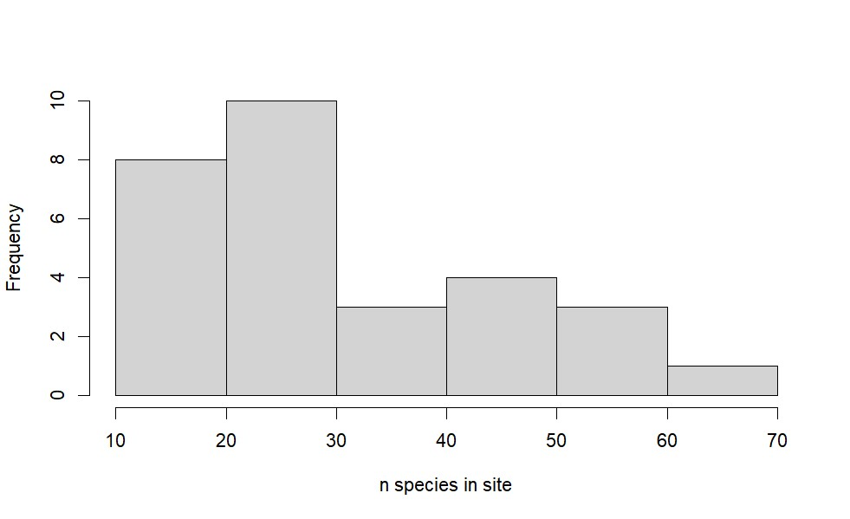
3 – 29 species in each bromeliad
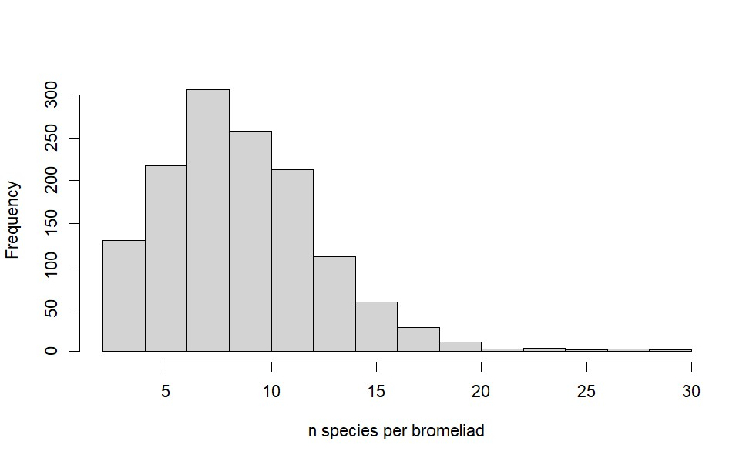
I – Power analysis

a. Data generation

15 sites of 20 - 100 bromeliads and 15 - 40 species (uniform draws)
5 - 20 species in each bromeliad (uniform draws)

crisp CPI value from binomial draws, random intercept for each site
phosphorus content values are generated by scaling crisp CPI values, then N and C random
raw influx to a node (i.e. species) generated by scaling phosphorus content values

b. Initial patterns
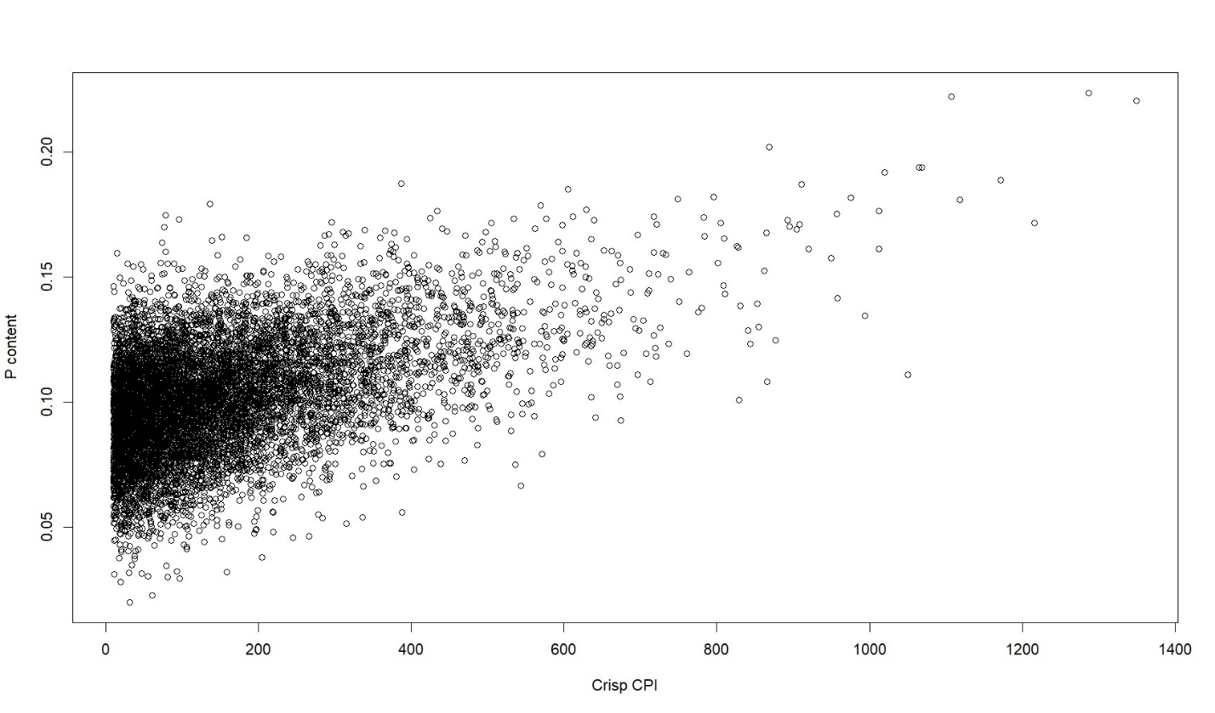
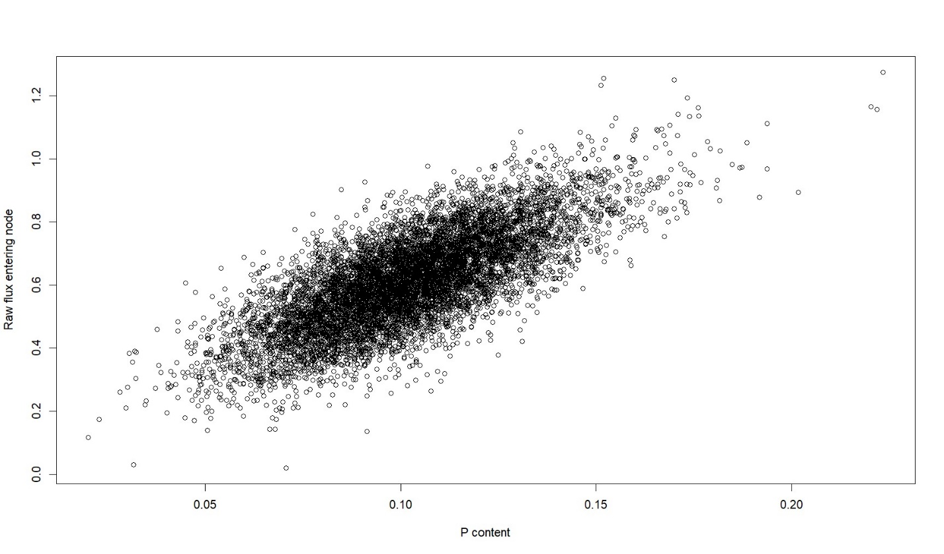c. Power analysis
Large loop, repeated 100 times, where we sequentially remove between 1 and 36 random species from the site-level food web by increments of 3 species
Then compute Gini index, total energy flow and average Euclidean distance between detritivore consumers at the bromeliad level at each increment

At each increment, compute two models using brms (these Bayesian models I have been doing lately):
log(gini index) ~ log(detritivore distance) + (1|site)
log(total energy flow) ~ log(detritivore distance ² + log(detritivore distance) + (1|site)

For each model, get R², pd (% of posterior distribution of the same sign that the median, effect presence), % in ROPE (% of posterior distribution within 0.1 sd around 0, effect significance).

Original models with full data (i.e. no species removed):
log(gini index) ~ log(detritivore distance) + (1|site):
R² = 0.01, pd_{intercept} = 100, % in ROPE_{intercept} = 0, pd_{distance} = 99.6, % in ROPE_{distance} = 0

log(total energy flow) ~ log(detritivore distance ² + log(detritivore distance) + (1|site):
R² = 0.07, pd_{intercept} = 100, % in ROPE_{intercept} = 0, pd_{first order} = 68.4, % in ROPE_{first order} = 2.7, pd_{second order} = 100, % in ROPE_{second order} = 0
d. Results for log(gini index) ~ log(detritivore distance) + (1|site)
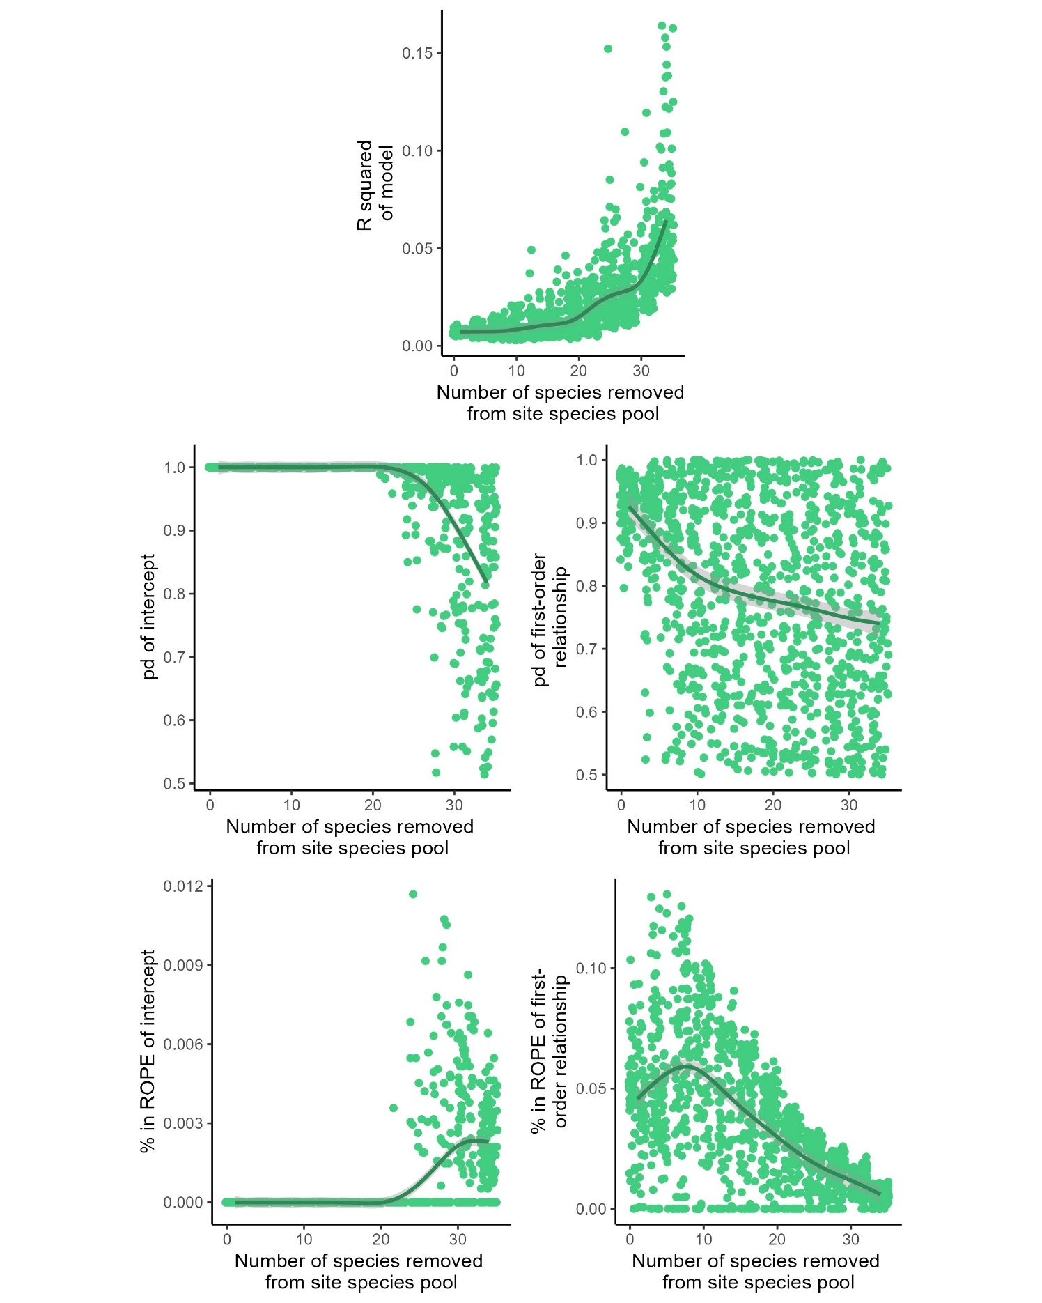
e. Results for log(gini index) ~ log(total energy flow) ~ log(detritivore distance ² + log(detritivore distance) + (1|site)
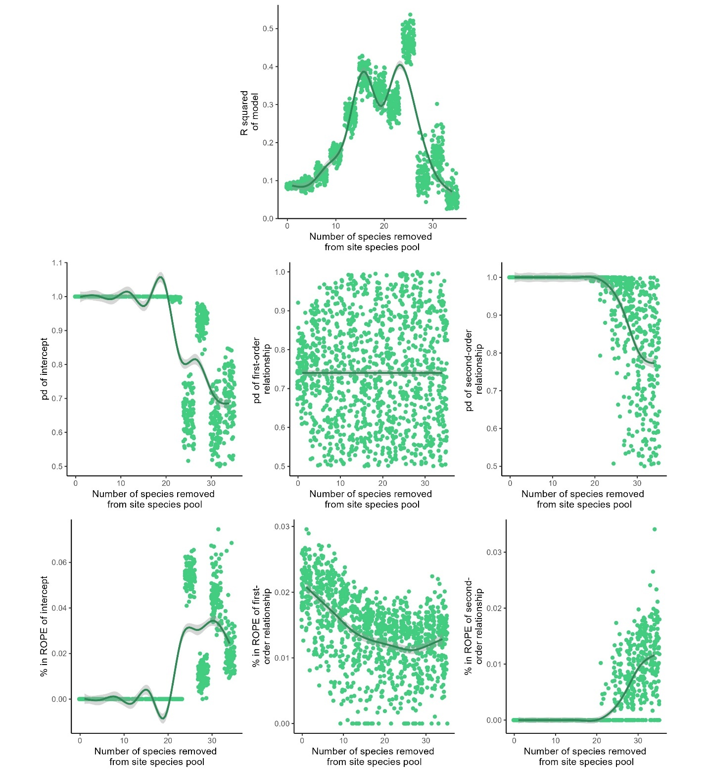

II – Artifact analysis

a. Data generation

15 sites of 100 - 500 bromeliads and 90 - 240 species (uniform draws)
30 - 50 species in each bromeliad (uniform draws)

crisp CPI value from binomial draws, without random intercepts for sites
phosphorus content values randomly generated from uniform distribution, then N and C randomly distributed
raw influx to a node (i.e. species) randomly generated from gamma distribution

b. Initial patterns
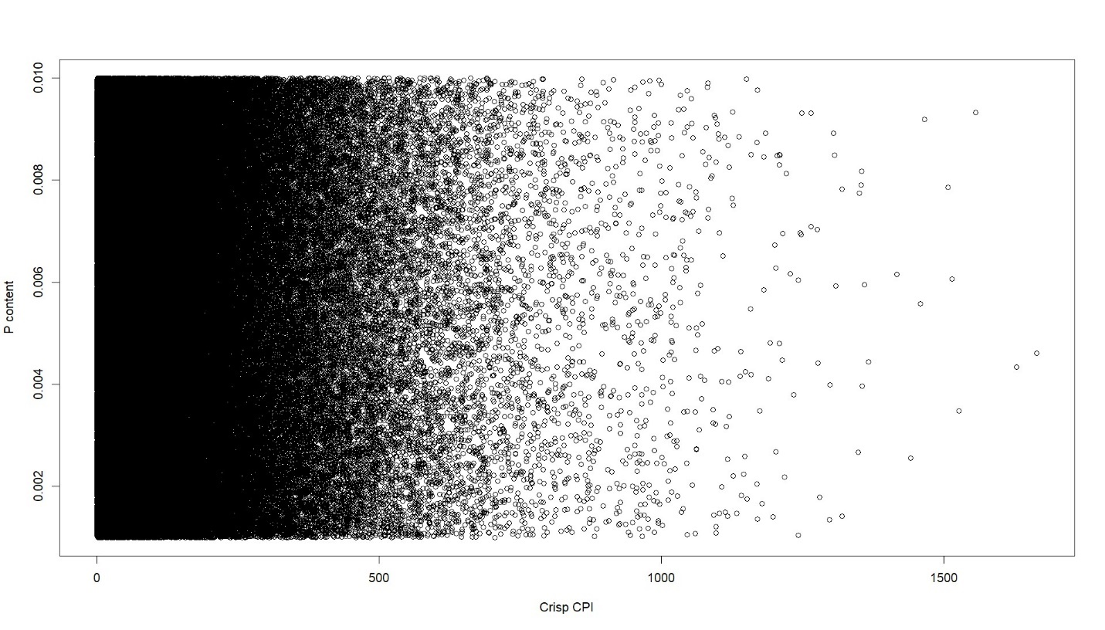
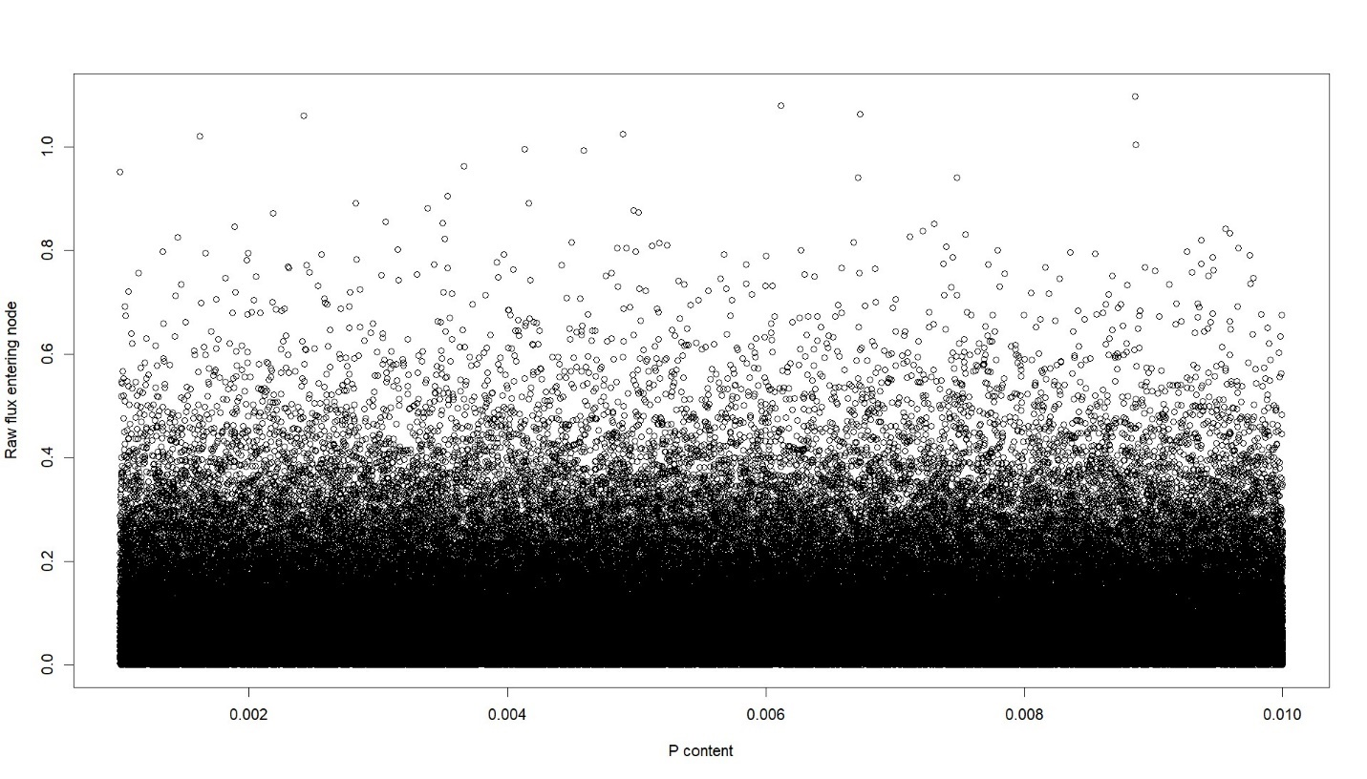c. Artifact analysis
Large loop, repeated 50 times, where we sequentially select from 2 to 71 species in each site-level food web (things get computationally very heavy very fast) by increments of three species
Then compute Gini index, total energy flow and average Euclidean distance between detritivore consumers at the bromeliad level at each increment

At each increment, compute two models using brms (these Bayesian models I have been doing lately):
log(gini index) ~ log(detritivore distance) + (1|site)
log(total energy flow) ~ log(detritivore distance ² + log(detritivore distance) + (1|site)

For each model, get R², pd (% of posterior distribution of the same sign that the median, effect presence), % in ROPE (% of posterior distribution within 0.1 sd around 0, effect significance).

Original models with full data (i.e. no species removed):
log(gini index) ~ log(detritivore distance) + (1|site):
R² = 0.001, pd_{intercept} = 100, % in ROPE_{intercept} = 0, pd_{distance} = 59.4, % in ROPE_{distance} = 40

log(total energy flow) ~ log(detritivore distance ² + log(detritivore distance) + (1|site):
R² = 0.07, pd_{intercept} = 100, % in ROPE_{intercept} = 0, pd_{first order} = 60.4, % in ROPE_{first order} = 3.7, pd_{second order} = 100, % in ROPE_{second order} = 0
d. Results for log(gini index) ~ log(detritivore distance) + (1|site)
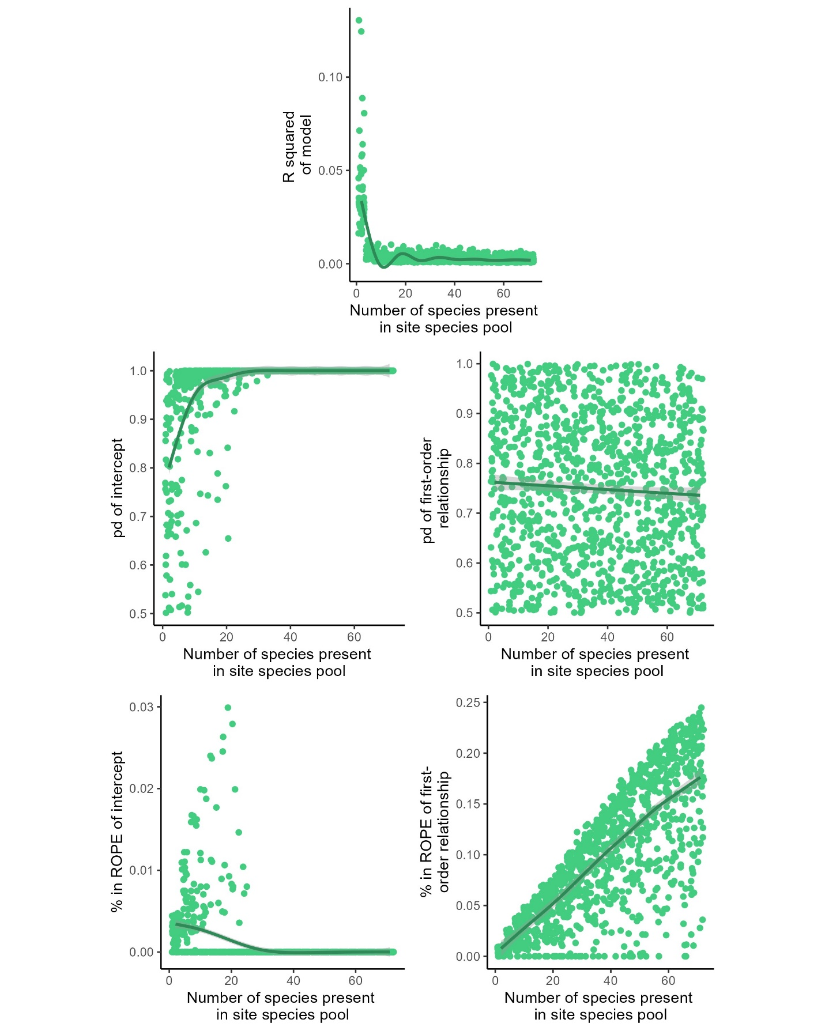

e. Results for log(gini index) ~ log(total energy flow) ~ log(detritivore distance ² + log(detritivore distance) + (1|site)
