Environmental Logger Sensor Selection

Atmospheric Pressure Sensor

# Atmosphere of Mars

The atmosphere of mars varies from 30 pascals on Olympus Mon’s peak to 1155 pascals in the deepest part of Hellas Planitia with a surface average of 600 pascals. Sensor selection should be based on where the environmental logger will be placed on mars to maximize sensor resolution and data accuracy. For cost reasons such a sensor will not be used for alpha proof of concept and instead an easily available sensor capable of measuring earth’s atmospheric pressure will be used.

# Omron Z3059-ND Gauge Pressure Sensor

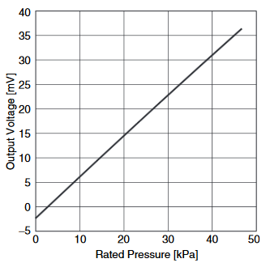The Z3059-ND is a Piezo Resistive bridge sensor that produces an output voltage based on the change in resistance caused by change in air pressure. The sensor has an input range of 0 – 37kPa which produces an output voltage between 0.6 – 38mV.

The sensor operates with a constant current supply which is used by the Wheatstone bridge inside the sensor to determine change in resistance. Recommended operating current is 100uA with a maximum rating of 130uA. The datasheet recommends an op-amp based current source.

The datasheet also recommends the use of an instrumentation amp as means to amplify the sensor output to a level usable by our onboard ADC.

Figure : Rated Pressure vs. Output Voltage

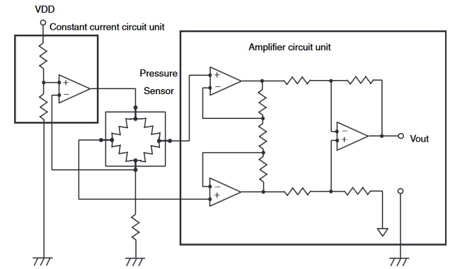

Figure : Datasheet Application Circuit