Hospital Bed Coordination System
System Documentation & Technical Specifications
Frontend-First • Public Access • Hospital-Driven • Scalable
Deployment Region:
Greater Accra Region, Ghana
(Scalable to National Deployment)

Executive Summary
Problem Statement: Hospitals frequently report 'no bed' situations, not because beds do not exist, but because accurate real-time information is unavailable when critical decisions must be made. Patients, clinics, and emergency responders lose precious time calling hospitals blindly, often resulting in preventable delays and adverse outcomes.
Solution: The Hospital Bed Coordination System provides a centralized, real-time view of hospital bed availability, appointment scheduling, and home healthcare services across the Greater Accra region. The system maintains hospital autonomy by allowing each facility to remain the sole authority over its own data while providing public visibility and coordination capabilities.
Impact: By eliminating blind referrals and reducing emergency response delays, this system addresses a critical failure point in healthcare delivery: patients often die due to slow information flow, not lack of available beds.

Core Design Principles
- No user login required for public access
- Frontend-first with minimal UI complexity
- Hospitals are the source of truth for all data
- Simple pages with low cognitive load
- Emergency clarity prioritized over feature richness
- Calm, healthcare-friendly color tones and design

1. System Architecture

1.1 Architecture Style
The system adopts a Centralized Hub-and-Spoke Architecture. This model ensures real-time coordination without central data ownership, balancing control, scalability, and institutional trust.
Key Characteristics:
- The central system (hub) provides visibility, coordination, and temporary reservation logic
- Each hospital operates independently (spoke) and remains the sole authority over its data
- The architecture ensures real-time coordination without centralized data ownership

1.2 Architectural Components

Central Coordination System (Hub)
Responsibilities:
- Aggregate real-time bed availability from hospitals
- Display hospital information to the public
- Coordinate temporary bed reservations
- Enforce booking rules and expiration timing
- Provide dashboards for public access and admin management
Constraints:
- Does not create, alter, or assume bed availability
- Acts strictly as a coordination and visibility layer

Hospital Admin Dashboards (Spokes)
Each hospital is provided with its own admin dashboard. Hospitals are the source of truth for all operational data.
Responsibilities:
- Update bed availability by type (General Ward, HDU, ICU, Emergency Department)
- Confirm, cancel, or release bed bookings
- Manage patient appointments
- Manage home service requests
- Ensure data accuracy in real-time

1.3 Component Architecture Diagram
The following diagram illustrates the hub-and-spoke relationship between the central coordination system and individual hospital admin systems:
Central Coordination System (HUB)
• Public Web Interface
• Hospital Search & Map View
• Reservation & Expiry Engine
• Booking Rules Enforcement
• Aggregated Read-Only Data Store
↕
Real-Time Data Synchronization

Hospital A  Admin System | Hospital B  Admin System | Hospital C  Admin System
• Bed Management  • Bookings  • Appointments  • Home Services | • Bed Management  • Bookings  • Appointments  • Home Services | • Bed Management  • Bookings  • Appointments  • Home Services

2. User Roles and Permissions
User Role | Capabilities
Public User | • Search for hospitals by name  • Find hospitals near current location  • View real-time bed availability  • Book available beds (when criteria met)  • Request home healthcare services  • Book medical appointments  • No login required
Hospital Admin | • Manage hospital profile information  • Update bed availability in real-time  • Confirm, cancel, or release bed bookings  • Manage appointment requests  • Manage home service requests  • View booking analytics and history  • Requires authentication
System Admin | Future Implementation:  • System configuration and settings  • User management and permissions  • System monitoring and audits  • Performance analytics

3. Public User Interface and Features

3.1 Dashboard (Landing Page)
The dashboard serves as the main entry point for all public users. It features a clean, minimalist design optimized for emergency situations where users need immediate access to critical information.
Key Elements:
- Clear headline emphasizing quick hospital access
- Two primary action buttons displayed in flex row:
○ Search for a Hospital
○ Find Hospitals Near Me
- Services section displayed as cards: Bed Availability, Book Home Services, Appointment

3.2 Search for Hospital Page
Allows users to search for hospitals by name with real-time filtering.
Hospital Card Display:
- Hospital name and type
- Available beds by type (General, HDU, ICU, Emergency)
- Contact phone or email
- Link to detailed hospital information page

3.3 Find Hospitals Near Me Page
Provides location-based hospital discovery with integrated mapping functionality.
Features:
- List of nearby hospitals sorted by distance from user's current location
- Interactive map view showing all hospital locations
- Distance indicator for each hospital
- Available beds by type
- Contact details
- 'Get Directions' link for navigation
- Link to detailed hospital page

3.4 Hospital Detail Page
Comprehensive hospital information hub providing all necessary details for informed decision-making.
Information Displayed:
- Hospital description and facility images
- General and emergency contact numbers
- Head doctors and department information
- Patient reviews and ratings
- Real-time bed availability breakdown by type
- Booking eligibility status with clear explanations
- Action buttons for bookings, appointments, and home services

4. Bed Classification and Management

4.1 Bed Classification System
Beds are classified by level of care, not by admission context. This ensures clarity and consistency across all hospitals in the system.
Bed Type | Description & Booking Status
General Ward | Standard inpatient care beds  ✓ Reservable when ≥20 beds available
HDU (High Dependency Unit) | Intermediate care between general ward and ICU  ✓ Reservable when ≥20 beds available
ICU (Intensive Care Unit) | Critical care for life-threatening conditions  ✓ Reservable when ≥20 beds available
Emergency Department | Immediate emergency treatment beds  ✗ View Only - Not Reservable

4.2 Bed Status States
Each bed group can exist in one of four states. All status updates are timestamped and hospital-controlled.
Status | Definition
Available | Bed is clean, prepared, and ready for immediate patient admission
Reserved | Bed has been temporarily booked by a patient/family (45-minute expiry timer active)
Occupied | Bed is currently occupied by an admitted patient
Cleaning/Maintenance | Bed is undergoing cleaning, sanitization, or equipment maintenance

4.3 Bed Status State Diagram
The following diagram illustrates the lifecycle of a hospital bed through various states:
AVAILABLE
↓
Patient books bed
RESERVED
(45-minute timer)
↓
Hospital confirms OR timer expires
OCCUPIED / RELEASED
↓
Patient discharged
CLEANING / MAINTENANCE
↓
Cleaning complete
AVAILABLE

5. Booking Rules and Reservation Logic

5.1 Booking Eligibility Criteria
The system implements strict booking rules to ensure emergency capacity is always maintained and beds remain available for critical cases.
Condition | Rule
Minimum Available Beds | Beds cannot be booked if available beds < 20
Emergency Department Beds | View only - Never reservable
Active Bookings per User | One active booking per request (no multiple simultaneous bookings)
Emergency Override | Hospital admins can override reservations for critical emergency cases

5.2 Reservation Timing and Expiration
Critical Design Decision: All bookings are temporary to prevent indefinite bed locking and ensure availability for genuine emergencies.
Reservation Timeline:
- User initiates booking → System marks bed as 'Reserved'
- 45-minute countdown timer begins immediately
- Timer is visible to both user and hospital admin
- Hospital admin confirms arrival → Bed becomes 'Occupied'
- If timer expires without confirmation → Booking auto-releases
- Released bed returns to 'Available' status
Rationale: The 45-minute window provides sufficient time for emergency travel within Greater Accra while preventing abuse and ensuring beds don't remain locked for extended periods.

6. Database Architecture

6.1 Entity-Relationship Diagram (ERD)
The following Entity-Relationship Diagram illustrates the complete database schema for the Hospital Bed Coordination System, showing all entities, attributes, and relationships:
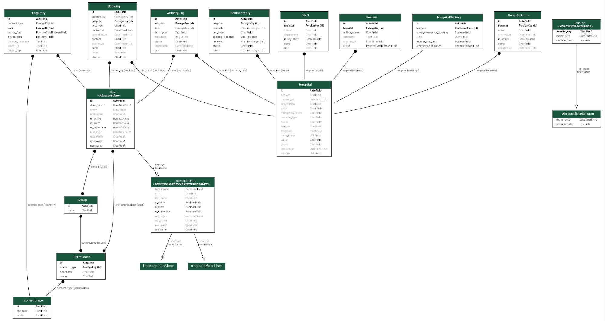
Figure 6.1: Complete Entity-Relationship Diagram

6.2 Core Database Entities
The database consists of the following primary entities:
Entity | Purpose
Hospital | Stores hospital profile information including name, contact details, location, description, and operational status
HospitalAdmin | Manages authentication and authorization for hospital administrative users
User (AbstractUser) | Base user model for authentication and authorization across all user types
BedInventory | Tracks real-time bed availability by type (General, HDU, ICU, Emergency) for each hospital
Booking | Records bed reservation requests with patient details, booking timestamps, and expiration timers
ActivityLog | Audit trail for all system actions including bed updates, bookings, and administrative changes
VMed | Manages home healthcare service requests including scheduling and assignment
Staff | Stores healthcare staff information for assignment to home services and appointments
Review | Captures patient reviews and ratings for hospitals and services
HospitalSetting | Configurable hospital-specific settings and preferences
Permission | Defines granular permissions for role-based access control
Group | Groups users by role for permission management
ContentType | Django framework component for generic foreign key relationships
LogEntry | Django admin action logging for administrative interface
Session | Manages user session data for authentication persistence

7. System Impact and Benefits

7.1 Problem Resolution
The Hospital Bed Coordination System directly addresses critical failures in Ghana's healthcare information infrastructure:
- Eliminates blind referrals: Patients and emergency responders no longer waste time calling multiple hospitals
- Reduces emergency delays: Real-time visibility enables immediate decision-making in life-threatening situations
- Improves inter-hospital coordination: Hospitals can quickly identify receiving facilities for patient transfers
- Makes existing beds usable: Available beds are no longer invisible due to information gaps
Critical Insight: Patients die due to slow information flow, not lack of beds. This system addresses that exact failure point.

7.2 Scalability and Future Development
While initially deployed in Greater Accra, the system architecture is designed for seamless national expansion:
- Hub-and-spoke model scales horizontally to accommodate unlimited hospitals
- Regional database partitioning can support national deployment without redesign
- System administrator role enables centralized management at scale
- API architecture allows integration with national health information systems
The Greater Accra deployment serves as a proven model for replication across Ghana's regions and potentially other West African nations facing similar healthcare coordination challenges.
— END OF DOCUMENT —

