How to export a list of flights in Skylegs and import it in the Crewing Tool
In Skylegs: use tab “operaties” – “flights overview”
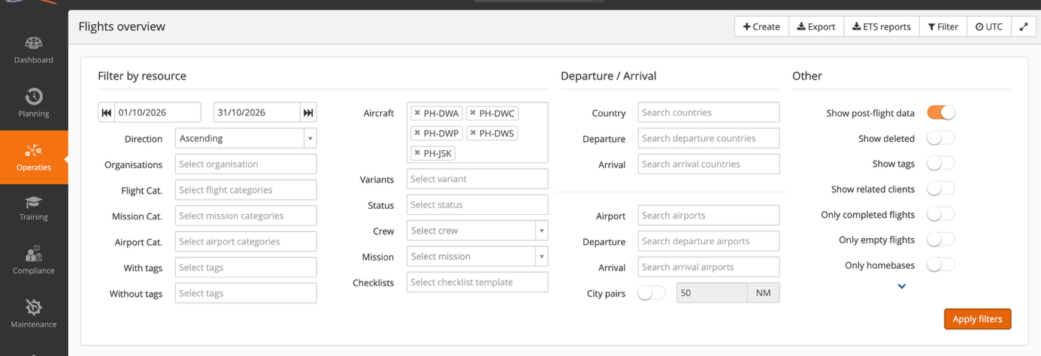
Set filter as follows:
- Select date range (in figure here: 1/10/2026 until 31/10/2026)
- Ascending
- Aircraft: select: DWA-DWC-DWP-DWS-JSK

Click “export”
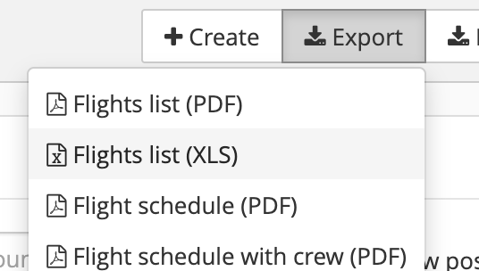

Select “Flights list (XLS)”
This will generate an XLS that you can use straight away in the crewing tool:
In the mission planning tab: click “upload” and selected the .XLS that you generated in Skylegs

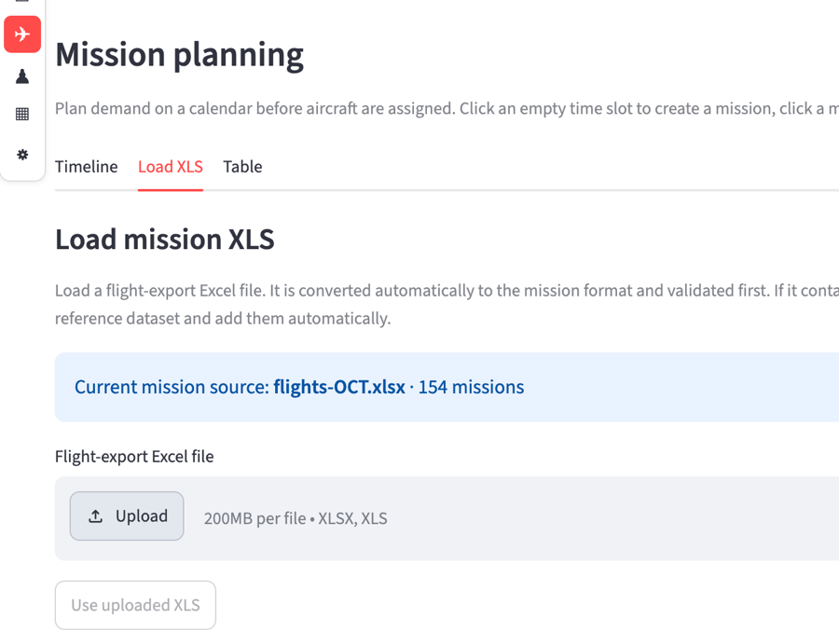

The system checks validity, adds extra unknown airports if needed. Click “Use uploaded XLS” to be able to use it.

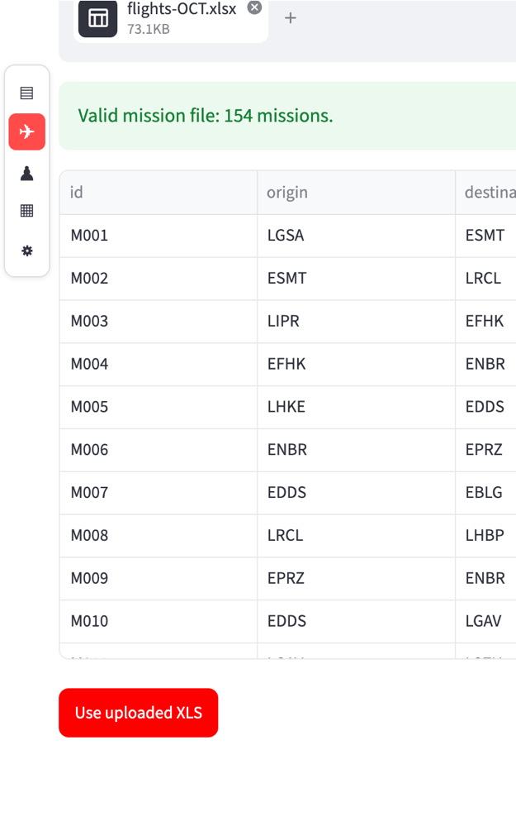

How to export Pilot agenda’s in Skylegs and import it in the Crewing Tool
In Skylegs: use tab “operaties” – “Agendas overview”
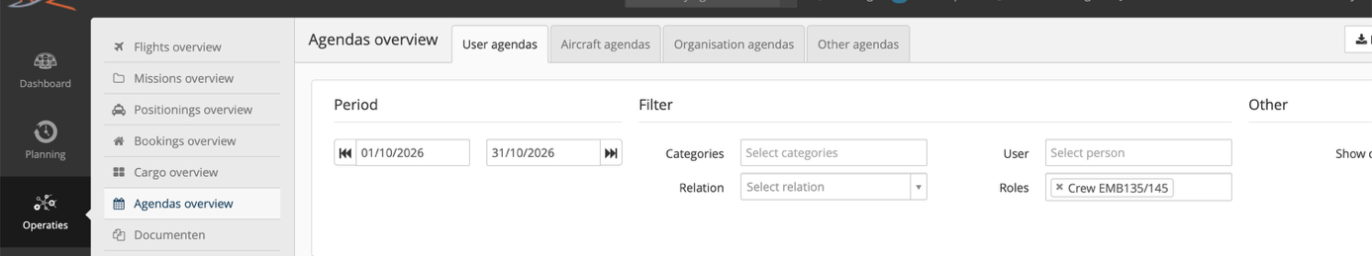
Set filter as follows:
- Select date range (in figure here: 1/10/2026 until 31/10/2026)
- Roles: select: Crew EMB135/145

Click “export”
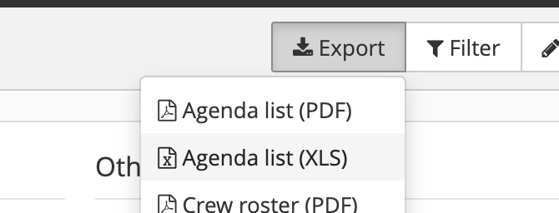

Select “Agenda list (XLS)”
This will generate an XLS that you can use straight away in the crewing tool:
In the pilot planning tab: click “upload” and selected the .XLS that you generated in Skylegs
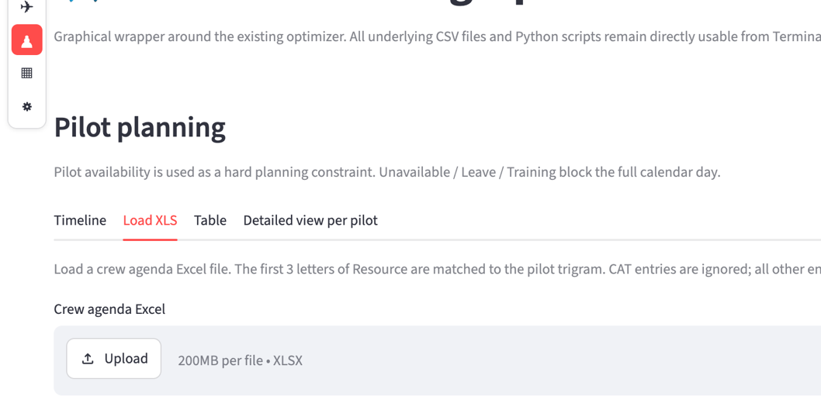
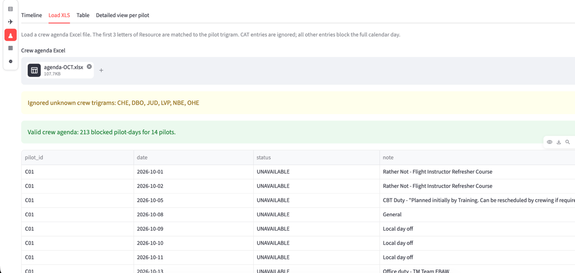

The system checks validity, it also disregards cabin crew for now. The unavailable days per pilot are now added in the crewing tool.

How to calculate a full mission plan with the Crewing Tool
Go to the “Optimizer” page. The basic mode has everything you need. Click “start optimization”.
You will see text appearing in the live terminal with some information. For complex schedules these calculations can take a few minutes.
When the calculation is DONE, it is mentioned below.

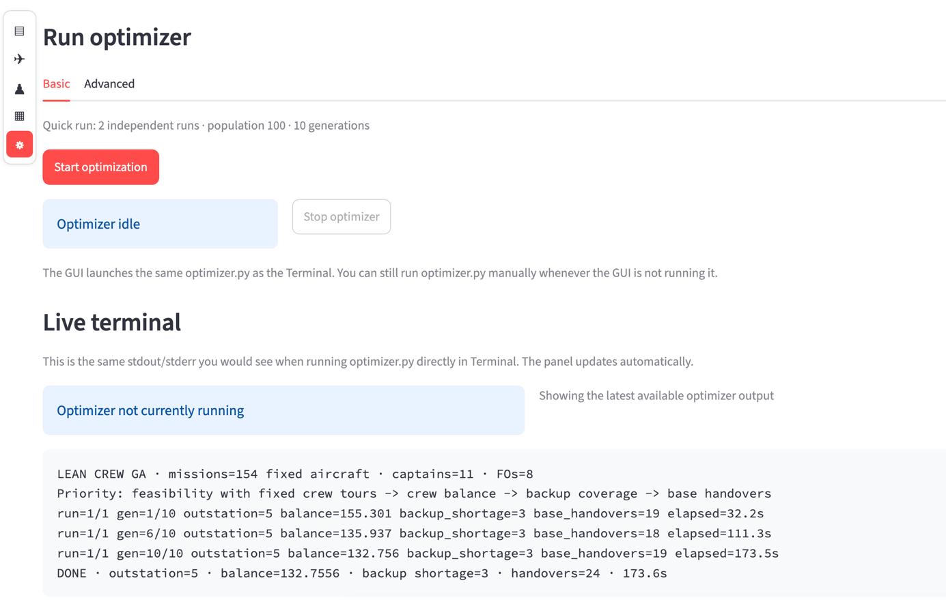

Now go the the “Mission planning board” page to inspect the set of results that were calculated by the crewing tool.

