A Conceptual Framework for Agent-Based Modelling of Macroeconomic Dynamics

# Abstract

This paper introduces a proof-of-concept agent-based modelling (ABM) framework for simulating macroeconomic dynamics. Using simplified representations of countries, citizens, and businesses, the model explores the interactions between economic policies, external influences, and citizen well-being. While the results are not intended to predict real-world outcomes, the framework provides a flexible foundation for future model development and refinement.

# 1. Introduction

Macroeconomic systems are complex, adaptive environments driven by the interactions of countless individuals, organizations, and institutions. Traditional economic models often rely on aggregate equations and rational expectations. In contrast, agent-based modelling (ABM) offers a bottom-up approach, simulating the behavior of individual agents and observing the emergent outcomes.  
  
This study presents an early-stage, conceptual ABM framework designed to explore the effects of government policies on key macroeconomic indicators such as citizen happiness, economic growth, inflation, and fiscal balance.  
  
The motivation for this project stems from observing the radically different reactions among leading economists to recent macroeconomic events—particularly the introduction of tariffs under the Trump administration. Some praised the tariffs as a bold and necessary corrective measure; others criticized them as economically harmful and deeply misguided. I personally believe this sharp divergence of expert opinion highlights a fundamental limitation in conventional macroeconomic theory: its top-down, often rigidly analytical approach. I hold the strong view that agent-based modelling—built from the bottom up and grounded in simulated behavioral interactions—has the potential to offer new and more insightful ways to understand macroeconomic outcomes.  
  
In general, I prefer to support leaders who take action. But I also want to understand what they do, as well as the possible consequences of their actions, before rushing to judge or criticize. This model is an initial step toward creating a simulation tool that can help provide such understanding.

# 2. Methodology Overview

The model conceptualizes an economy consisting of three main agent types:  
- Countries: Governments that set fiscal and monetary policies.  
- Citizens: Individuals with varying salaries, savings, employment status, and value systems.  
- Businesses: Entities engaging in production, trade, and employment, sensitive to economic conditions.  
  
Each agent follows simple behavioral rules, allowing the simulation of dynamic feedback loops between policy decisions, economic conditions, and agent well-being.  
  
Key adjustable parameters include:  
- Tax rates  
- Interest rates  
- Social service spending  
- Immigration incentives  
- Import duty rates  
  
External factors (e.g., global trade influences) are also incorporated to introduce environmental variability.

# 3. Simulation Structure

The model operates in discrete time steps. In each step:  
- Businesses adjust production and hiring based on profitability and economic conditions.  
- Citizens seek employment, consume goods, and adjust their savings and happiness based on their financial and social environment.  
- Governments collect taxes, adjust spending, and respond to inflation and growth metrics.  
  
Policy experiments are run by systematically varying combinations of tax, interest, and spending parameters, observing their effect over multiple simulation runs.

# 4. Results

## 4.1 Citizen Happiness vs. Tax Rate

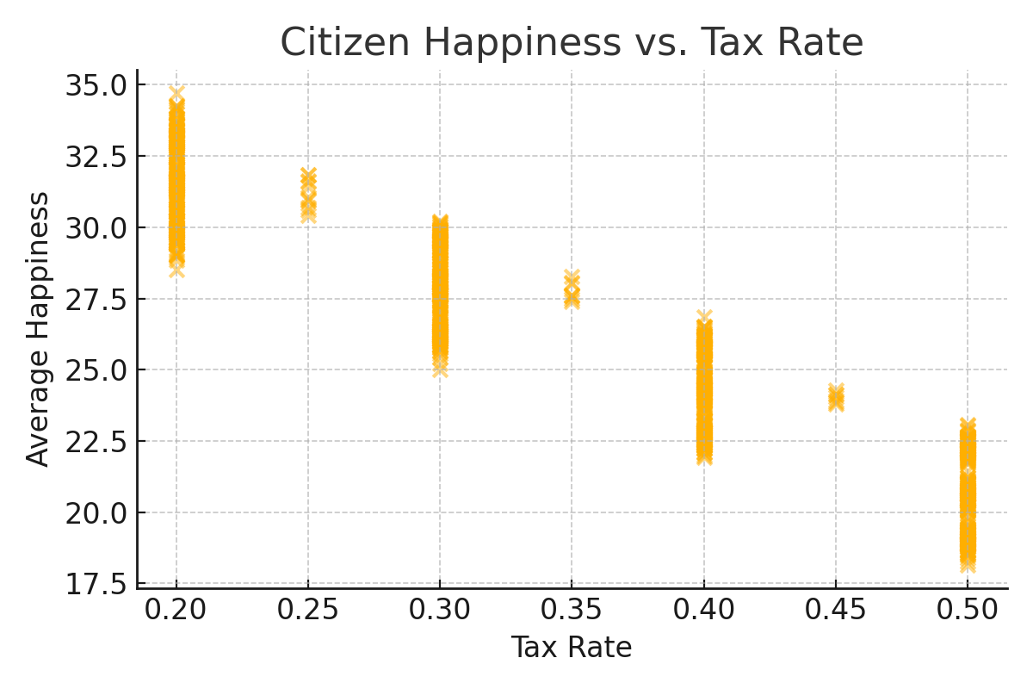

Figure 1: Citizen Happiness vs. Tax Rate.

## 4.2 Economic Growth vs. Interest Rate

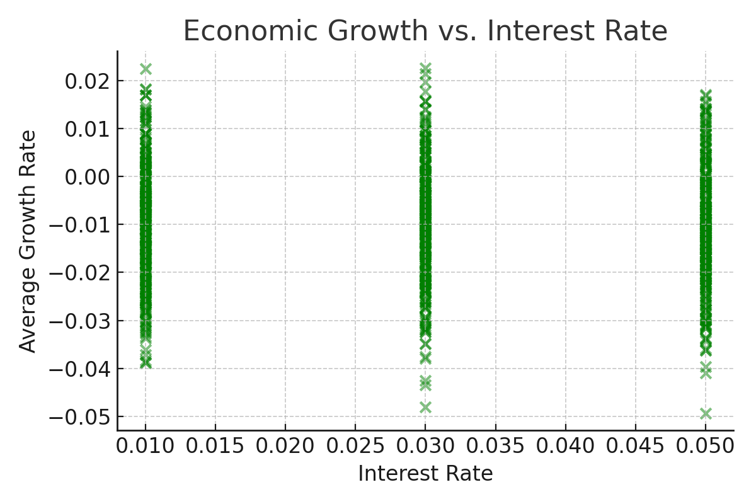

Figure 2: Economic Growth vs. Interest Rate.

## 4.3 Citizen Happiness vs. Social Services Spending

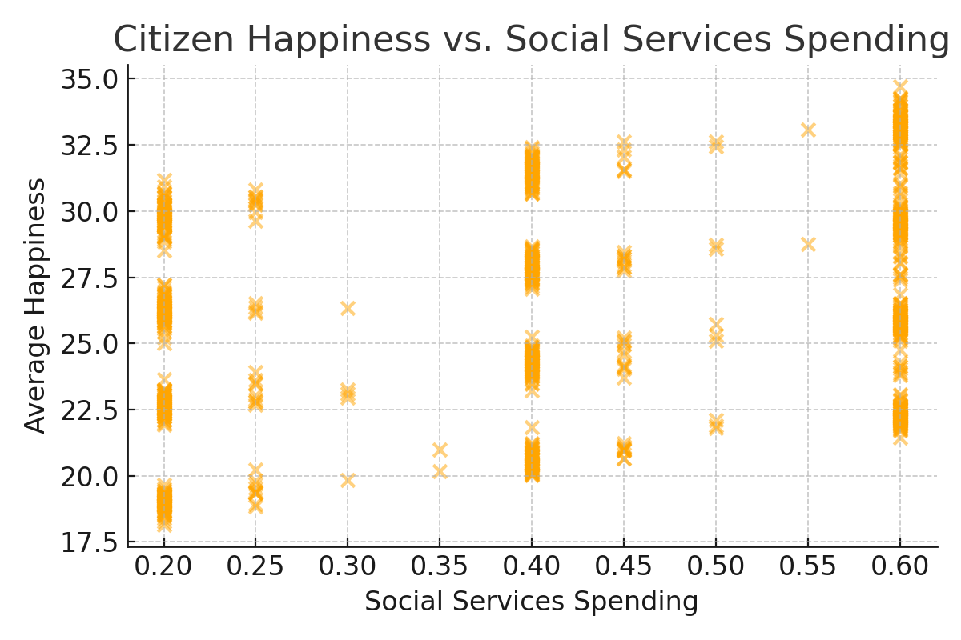

Figure 3: Citizen Happiness vs. Social Services Spending.

## 4.4 Government Revenue vs. Import Duty Rate

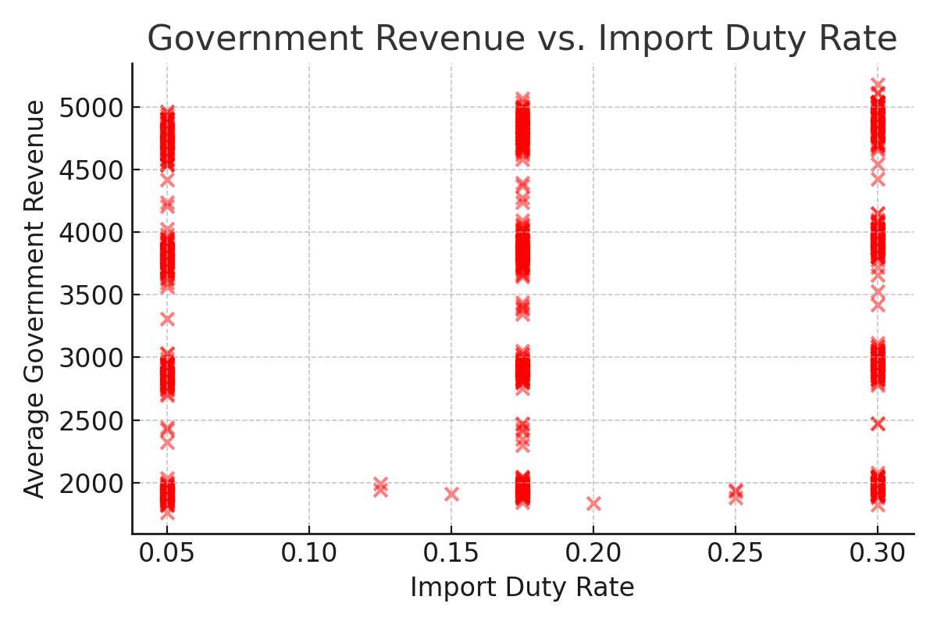

Figure 4: Government Revenue vs. Import Duty Rate.

# 5. Limitations

This model is intended as a conceptual framework, not a predictive tool. It simplifies many real-world complexities, including:  
- Homogenous business sectors and labor markets  
- Simplified financial systems  
- Abstract representations of cultural and political differences  
  
Future work would require calibration against real-world data, more sophisticated agent behavior, and richer cross-country interactions.

# 6. Conclusion and Future Work

This proof-of-concept demonstrates the potential of agent-based modelling to explore macroeconomic policy outcomes in a flexible, bottom-up manner. Future enhancements could include:  
- Adding international trade between countries  
- Modeling financial markets and credit systems  
- Introducing behavioral economics factors (e.g., bounded rationality, adaptive learning)  
- Calibration with empirical economic data  
  
That said, it is important to emphasize that the model in its current form is still far from useful in terms of yielding real macroeconomic insight. The assumptions are intentionally crude, and much work remains to be done to make the model a truly valuable tool. As George Box famously said, "All models are wrong, but some are useful." This model is certainly still in the "wrong and not yet useful" category. It serves as a skeleton or framework—a sketch of what a more robust and nuanced ABM-based macroeconomic model might one day become.  
  
The project, including all source code, is openly available at https://github.com/pieterSteenekamp/bottom-up-macroeconomics. Contributions and collaboration are welcome.

# Acknowledgements

The author gratefully acknowledges the indispensable assistance of artificial intelligence in both developing the underlying computer code and in preparing this report. While the high-level ideas and conceptual direction of this work are entirely my own, I would not have been able to complete this project within the limited time I had available without the speed, breadth, and reliability of AI support. From debugging code to refining written explanations, AI played a crucial and enabling role. This collaboration between human insight and machine assistance illustrates the transformative potential of modern tools—not just in the domains of economics and modelling, but in research and creativity more broadly.