OPTAM-MPC
Hands-on Application Tutorial
Part 2: The 2×2 Linear Heat Exchanger
Interaction, measured-disturbance feedforward, scaling, mismatch and detuning
Applies to | OPTAM-MPC Linear Starter v0.6.0
Prerequisite | Tutorial Part 1 or equivalent familiarity
Issue | Draft 1 — 6 September 2026
Method | Predict → configure → validate → run → record evidence
The frozen software and user manual remain authoritative.

How Part 2 extends Part 1
Part 1 used one CV, one MV and an unmeasured disturbance. Part 2 retains the same frozen engine and generic commands, but introduces the coordination problem that makes MPC especially useful: both valves affect both controlled variables, and two measured disturbances can be used before their full effect appears at the outlet.
Part 1 | Part 2
1 measured CV | 2 measured CVs
1 MV | 2 interacting MVs
No measured DVs | 2 measured DVs
One integrator path | Seven nonzero first-order paths
Hidden-disturbance feedback | Feedforward plus velocity-form feedback
Single baseline | Baseline, feedforward comparison and mismatch challenge

LEARNING CONTRACT You will not edit Python or the controller core. Every application change is made through copied generic TOML templates, and every conclusion must be tied to numerical evidence.

What you will be able to explain
- Why equal opening of both valves mainly changes flow, while unequal opening changes mixed temperature.
- Why CV normalization matters before choosing relative weights.
- How measured-DV feedforward differs from future preview.
- Why velocity-form feedback is still required when measured feedforward is enabled.
- Why a nominally successful controller can oscillate when plant gain, lag and delay are wrong.
- Why detuning is a robustness trade-off rather than a universal cure.

Module 3 — Understand the 2×2 control problem
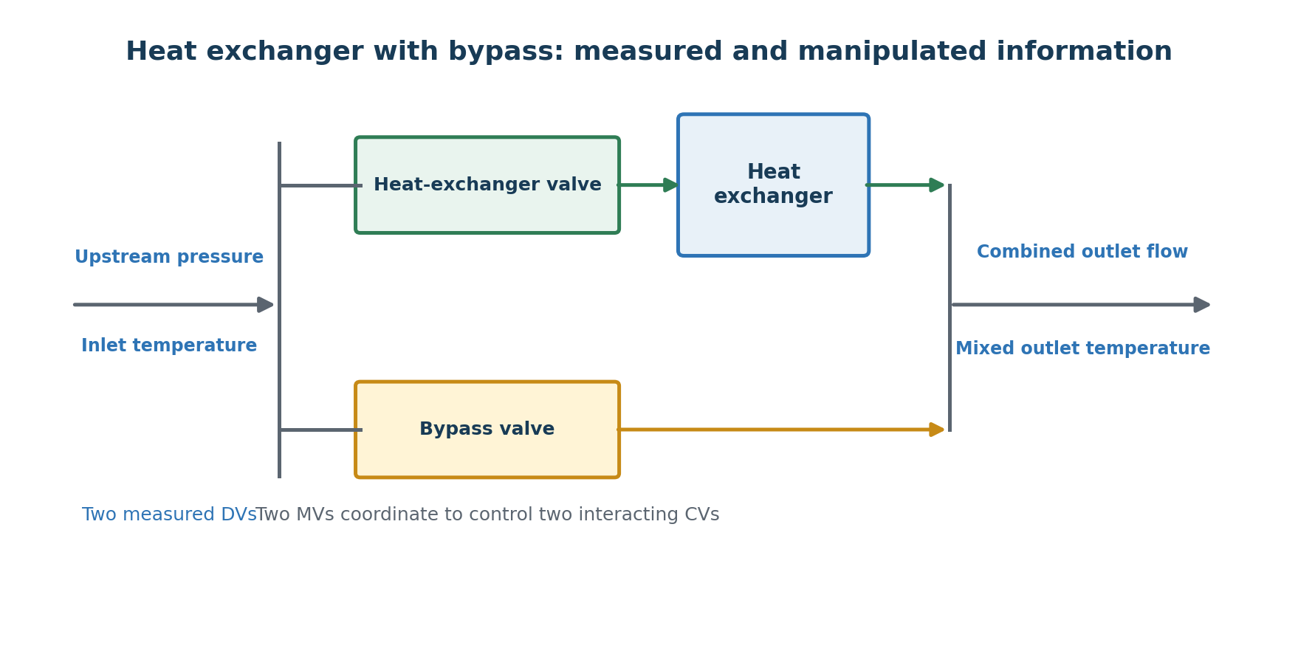
Figure 1. Both valves are manipulated; upstream pressure and inlet temperature are measured disturbances.

3.1 Process objective
A process stream splits into an exchanger branch and a bypass branch, then recombines. The controller must maintain combined outlet flow and mixed outlet temperature. The exchanger-line and bypass-line valves are both available for manipulation. Inlet temperature and upstream pressure are measured before their effects have completely reached the outlet.
Variable | Nominal and operating information
Combined outlet flow CV | 60 m³/h target; protected range 45–75 m³/h
Mixed outlet temperature CV | 64 °C target; protected range 55–75 °C
HX valve MV | 50%; allowed 25–75%; move ≤1 percentage point/sample
Bypass valve MV | 50%; allowed 25–75%; move ≤1 percentage point/sample
Inlet-temperature DV | 40 °C nominal
Upstream-pressure DV | 5 barg nominal

PAUSE AND PREDICT To raise flow without changing temperature much, should the valves move together or in opposite directions? To raise temperature at approximately unchanged flow, how should they move?

Because both valve-to-flow gains are positive and equal, common opening raises flow. Because the bypass valve has a negative temperature gain while the exchanger valve has a small positive temperature gain, temperature increase at approximately constant flow requires opening the exchanger valve and closing the bypass valve in a coordinated fashion.

3.2 The seven-path linear model
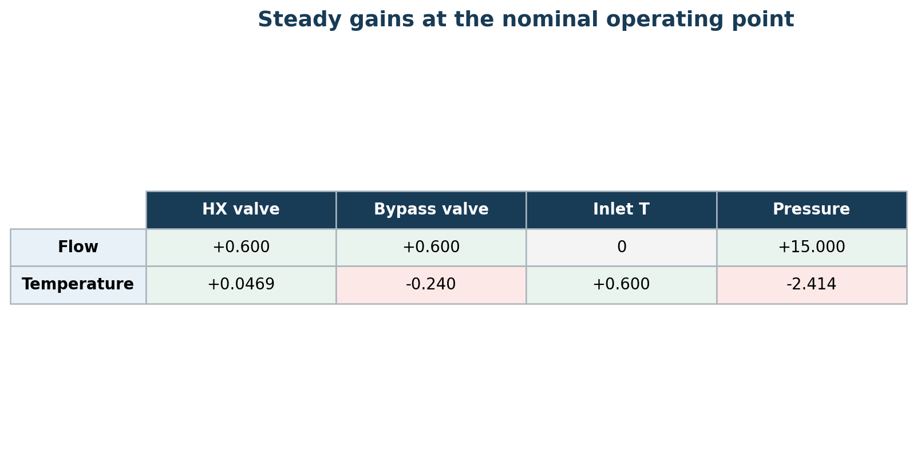
Figure 2. Positive cells raise the destination; red cells reduce it. Units differ by row and source.
Path | Dynamic model
HX valve → flow | K=+0.6 (m³/h)/%; τ=10 s; θ=0 s
Bypass valve → flow | K=+0.6 (m³/h)/%; τ=10 s; θ=0 s
HX valve → temperature | K=+0.046867 °C/%; τ=45 s; θ=5 s
Bypass valve → temperature | K=−0.24 °C/%; τ=35 s; θ=5 s
Inlet temperature → temperature | K=+0.6 °C/°C; τ=25 s; θ=15 s
Pressure → flow | K=+15 (m³/h)/bar; τ=10 s; θ=0 s
Pressure → temperature | K=−2.414157 °C/bar; τ=40 s; θ=5 s

The omitted inlet-temperature-to-flow path has zero gain under the stated constant-property assumptions. Seven nonzero paths are therefore correct; an 8-path full matrix is not automatically better.
MODEL BOUNDARY The steady gains are derived from illustrative physical equations. Lags and delays are engineering assumptions. They are not identified plant data and must not be presented as such.

3.3 Scaling before weighting
Flow error and temperature error cannot be compared directly because they use different units and typical magnitudes. The objective uses normalized errors:
normalized flow error = (flow − target) / 5 m³/h
normalized temperature error = (temperature − target) / 2 °C
With both CV weights equal to 1, a 5 m³/h flow error and a 2 °C temperature error contribute equally before considering their future duration. Weight is priority after scaling; normalization is the engineering scale that makes the comparison meaningful.
PAUSE AND PREDICT If temperature normalization were incorrectly changed from 2 °C to 20 °C with weights unchanged, would temperature become effectively more or less important?

Module 4 — Configure the controller from generic templates

4.1 Create the application workspace
mkdir applications\my_hx
copy application_template.toml applications\my_hx\application.toml
copy simulation_template.toml applications\my_hx\simulation.toml
copy opc_template.toml applications\my_hx\opc.toml
NO SHORTCUTS Build from the generic files. Consult the completed reference only after your own configuration validates or you have recorded exactly where you became blocked.

4.2 Controller structure
[application]
name = "Heat exchanger with bypass"
sample_time_seconds = 5
model_type = "linear_paths"
[controller]
prediction_form = "velocity"
prediction_horizon_samples = 30
control_horizon_samples = 10
maximum_solver_cpu_seconds = 4
use_measured_disturbances = true
The prediction horizon is 150 seconds and the control horizon is 50 seconds. The controller uses current DV measurements across the prediction; it does not know the future event schedule.

4.3 Configure two CVs
Field | Flow / temperature
Initial and target | 60 m³/h / 64 °C
Weight | 1 / 1
Normalization | 5 m³/h / 2 °C
Protected low | 45 m³/h / 55 °C
Protected high | 75 m³/h / 75 °C
Protected-limit weight | 1000 / 1000
Protected-limit normalization | 2 / 2

4.4 Configure two MVs and two measured DVs
[[mvs]]
id = "hx_valve"
name = "Heat-exchanger valve"
unit = "%"
initial = 50
lower = 25
upper = 75
maximum_increase_per_sample = 1
maximum_decrease_per_sample = 1
move_weight = 0.05
move_normalization = 1
[[mvs]]
id = "bypass_valve"
name = "Bypass valve"
unit = "%"
initial = 50
lower = 25
upper = 75
maximum_increase_per_sample = 1
maximum_decrease_per_sample = 1
move_weight = 0.05
move_normalization = 1
[[measured_disturbances]]
id = "inlet_temperature"
name = "Inlet temperature"
unit = "degC"
initial = 40
[[measured_disturbances]]
id = "upstream_pressure"
name = "Upstream pressure"
unit = "barg"
initial = 5
A measured DV is information supplied to the controller, not a variable it can manipulate. Do not declare a disturbance measured merely because it exists in a simulation.

4.5 Convert every path to first_order
[[model_paths]]
source = "hx_valve"
destination = "flow"
type = "first_order"
gain = 0.6
time_constant_seconds = 10
dead_time_seconds = 0
engineering_basis = "DESIGN_BASIS.md: local physical gain; illustrative lag/delay"
[[model_checks]]
source = "hx_valve"
destination = "flow"
metric = "steady_change"
step = 1
expected_change = 0.6
tolerance = 1e-10
Repeat the complete path and check blocks for all seven nonzero relationships. Do not leave generic integrator paths or irrelevant template blocks. Add the explicit zero-gain implementation check for inlet temperature → flow.
CHECKPOINT application.toml must contain 2 CVs, 2 MVs, 2 measured DVs, 7 first-order paths, 7 nonzero steady-change checks and 1 zero-gain check.

4.6 Validate the model implementation
validate_application.bat applications\my_hx\application.toml
Read all eight check results. Validation confirms that the configured path bank produces the independently specified steady changes. It does not validate the physical assumptions against a real plant.
HONEST FAILURE CHALLENGE Change the pressure-to-temperature expected gain to +2.414 instead of −2.414. Validate, explain the physical sign, then restore the correct value.

Module 5 — Build and run the combined scenario

5.1 Independent plant structure
The simulation has two outputs, two MV inputs and two measured-DV inputs. Each controller ID is mapped explicitly. The independent plant repeats the seven physical paths; it is not generated from the controller configuration.
Sample | Change
20 | Flow target 60 → 64 m³/h
100 | Flow target → 60 m³/h
180 | Temperature target 64 → 67 °C
260 | Temperature target → 64 °C
340 | Inlet temperature 40 → 37 °C
420 | Inlet temperature → 40 °C
500 | Pressure 5 → 5.4 barg
580 | Pressure → 5 barg

PAUSE AND PREDICT For each target or disturbance change, predict the initial direction of both valves and both CVs. Pay special attention to the pressure event: it directly raises flow and lowers temperature.

5.2 Acceptance criteria
- Zero solver failures.
- Flow remains within 45–75 m³/h and temperature within 55–75 °C.
- Both valve positions remain within 25–75%.
- Neither valve moves more than 1.000001 percentage points per sample.
- Both CVs meet their intermediate setpoint checks within 0.15 engineering units.
- Final flow and temperature errors are each below 0.1 engineering units.

5.3 Validate and run
validate_application.bat applications\my_hx\application.toml applications\my_hx\simulation.toml applications\my_hx\opc.toml
run_simulation.bat applications\my_hx\application.toml applications\my_hx\simulation.toml
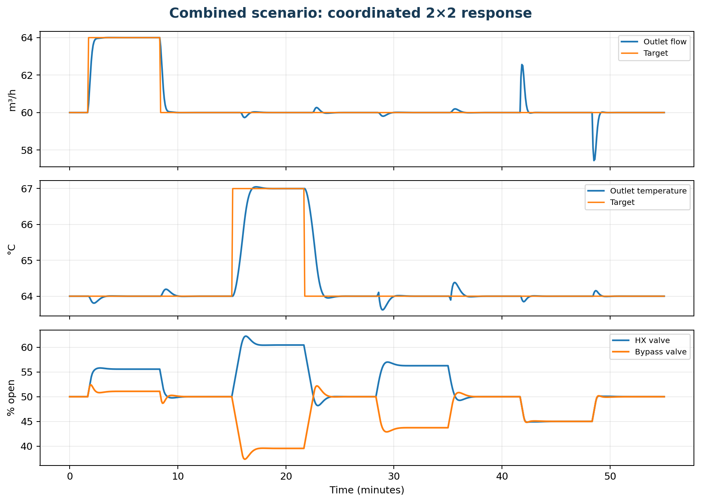
Figure 3. Frozen combined-scenario reference: coordinated setpoint and disturbance response.
Reference evidence | Value
Flow range | 57.43798–64.00357 m³/h
Temperature range | 63.61929–67.04813 °C
Largest HX-valve move | 0.99999998 percentage points/sample
Largest bypass move | 1.00000001 percentage points/sample
Final errors | <0.000002 in both CV engineering units
Acceptance | PASS; zero solver failures

Module 6 — Isolate the value of measured-DV feedforward

6.1 A controlled comparison
Use the same plant, disturbance events, targets, bounds and CV tuning in both runs. The only controller difference is use_measured_disturbances. With feedforward disabled, the actual twin disturbances still occur; only the controller’s DV values are held nominal. This isolates the effect of using the measurements.
run_simulation.bat applications\my_hx\application.toml applications\my_hx\disturbances.toml --output results\hx_ff_on
run_simulation.bat applications\my_hx\application_no_feedforward.toml applications\my_hx\disturbances.toml --output results\hx_ff_off
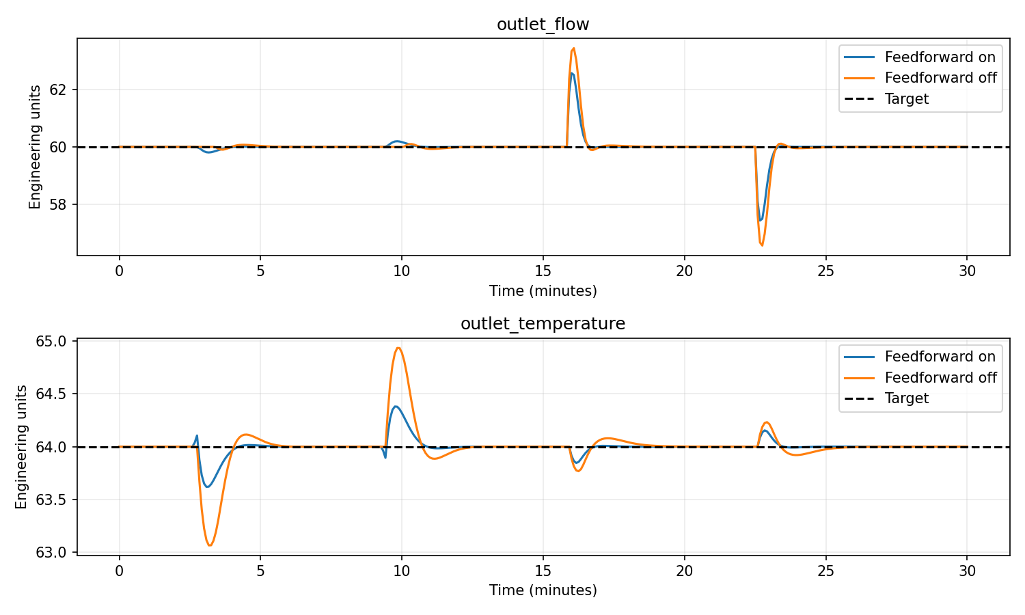
Figure 4. Feedforward reduces error, but feedback remains essential because the model is imperfect and not every disturbance will be measured.
Metric | Feedforward on / off
Flow IAE | 2.244 / 3.157 (m³/h)·min
Flow peak error | 2.562 / 3.431 m³/h
Temperature IAE | 0.757 / 2.063 °C·min
Temperature peak error | 0.381 / 0.935 °C

INTERPRET CAREFULLY Feedforward is better in this supplied case because the DV models are useful. It is not automatically beneficial when measurements are bad or disturbance models have incorrect sign, timing or gain.

6.2 Feedforward is not preview
The controller learns of a DV change only when the measurement changes. It then predicts the future CV effect using the path lag and dead time. It does not read the simulation event table or know a disturbance before it is measured.
PAUSE AND PREDICT Why is inlet-temperature feedforward especially helpful when its outlet-temperature path includes 15 seconds of dead time?

Module 7 — Deliberate mismatch and detuning

7.1 The mismatch challenge
The mismatch twin multiplies every nonzero plant gain by 1.15, every lag by 1.20, and adds 5 seconds to every delay. The controller model is unchanged. This deliberately combines magnitude and timing errors.
run_simulation.bat applications\my_hx\application.toml applications\my_hx\mismatch.toml --output results\hx_mismatch_aggressive
EXPECTED HONEST FAILURE The nominal move weights of 0.05 produce sustained flow oscillation. Final-value-only acceptance could miss it, so the scenario checks the complete final five-minute window.

7.2 Detune only the move penalties
Increase each valve move weight from 0.05 to 0.5. Do not change the plant, CV weights, horizons, limits or mismatch. This makes the comparison interpretable.
run_simulation.bat applications\my_hx\application_detuned.toml applications\my_hx\mismatch.toml --output results\hx_mismatch_detuned
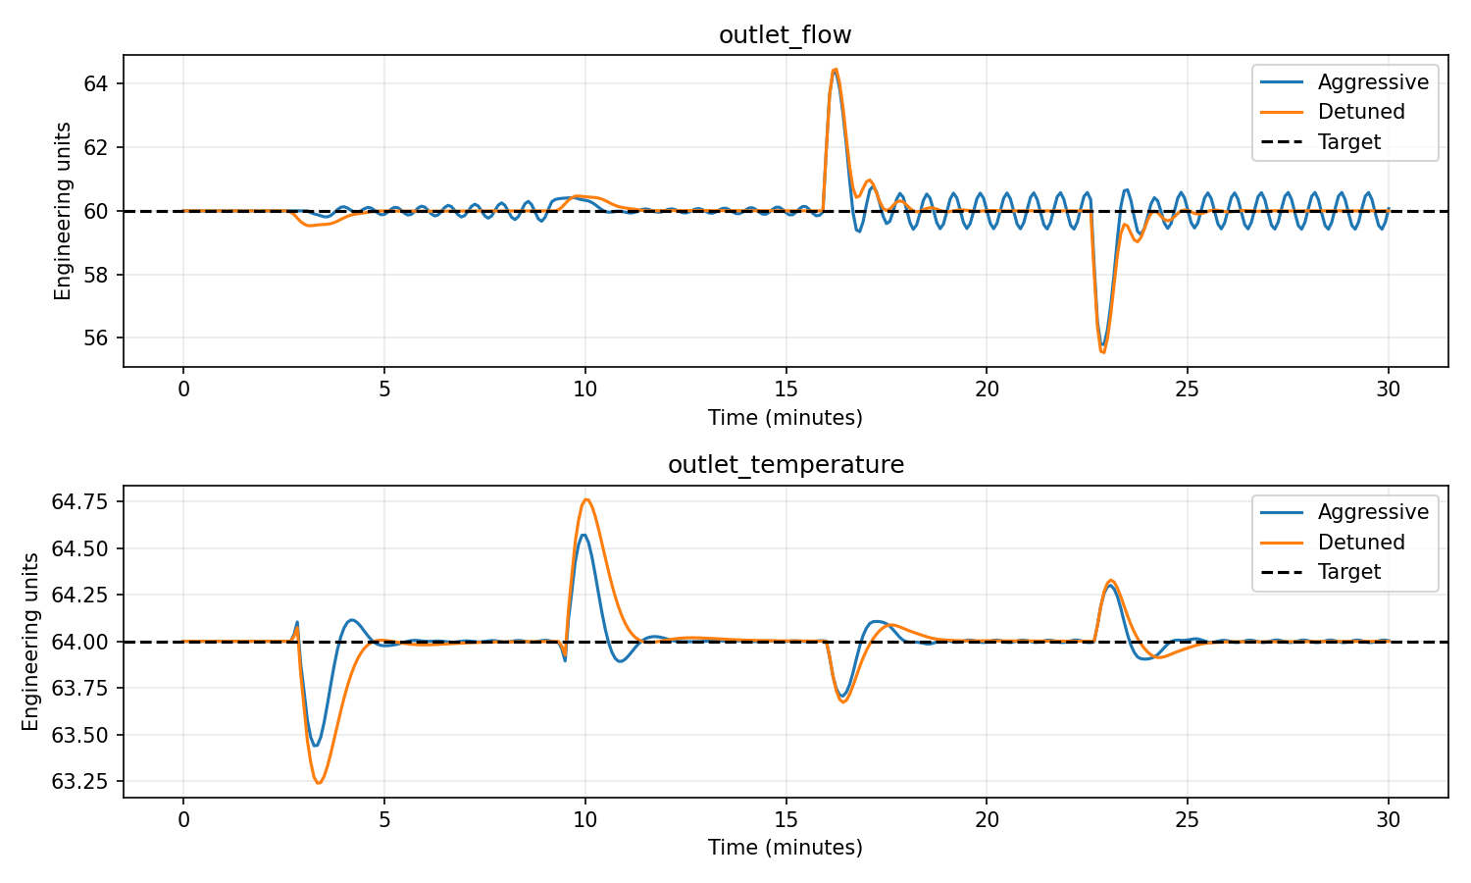
Figure 5. Detuning removes sustained oscillation in this mismatch case, while some transient peaks become larger.
Final five-minute maximum error | Aggressive / detuned
Flow | 0.5777 / 0.0974 m³/h
Temperature | 0.0132 / 0.0360 °C
Acceptance | FAIL / PASS

Detuning improves robustness here, but it is a trade-off. Temperature IAE and peak error increase in the detuned case. A controller should not be declared ‘better’ using only one metric.
ENGINEERING CONCLUSION Choose tuning against a declared uncertainty set and operational priorities. Passing one mismatch case does not prove general robustness.

Module 8 — OPC and completion record

8.1 Run the accepted nominal application through OPC UA
run_digital_twin.bat applications\my_hx\application.toml applications\my_hx\simulation.toml applications\my_hx\opc.toml
Wait for Twin READY, then open a second Command Prompt:
run_controller.bat applications\my_hx\application.toml applications\my_hx\opc.toml
Optional third window:
opc_tools.bat applications\my_hx\opc.toml trend applications\my_hx\simulation.toml
The OPC result should reproduce the accepted offline trajectory. The local test verifies process separation and protocol behaviour; it does not commission an external plant OPC server.

8.2 Completion checklist
- I built the 2×2 application from generic templates without editing Python.
- I can explain all seven nonzero path signs.
- I scaled CV errors before interpreting their equal weights.
- I kept measured DVs distinct from hidden disturbances and future preview.
- I performed a controlled feedforward-on/off comparison.
- I observed an intentionally failed mismatch case and understand why final-value checks were insufficient.
- I detuned only the MV move penalties and recorded both benefits and costs.
- I can state what the OPC equivalence test does and does not prove.

8.3 Independent-engineer evidence
Record | Purpose
Time to first valid 2×2 model | Tests template and validation usability
Incorrect path signs or units | Tests design-basis clarity
Questions about feedforward | Tests conceptual distinction
Predicted versus observed valve directions | Tests interaction understanding
Mismatch diagnosis | Tests evidence-based reasoning
Suggested tutorial changes | Basis for Draft 2

Where to go next
After independent review of Parts 1 and 2, the next tutorial should rebuild this same heat-exchanger problem with modest nonlinear equations. Keeping the physical arrangement and objectives familiar isolates what genuinely changes when the prediction model becomes nonlinear.
PROPOSED PART 3 Nonlinear model contract, operating domain, nonlinear transition function, symbolic/numeric checks, linear-versus-nonlinear evidence, mismatch and domain-failure exercises.

Appendix A — Supplied exercise files
- 00_blank_templates: untouched generic Linear Starter v0.6.0 templates.
- 90_completed_reference: application, no-feedforward application, detuned application, combined scenario, disturbance scenario, mismatch scenario, OPC file and design basis.
- verified_results: frozen reference outputs for nominal, feedforward and mismatch comparisons.
- engineering_record.md: predictions, validation failures, metrics and conclusions.

Appendix B — Minimum command set
validate_application.bat <application> [simulation] [opc]
run_simulation.bat <application> <simulation> [--output <folder>]
run_digital_twin.bat <application> <simulation> <opc>
run_controller.bat <application> <opc>
opc_tools.bat <opc> trend <simulation>
opc_tools.bat <opc> stop

