OPTAM-MPC
Hands-on Application Tutorial
Part 3: Rebuild the Heat Exchanger as NMPC
Nonlinear equations, model contract, domain checks, independent calculations and honest evidence
Applies to | OPTAM-MPC Nonlinear Starter v0.2.0
Prerequisite | Tutorial Parts 1 and 2, or equivalent familiarity
Issue | Draft 1 — 6 September 2026
Method | Predict → configure → calculate → validate → run → record evidence
The frozen starter and user manual remain authoritative.

Why Part 3 keeps the same heat exchanger
Part 2 taught multivariable interaction with seven linear paths. Part 3 keeps the same measured signals, valves and control objectives, but replaces the path bank with one nonlinear state-transition function. The learner can therefore see exactly what the nonlinear model changes without simultaneously learning a new process.
Part 2: linear | Part 3: nonlinear
Seven independent first-order paths | One coupled transition function
Constant local gains | Gain varies with operating point
Path-specific lags and delays | Two lumped output lags; no explicit delay
TOML contains the model | TOML parameters plus engineer-owned model.py
Eight path checks | Five whole-model next-sample checks
Linear superposition applies | Responses need not add

HONEST SCOPE This example is deliberately only mildly nonlinear. It teaches the workflow; it is not evidence that NMPC will outperform linear MPC on every plant.

Learning outcomes
- Explain the four nonlinear mechanisms in engineering terms.
- Write a small CasADi-compatible transition function without changing the controller core.
- Define safe model domains and parameter checks.
- Calculate at least one next sample independently before trusting Python.
- Distinguish model consistency, simulation acceptance and plant validity.
- Explain why velocity-form feedback remains valuable with model mismatch.

Module 9 — See what is genuinely nonlinear
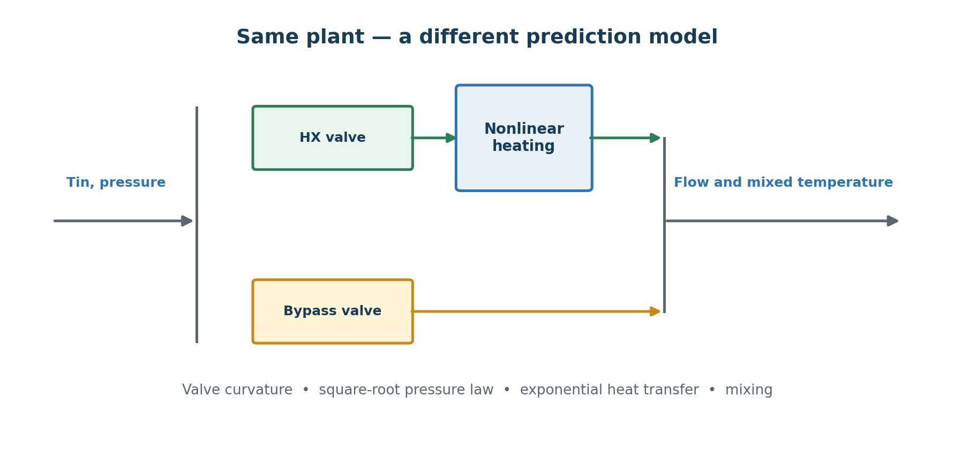
Figure 1. The physical arrangement is unchanged; the steady calculation is now coupled and nonlinear.

9.1 Variables and operating range
Role | Definition and tutorial range
CV flow | 60 m³/h nominal; protected 45–75; model domain 30–90
CV temperature | 64 °C nominal; protected 55–75; domain 45–85
HX and bypass MVs | 50% nominal; hard 35–65%; move ≤1 point/sample
Inlet-temperature DV | 40 °C nominal; domain 37–43
Pressure DV | 5 barg nominal; domain 4.6–5.4

9.2 The four nonlinear mechanisms
- Valve curvature: each branch flow includes c(v−1)².
- Pressure: both branch flows scale with the square root of differential pressure.
- Heat transfer: heated temperature contains exp(−A/qh), so effectiveness changes with flow.
- Mixing: outlet temperature is a flow-weighted ratio, not an independent additive path.
PAUSE AND PREDICT At higher HX-branch flow, does the branch have more or less time to approach the hot-side temperature? What happens to heat-exchanger effectiveness?

9.3 The equations
h = hx_valve / 50 b = bypass_valve / 50
s = sqrt((pressure - 3) / 2)
qh = 30 * (h + c*(h - 1)^2) * s
qb = 30 * (b + c*(b - 1)^2) * s
Qeq = qh + qb
Theated = 100 - (100 - Tin) * exp(-A/qh)
Teq = (qh*Theated + qb*Tin) / Qeq
At the nominal point c=0.1 and A=30 ln(5). Both branches carry 30 m³/h, the heated branch is 88 °C, and mixing equal branch flows gives 64 °C.

Module 10 — Understand the nonlinear model contract
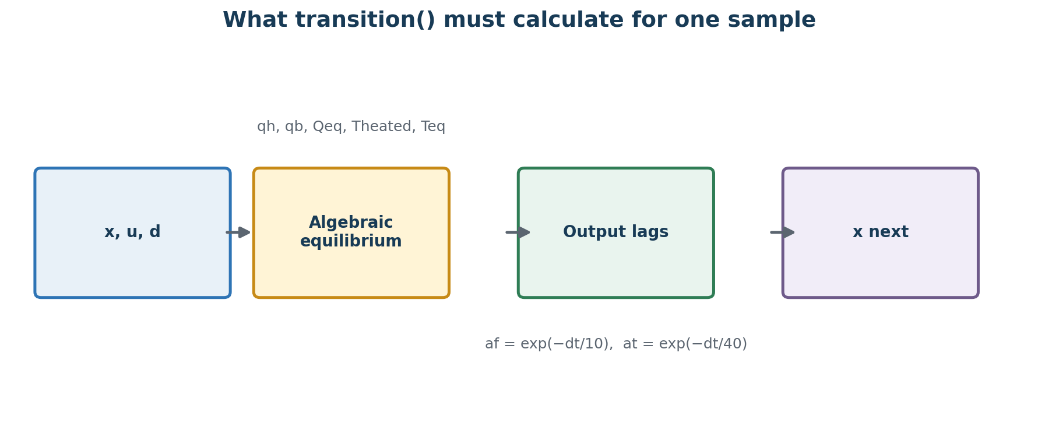
Figure 2. transition() returns the absolute next state after one controller sample.

10.1 The engineer owns only one small Python extension
Copy model_template.py beside application.toml and rename it model.py. The starter still owns optimisation, velocity-form prediction, simulation, OPC, plots and reports. The engineer supplies signal order, parameter validation and the physical transition equations.
STATE_IDS = ("flow", "temperature")
MV_IDS = ("hx_valve", "bypass_valve")
DV_IDS = ("inlet_temperature", "upstream_pressure")
ORDER IS A CONTRACT The ID tuples must match the TOML order exactly. A physically correct formula connected to the wrong ID is still a wrong controller model.

10.2 Numeric and symbolic compatibility
During validation the same function is evaluated with ordinary numbers and CasADi symbolic expressions. Use casadi.exp and casadi.sqrt for expressions involving x, u or d. Do not hide equations in unreviewed helper modules.
def transition(x, u, d, p, dt):
pressure_factor = ca.sqrt((d["upstream_pressure"] - p["downstream_pressure"])
/ (p["pressure_nominal"] - p["downstream_pressure"]))
# calculate qh, qb, total, heated and mixed
af = ca.exp(-dt / p["flow_tau_seconds"])
at = ca.exp(-dt / p["temperature_tau_seconds"])
return {"flow": af*x["flow"] + (1-af)*total,
"temperature": at*x["temperature"] + (1-at)*mixed}

10.3 Absolute state—not an increment
transition() must return the predicted absolute CV values one sample later. The controller itself applies velocity-form anchoring. Returning only Δflow and Δtemperature would double-confuse the state update and is a fundamental implementation error.

Module 11 — Build from the generic templates

11.1 Create an independent workspace
mkdir applications\my_nonlinear_hx
copy application_template.toml applications\my_nonlinear_hx\application.toml
copy model_template.py applications\my_nonlinear_hx\model.py
copy simulation_template.toml applications\my_nonlinear_hx\simulation.toml
copy opc_template.toml applications\my_nonlinear_hx\opc.toml
DO NOT EDIT THE FROZEN RUNTIME Only the copied application files are learner-owned. Keep the starter, generic templates and completed reference unchanged.

11.2 Configure the controller
[controller]
prediction_form = "velocity"
prediction_horizon_samples = 30
control_horizon_samples = 10
maximum_solver_cpu_seconds = 4
use_measured_disturbances = true
Setting | Part 3 value
Sample time | 5 seconds
CV normalisations | 5 m³/h; 2 °C
CV weights | 1; 1
MV bounds | 35–65%
MV move limits | ±1 point/sample
MV move weights | 0.5; 0.5
Protected-limit weights | 1000; 1000

11.3 Declare parameters and domains
[model]
file = "model.py"
[model.parameters]
branch_flow_nominal = 30
valve_nominal = 50
pressure_nominal = 5
downstream_pressure = 3
inlet_temperature_nominal = 40
hot_temperature = 100
heat_transfer_flow = 48.28313737302301
valve_curvature = 0.1
flow_tau_seconds = 10
temperature_tau_seconds = 40
[model.domain]
flow = [30, 90]
temperature = [45, 85]
hx_valve = [35, 65]
bypass_valve = [35, 65]
inlet_temperature = [37, 43]
upstream_pressure = [4.6, 5.4]
DOMAIN MEANS MATHEMATICAL VALIDITY The lower pressure bound must remain above downstream pressure so the square root is real. A domain is not a substitute for operating limits or process safety protection.

Module 12 — Verify the model before tuning

12.1 Independent cold-inlet calculation
With both valves at 50%, pressure 5 barg and Tin changed from 40 to 37 °C, both branch flows remain 30 m³/h. The heated branch becomes 100 − 63/5 = 87.4 °C and the mixed equilibrium becomes 62.2 °C.
temperature_next
= 64 + (1 - exp(-5/40)) * (62.2 - 64)
= 63.78849442465227 degC
flow_next = 60.0 m3/h
WHY THIS MATTERS The expected result is derived independently of model.py. Copying the program’s own output into the check would only prove that the program agrees with itself.

12.2 Add whole-model checks
- Nominal point remains exactly stationary.
- HX-valve step changes both outputs in the expected direction.
- Bypass-valve step raises flow and lowers temperature.
- Cold-inlet case matches the independent calculation above.
- High-pressure case verifies square-root pressure dependence and coupled temperature response.

12.3 Validate
validate_application.bat applications\my_nonlinear_hx\application.toml applications\my_nonlinear_hx\simulation.toml applications\my_nonlinear_hx\opc.toml
Fresh validation evidence | Result
Numeric/symbolic domain probes | 77
Independent nonlinear checks | 5 of 5 PASS
Nominal solver smoke test | PASS
Configuration/model consistency | PASS

DELIBERATE FAILURE Reverse the sign of the bypass contribution in the mixing equation. Predict which checks fail, validate, record the diagnostic, then restore the equation.

Module 13 — Run and interpret the nonlinear controller

13.1 Combined scenario
Sample | Change
20 / 100 | Flow target 60→64→60 m³/h
180 / 260 | Temperature target 64→66→64 °C
340 / 420 | Tin 40→37→40 °C
500 / 580 | Pressure 5→5.4→5 barg

run_simulation.bat applications\my_nonlinear_hx\application.toml applications\my_nonlinear_hx\simulation.toml --output results\combined
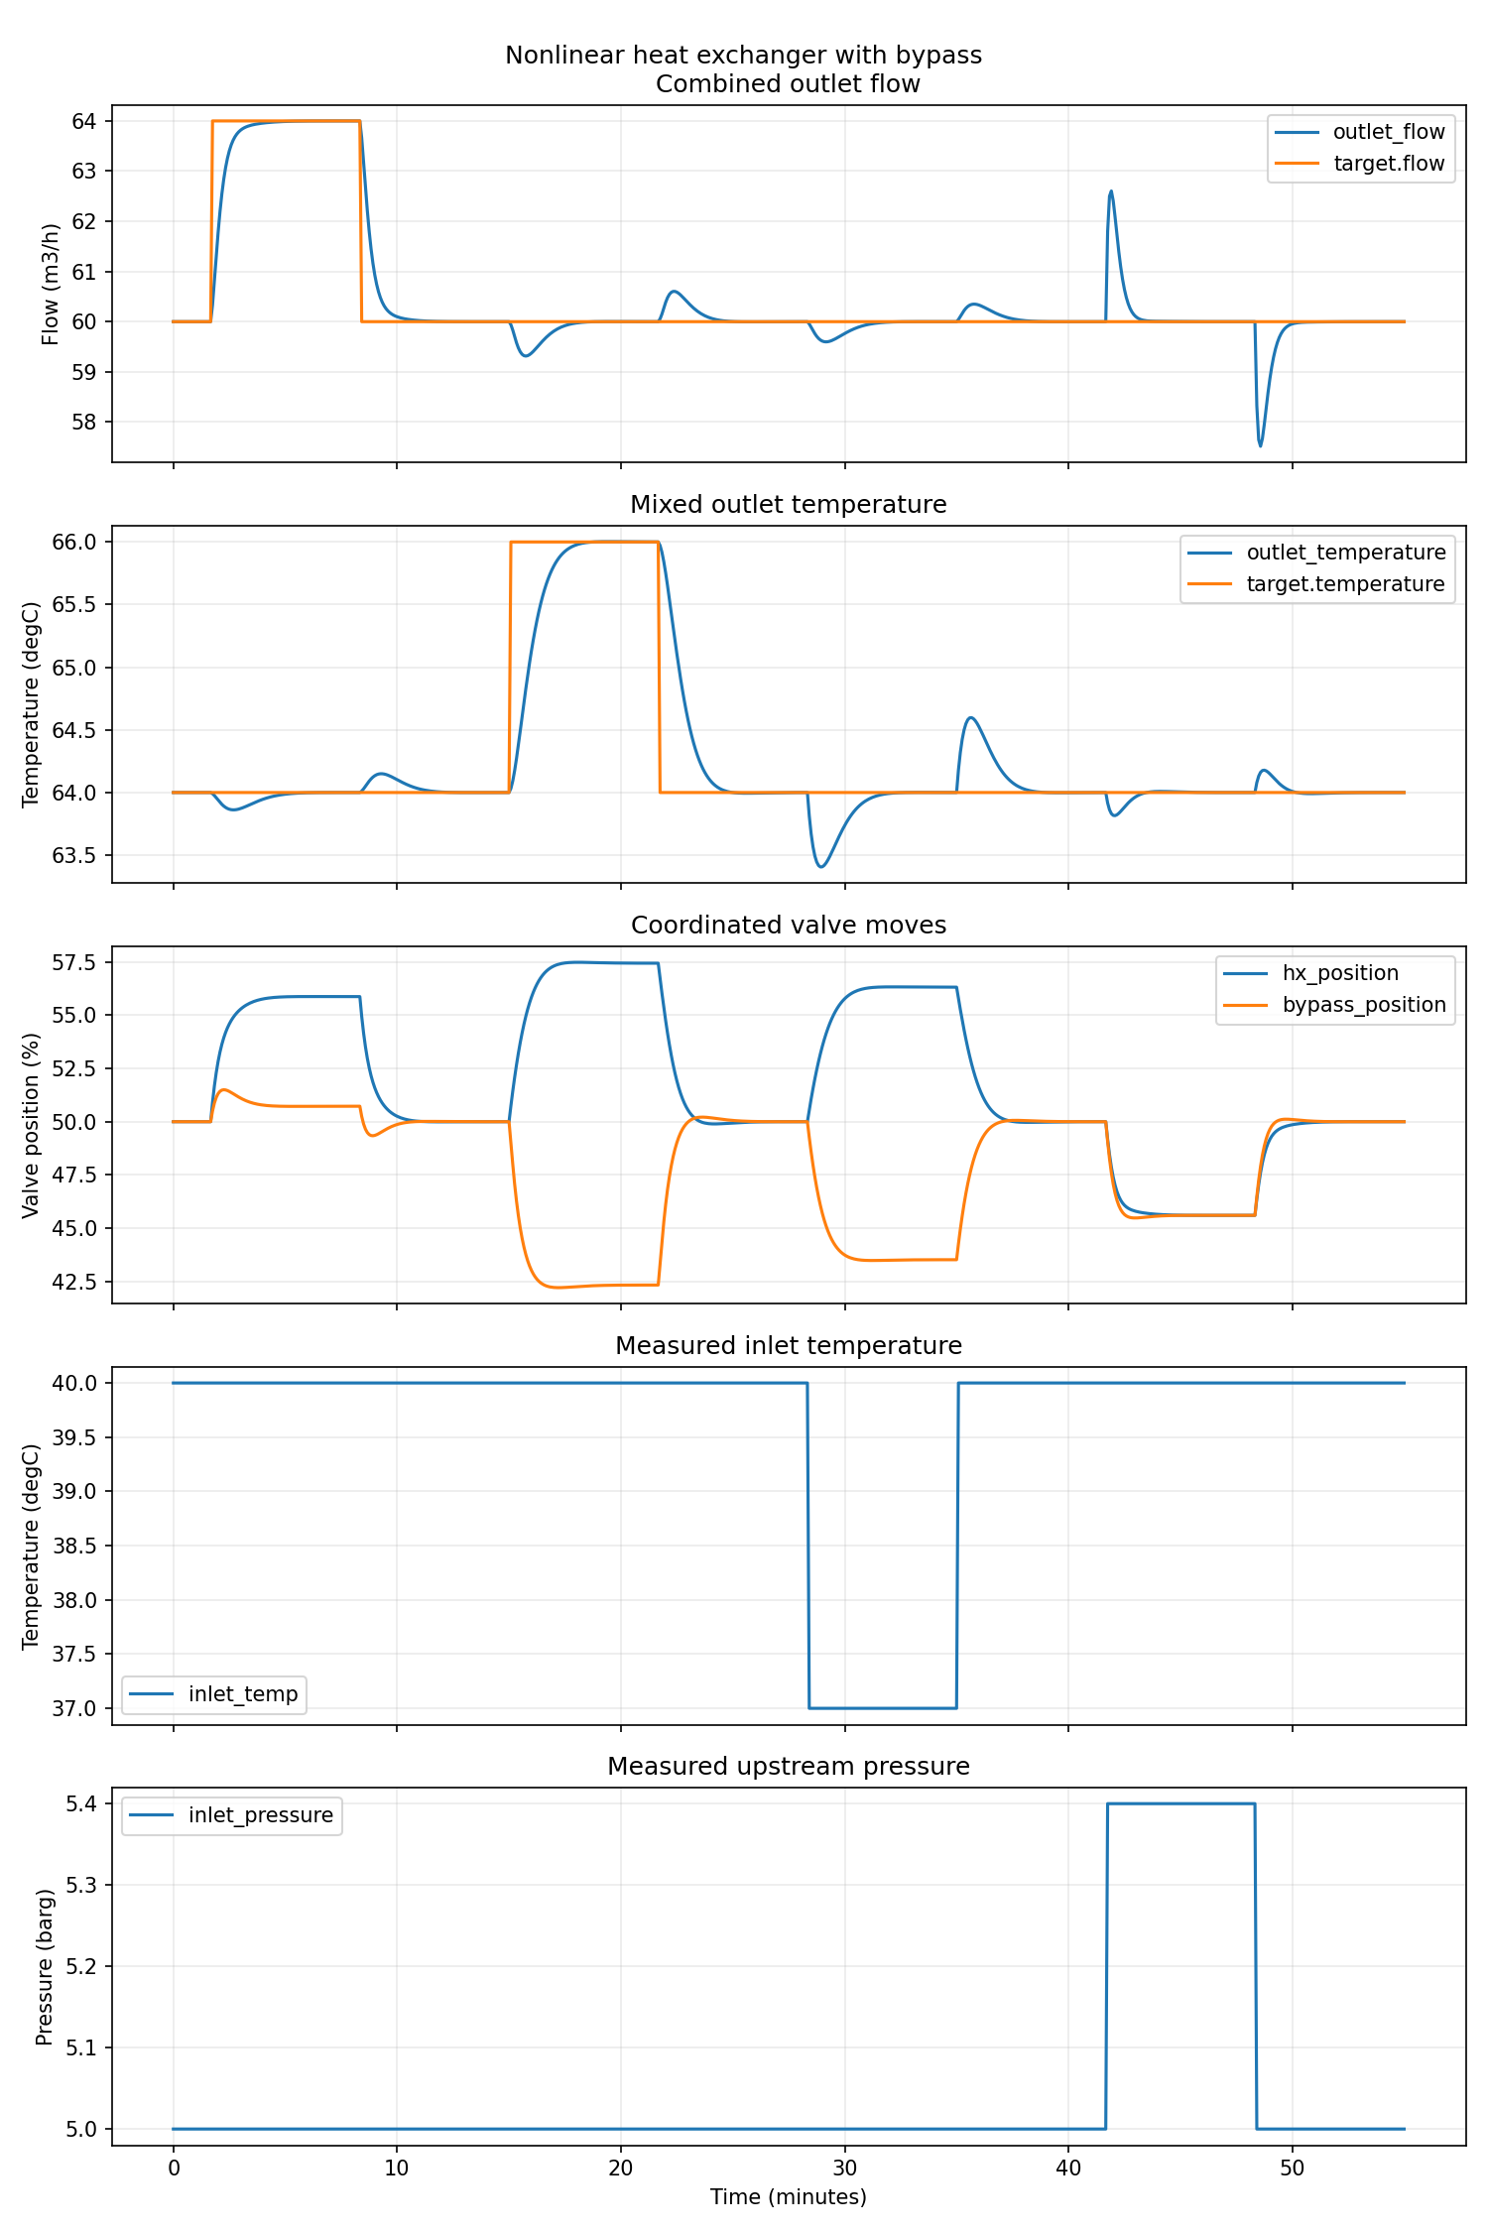
Figure 3. Verified nonlinear combined scenario: setpoint and measured-disturbance responses.
Archived reference evidence | Value
Flow range | 57.5168–64.0001 m³/h
Temperature range | 63.4056–66.0027 °C
Valve ranges | HX 45.60–57.48%; bypass 42.21–51.50%
Maximum moves | HX 0.9316; bypass 1.0000 points/sample
Acceptance | PASS

13.2 Read the valve coordination
A flow target change mainly drives common valve movement. A temperature target change mainly drives differential movement. Pressure affects both branch flows together but also changes exchanger effectiveness; the nonlinear model calculates these effects jointly rather than adding fixed paths.
DO NOT COMPARE FIGURES 2 AND 3 AS A CONTEST Part 2 and Part 3 use different lags, delays, bounds, temperature excursion and tuning. This tutorial comparison is structural, not a fair performance benchmark.

Module 14 — Feedforward, mismatch and limits of evidence

14.1 Feedforward on/off
Repeat the controlled comparison from Part 2. Only use_measured_disturbances changes; plant events and acceptance checks remain identical.
run_simulation.bat applications\my_nonlinear_hx\application.toml applications\my_nonlinear_hx\disturbances.toml --output results\ff_on
run_simulation.bat applications\my_nonlinear_hx\application_no_feedforward.toml applications\my_nonlinear_hx\disturbances.toml --output results\ff_off
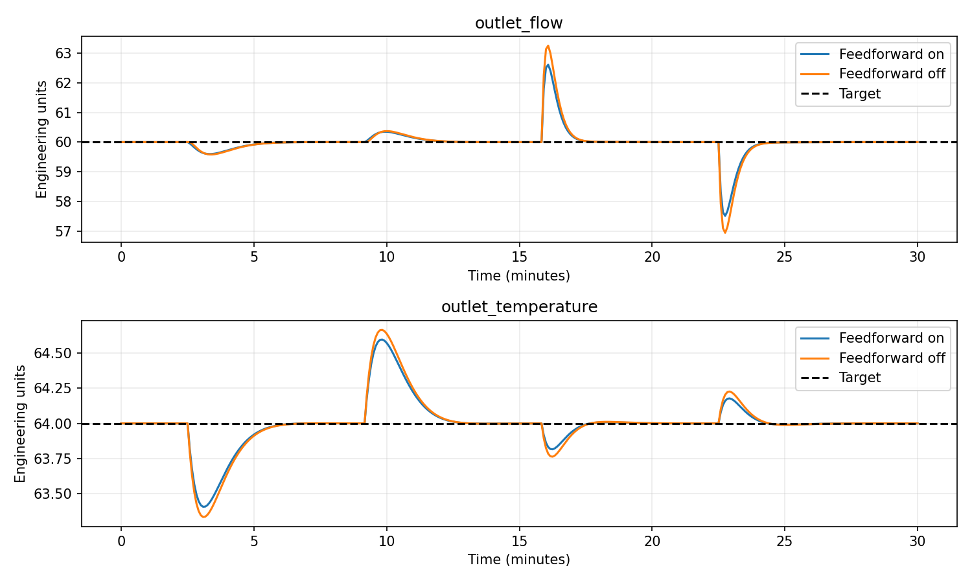
Figure 4. Measured-DV feedforward reduces the disturbance error in this verified example.
Final five-minute max error | Feedforward on / off
Flow | 0.00785 / 0.00906 m³/h
Temperature | 0.00910 / 0.01038 °C
Acceptance | PASS / PASS

14.2 Modest mismatch
The plant time constants increase by 20% and valve curvature doubles from 0.1 to 0.2. The controller remains nominal. This is a separate plant instance using the same equation form, not independent validation against reality.
run_simulation.bat applications\my_nonlinear_hx\application.toml applications\my_nonlinear_hx\mismatch.toml --output results\mismatch
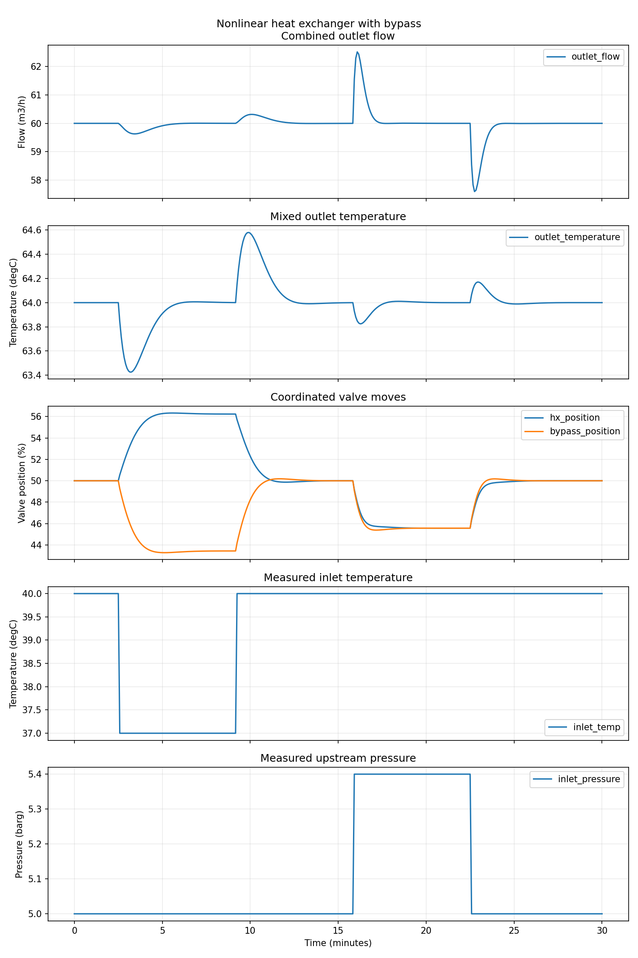
Figure 5. The modest mismatch case passes the declared final-window checks.
Mismatch evidence | Value
Final-window flow error | ≤0.00543 m³/h
Final-window temperature error | ≤0.01111 °C
Acceptance | PASS

FRANK CONCLUSION Passing this modest case is useful regression evidence. It is not a robustness certificate, plant validation, proof of global convergence or proof that all predicted states stay in a physically safe region.

Module 15 — OPC and completion

15.1 Run the accepted case through local OPC UA
run_digital_twin.bat applications\my_nonlinear_hx\application.toml applications\my_nonlinear_hx\simulation.toml applications\my_nonlinear_hx\opc.toml
After Twin READY, open a second Command Prompt:
run_controller.bat applications\my_nonlinear_hx\application.toml applications\my_nonlinear_hx\opc.toml
Optional third window:
opc_tools.bat applications\my_nonlinear_hx\opc.toml trend applications\my_nonlinear_hx\simulation.toml

15.2 Completion checklist
- I created my own four application files from generic templates.
- I can explain every term in the nonlinear equations.
- I calculated one next sample independently.
- I understand absolute transition versus velocity-form anchoring.
- I validated numeric and symbolic evaluation and all declared domains.
- I ran the combined, feedforward and mismatch cases and recorded evidence.
- I can state why this is not a fair linear-versus-nonlinear benchmark.
- I did not edit the frozen controller or runtime.

15.3 Evidence for independent review
Record | What it tests
Time to first valid model.py | Usability for an APC engineer with limited Python
Failed check and diagnosis | Quality of validation feedback
Independent calculation | Protection against circular verification
Predicted valve directions | Physical understanding
Metrics and solver failures | Operational evidence
Suggested wording changes | Input to Draft 2

Where the tutorial series goes next
Part 3 completes the controlled transition from a 1×1 linear example to a 2×2 linear example and then to modest NMPC. A later tutorial can introduce the surge-vessel, heat-exchanger and nonlinear reactor system, where Arrhenius kinetics and residence-time trade-offs create a stronger reason for nonlinear economic optimisation.
RECOMMENDED SEQUENCE Test Parts 1–3 with an independent APC engineer before expanding the process. Their difficulties should determine what is clarified in Draft 2.

Appendix A — Supplied exercise files
- 00_blank_templates: untouched nonlinear application, model, simulation and OPC templates.
- 90_completed_reference: completed nonlinear exchanger files, design basis and verified outputs.
- fresh_verification: current validation, unit-test and simulation evidence produced for this tutorial.
- engineering_record.md: a structured place for predictions, calculations, failures, metrics and conclusions.

Appendix B — Minimum command set
validate_application.bat <application> [simulation] [opc]
run_simulation.bat <application> <simulation> [--output <folder>]
run_digital_twin.bat <application> <simulation> <opc>
run_controller.bat <application> <opc>
opc_tools.bat <opc> trend <simulation>
opc_tools.bat <opc> stop

Appendix C — What validation does not prove
- That the equations match a real plant.
- That unmeasured states are observable; this starter uses measured primary CV states.
- That all possible predicted steps remain inside the physical domain.
- That solver success guarantees a safe move.
- That passing one nominal and one modest mismatch case establishes production readiness.

