FOSDEM 2023 BUILD-UP
AW BUILDING

Contents
Contents
Rooms 5
General timeline 7
FOSDEM -1 week 7
Thursday 7
Friday 7
Finishing touches (mostly network and video). Most volunteers go home. 9
Equipment checklist 10
People checklist 12
Task checklist 13
General timeline 17
Sunday 17
Monday 18
We provide food. 18
Equipment checklist 19
People checklist 20
Task checklist 21
General map 25
Stands 26
Map 26
List 27
Signage 28
Outside 28

Useful information

Rooms
- AW1.120
- AW1.121 (FIT)
- AW1.125 (Stream viewing)
- AW1.126

BUILD-UP
FRIDAY

General timeline

FOSDEM -1 week
- Etat des lieux with team of Arnaud Slotte.

Thursday

17:00 – 20:00
- Load vans at the office with Ulysses. We provide food.

Friday
(Provide your own lunch.)

08:30
- Primary building person arrives at ULB and waits.

08:30 – 12-30
- Rentevent delivery at ULB (building K & building H).
- Solucious Delivery at ULB (building K).

11:00 – 12:00
- Delivery and installation walkie-talkies (Walkies4Events).

11:00
- Staff arrives at ULB.
- Open Kitchen and NOC (ULB 7).

11:00 – 12:00
- Transportation drop off (K and H).
- Prepare for build-up:
  - Check all rooms and buildings are open (except the ones that are not yet available).
  - Grab a bite of food.
  - Exchange phone numbers unless the repeater already works.

12:00
- Volunteers should arrive at campus for buildup tasks

12:00 - 18:00
- Build-up.
- Catering vans might arrive.
  - Wafels & zo (14:00).
  - Melis Events (14:00).

18:00 - 18:30
- Collection of all volunteers in K. Build-up should be finished.
- Catering orders food (Chinese): vegan and non-vegan; ask allergies.

18:30 - 19:30
- Dinner.

19:30 - 22:00
- Finishing touches (mostly network and video). Most volunteers go home.

Equipment checklist
What should you have? | Where should it be? | Who should give it to you? | Do you have it?
9 tables (in carts) | H+1 | RentEvent
16 chairs (in carts) | H+1 | RentEvent
4 table cloths (in boxes) | H+1 | RentEvent
6 benches (stacked) | H+1 | RentEvent
4 garbage bins | H+1 | RentEvent
2 ropes | H+1 | RentEvent
2 Welcome to AW building (A1) | H+1 | Signage
4 What’s going on in AW (A1)  - 2 Saturday  - 2 Sunday | H+1 | Signage
Devroom folders (A4 in folder) | H+1 (Box 55) | Signage
Exterior AW signage (arrows) | H+1 (Box 55) | Signage
Box 66 (power) | H+1 | Equipment
Box 78 (building box) | H+1 | Equipment
Box 79 (broom sticks) | H+1 | Equipment

People checklist
Who should be there? | Are they here?
FOSDEM Staff
4 FOSDEM volunteers
2 FOSDEM signage volunteers

Task checklist
What should be done? | When should it be done? | Who should do it? | Has it been done?
Cover University announcement boards with brown paper.  Do not cover vending machines. | 12:00 – 18:00 | Volunteers
Put devroom folders in each devroom. | 12:00 – 18:00 | Volunteers
Use safety tape to cordon off each fire exit and all fire equipment. | 12:00 – 18:00 | Volunteers
Tape signs to each devroom.  - Full/Empty spaces  - Name of the devroom | 12:00 – 18:00 | Volunteers
Tape signs to video room and watch room.  - Reserved for FOSDEM staff (AW.1.121)  - Watching video stream (AW.1.126) | 18:00 – 19:00 | Staff
Assemble the stands.  - See map and list.  - 1 table per stand.  - 1 table cloth per 2 stands.  - 1 power cord (4 sockets) per stand. Larger ones can be shared.  - Put stand name on the stand. | 12:00 – 18:00 | Volunteers
Add What’s going on and Welcome to signs.  - See map.  - One of each at every entrance (front and back entrance).  - Note that “What’s going on” is different between Saturday and Sunday. | 12:00 – 18:00 | Volunteers
Place exterior signage (arrows). See below. | 12:00 – 18:00 | Signage volunteers
Put glass recycling boxes at every entrance (front and back). | 12:00 – 18:00 | CI
Set up the network. | 12:00 – 18:00 | Network team
Set up the video system. | 12:00 – 18:00 | Video team
Tape off all cables that run over floors or corridors with gaffer tape (do not use duct tape). | 12:00 – 18:00 | Volunteers
Put carts for tables and chairs; the boxes that the table cloths came in beneath the stairs. Put building box in AW.1.121. | 16:00 – 18:00 | Volunteers

TEAR-DOWN
SUNDAY

General timeline

Sunday

15:00
- BR meeting in K.4.401. Change walkie-talkie batteries.
- BR check on their buildings to ensure that stands/devrooms are aware of tear-down. Make sure the collection points have everything they need.
- BR estimates how many volunteers they need for their building. Contact volunteers team.

16:00 – 20:00
- Tear-down. There is an order in clearing out the buildings: start with AW and U; move to H, F and J; finish with K. Apart from Janson, K-1 and lower H, cleanup starts at 17:00. K-1, Janson and lower H start as soon as the closing talk finishes (~18:00).
- Catering vans will leave. They take care of themselves usually.

20:00 – 20:30
- Collect volunteers in K for volunteer dinner.

20:30 – 20:45
- Sweep K. Garbage out.
- Volunteers leave.

21:00

- Staff dinner.

22:00
- CI closes the bar(s).

Monday

08:30
- Primary building person arrives at ULB. Waits for RentEvent to pick stuff up.

17:00 – 20:00
- Unload vans at the office. Boxes stacked according to the label; and with the label in front.
- We provide food.

Equipment checklist
What should you bring back? | Where should it go? | Is it where it should be?
9 tables (in carts) | H+1
16 chairs (in carts) | H+1
4 table cloths (in boxes) | H+1
6 benches (stacked) | H+1
4 garbage bins | H+1
2 ropes | H+1
2 Welcome to AW building (A1) | Garbage
4 What’s going on in AW (A1)  - 2 Saturday  - 2 Sunday | Garbage
Devroom folders | H+1 (Box 55)
Arrows | H+1 (Box 55)

People checklist
Who should be there? | Are they here?
FOSDEM Staff
4 FOSDEM volunteers

Task checklist
What should be done? | When should it be done? | Who should do it? | Has it been done?
Change signage from Saturday to Sunday.  - Devroom signs (should be in Devroom folder).  - What’s going on. | 07:00 – 09:00 | Signage volunteers  Staff
All hands meeting in the FIT room (K). | 15:00 | Staff
Swap walkie-talkie battery. | 15:00 | You
Do a round of all devrooms informing them of clean-up instructions.  - They should clean-up from 17:00 and finish by 18:00.  - They should sweep the room, remove all the trash and take the full trash bags to the containers outside.  - Brooms, dust pans and garbage bags can be gotten from the Infodesk.  - Laminated signs that are in the Devroom must be put in the folder and handed to the Infodesk.  - Video and network should not be touched. | 16:00 – 17:00 | You
Do a round of all stands informing them of clean-up instructions.  - They should clean-up from 17:00 and finish by 18:00.  - They should put the tables and chairs on carts (K+2 behind the auditorium). Table cloths must be put in the boxes (also K+2).  - They should remove the garbage in the direct surroundings of their stands, as well as everything they brought.  - Brooms, dust pans and garbage bags can be gotten from the Infodesk.  - Video and network should not be touched. | 16:00 – 17:00 | You
Remove all FOSDEM stuff.  - Brown paper  - FOSDEM signage  - Devroom signs  - All tape  - Outside arrows | 18:00 – 19:00 | Volunteers
Put FOSDEM equipment in the boxes (if it came out of a box). | 17:00 – 19:00 | Staff  Volunteers
Load the vans with boxes. Follow the instructions of the transportation team. | 17:00 – 19:00 | Volunteers
Put all carts and all stuff in H+1 for collection. | 18:00 – 19:00 | Volunteers
Sweep floors, empty garbage bins, clean out devrooms, auditoria, corridors and whatever seems dirty. | 17:00 – 19:00 | Volunteers
Remove network.  Only after a go from the network team. | 18:30 – 19:30 | Network team  Volunteers
Remove video.  Only after a go from the video team. | 18:30 – 19:30 | Video team  Volunteers
Send volunteers to H when finished. | 18:00 – 19:00 | Volunteers

MAPS AND LISTS

General map
(ignore the stands, see the stands map)
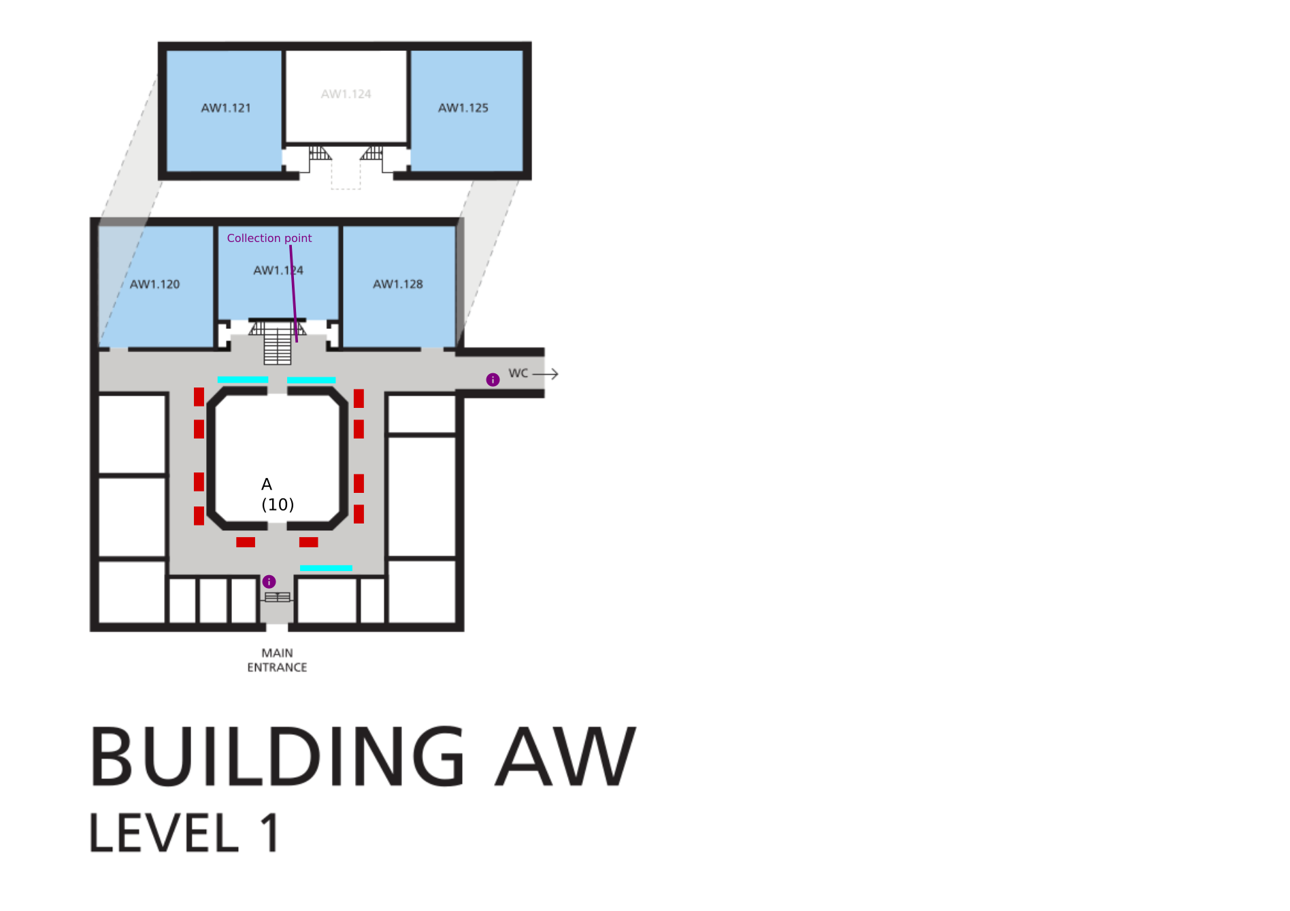

Stands

Map

List
Stand | Theme | Building | Group | Number | Location
OpenEmbedded + AGL | Operating systems | AW+1 | A | 1 | AW+1A1
coreboot/flashrom | Hardware | AW+1 | A | 2 | AW+1A2
PINE64 | Hardware | AW+1 | A | 3 | AW+1A3
MicroPython & Espruino | IoT | AW+1 | A | 4 | AW+1A4
openHAB | IoT | AW+1 | A | 5 | AW+1A5
Embedded JavaScript: Moddable SDK & Node-RED MCU Edition | IoT | AW+1 | A | 6 | AW+1A6
wolfSSL | IoT | AW+1 | A | 7 | AW+1A7
infobooth on amateur radio (hamradio) | HAM Radio | AW+1 | A | 8 | AW+1A8
GNU GRUB | Operating systems | AW+1 | A | 9 | AW+1A9

Signage

Outside
- Arrows must be attached to trees, poles, … Be creative (see photo’s as a guidance).
- Remember that you must place arrows for people coming to AW and people going from AW.
- Remember that the main entrance is the back entrance.
- Attach with black rubber bands.
- Add Centre and Food signs on AW1 pointing towards U/K.
- The “path of slippery death” between H and F is not to be used. All access is via F.

List
(spares are in the H FIT Room)
Sign | Amount
U | 2
Janson accessible | 2
Janson | 2
K | 2
Shuttle | 2
Taxi | 2
Food | 2
Centre | 2
H | 2
FOSDEM | 2
AW | 4

Routes
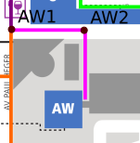

AW1
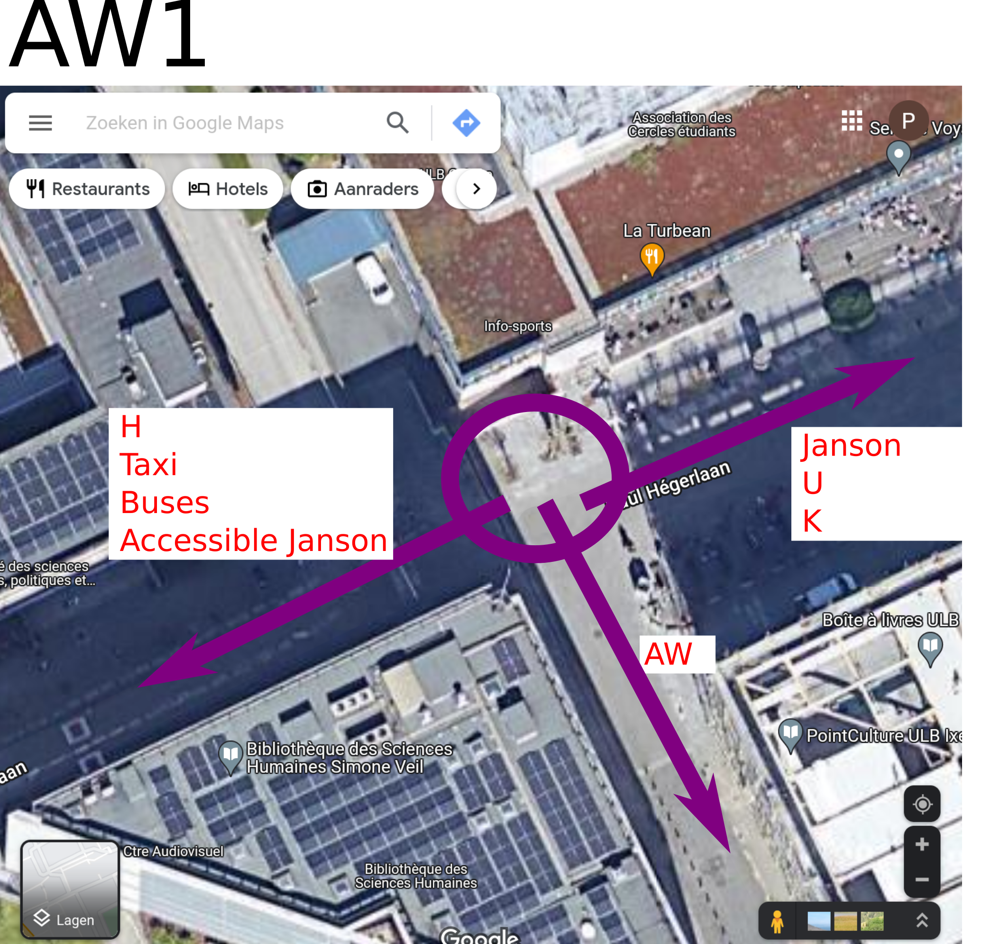

AW2


