FOSDEM 2023 BUILD-UP
H BUILDING

Contents
Contents
Rooms 5
General timeline 7
FOSDEM -1 week 7
Thursday 7
Friday 7
Finishing touches (mostly network and video). Most volunteers go home. 9
Equipment checklist 10
People checklist 12
Task checklist 13
General timeline 18
Sunday 18
Monday 19
We provide food. 19
Equipment checklist 20
People checklist 22
Task checklist 23
General map 28
Stands 30
Map 30
List 31
Signage 32
Accessible access Janson via H 32
Internal 33

Useful information

Rooms
- H.2111 (FIT) (not on Friday)
- H.2213
- H.2214
- H.2215
- H.1301
- H.1302
- H.1308
- H.1309
- H.3242
- H.3244

BUILD-UP
FRIDAY

General timeline

FOSDEM -1 week
- Etat des lieux with team of Arnaud Slotte.

Thursday

17:00 – 20:00
- Load vans at the office with Ulysses. We provide food.

Friday
(Provide your own lunch.)

08:30
- Primary building person arrives at ULB and waits.

08:30 – 12-30
- Rentevent delivery at ULB (building K & building H).
- Solucious Delivery at ULB (building K).

11:00 – 12:00
- Delivery and installation walkie-talkies (Walkies4Events).

11:00
- Staff arrives at ULB.
- Open Kitchen and NOC (ULB 7).

11:00 – 12:00
- Transportation drop off (K and H).
- Prepare for build-up:
  - Check all rooms and buildings are open (except the ones that are not yet available).
  - Grab a bite of food.
  - Exchange phone numbers unless the repeater already works.

12:00
- Volunteers should arrive at campus for buildup tasks

12:00 - 18:00
- Build-up.
- Catering vans might arrive.
  - Wafels & zo (14:00).
  - Melis Events (14:00).

18:00 - 18:30
- Collection of all volunteers in K. Build-up should be finished.
- Catering orders food (Chinese): vegan and non-vegan; ask allergies.

18:30 - 19:30
- Dinner.

19:30 - 22:00
- Finishing touches (mostly network and video). Most volunteers go home.

Equipment checklist
What should you have? | Where should it be? | Who should give it to you? | Do you have it?
45 tables (in carts) | H+1 | RentEvent
60 chairs (in carts) | H+1 | RentEvent
28 table cloths (in boxes) | H+1 | RentEvent
12 benches (stacked) | H+1 | RentEvent
4 high tables (in carts) | H+1 | RentEvent
4 high table table cloths (in boxes) | H+1 | RentEvent
4 high chairs (in carts) | H+1 | RentEvent
10 garbage bins | H+1 | RentEvent
10 ropes | H+1 | RentEvent
9 Welcome to H building (A1) | H+2 (Box 55) | Signage
18 What’s going on in H (A1)  - 9 Saturday  - 9 Sunday | H+2 | Signage
Devroom folders (A4 in folder) | H+2(Box 55) | Signage
Interior H signage (A4 in folder) | H+1 (Box 55) | Signage
Box 5 (Printer) | H+2 | Transportation
Box 46 (Infodesk) | H+2 | Transportation
Box 62 (Power cords) | H+2 | Transportation
Box 67 (Building box) | H+2 | Transportation
Box 70 (Coffee) | H+2 | Transportation
Box 74 (Broom sticks) | H+2 | Transportation

People checklist
Who should be there? | Are they here?
FOSDEM Staff
12 FOSDEM volunteers
(Send volunteers to Janson when H is finished).

Task checklist
What should be done? | When should it be done? | Who should do it? | Has it been done?
Assemble the main infodesk.  - Put a ribbon in front of the entrance to the infodesk. | 12:00 – 16:00 | Staff  Volunteers
Cover University announcement boards with brown paper.  Do not cover vending machines. | 12:00 – 18:00 | Volunteers
Put devroom folders in each devroom. | 12:00 – 18:00 | Volunteers
Use safety tape to cordon off each fire exit and all fire equipment. | 12:00 – 18:00 | Volunteers
Tape signs to each devroom (except H.2.111).  - Full/Empty spaces  - Name of the devroom | 12:00 – 18:00 | Volunteers
Tape signs to FIT room.  - FIT room sign.  Only when room is empty! | 18:00 – 19:00 | Staff
Assemble the stands.  - See map and list.  - 1 table per stand.  - 1 table cloth per 2 stands.  - 1 power cord (4 sockets) per stand. Larger ones can be shared.  - Put stand name on the stand. | 12:00 – 18:00 | Volunteers
Add What’s going on and Welcome to signs.  - See map.  - One of each at every entrance (1 H+1, H+2 and 1 in the entrance from Janson).  - Note that “What’s going on” is different between Saturday and Sunday. | 12:00 – 18:00 | Volunteers
Divide the space between the stands group A and group B with a black ribbon. | 12:00 – 18:00 | Volunteers
Put out ribbons.  - See map.  - In front of the right door of H.2.215.  - In front of the left and right door of H.1.308 and H.1.309.  - In front of the right door of H.1.302.  - In front of the left door of H.1.301. | 12:00 – 18:00 | Volunteers
Check glass recycling boxes at every entrance (1 on H+1 and 1 on H+2). | 12:00 – 18:00 | CI
Set up the network. | 12:00 – 18:00 | Network team
Set up the video system. | 12:00 – 18:00 | Video team
Tape off all cables that run over floors or corridors with gaffa tape (do not use duct tape). | 12:00 – 18:00 | Volunteers
Put carts for tables and chairs; the boxes that the table cloths came in and signage box in the corridor next to H.2.111.  - If the room is empty, put them in the room.  - Otherwise, do this on Saturday morning. | 16:00 – 18:00 | Volunteers
Put garbage bins around the building, especially where there are not a lot of garbage bins. | 12:00 – 18:00 | Volunteers
Assemble the job corner and announcement corner.  - 4 tables, with table cloth.  - Attach rules to the windows. | 12:00 – 18:00 | Volunteers
Add signage to go to Janson. | 12:00 – 18:00 | Volunteers

TEAR-DOWN
SUNDAY

General timeline

Sunday

15:00
- BR meeting in K.4.401. Change walkie-talkie batteries.
- BR check on their buildings to ensure that stands/devrooms are aware of tear-down. Make sure the collection points have everything they need.
- BR estimates how many volunteers they need for their building. Contact volunteers team.

16:00 – 20:00
- Tear-down. There is an order in clearing out the buildings: start with AW and U; move to H, F and J; finish with K. Apart from Janson, K-1 and lower H, cleanup starts at 17:00. K-1, Janson and lower H start as soon as the closing talk finishes (~18:00).
- Catering vans will leave. They take care of themselves usually.

20:00 – 20:30
- Collect volunteers in K for volunteer dinner.

20:30 – 20:45
- Sweep K. Garbage out.
- Volunteers leave.

21:00

- Staff dinner.

22:00
- CI closes the bar(s).

Monday

08:30
- Primary building person arrives at ULB. Waits for RentEvent to pick stuff up.

17:00 – 20:00
- Unload vans at the office. Boxes stacked according to the label; and with the label in front.
- We provide food.

Equipment checklist
What should you bring back? | Where should it go? | Is it where it should be?
45 tables (in carts) | H+1
60 chairs (in carts) | H+1
28 table cloths (in boxes) | H+1
12 benches (stacked) | H+1
4 high tables (in carts) | H+1
4 high table table cloths (in boxes) | H+1
4 high chairs (in carts) | H+1
10 garbage bins | H+1
10 ropes | H+1
9 Welcome to H building (A1) | Garbage
18 What’s going on in H (A1)  - 9 Saturday  - 9 Sunday | Signage
Devroom folders | H+1 (Box 55)
Interior signage | H+1 (Box 55)
Box 5 (Printer) | H+1
Box 46 (Infodesk) | H+1
Box 62 (Power cords) | H+1
Box 67 (Building box) | H+1
Box 70 (Coffee) | H+1

People checklist
Who should be there? | Are they here?
FOSDEM Staff
12 FOSDEM volunteers
(Send volunteers to Janson when H is finished).

Task checklist
What should be done? | When should it be done? | Who should do it? | Has it been done?
Change signage from Saturday to Sunday.  - Devroom signs (should be in Devroom folder).  - What’s going on. | 07:00 – 09:00 | Signage volunteers  Staff
All hands meeting in the FIT room (K). | 15:00 | Staff
Swap walkie-talkie battery. | 15:00 | You
Do a round of all devrooms informing them of clean-up instructions.  - They should clean-up from 17:00 and finish by 18:00.  - They should sweep the room, remove all the trash and take the full trash bags to the containers outside.  - Brooms, dust pans and garbage bags can be gotten from the Infodesk.  - Laminated signs that are in the Devroom must be put in the folder and handed to the Infodesk.  - Video and network should not be touched. | 16:00 – 17:00 | You
Do a round of all stands informing them of clean-up instructions.  - They should clean-up from 17:00 and finish by 18:00.  - They should put the tables and chairs on carts (H2.211). Table cloths must be put in the boxes (also H2.211).  - They should remove the garbage in the direct surroundings of their stands, as well as everything they brought.  - Brooms, dust pans and garbage bags can be gotten from the Infodesk.  - Video and network should not be touched. | 16:00 – 17:00 | You
Remove all FOSDEM stuff.  - Brown paper  - FOSDEM signage  - Devroom signs  - All tape | 18:00 – 19:00 | Volunteers
Put FOSDEM equipment in the boxes (if it came out of a box). | 17:00 – 19:00 | Staff  Volunteers
Load the vans with boxes (there will be a van in H). Follow the instructions of the transportation team. | 17:00 – 19:00 | Volunteers
Put all carts and all stuff in H+2 for collection. | 18:00 – 19:00 | Volunteers
Sweep floors, empty garbage bins, clean out devrooms, auditoria, corridors and whatever seems dirty. | 17:00 – 19:00 | Volunteers
Disassemble the infodesk. | 19:00 – 19:30 | Volunteers
Disassemble the FIT room. | 18:30 – 19:30 | Volunteers
Remove network.  Only after a go from the network team. | 18:30 – 19:30 | Network team  Volunteers
Remove video.  Only after a go from the video team. | 18:30 – 19:30 | Video team  Volunteers

MAPS AND LISTS

General map
(ignore the stands, see the stands map)
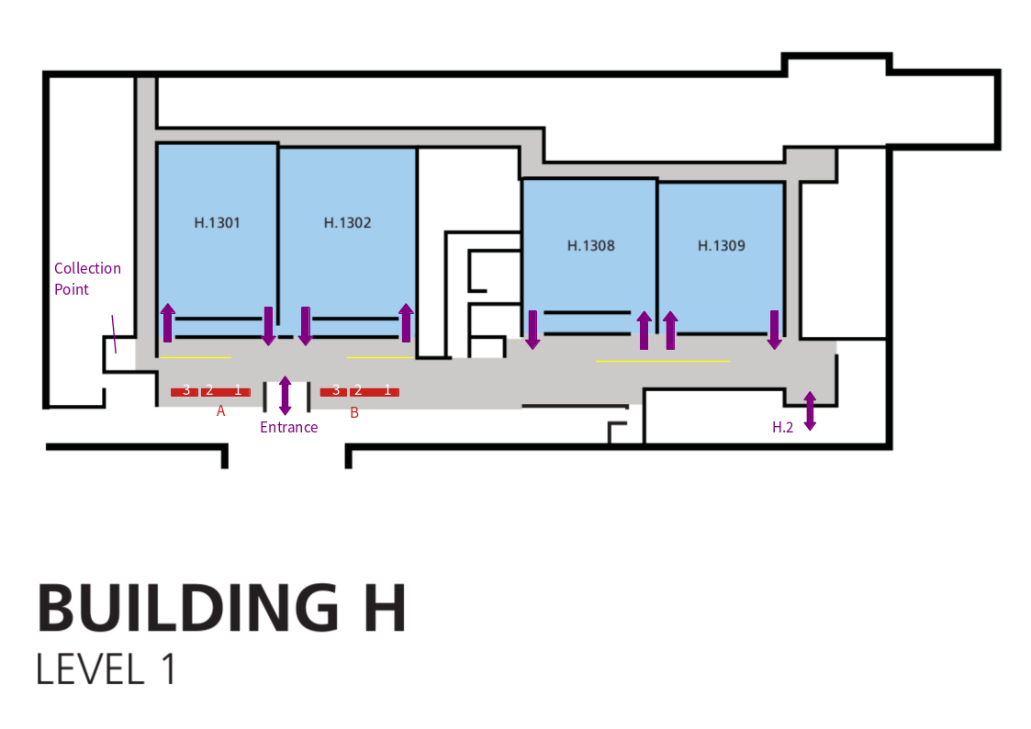

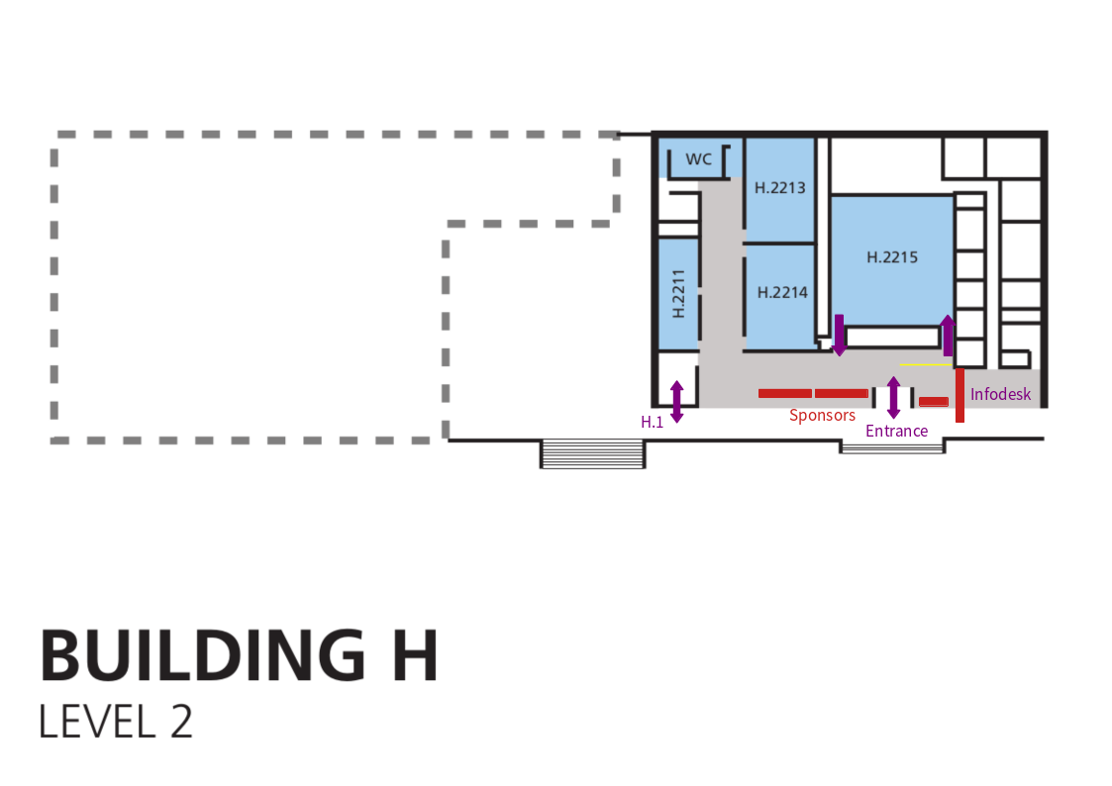

Stands

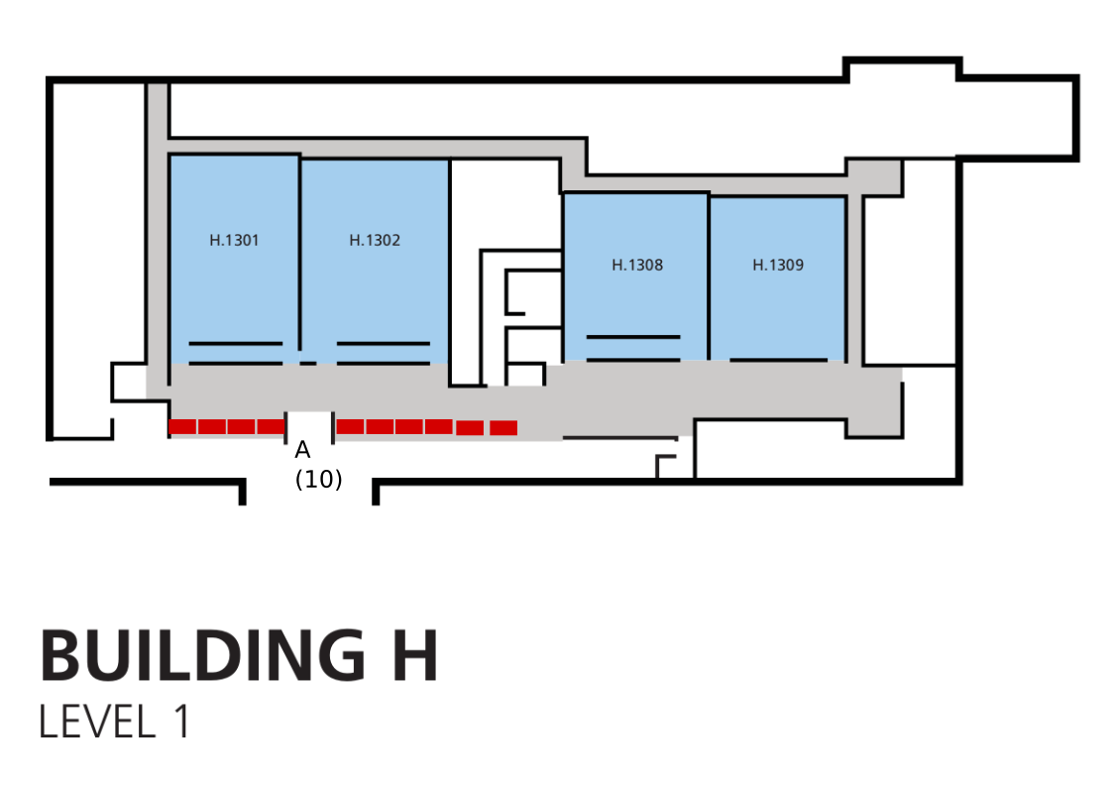
Map

List
Stand | Theme | Floor | Group | Number | Location
AlmaLinux OS | Operating systems | H+1 | A | 4 | H+1A4
Debian | Operating systems | H+1 | A | 5 | H+1A5
Fedora Project | Operating systems | H+1 | A | 1 | H+1A1
CentOS and RDO | Operating systems | H+1 | A | 2 | H+1A2
FreeBSD Project | Operating systems | H+1 | A | 6 | H+1A6
GNOME | Desktop environments | H+1 | A | 3 | H+1A3
openSUSE Project | Operating systems | H+1 | A | 7 | H+1A7
Ubuntu Ecosystem | Operating systems | H+1 | A | 8 | H+1A8
Gentoo | Operating systems | H+1 | A | 9 | H+1A9

Signage

Accessible access Janson via H
- Accessible access to Janson is via H+1.
- Attach signs pointing to Janson in the corridor.
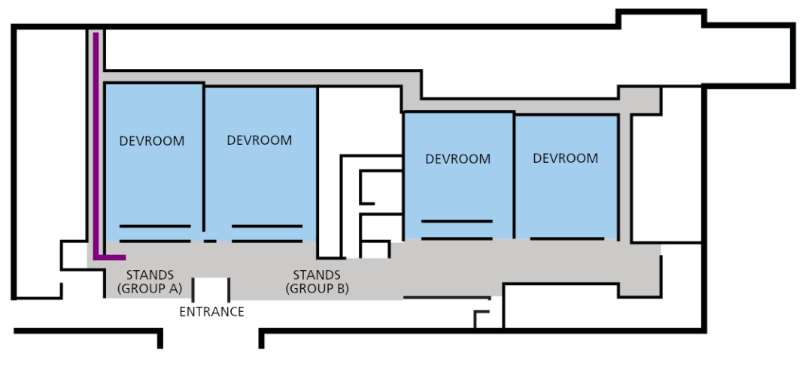

Internal
- Add a sign pointing to the taxi’s and buses at each front door. They should point to the right when inside the building.
- Add a sign to the food at each front door. This should point to the left.

