FOSDEM 2023 BUILD-UP
K BUILDING

Contents
Contents
Rooms 4
General timeline 6
FOSDEM -1 week 6
Thursday 6
Friday 6
Equipment checklist 9
People checklist 11
Task checklist 12
General timeline 18
Sunday 18
Monday 19
Equipment checklist 20
People checklist 22
Task checklist 23
General map 28
Infodesk 30
FIT room 31
Stands 32
Map 32
List 34
Outside 37

Useful information

Rooms
- K.1.105
- K.3.201
- K.3.401
- K.4.201
- K.4.401 (FIT) (not on Friday)
- K.4.601
- NOC/VOC
- Cloak room

BUILD-UP
FRIDAY

General timeline

FOSDEM -1 week
- Etat des lieux with team of Arnaud Slotte.

Thursday

17:00 – 20:00
- Load vans at the office with Ulysses. We provide food.

Friday
(Provide your own lunch.)

08:30
- Primary building person arrives at ULB and waits.

08:30 – 12-30
- Rentevent delivery at ULB (building K & building H).
- Solucious Delivery at ULB (building K).

11:00 – 12:00
- Delivery and installation walkie-talkies (Walkies4Events).

11:00
- Staff arrives at ULB.
- Open Kitchen and NOC (ULB 7).

11:00 – 12:00
- Transportation drop off (K and H).
- Prepare for build-up:
  - Check all rooms and buildings are open (except the ones that are not yet available).
  - Grab a bite of food.
  - Exchange phone numbers unless the repeater already works.

12:00
- Volunteers should arrive at campus for buildup tasks

12:00 - 18:00
- Build-up.
- Catering vans might arrive.
  - Wafels & zo (14:00).
  - Melis Events (14:00).

18:00 - 18:30
- Collection of all volunteers in K. Build-up should be finished.
- Catering orders food (Chinese): vegan and non-vegan; ask allergies.

18:30 - 19:30
- Dinner.

19:30 - 22:00
- Finishing touches (mostly network and video). Most volunteers go home.

Equipment checklist
What should you have? | Where should it be? | Who should give it to you? | Do you have it?
84 tables (in carts) | K+1 | RentEvent
300 chairs (in carts) | K+1 | RentEvent
32 table cloths (in boxes) | K+1 | RentEvent
15 benches (stacked) | K+1 | RentEvent
6 high tables (in carts) | K+1 | RentEvent
6 high table table cloths (in boxes) | K+1 | RentEvent
6 high chairs (in carts) | K+1 | RentEvent
10 garbage bins | K+1 | RentEvent
6 ropes | K+1 | RentEvent
1 fridge | K+1 | RentEvent
2 coat hanger racks | K+1 | RentEvent
1 set of room dividers | K+1 | RentEvent
30 black chairs | K+1 | RentEvent
11 Welcome to K building (A1) | K+1 | Signage
22 What’s going on in K (A1)  - 11 Saturday  - 11 Sunday | K+1 | Signage
Devroom folders (A4 in folder) | K+1 | Signage
General signage (A4 in folder) | K+1 | Signage
Exterior K signage (arrows) | K+1 | Signage
Exterior F signage (arrows) | K+1 | Signage

People checklist
Who should be there? | Are they here?
FOSDEM Staff
16 FOSDEM volunteers
2 FOSDEM signage volunteers

Task checklist
What should be done? | When should it be done? | Who should do it? | Has it been done?
Increase capacity in devrooms on 3rd and 4th floor (except K.4.401). Do not do this if lessons are happening.  - Remove last row of tables.  - Add two rows of chairs (in front). | 12:00 – 18:00 | Volunteers
Assemble the main infodesk (see plan Infodesk).  - Put a ribbon in front of the entrance to the infodesk.  - Add the kitchen sign to the kitchen.  - Put 10 black chairs at the Infodesk. | 10:00 – 12:00 | Staff  Volunteers
Cover University announcement boards with brown paper.  Do not cover vending machines. | 12:00 – 18:00 | Volunteers
Put devroom folders in each devroom. | 12:00 – 18:00 | Volunteers
Use safety tape to cordon off each fire exit and all fire equipment. | 12:00 – 18:00 | Volunteers
Tape signs to each devroom (except K4.401).  - Full/Empty spaces  - Name of the devroom | 12:00 – 18:00 | Volunteers
Tape signs to FIT room and NOC.  - FIT room sign (left door of K4.401)  - First Aid/CoC (right door of K4.401)  - NOC (NOC)  Only when room is empty! | 18:00 – 19:00 | Staff
Assemble the cloak room.  - Everything that is not a coat hanger or table that is in the cloak room must be placed beneath the auditorium.  - Put the 2 extra coat hangers in the room.  - Stack 8 tables in front of the room (put one table on another to create 4 pairs).  - Stack 16 tables in the room itself.  - Provide 4 chairs.  - Provide a ladder (from NOC). | 12:00 – 18:00 | Volunteers
Assemble the stands.  - See map and list.  - 1 table per stand.  - 1 table cloth per 2 stands.  - 1 power cord (4 sockets) per stand. Larger ones can be shared.  - Put stand name on the stand. | 12:00 – 18:00 | Volunteers
Add What’s going on and Welcome to signs.  - See map.  - One of each at every entrance (2 on K+1 and 1 on K+2).  - One of each on every floor in the stair cases (2).  - Not on +1.  - +2  - +3  - +4  - Note that “What’s going on” is different between Saturday and Sunday. | 12:00 – 18:00 | Volunteers
Divide the space between the stands group A and group B with a black ribbon. | 12:00 – 18:00 | Volunteers
Put a ribbon in front of the Infodesk to create some kind of queue. | 12:00 – 18:00 | Volunteers
Put glass recycling boxes at every entrance (2 on K+1 and 1 on K+2). | 12:00 – 18:00 | CI
Create the FIT room (K4.401).  - See map.  - Put one printer and one spare laptop in the room.  - Put 10 black chairs in the FIT room.  If the room is not empty or closed, this must be done on Saturday 07:00 – 09:00. | 18:00 – 19:00 | Volunteers  Staff
Set up the network and NOC.  - Put 10 black chairs in the NOC. | 12:00 – 18:00 | Network team
Set up the video system and VOC. | 12:00 – 18:00 | Video team
Tape off all cables that run over floors or corridors with gaffa tape (do not use duct tape). | 12:00 – 18:00 | Volunteers
Put carts for tables and chairs; the boxes that the table cloths came in and signage box on K+2 behind the auditorium. | 16:00 – 18:00 | Volunteers
Put garbage bins around the building, especially where there are not a lot of garbage bins (including K+2). | 12:00 – 18:00 | Volunteers
Place exterior signage (arrows). See below. | 12:00 – 18:00 | Signage volunteers
Place welcome to/what’s going in in F.  - 1 at the entrance Av. Paul Héger  - 1 at the entrance coming from K | 12:00 – 18:00 | Signage volunteers

TEAR-DOWN
SUNDAY

General timeline

Sunday

15:00
- BR meeting in K.4.401. Change walkie-talkie batteries.
- BR check on their buildings to ensure that stands/devrooms are aware of tear-down. Make sure the collection points have everything they need.
- BR estimates how many volunteers they need for their building. Contact volunteers team.

16:00 – 20:00
- Tear-down. There is an order in clearing out the buildings: start with AW and U; move to H, F and J; finish with K. Apart from Janson, K-1 and lower H, cleanup starts at 17:00. K-1, Janson and lower H start as soon as the closing talk finishes (~18:00).
- Catering vans will leave. They take care of themselves usually.

20:00 – 20:30
- Collect volunteers in K for volunteer dinner.

20:30 – 20:45
- Sweep K. Garbage out.
- Volunteers leave.

21:00

- Staff dinner.

22:00
- CI closes the bar(s).

Monday

08:30
- Primary building person arrives at ULB. Waits for RentEvent to pick stuff up.

17:00 – 20:00
- Unload vans at the office. Boxes stacked according to the label; and with the label in front.
- We provide food.

Equipment checklist
What should you bring back? | Where should it go? | Is it where it should be?
84 tables (in carts) | K+1 (cart)
300 chairs (in carts) | K+1 (cart)
32 table cloths (in boxes) | K+1 (box)
15 benches (stacked) | K+1 (stack)
6 high tables (in carts) | K+1 (cart)
6 high table table cloths (in boxes) | K+1 (box)
6 high chairs (in carts) | K+1 (cart)
10 garbage bins | K+1
6 ropes | K+1
1 fridge | K+1
2 coat hanger racks | K+1
1 set of room dividers | K+1
30 black chairs | K+1 (cart)
11 Welcome to K building (A1) | Garbage
22 What’s going on in K (A1) | Garbage
Devroom folders | Signage box
Interior K signageSignage box | Signage box
Arrows | Signage box

People checklist
Who should be there? | Are they here?
FOSDEM Staff
16 FOSDEM volunteers

Task checklist
What should be done? | When should it be done? | Who should do it? | Has it been done?
Change signage from Saturday to Sunday.  - Devroom signs (should be in Devroom folder).  - What’s going on. | 07:00 – 09:00 | Signage volunteers  Staff
All hands meeting in the FIT room (K). | 15:00 | Staff
Swap walkie-talkie battery. | 15:00 | You
Do a round of all devrooms informing them of clean-up instructions.  - They should clean-up from 17:00 and finish by 18:00.  - They should sweep the room, remove all the trash and take the full trash bags to the containers outside.  - Brooms, dust pans and garbage bags can be gotten from the Infodesk.  - Laminated signs that are in the Devroom must be put in the folder and handed to the Infodesk.  - Video and network should not be touched. | 16:00 – 17:00 | You
Do a round of all stands informing them of clean-up instructions.  - They should clean-up from 17:00 and finish by 18:00.  - They should put the tables and chairs on carts (K+2 behind the auditorium). Table cloths must be put in the boxes (also K+2).  - They should remove the garbage in the direct surroundings of their stands, as well as everything they brought.  - Brooms, dust pans and garbage bags can be gotten from the Infodesk.  - Video and network should not be touched. | 16:00 – 17:00 | You
Undo the changes in the devrooms (K+3 & K+4). | 17:00 – 18:00 | Volunteers
Remove all FOSDEM stuff.  - Brown paper  - FOSDEM signage  - Devroom signs  - All tape  - Outside signage  Do not forget F. | 18:00 – 19:00 | Volunteers
Put FOSDEM equipment in the boxes (if it came out of a box). People will come from other buildings with stuff, make sure it is in the right box. | 17:00 – 19:00 | Staff  Volunteers
Load the vans with boxes. Follow the instructions of the transportation team. | 17:00 – 19:00 | Volunteers
Put all carts and all stuff in K+1 for collection. | 18:00 – 19:00 | Volunteers
Sweep floors, empty garbage bins, clean out devrooms, auditoria, corridors and whatever seems dirty. | 17:00 – 19:00 | Volunteers
Disassemble the cloak room. | 19:00 – 19:30 | Volunteers
Disassemble the infodesk. | 19:00 – 19:30 | Volunteers
Disassemble the FIT room. | 18:30 – 19:30 | Volunteers
Remove network.  Only after a go from the network team. | 18:30 – 19:30 | Network team  Volunteers
Remove video.  Only after a go from the video team. | 18:30 – 19:30 | Video team  Volunteers

MAPS AND LISTS

General map
(ignore the stands, see the stands map)

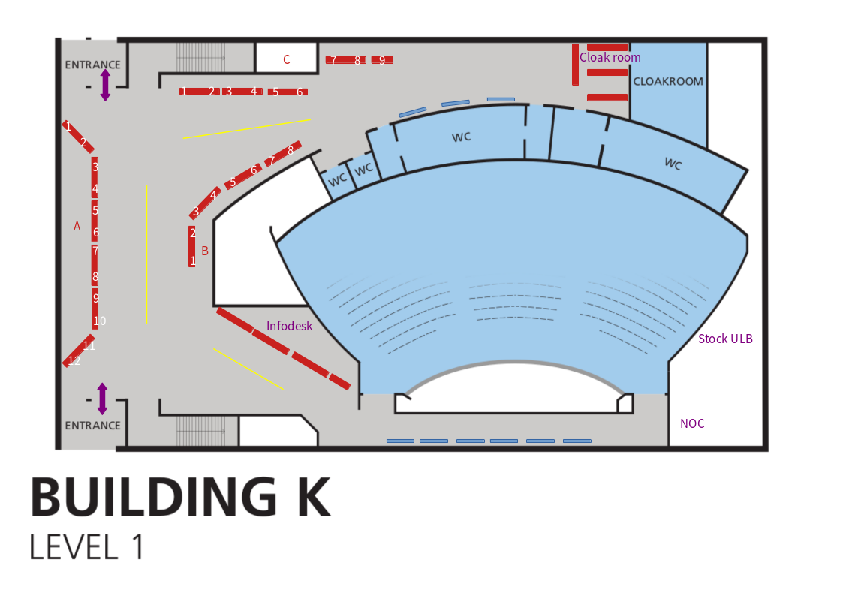
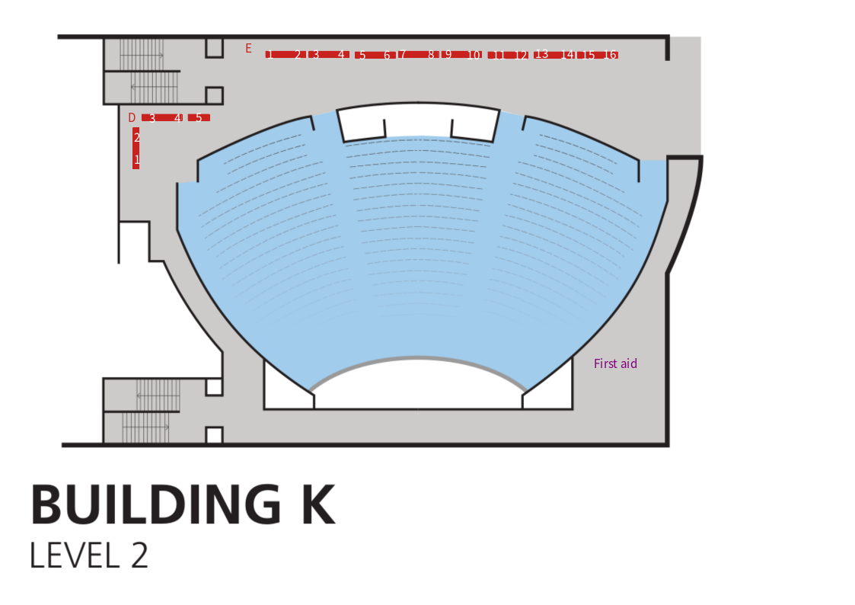

Infodesk
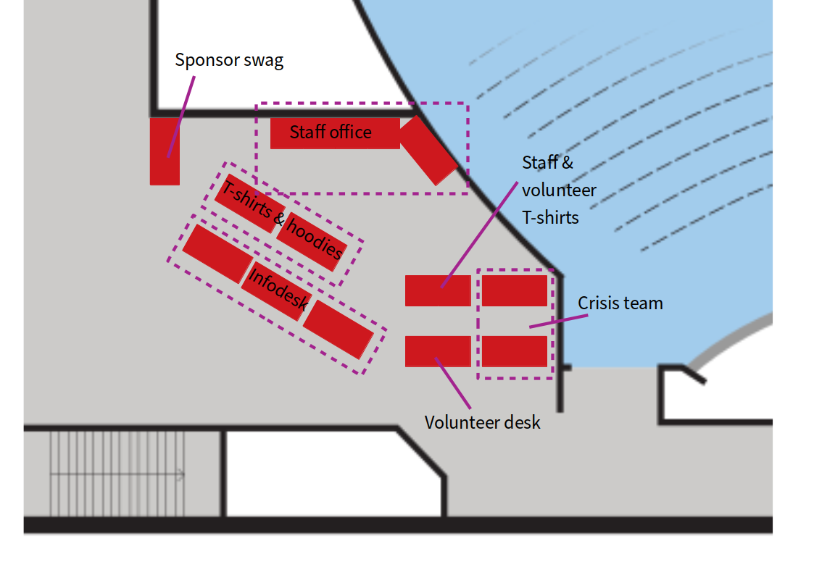

FIT room
K4.401
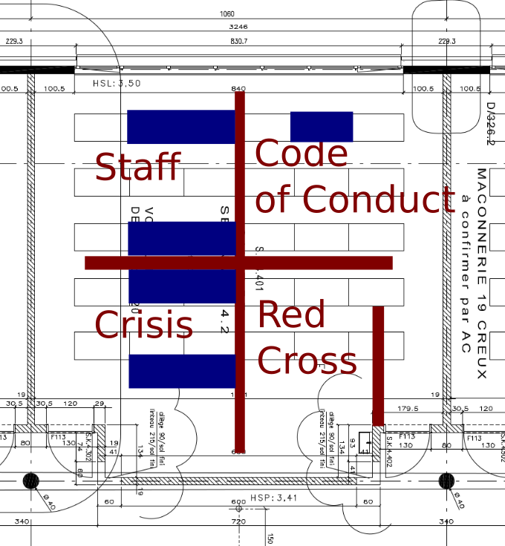

Stands

Map
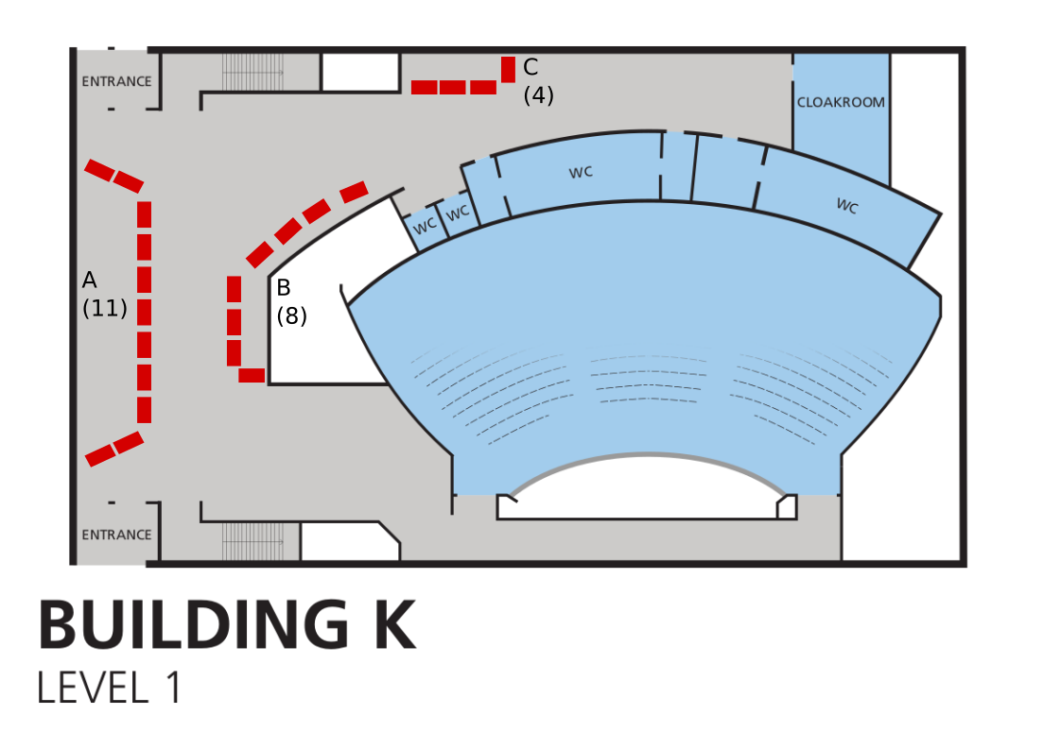

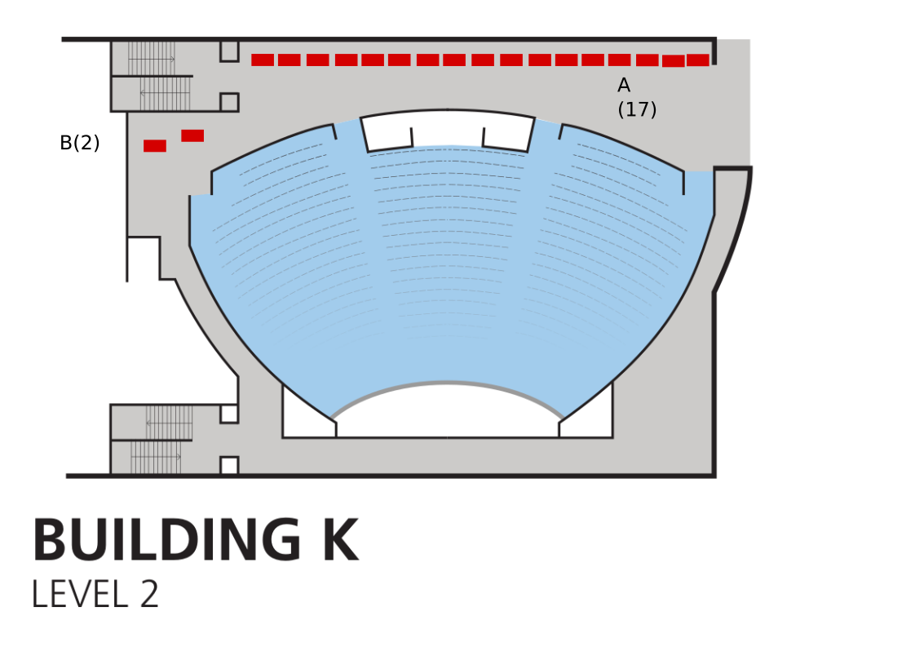

List

Stand | Theme | Floor | Group | Number | Location
Eclipse Foundation | Community advocacy | K+1A | A | 1 | K+1AA1
FOSSASIA | Community advocacy | K+1A | A | 2 | K+1AA2
Matrix.org Foundation | Community advocacy | K+1A | A | 3 | K+1AA3
Software Freedom Conservancy | Community advocacy | K+1A | A | 4 | K+1AA4
Free Software Foundation Europe | Community advocacy | K+1A | A | 5 | K+1AA5
Free Culture Podcasts | Community advocacy | K+1A | A | 7 | K+1AA7
Open Culture Foundation + COSCUP | Community advocacy | K+1A | A | 8 | K+1AA8
Open Toolchain Foundation | Community advocacy | K+1A | A | 9 | K+1AA9
Open UK and Book Signing Stand | Community advocacy | K+1A | A | 10 | K+1AA10
The Apache Software Foundation | Community advocacy | K+1A | A | 11 | K+1AA11
Ansible | System administration | K+1B | B | 1 | K+1BB1
Grafana | System administration | K+1B | B | 2 | K+1BB2
Bareos | System administration | K+1B | B | 3 | K+1BB3
Foreman | System administration | K+1B | B | 4 | K+1BB4
PostgreSQL | Database engines | K+1B | B | 5 | K+1BB5
DRLM (Disaster Recovery Linux Manager) | System administration | K+1B | B | 6 | K+1BB6
OpenNebula | System administration | K+1B | B | 7 | K+1BB7
MariaDB Server | Database engines | K+1B | B | 8 | K+1BB8
CiviCRM | Office suites and productivity | K+1C | C | 1 | K+1CC1
DAVx5 – CalDAV / CardDAV / WebDAV client for Android + jtx Board | Office suites and productivity | K+1C | C | 2 | K+1CC2
XWiki & CryptPad | Office suites and productivity | K+1C | C | 3 | K+1CC3
Libreoffice | Office suites and productivity | K+1C | C | 4 | K+1CC4
Linux on Mobile (Sailfish OS, Ubuntu Touch, postmarketOS, Mobian and more) | Operating systems | K+2A | A | 1 | K+2AA1
KDE | Desktop environments | K+2A | A | 2 | K+2AA2
GitLab | Developer environment | K+2A | A | 3 | K+2AA3
Homebrew | Developer environment | K+2A | A | 4 | K+2AA4
Audacity and MuseScore | Multimedia and graphics | K+2A | A | 5 | K+2AA5
Mozilla | World wide web | K+2A | A | 6 | K+2AA6
Nextcloud: Self-hosted, open file sync & communication platform | World wide web | K+2A | A | 7 | K+2AA7
Jenkins | Developer environment | K+2A | A | 8 | K+2AA8
La Contre-Voie | Education | K+2A | A | 9 | K+2AA9
VideoLAN | Multimedia and graphics | K+2A | A | 10 | K+2AA10
The Perl/Raku Foundation | Developer environment | K+2A | A | 11 | K+2AA11
IEEE SA Open | Education | K+2A | A | 13 | K+2AA13
It's time to learn Ada! | Education | K+2A | A | 14 | K+2AA14
AlekSIS | Education | K+2A | A | 15 | K+2AA15
Chamilo | Education | K+2A | A | 16 | K+2AA16
IsardVDI | Education | K+2A | A | 17 | K+2AA17
Realtime Lounge | Community advocacy | K+2B | B | 1 | K+2BB1

Outside
- Arrows must be attached to trees, poles, … Be creative (see photo’s as a guidance).
- Remember that you must place arrows for people coming to K and people going from K.
- Remember accessib ility.
  - F is not accessible from K. Send people via the car access (see extra map). Use FOSDEM accessible signs.
- Attach with black rubber bands.
- Add Accessible Janson to each H arrow (not shown on picture).
- Add Taxi/Shuttle on F1 pointing to H. Add Centre on F1 pointing to the other side (not shown on picture).

List
(spares are in the K FIT Room)
Sign | Amount
K | 4
Janson | 5
Janson (accessible) | 3
U | 4
H | 4
AW | 4
Taxi | 1
Shuttle | 1
Centre | 1

Routes
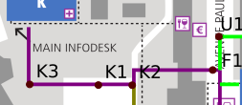

K1
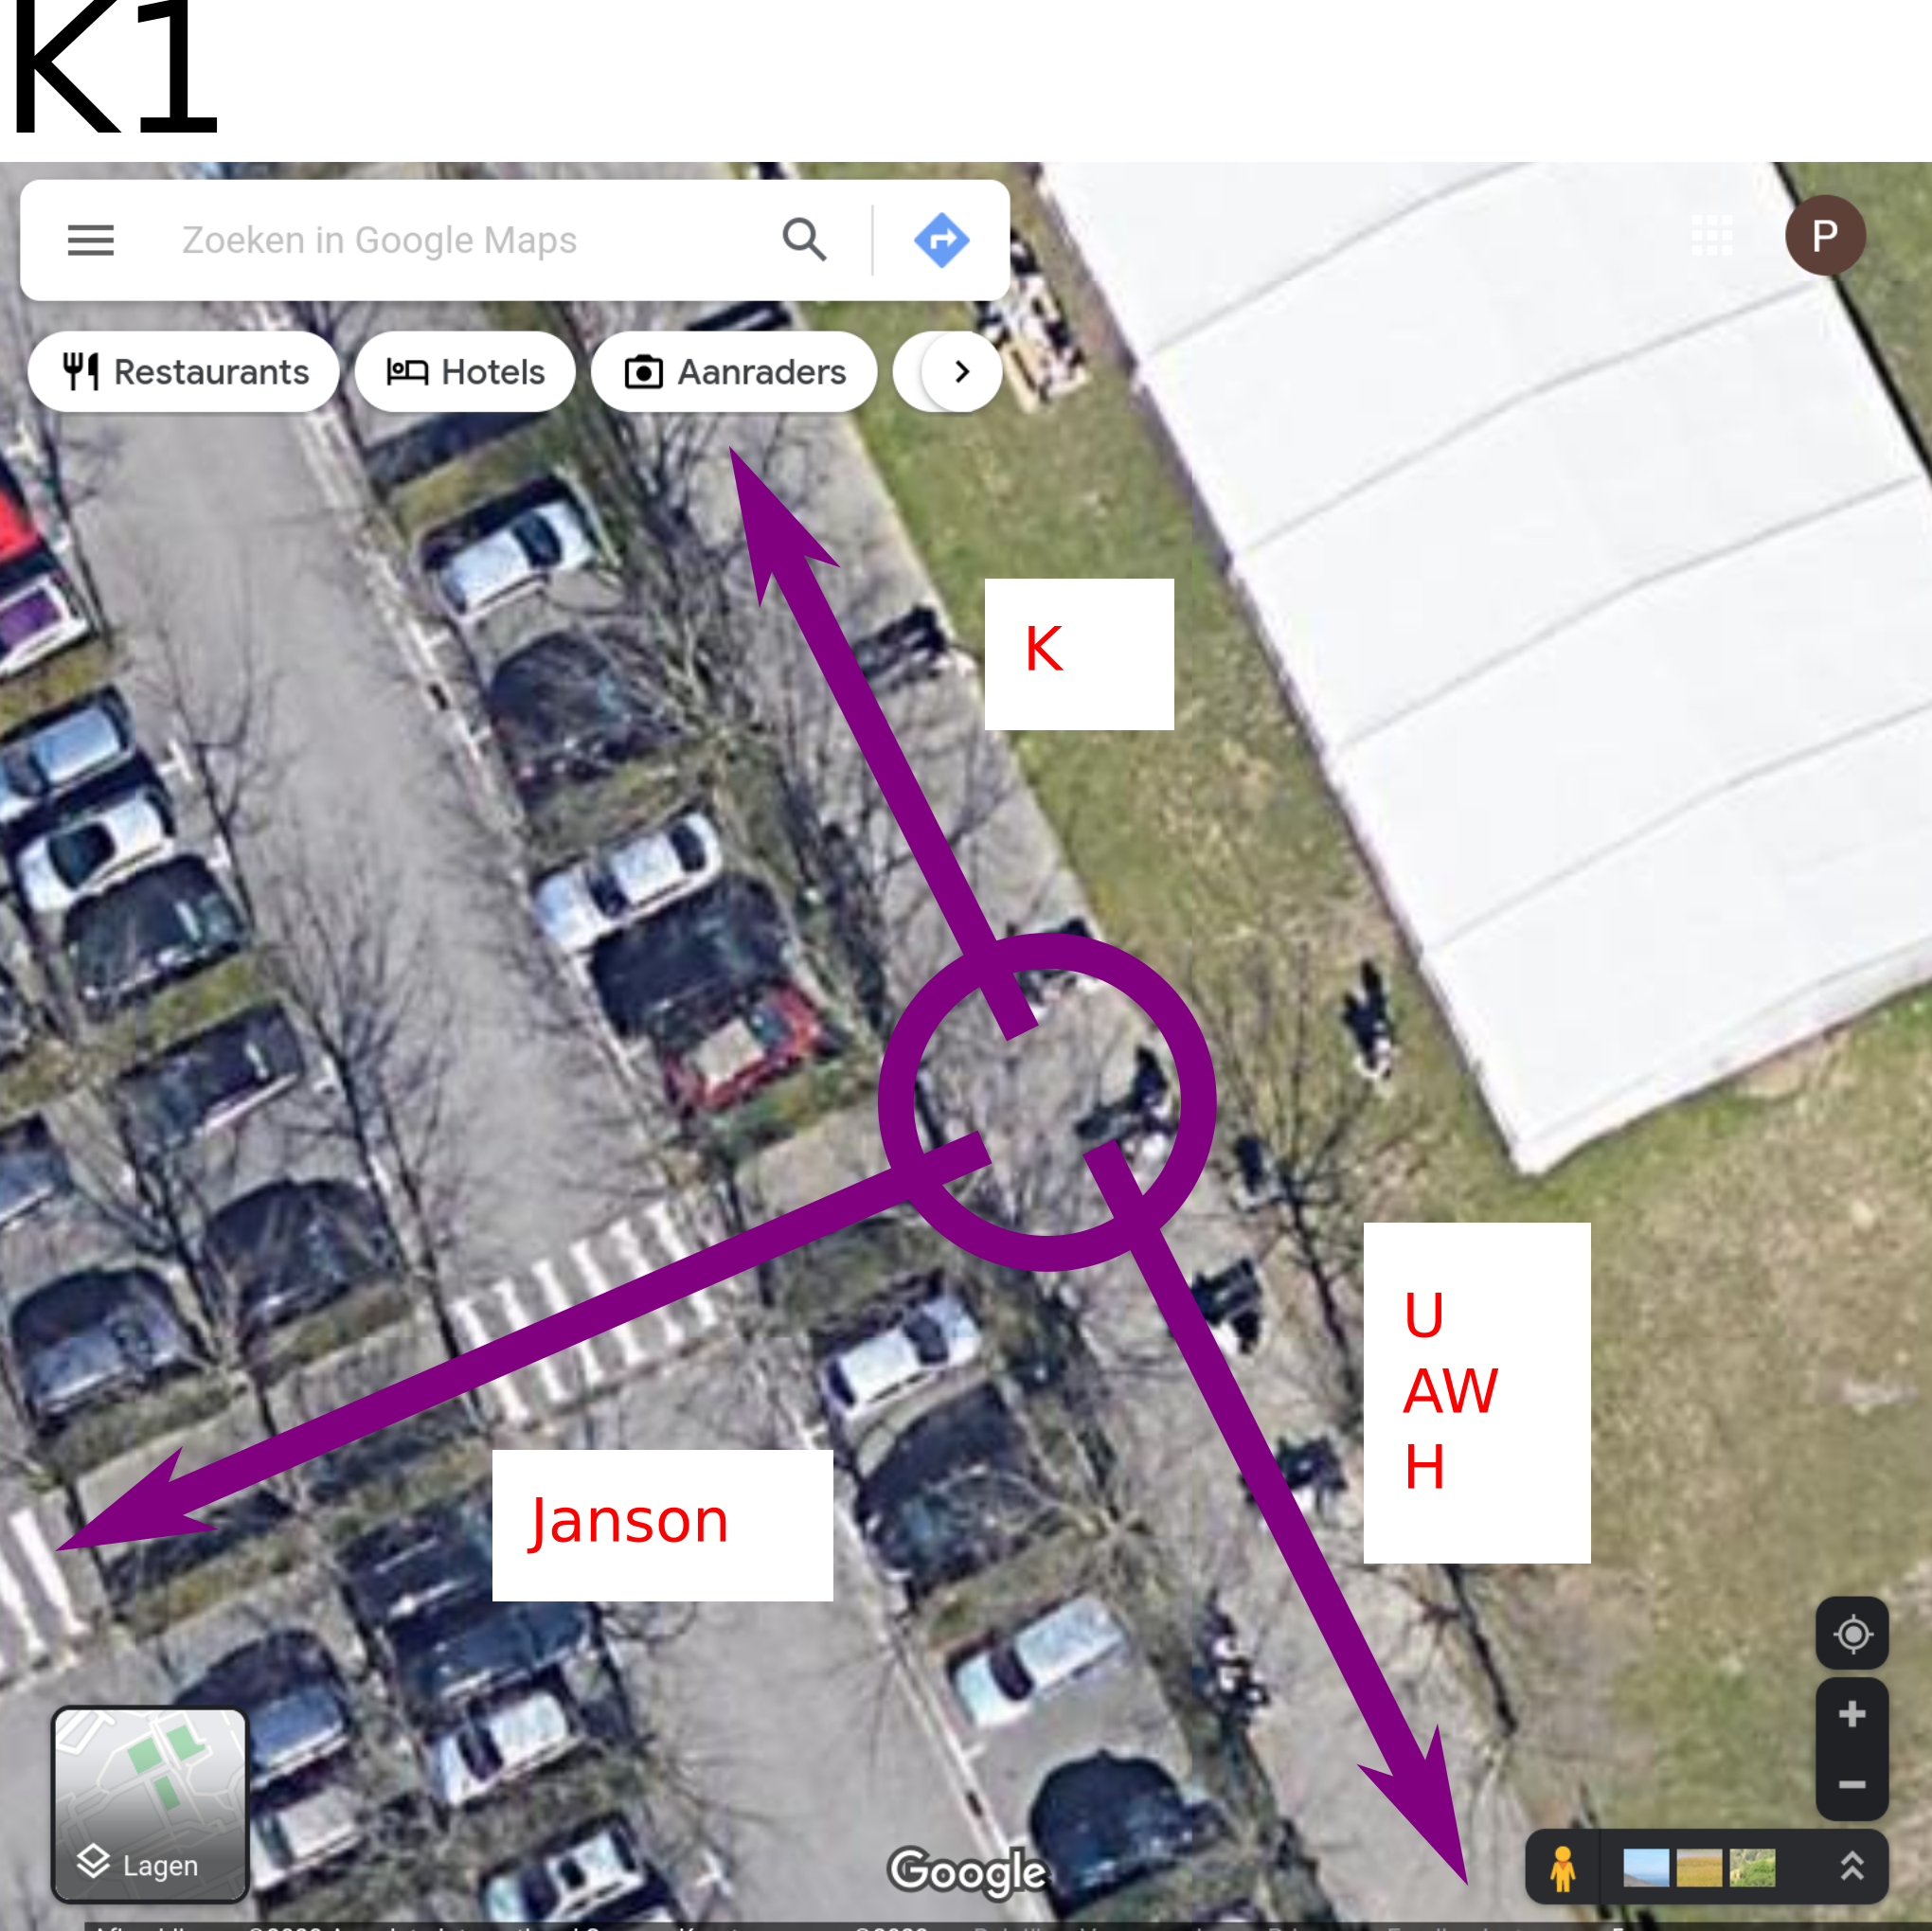

K2
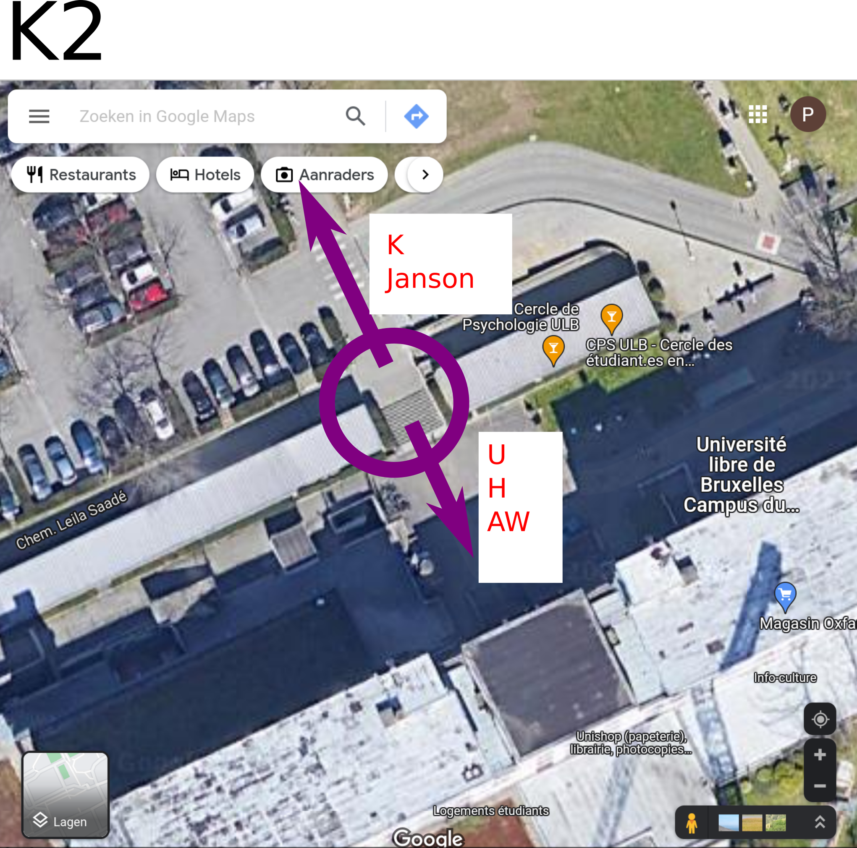

K3
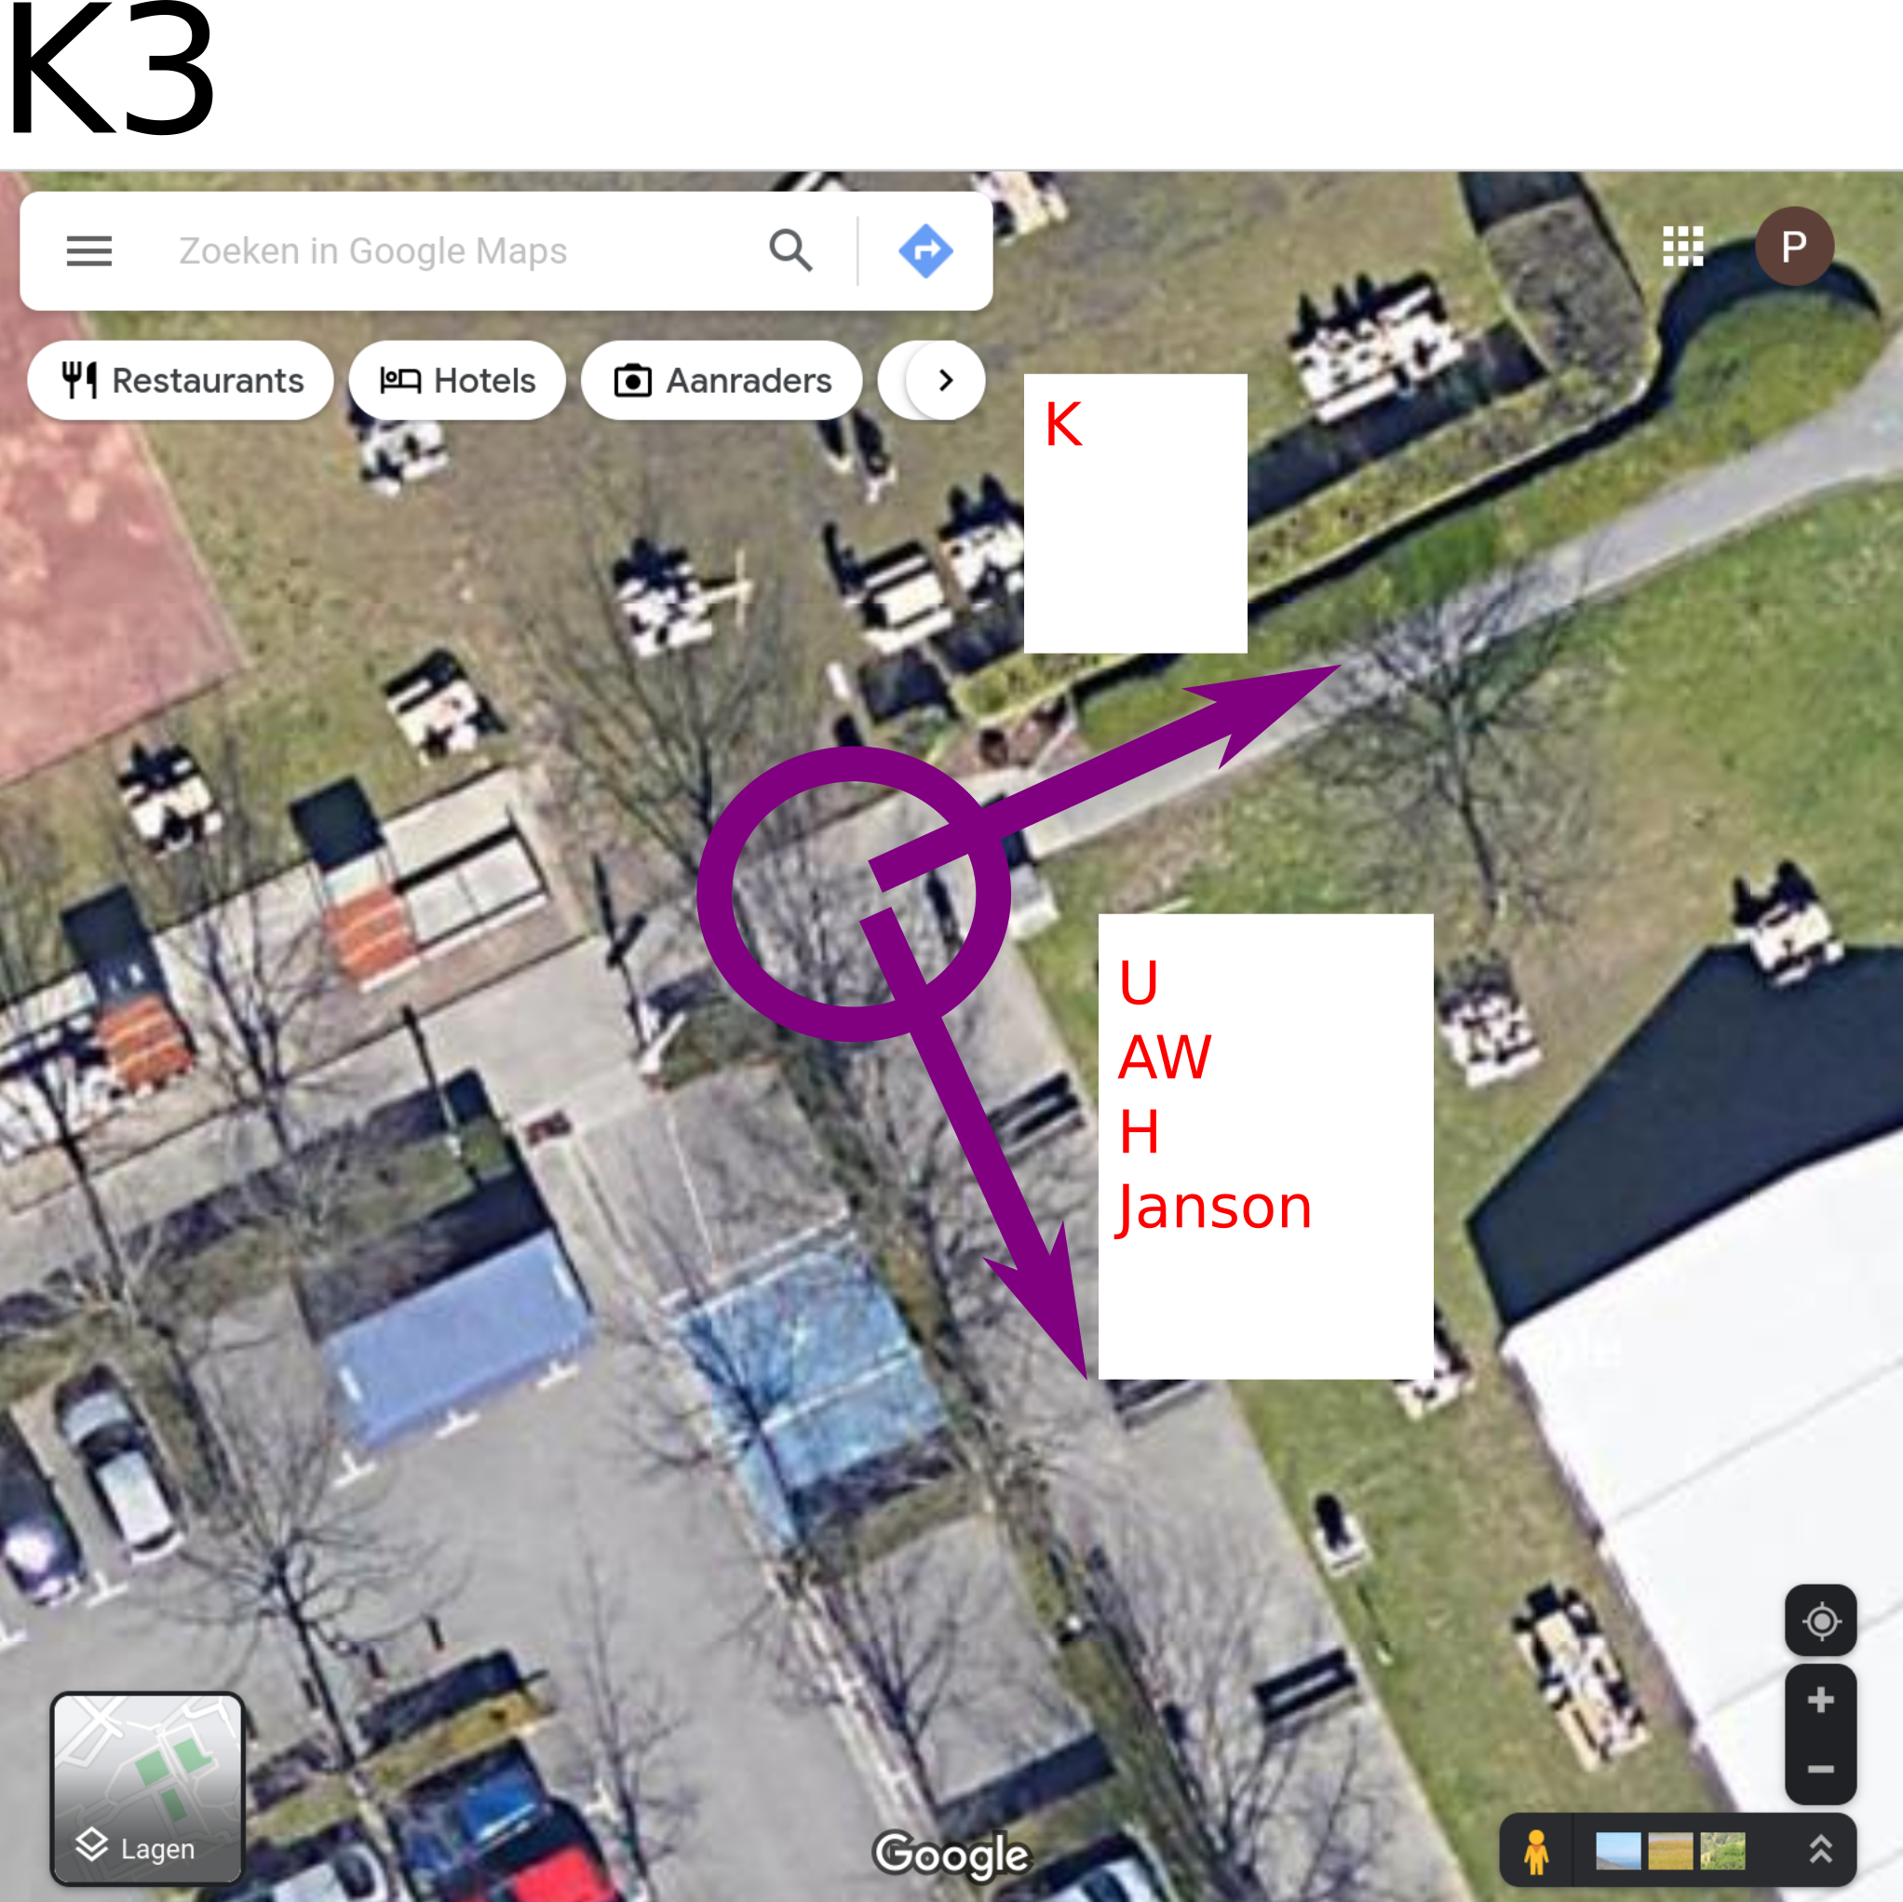

F1
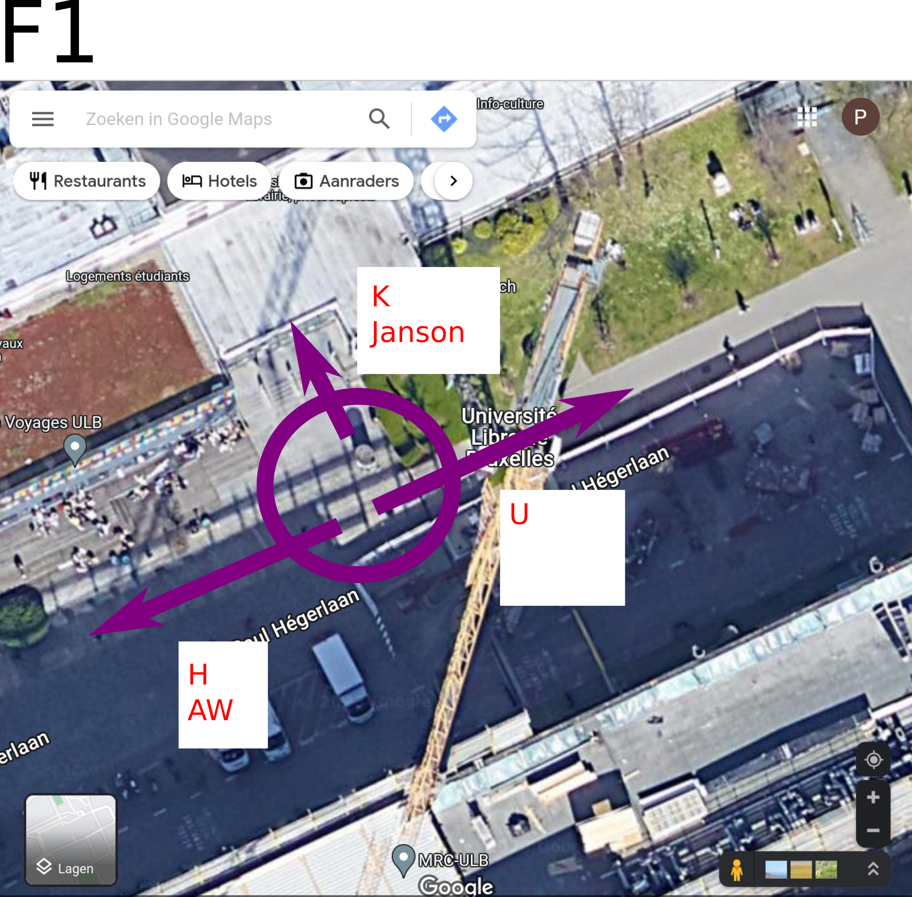

Acessible access to Av. Paul Héger
- This is no longer possible via F.
- Use FOSDEM accessible signs (K.4.401).


