FOSDEM 2023 BUILD-UP
K BUILDING

Contents
Contents
Equipment checklist 4
People checklist 6
Task checklist 7
Equipment checklist 12
People checklist 14
Task checklist 15
General map 19
Infodesk 21
FIT room 22
Stands 23
Map 23
List 25

BUILD-UP
FRIDAY

Equipment checklist
What should you have? | Where should it be? | Who should give it to you? | Do you have it?
84 tables (in carts) | K+1 | RentEvent
300 chairs (in carts) | K+1 | RentEvent
32 table cloths (in boxes) | K+1 | RentEvent
15 benches (stacked) | K+1 | RentEvent
6 high tables (in carts) | K+1 | RentEvent
6 high table table cloths (in boxes) | K+1 | RentEvent
6 high chairs (in carts) | K+1 | RentEvent
10 garbage bins | K+1 | RentEvent
6 ropes | K+1 | RentEvent
1 fridge | K+1 | RentEvent
2 coat hanger racks | K+1 | RentEvent
1 set of room dividers | K+1 | RentEvent
30 black chairs | K+1 | RentEvent
11 Welcome to K building (A1) | K+1 | Signage
22 What’s going on in K (A1)  - 11 Saturday  - 11 Sunday | K+1 | Signage
4 Devroom folders (A4 in folder) | K+1 | Signage
4 laminated elevator signs | K+1 | Signage

People checklist
Who should be there? | Are they here?
FOSDEM Staff
16 FOSDEM volunteers

Task checklist
What should be done? | When should it be done? | Who should do it? | Has it been done?
Increase capacity in devrooms on 3rd and 4th floor (except K.4.401). Do not do this if lessons are happening.  - Remove last row of tables.  - Add two rows of chairs (in front). | 12:00 – 18:00 | Volunteers
Assemble the main infodesk (see plan Infodesk).  - Put a ribbon in front of the entrance to the infodesk.  - Add the kitchen sign to the kitchen.  - Put 10 black chairs at the Infodesk. | 10:00 – 12:00 | Staff  Volunteers
Cover University announcement boards with brown paper.  Do not cover vending machines. | 12:00 – 18:00 | Volunteers
Put devroom folders in each devroom. | 12:00 – 18:00 | Volunteers
Use safety tape to cordon off each fire exit and all fire equipment. | 12:00 – 18:00 | Volunteers
Tape signs to each devroom (except K4.401).  - Full/Empty spaces  - Name of the devroom | 12:00 – 18:00 | Volunteers
Tape signs to FIT room and NOC.  - FIT room sign (left door of K4.401)  - First Aid/CoC (right door of K4.401)  - NOC (NOC)  Only when room is empty! | 18:00 – 19:00 | Staff
Assemble the cloak room.  - Everything that is not a coat hanger or table that is in the cloak room must be placed beneath the auditorium.  - Put the 2 extra coat hangers in the room.  - Stack 8 tables in front of the room (put one table on another to create 4 pairs).  - Stack 16 tables in the room itself.  - Provide 4 chairs.  - Provide a ladder (from NOC). | 12:00 – 18:00 | Volunteers
Assemble the stands.  - See map and list.  - 1 table per stand.  - 1 table cloth per 2 stands.  - 1 power cord (4 sockets) per stand. Larger ones can be shared.  - Put stand name on the stand. | 12:00 – 18:00 | Volunteers
Add What’s going on and Welcome to signs.  - See map.  - One of each at every entrance (2 on K+1 and 1 on K+2).  - One of each on every floor in the stair cases (2).  - Not on +1.  - +2  - +3  - +4  - Note that “What’s going on” is different between Saturday and Sunday. | 12:00 – 18:00 | Volunteers
Divide the space between the stands group A and group B with a black ribbon. | 12:00 – 18:00 | Volunteers
Put a ribbon in front of the Infodesk to create some kind of queue. | 12:00 – 18:00 | Volunteers
Put glass recycling boxes at every entrance (2 on K+1 and 1 on K+2). | 12:00 – 18:00 | CI
Create the FIT room (K4.401).  - See map.  - Put one printer and one spare laptop in the room.  - Put 10 black chairs in the FIT room.  If the room is not empty or closed, this must be done on Saturday 07:00 – 09:00. | 18:00 – 19:00 | Volunteers  Staff
Set up the network and NOC.  - Put 10 black chairs in the NOC. | 12:00 – 18:00 | Network team
Set up the video system and VOC. | 12:00 – 18:00 | Video team
Tape off all cables that run over floors or corridors with gaffa tape (do not use duct tape). | 12:00 – 18:00 | Volunteers
Put carts for tables and chairs; the boxes that the table cloths came in and signage box on K+2 behind the auditorium. | 16:00 – 18:00 | Volunteers
Put garbage bins around the building, especially where there are not a lot of garbage bins (including K+2). | 12:00 – 18:00 | Volunteers

TEAR-DOWN
SUNDAY

Equipment checklist
What should you bring back? | Where should it go? | Is it where it should be?
84 tables (in carts) | K+1 (cart)
300 chairs (in carts) | K+1 (cart)
32 table cloths (in boxes) | K+1 (box)
15 benches (stacked) | K+1 (stack)
6 high tables (in carts) | K+1 (cart)
6 high table table cloths (in boxes) | K+1 (box)
6 high chairs (in carts) | K+1 (cart)
10 garbage bins | K+1
6 ropes | K+1
1 fridge | K+1
2 coat hanger racks | K+1
1 set of room dividers | K+1
30 black chairs | K+1 (cart)
11 Welcome to K building (A1) | Garbage
22 What’s going on in K (A1) | Garbage
4 Devroom folders (A4 in folder) | Signage box
Laminated FOSDEM signs | Signage box

People checklist
Who should be there? | Are they here?
FOSDEM Staff
16 FOSDEM volunteers

Task checklist
What should be done? | When should it be done? | Who should do it? | Has it been done?
Change signage from Saturday to Sunday.  - Devroom signs (should be in Devroom folder).  - What’s going on. | 07:00 – 09:00 | Signage volunteers  Staff
All hands meeting in the FIT room (K). | 15:00 | Staff
Swap walkie-talkie battery. | 15:00 | You
Do a round of all devrooms informing them of clean-up instructions.  - They should clean-up from 17:00 and finish by 18:00.  - They should sweep the room, remove all the trash and take the full trash bags to the containers outside.  - Brooms, dust pans and garbage bags can be gotten from the Infodesk.  - Laminated signs that are in the Devroom must be put in the folder and handed to the Infodesk.  - Video and network should not be touched. | 16:00 – 17:00 | You
Do a round of all stands informing them of clean-up instructions.  - They should clean-up from 17:00 and finish by 18:00.  - They should put the tables and chairs on carts (K+2 behind the auditorium). Table cloths must be put in the boxes (also K+2).  - They should remove the garbage in the direct surroundings of their stands, as well as everything they brought.  - Brooms, dust pans and garbage bags can be gotten from the Infodesk.  - Video and network should not be touched. | 16:00 – 17:00 | You
Undo the changes in the devrooms (K+3 & K+4). | 17:00 – 18:00 | Volunteers
Remove all FOSDEM stuff.  - Brown paper  - FOSDEM signage  - Devroom signs  - All tape | 18:00 – 19:00 | Volunteers
Put FOSDEM equipment in the boxes (if it came out of a box). People will come from other buildings with stuff, make sure it is in the right box. | 17:00 – 19:00 | Staff  Volunteers
Load the vans with boxes. Follow the instructions of the transportation team. | 17:00 – 19:00 | Volunteers
Put all carts and all stuff in K+1 for collection. | 18:00 – 19:00 | Volunteers
Sweep floors, empty garbage bins, clean out devrooms, auditoria, corridors and whatever seems dirty. | 17:00 – 19:00 | Volunteers
Disassemble the cloak room. | 19:00 – 19:30 | Volunteers
Disassemble the infodesk. | 19:00 – 19:30 | Volunteers
Disassemble the FIT room. | 18:30 – 19:30 | Volunteers
Remove network.  Only after a go from the network team. | 18:30 – 19:30 | Network team  Volunteers
Remove video.  Only after a go from the video team. | 18:30 – 19:30 | Video team  Volunteers

MAPS AND LISTS

General map
(ignore the stands, see the stands map)

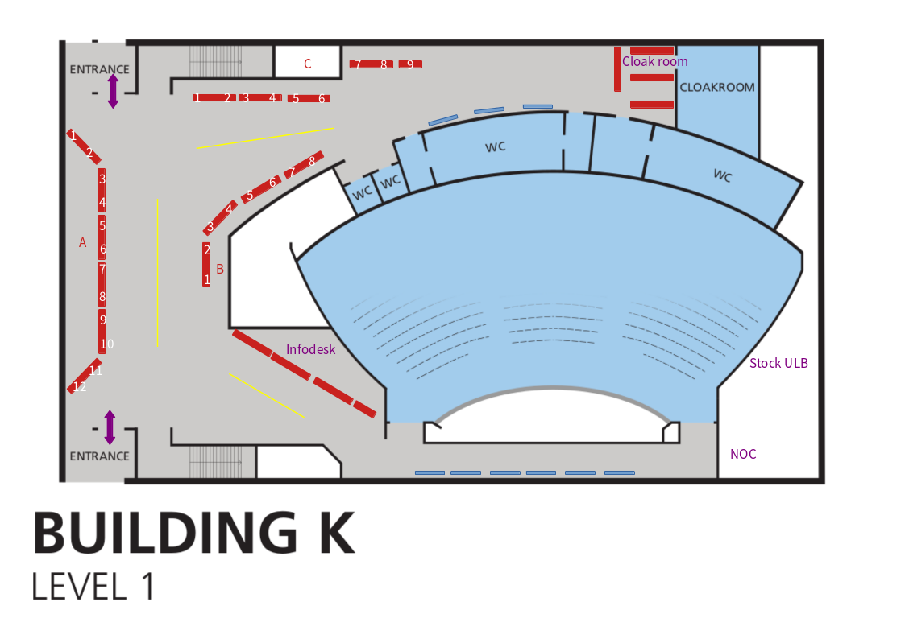
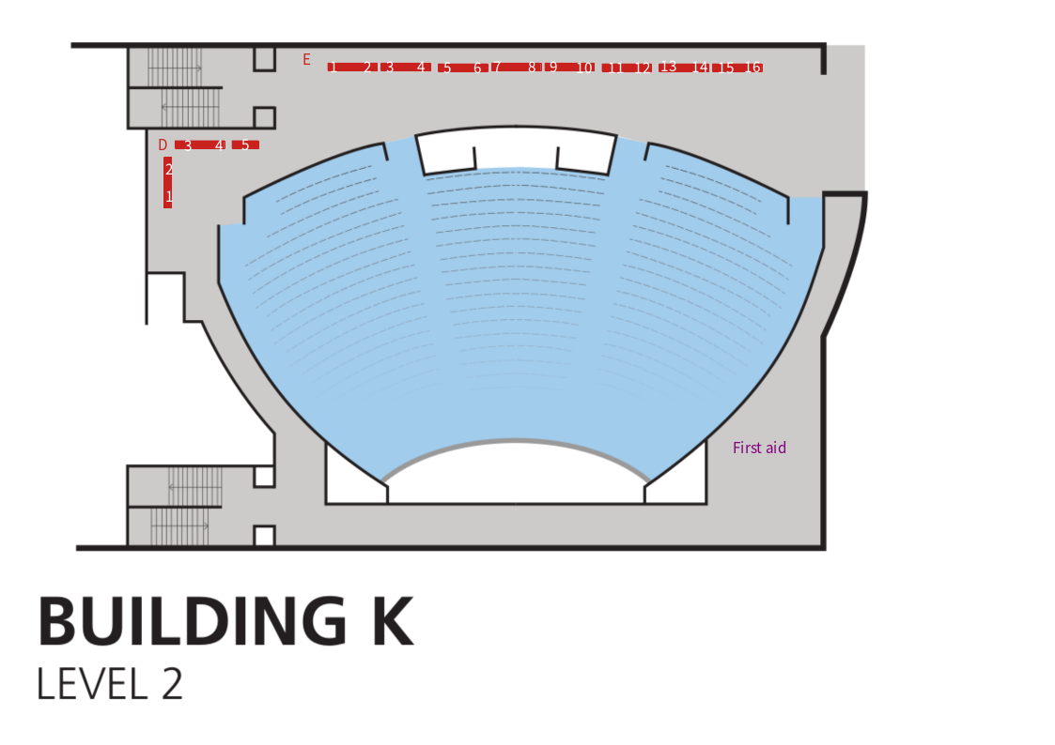

Infodesk
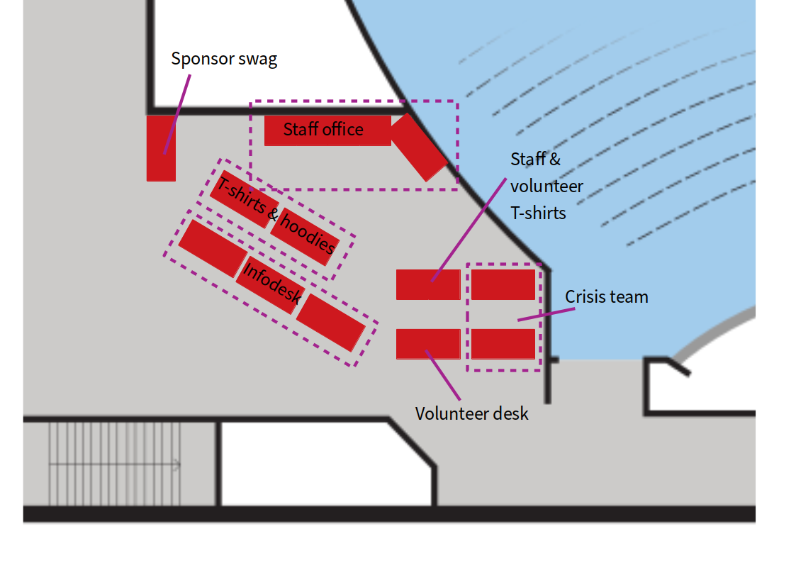

FIT room
K4.401
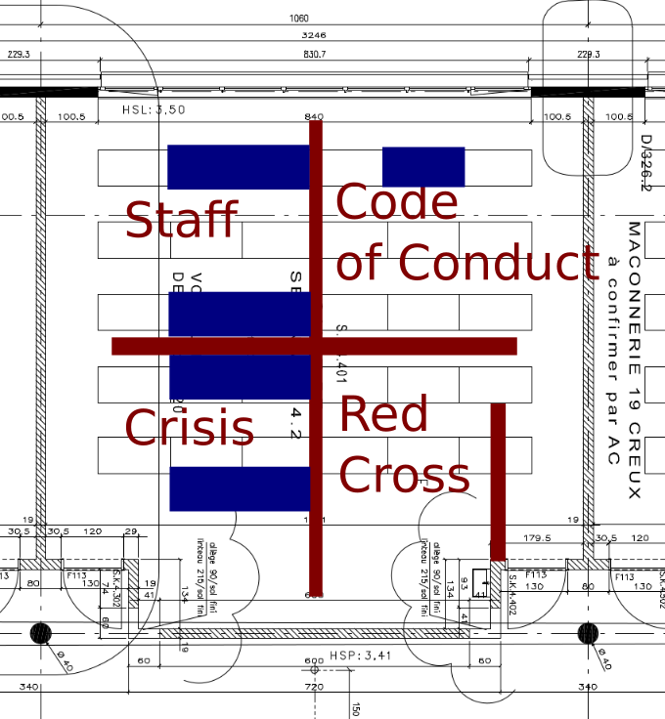

Stands

Map
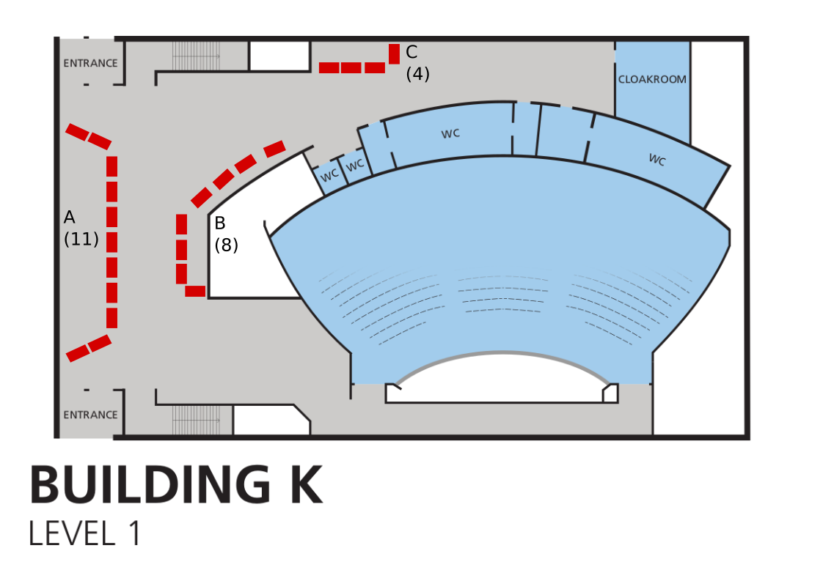

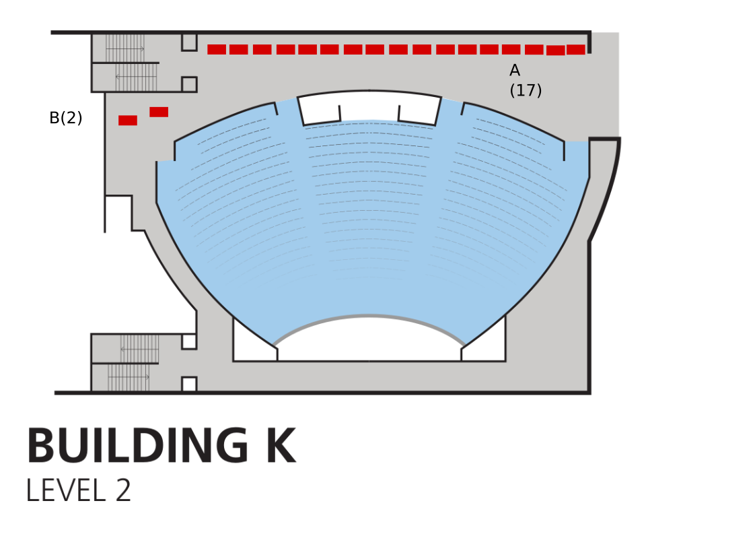

List

Stand | Theme | Floor | Group | Number | Location
Eclipse Foundation | Community advocacy | K+1A | A | 1 | K+1AA1
FOSSASIA | Community advocacy | K+1A | A | 2 | K+1AA2
Matrix.org Foundation | Community advocacy | K+1A | A | 3 | K+1AA3
Software Freedom Conservancy | Community advocacy | K+1A | A | 4 | K+1AA4
Free Software Foundation Europe | Community advocacy | K+1A | A | 5 | K+1AA5
Free Culture Podcasts | Community advocacy | K+1A | A | 7 | K+1AA7
Open Culture Foundation + COSCUP | Community advocacy | K+1A | A | 8 | K+1AA8
Open Toolchain Foundation | Community advocacy | K+1A | A | 9 | K+1AA9
Open UK and Book Signing Stand | Community advocacy | K+1A | A | 10 | K+1AA10
The Apache Software Foundation | Community advocacy | K+1A | A | 11 | K+1AA11
Ansible | System administration | K+1B | B | 1 | K+1BB1
Grafana | System administration | K+1B | B | 2 | K+1BB2
Bareos | System administration | K+1B | B | 3 | K+1BB3
Foreman | System administration | K+1B | B | 4 | K+1BB4
PostgreSQL | Database engines | K+1B | B | 5 | K+1BB5
DRLM (Disaster Recovery Linux Manager) | System administration | K+1B | B | 6 | K+1BB6
OpenNebula | System administration | K+1B | B | 7 | K+1BB7
MariaDB Server | Database engines | K+1B | B | 8 | K+1BB8
CiviCRM | Office suites and productivity | K+1C | C | 1 | K+1CC1
DAVx5 – CalDAV / CardDAV / WebDAV client for Android + jtx Board | Office suites and productivity | K+1C | C | 2 | K+1CC2
XWiki & CryptPad | Office suites and productivity | K+1C | C | 3 | K+1CC3
Libreoffice | Office suites and productivity | K+1C | C | 4 | K+1CC4
Linux on Mobile (Sailfish OS, Ubuntu Touch, postmarketOS, Mobian and more) | Operating systems | K+2A | A | 1 | K+2AA1
KDE | Desktop environments | K+2A | A | 2 | K+2AA2
GitLab | Developer environment | K+2A | A | 3 | K+2AA3
Homebrew | Developer environment | K+2A | A | 4 | K+2AA4
Audacity and MuseScore | Multimedia and graphics | K+2A | A | 5 | K+2AA5
Mozilla | World wide web | K+2A | A | 6 | K+2AA6
Nextcloud: Self-hosted, open file sync & communication platform | World wide web | K+2A | A | 7 | K+2AA7
Jenkins | Developer environment | K+2A | A | 8 | K+2AA8
La Contre-Voie | Education | K+2A | A | 9 | K+2AA9
VideoLAN | Multimedia and graphics | K+2A | A | 10 | K+2AA10
The Perl/Raku Foundation | Developer environment | K+2A | A | 11 | K+2AA11
IEEE SA Open | Education | K+2A | A | 13 | K+2AA13
It's time to learn Ada! | Education | K+2A | A | 14 | K+2AA14
AlekSIS | Education | K+2A | A | 15 | K+2AA15
Chamilo | Education | K+2A | A | 16 | K+2AA16
IsardVDI | Education | K+2A | A | 17 | K+2AA17
Realtime Lounge | Community advocacy | K+2B | B | 1 | K+2BB1

