FOSDEM 2023 BUILD-UP
U BUILDING

Contents
Contents
Rooms 4
General timeline 6
FOSDEM -1 week 6
Thursday 6
Friday 6
Finishing touches (mostly network and video). Most volunteers go home. 8
Equipment checklist 9
People checklist 11
Task checklist 12
General timeline 16
Sunday 16
Monday 17
We provide food. 17
Equipment checklist 18
People checklist 19
Task checklist 20
General map 24
Signage 25
Accessible access UA←>UB 25
Outside 26

Useful information

Rooms
- UA2.118
- UA2.114 (not on Friday and Saturday before 13:00)
- UA2.220 (not on Friday and Saturday before 13:00)
- UB2.147
- UB2.252A
- UB4.132
- UB4.136
- UB4.228 (FIT)
- UB5.132
- UB5.230
- UD2.120
- UD2.208 (not on Friday and Saturday before 13:00)
- UD2.218A

BUILD-UP
FRIDAY

General timeline

FOSDEM -1 week
- Etat des lieux with team of Arnaud Slotte.

Thursday

17:00 – 20:00
- Load vans at the office with Ulysses. We provide food.

Friday
(Provide your own lunch.)

08:30
- Primary building person arrives at ULB and waits.

08:30 – 12-30
- Rentevent delivery at ULB (building K & building H).
- Solucious Delivery at ULB (building K).

11:00 – 12:00
- Delivery and installation walkie-talkies (Walkies4Events).

11:00
- Staff arrives at ULB.
- Open Kitchen and NOC (ULB 7).

11:00 – 12:00
- Transportation drop off (K and H).
- Prepare for build-up:
  - Check all rooms and buildings are open (except the ones that are not yet available).
  - Grab a bite of food.
  - Exchange phone numbers unless the repeater already works.

12:00
- Volunteers should arrive at campus for buildup tasks

12:00 - 18:00
- Build-up.
- Catering vans might arrive.
  - Wafels & zo (14:00).
  - Melis Events (14:00).

18:00 - 18:30
- Collection of all volunteers in K. Build-up should be finished.
- Catering orders food (Chinese): vegan and non-vegan; ask allergies.

18:30 - 19:30
- Dinner.

19:30 - 22:00
- Finishing touches (mostly network and video). Most volunteers go home.

Equipment checklist
What should you have? | Where should it be? | Who should give it to you? | Do you have it?
3 ropes | H+1 | RentEvent
13 Welcome to U building (A1)  - 4 UA  - 5 UB  - 4 UD | H+1 | Signage
26 What’s going on in U (A1)  - 13 Saturday  - 4 UA  - 5 UB  - 4 UD  - 13 Sunday  - 4 UA  - 5 UB  - 4 UD | H+1 | Signage
U Devroom folders (A4 in folder) | H+1 (Box 55) | Signage
Interior U signage (A4 in folder) | H+1 (Box 55) | Signage
Exterior U signage (arrows) | H+1 (Box 55)
Box 65 (building box) | H+1 | Equipment
Box 75 (broom sticks) | H+1 | Equipment

People checklist
Who should be there? | Are they here?
FOSDEM Staff
10 FOSDEM volunteers
2 FOSDEM signage volunteers

Task checklist
What should be done? | When should it be done? | Who should do it? | Has it been done?
Cover University announcement boards with brown paper.  Do not cover vending machines. | 12:00 – 18:00 | Volunteers
Put devroom folders in each devroom. | 12:00 – 18:00 | Volunteers
Use safety tape to cordon off each fire exit and all fire equipment. | 12:00 – 18:00 | Volunteers
Tape signs to each devroom.  - Full/Empty spaces (both doors)  - Name of the devroom  Add “room only available from 13:00” (both doors)  - UA.2.220  - UB.2.147 | 12:00 – 18:00 | Volunteers
Tape signs to FIT room.  - Reserved for FOSDEM staff (UB.4.228).  Only when room is empty! | 18:00 – 19:00 | Staff
Add What’s going on and Welcome to signs.  - See map.  - One of each at every entrance.  - UD Av. Paul Héger + UD Garden  - UB Garden (not UB Lameere!)  - UA Garden  - One of each on every floor in UB.  - Not on +2 (= main entrance)  - +1  - +4  - +5  - Note that “What’s going on” is different between Saturday and Sunday. | 12:00 – 18:00 | Volunteers
Add signage to go from UA to UB. This is via the +1: take the lift and follow the corridor. This should be clearly signposted so people can find it. This is the disabled access to UA. | 12:00 – 18:00 | Signage volunteers
Place exterior signage (arrows). See below. | 12:00 – 18:00 | Signage volunteers
Put glass recycling boxes at every entrance (UD Av. Paul Héger, UD Garden, UB Lameere, UB Garden, UA Garden). | 12:00 – 18:00 | CI
Create the FIT room (UB.4.228).  If the room is not empty or closed, this must be done on Saturday 07:00 – 09:00. | 18:00 – 19:00 | Volunteers  Staff
Set up the network. | 12:00 – 18:00 | Network team
Set up the video system. | 12:00 – 18:00 | Video team
Tape off all cables that run over floors or corridors with gafer tape (do not use duct tape). | 12:00 – 18:00 | Volunteers
Put garbage bins around the building, especially where there are not a lot of garbage bins. | 12:00 – 18:00 | Volunteers

TEAR-DOWN
SUNDAY

General timeline

Sunday

15:00
- BR meeting in K.4.401. Change walkie-talkie batteries.
- BR check on their buildings to ensure that stands/devrooms are aware of tear-down. Make sure the collection points have everything they need.
- BR estimates how many volunteers they need for their building. Contact volunteers team.

16:00 – 20:00
- Tear-down. There is an order in clearing out the buildings: start with AW and U; move to H, F and J; finish with K. Apart from Janson, K-1 and lower H, cleanup starts at 17:00. K-1, Janson and lower H start as soon as the closing talk finishes (~18:00).
- Catering vans will leave. They take care of themselves usually.

20:00 – 20:30
- Collect volunteers in K for volunteer dinner.

20:30 – 20:45
- Sweep K. Garbage out.
- Volunteers leave.

21:00

- Staff dinner.

22:00
- CI closes the bar(s).

Monday

08:30
- Primary building person arrives at ULB. Waits for RentEvent to pick stuff up.

17:00 – 20:00
- Unload vans at the office. Boxes stacked according to the label; and with the label in front.
- We provide food.

Equipment checklist
What should you bring back? | Where should it go? | Is it where it should be?
3 ropes | H+1
13 Welcome to U building (A1) | Garbage
26 What’s going on in U (A1) | Garbage
Devroom folders | H+1 (Box 55)
Interior U signage | H+1 (Box 55)
Arrows | H+1 (Box 55)

People checklist
Who should be there? | Are they here?
FOSDEM Staff
10 FOSDEM volunteers

Task checklist
What should be done? | When should it be done? | Who should do it? | Has it been done?
Change signage from Saturday to Sunday.  - Devroom signs (should be in Devroom folder).  - What’s going on. | 07:00 – 09:00 | Signage volunteers  Staff
All hands meeting in the FIT room (K). | 15:00 | Staff
Swap walkie-talkie battery. | 15:00 | You
Do a round of all devrooms informing them of clean-up instructions.  - They should clean-up from 17:00 and finish by 18:00.  - They should sweep the room, remove all the trash and take the full trash bags to the containers outside.  - Brooms, dust pans and garbage bags can be gotten from the Infodesk.  - Laminated signs that are in the Devroom must be put in the folder and handed to the Infodesk.  - Video and network should not be touched. | 16:00 – 17:00 | You
Remove all FOSDEM stuff.  - Brown paper  - FOSDEM signage  - Devroom signs  - All tape  - Outside arrows | 18:00 – 19:00 | Volunteers
Put FOSDEM equipment in the boxes (if it came out of a box). People will come from other buildings with stuff, make sure it is in the right box. | 17:00 – 19:00 | Staff  Volunteers
Load the vans with boxes. Follow the instructions of the transportation team. | 17:00 – 19:00 | Volunteers
Put all carts and all stuff in H+1 for collection. | 18:00 – 19:00 | Volunteers
Sweep floors, empty garbage bins, clean out devrooms, auditoria, corridors and whatever seems dirty. | 17:00 – 19:00 | Volunteers
Disassemble the FIT room. | 18:30 – 19:30 | Volunteers
Remove network.  Only after a go from the network team. | 18:30 – 19:30 | Network team  Volunteers
Remove video.  Only after a go from the video team. | 18:30 – 19:30 | Video team  Volunteers
Send volunteers to H when finished. | 18:30 – 19:30 | Volunteers

MAPS AND LISTS

General map
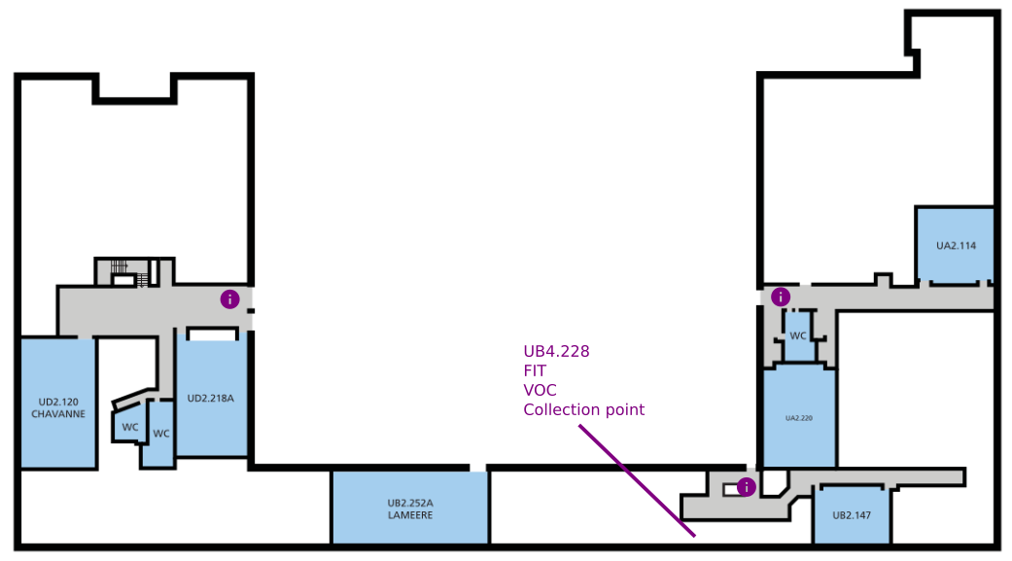

Signage

Accessible access UA←>UB
- Accessible access to UA is from UB. The corridor is on level 1 (you enter on level 2).
- Attach signs pointing to the elevator and in the corridor. Tape them with gaffer tape at least at every corner.
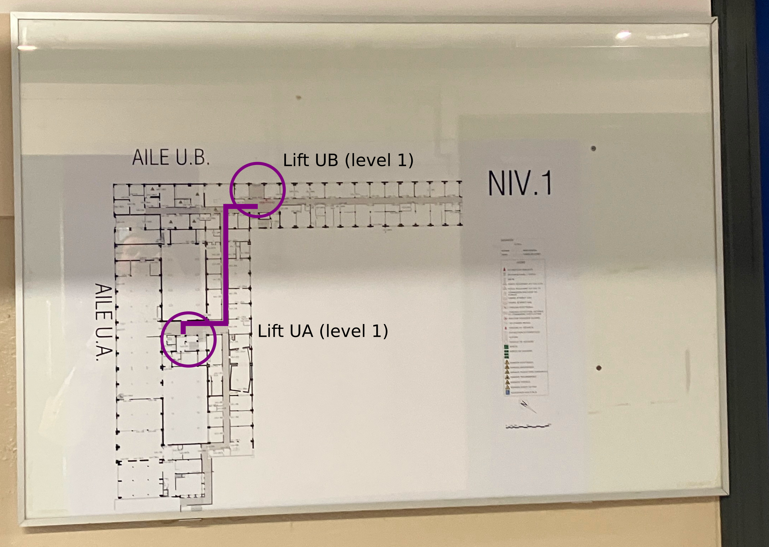

Outside
- Arrows must be attached to trees, poles, … Be creative (see photo’s as a guidance).
- Remember that you must place arrows for people coming to U and people going from U.
- Remember accessib ility.
  - UD via Av. Paul Héger.
  - UB and UA via UB.
- UA, UD, UB are from Paul Héger via point U1 and U2.
- UD accessible is via Paul Héger.
- Add extra signs in front of UB point that accessible UA is via UB.
- Attach with black rubber bands.

List
(spares are in the H FIT Room)
Sign | Amount
FOSDEM | 3
UA accessible | 4
UD | 4
UB | 4
UA | 5

Routes
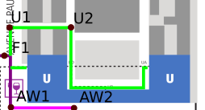

U1
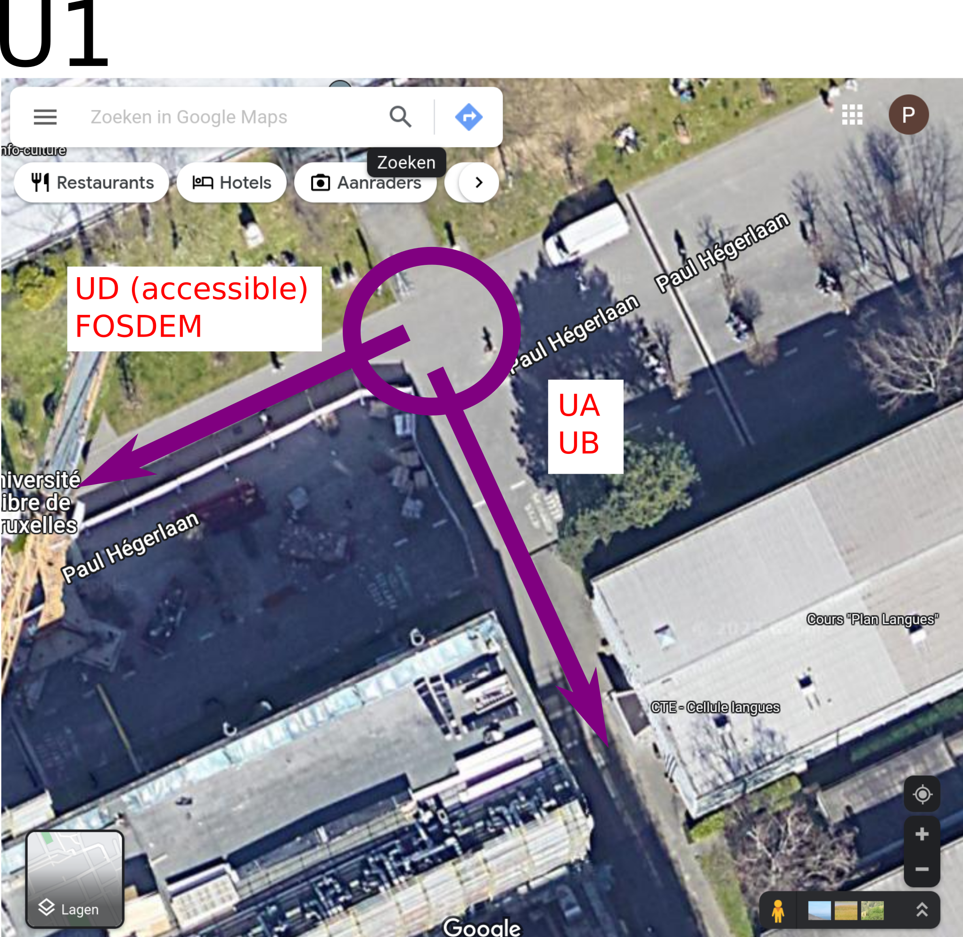

U2


