# DesignThinking

Empathize:

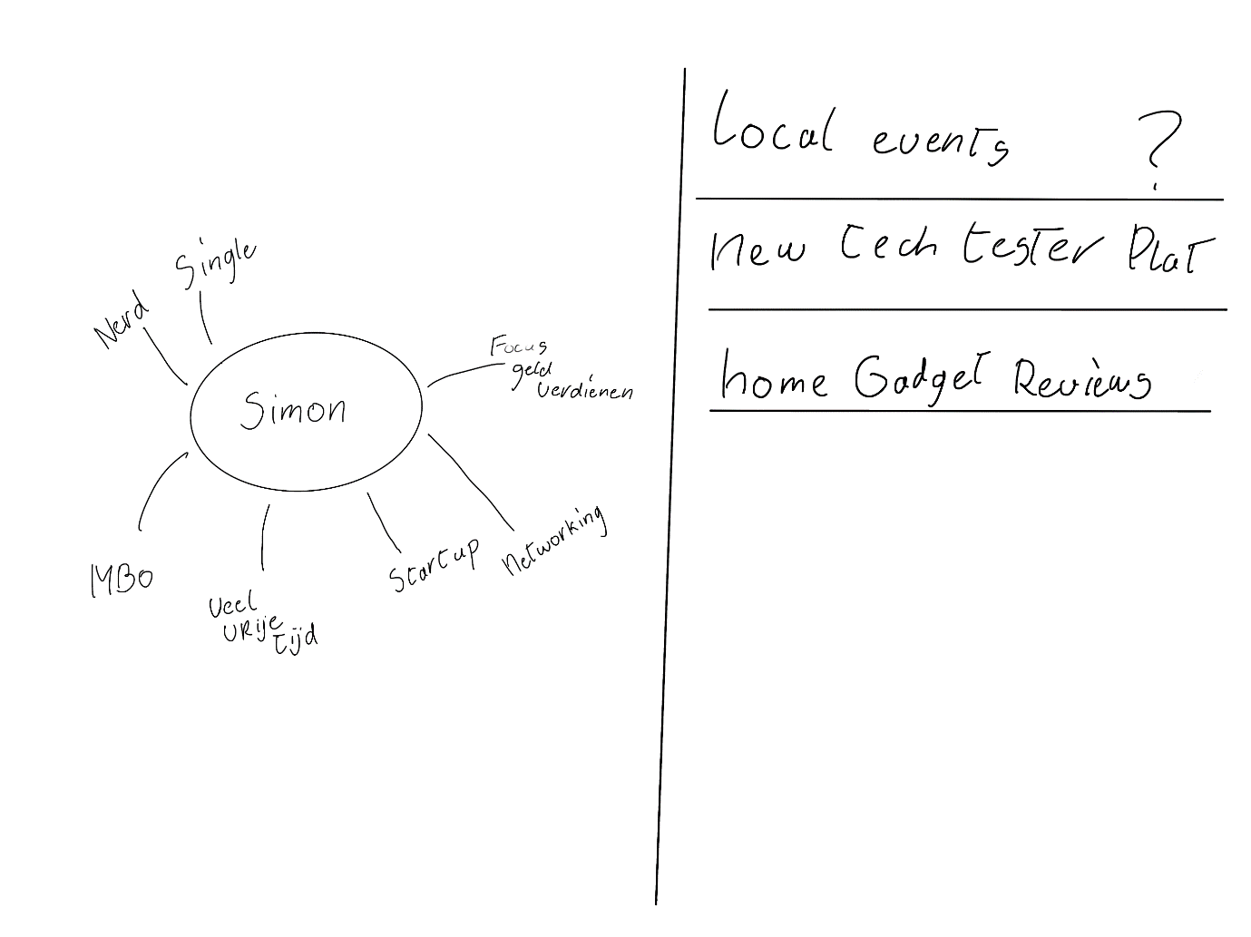

* Super comfortable with technology
* Single
* Undergraduate degree
* A lot of spare time
* Has a start-up
* Busy with networking.
* Focused on making money on new technology.

Simon:

Simon works a lot on his start-up, but when he isn’t working, he has a lot of spare time. He lives by himself away from his family. He recently moved to the Netherlands, which is why his apartment isn’t fully furnished yet. He is up to date with new technologies. He really likes the idea of automated smart homes and gadgets.

Define:

* Motivated by new technology and would like to find ways to monetize this. Therefore, he likes to have and see new technology.
* He lives by himself, meaning he must do everything by himself (think of chores, cooking)
* He is an entrepreneur this often implies he is curious.
* He is searching for local talent.

Ideation:

We’ve chosen the New Tech Tester Platform because it something in or around the house, and it within the interests of Simon.



* Local events
  + A platform where you can find local events around you.
  + Helps finding local talents
  + Creates a network around him with new contacts, friends, and possible colleagues
* ***New Tech Tester Platform***
  + Shows new tech innovations
  + You can apply which product you would like to test
  + You get familiar with new upcoming technology
  + You can keep the products, or you can get paid to test it.
  + The gadgets can possibly help around the house.
* Home gadget Reviews
  + Platform where you can view all home gadgets
  + People review the gadgets, and you can review them yourself.

Prototyping:

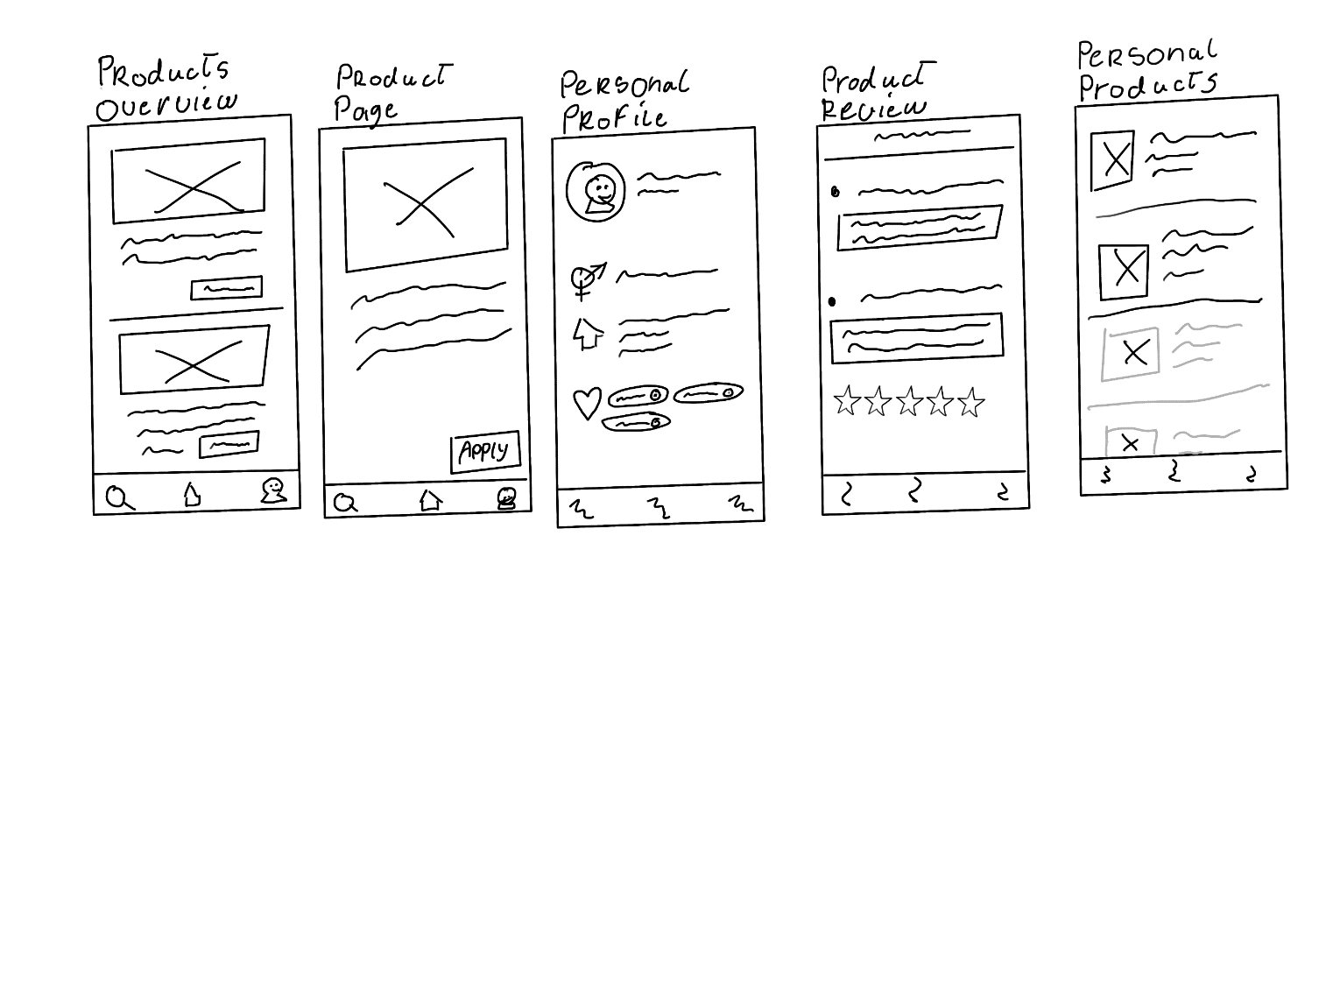

Ideas:

* A manual for the product sent with the product itself
* Camera use for pictures/videos to show proper use.
* Company needs other pages to add product to app.
* Scan when the gadget(product) arrives?
* Shake is bug report?

Why an app?

* People just like to quickly see what’s new (they’re lazy)
* Pop-up notifications
* Camera usage for reviews or confirmation.
* Quick sign in (touch/face id)
* Possible chat with product owner?
* It’s conveniently always with you, so you can even ‘work’ in the train or bus (people like money). And you can always see what’s new.
* You can have the manual on your phone while you are trying out the product.

Playful Experience:

* Instead of a simple survey form, give the questions one by one with a transition animation.
* Maybe when you apply for a product, it will ‘fly’ into your profile or to the product owner.
* Level/ Title for experienced reviewer, this gives them validation (and possibly motivation) for their work as well.
* Achievements/badges.
* Statistics.
* Possible sign in streak?
* Depending on amount of product “Only… left”, and a rarity indicator.

Feedback other students:

* Rarity badge colours and text were ugly.
* Had to still make a Login and Review page
* Function phone is not enough, products that require phone.
* Without info, it looks like a marketplace.
* Chat already makes it more interesting
* Not a general review.
* Focus on the testing itself, seems much more interesting.
* Do specific tests.
* Very useful if it really benefits the company. Just a review is not enough.
* Great that we have already done a lot so that he can have a lot of criticism.
* Have user stories tested.
* Think of quantity maybe 1000 members and only 5 products.