**Bando di concorso Premio Minerva alla Ricerca scientifica - II edizione**

**Estratto riassuntivo della Tesi di Dottorato del candidato PIETRO MESCHINI**

***Forecast Based Traffic Signal Coordination Using Congestion Modelling and Real-Time Data***

# **1.Abstract**

**This dissertation focusses on the implementation of a Real-Time Simulation-Based Signal Coordination module for arterial traffic, as proof of concept for the potential of integrating a new generation of advanced heuristic optimisation tools into Real-Time Traffic Management Systems. The endeavour represents an attempt to address a number of shortcomings observed in most currently marketed on-line signal setting solutions, to provide better adaptive signal timings to meet the unpredictable nature of traffic demand.**

**It is *unprecedented* in its use of a Genetic Algorithm coupled with Continuous Dynamic Traffic Assignment as solution evaluation method, only made possible by the recently presented parallelisation strategies for the underlying algorithms.**

**Within a fully functional traffic modelling and management framework, the optimiser is developed independently, leaving ample space for future adaptations and extensions, while relying on *the best available technology* to provide it fast and realistic solution evaluation based on reliable real-time supply and demand data. The optimiser can in fact operate on high quality network models that are well calibrated and always up-to-date with real-world road conditions; rely on robust, multi-source network wide traffic data, rather than being attached to single detectors; manage area coordination using an external simulation engine, rather than a naive flow propagation model that overlooks crucial traffic dynamics; and even incorporate real-time traffic forecast to account for transient phenomena in the near *future* to act as a feedback controller.**

**Results clearly confirm the efficacy of the proposed method, by which it is possible to obtain relevant and consistent corridor performance improvements with respect to widely known arterial bandwidth maximisation techniques under a range of different traffic conditions.**

**The computational efforts involved are already manageable for realistic real-world applications, and future extensions of the presented approach to more complex problems seem within reach thanks to the load distribution strategies already envisioned and prepared for in the context of this work.**

# **2.** **A Real-Time Forecast-Based Optimiser**

The foremost aim of this work is to exploit the versatility and speed of advanced macroscopic traffic simulation to bring forth a heuristic approach capable of improving signal plans *in real time* using live reliable data and dynamic traffic forecast. It represents an attempt to bring together the best of most signal setting approaches introduced in the previous chapters, in that by integration within the real-time traffic management environment outlined in section […] it aims to be:

* **adaptive -** since real-time operation should guarantee a degree of adaptivity so far only expected of actuated signals, besting other plan-generating systems particularly in terms of response times;
* **accurate -** thanks to the detailed network and traffic propagation models provided by the traffic management environment, coupled with solid real-time data, which enable it to operate on more reliable assumptions about traffic and its movements;
* **impartial -** by relying on an objective-driven heuristic search method to avoid the simplifications involved in a strictly analytical approach, behaving like a feedback controller and accounting for the short-term consequences of its decisions, rather than making assumptions about the best way to operate signals optimally;
* **versatile -** because once the principles of operation are proven sound and the system integration is functional, the same can be used to approach more complex optimisation problems, operate on longer time scales or be used as powerful offline planning tools;
* **scalable** - by relying on task distribution and parallel computing.

**The proposed *active signal control* approach uses a Genetic Algorithm coupled with a superior macro-simulation traffic forecast engine to generate and select candidate signal timings, gradually guiding their evolution towards a global optimum that yields the best network performance on the affected area. Previous chapters introduced the different components that allow the real-time optimisation, from the Dynamic Traffic Assignment engine to the Genetic Algorithm itself, detailing their inner workings and the importance of their contribution. The most relevant known signal optimisation approaches, a study of which drove the design of this unprecedented alternative, were also presented.**

***Heuristic Offset Optimisation***

**The task at hand is to develop an optimiser that can choose the timing *offsets*  (see section […]) between a group of adjacent signalised junctions that regulate traffic progression along a corridor as defined in section […].**

**The problem of arterial *coordination* has been tackled in a variety of ways: mostly, as the relevant scientific literature testifies, analytical approaches to the problem have been sought which revolve around the concept of *bandwidth* as the driving metric. These stem from the extremely reasonable assumption that to increase the chance of encountering a *green wave* along a traffic artery should ultimately mean to maximise its throughput; they are also a testimony to the extreme difficulty of encapsulating the complex dynamics of traffic itself into a closed-form analytical formulation that would be nearly as elegant as those that can be built upon the relatively simple paradigm of bandwidth, discussed in detail in section […].**

**Although moving *from* the idea of bandwidth maximisation, as illustrated in this chapter, this work aims to do *away* not only with the search for green waves but with the very need to explicitly model the correlation between signal offsets and arterial traffic fluidity. The idea is to rely on *simulation* to verify *a posteriori* whether certain timing choices bring about an improvement in performance of the corridor, and to what extent: this allows to concentrate on the *results*, which can be assessed according to any chosen metric and may well arise from less obvious decisions than those which would only seek to maximise the throughput. […]**

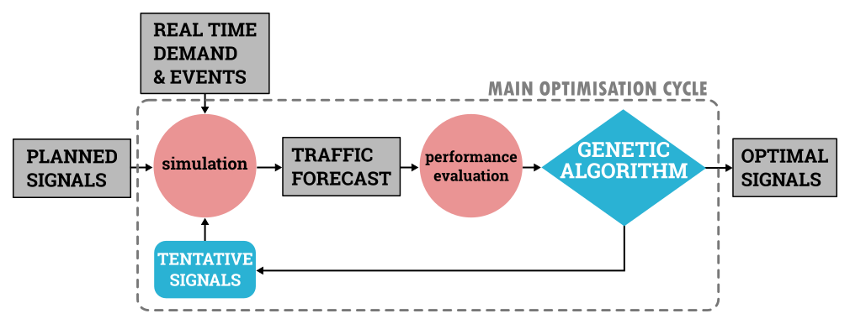

Figure 1 - **The optimisation relies on accurate propagation of real-time traffic data to assess the benefits in the near future of potential modifications to the scheduled signal plans. The performance of the corridor is evaluated on the basis of the resulting forecast, which serves as a ranking metric for the evolutionary algorithm to generate better offset combinations until the optimal solution is found**

*Rolling Look-Ahead Window Optimisation*

Two of the strongest features […] are the capability to account for transient traffic phenomena (such as the gradual build-up or dissipation of queues over a number of signal cycles) and of future events which may be known in advance (such as road closures and deviations). In order to fully exploit these advantages, the optimisation is performed by evaluating traffic conditions as they develop over a *rolling look-ahead window*, i.e. a time span in the order of a few signal cycles that is completely in the future with respect to the real time during which the optimisation occurs.

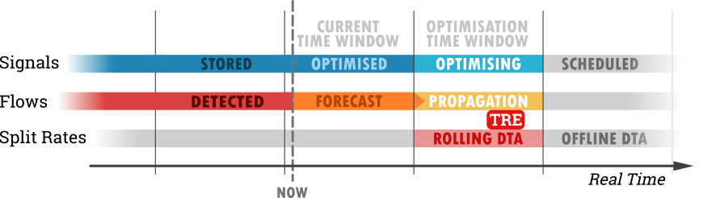

Figure 2 - Rolling Optimisation is performed in real-time on a time window in the near future, while the previous (now current) time window plays out and results of the corresponding optimisation are implemented on the street-level equipment.

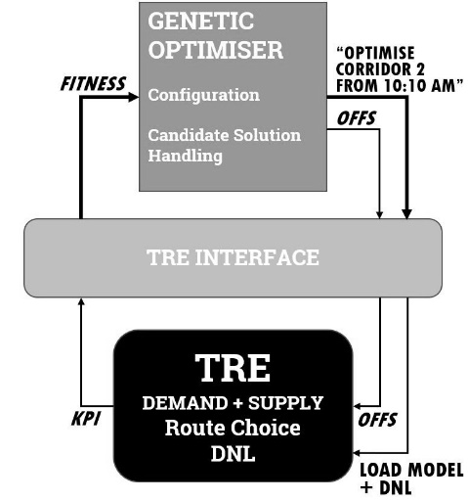

Figure 3 The Dynamic Traffic Assignment algorithm known as TRE serves as a single point of contact between the traffic management system and the offset optimiser, to which it delivers the precious information available within the system in the only form that is truly useful, i.e. that of accurate predictions about the outcome of a choice of signal offsets.

*Continuous Dynamic Network Loading as performance function*

Optimisation by evolutionary algorithm is driven by assessing the quality of traffic propagation that arises from current conditions and the tentative timing choices. This is determined by simulation in several steps:

1. **start:** when the optimiser is first launched, the only parameter it requires beyond its own algorithm configuration is the index of the corridor to be optimised.
2. **DTA:** TRE performs a full *dynamic user equilibrium assignment* from the current time, covering a span of *two* optimisation windows into the future, and saves:
   1. flows onto and out of the cordon (access and egress) links of the corridor,
   2. turn rates (averaged over the entire period) splitting flows at each intersection all along the corridor
   3. vehicles present on each arc at the beginning of the next window

obviously starting itself with a loaded network if arc occupancy data is available for the initial instant of the DTA span.

1. **DNL:** using the split rates just calculated, TRE propagates flows over the *optimisation window* for each set of offsets proposed by the optimiser, returning the desired performance indices: this is not an equilibrium assignment, and is performed *only* on the corridor and cordon links.
2. **finalisation:** when the optimisation objectives are satisfied or the current time window is almost elapsed, optimised offsets are sent to the data model to be included as *future events* by subsequent simulations, and handled as appropriate by Optima for their implementation on the field.
3. **rolling forward:** with the new offsets finalised and the state of the network known, TRE can go back to Step 1 and perform a new DTA, so that the next window can be optimised while the one just finalised plays out.

# **3.** Performance enhancement and new bandwidth paradigm

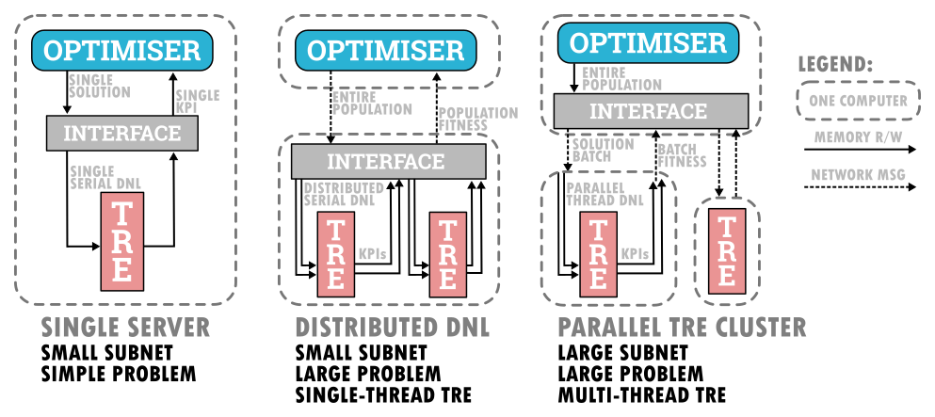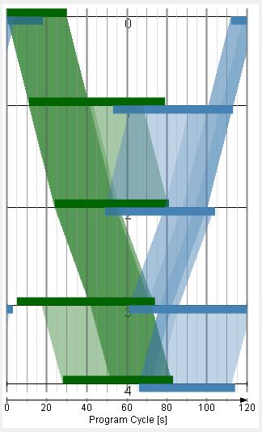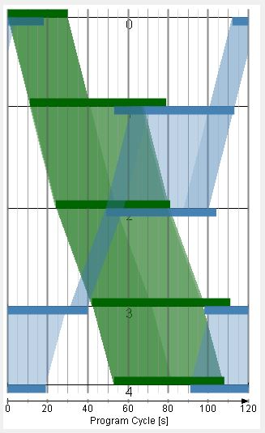

**VS**

Figure 4 - Initial solutions for the GA are obtained by optimising the “slack band” metric described in this work (left) rather than the “canonical” bandwidth definition (right). This allows to start off with much better solutions, particularly for two-way optimisation where timings in the two directions conflict. Bands crossing the T-D diagram from the bottom-left to the top-right are travelling in the main direction, the others in the secondary direction. Darker bands are green waves in common between a higher number of junctions, the darkest corresponding to the canonical bandwidth and all others to the fringes and partial green waves that the new metric allows to weigh in.

*Figure 5 - Parallelisation Options: DISTRIBUTED DNL -several single-thread TRE instances running on the same machine can speed up solution evaluation by distributing the load without competing for processor cores, to tackle a slightly more complicated application such as could be a corridor optimiser that can also determine phase green shares; PARALLEL TRE CLUSTER: by increasing the number of machines TRE can also deal with more demanding DNL in a short time by fully exploiting multi-threading.* *Notice that for reasonably sized problems and sub-networks, ordinary inexpensive four-core processors would already be more than enough to reap all the available benefits of parallel evaluations or multi-thread DNL.*

***4.*** *Performance and Results*

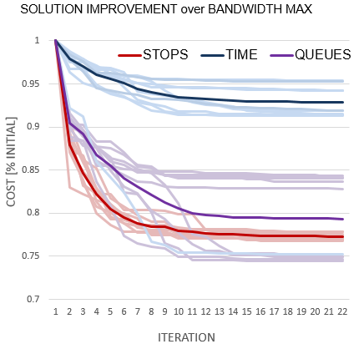Tests performed on real world networks and randomly generated corridors with side flows show that the algorithm is capable of improving the performance consistently with respect to the already optimised slack-band solutions used to prime the Genetic Algorithm. In particular:

* The optimiser finds sensible solutions coherent with band maximisation
* Significant corridor performance improvement (10-20% less queues and travel time) for a range of saturation levels
* Execution times are practicable for a 10 minute time window
* Real-Time Simulation-Based Optimisation with congestion modelling may well become a reality.